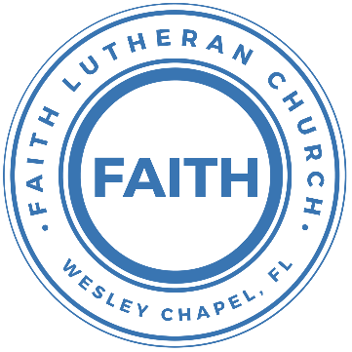

**Leading our community into a deep connection in Christ**

**Worship Service for November 27, 2021, at 11 AM**

**Welcome**

**Faith: This Is Who We Are:**Our Measures: “Growing in God’s Way”

**Opening Song:**Sing To The King

Verse 1:

Sing to the King Who is coming to reign  
Glory to Jesus, the Lamb that was slain

Life and salvation His empire shall bring

And joy to the nations when Jesus is King

Chorus:

Come, let us sing a song, A song declaring that we belong to Jesus

He’s all we need

Lift up a heart of praise. Sing now with voices raised to Jesus

Sing to the King

Verse 2:

For His returning we watch and we pray

We will be ready the dawn of that day

We'll join in singing with all the redeemed

'Cause Satan is vanquished and Jesus is King

Chorus 2x

**Invocation**

**Confession and Forgiveness:**

**P:** Come into the presence of the Lord our God.

**C:** Have mercy, O Lord. If you, Lord, kept a record of sins, Lord, who could stand; but if we confess our sins, he is faithful and just to forgive us our sins and to cleanse us from all unrighteousness.

*(a time of silence to reflect and personally confess our sins)*

**P:** I said, "I will confess my transgressions to the LORD." And you forgave the guilt of my sin. Let us confess our sin before the Lord. Let us confess together.

**C:** Heavenly Father, we confess that we are sinners.  We have sinned against you and our neighbors. We have not loved you with our whole heart and we have not loved our neighbors as ourselves. We justly deserve Your punishment.  For the sake of Your Son, Jesus Christ, have mercy on us.  Forgive us, renew us, and lead us, so that we may delight in Your will and walk in Your ways to the glory of Your holy name.  Amen.

**P:** The Lord is gracious and merciful. He promises to forgive our sins. Therefore, upon this, your confession, as a called and ordained servant of the Lord, in the stead and by the command of my Lord, Jesus Christ, I forgive you all your sins in the name of the Father and of the Son and of the Holy Spirit.

**C:** Amen.

**Song of Praise and Thanksgiving –** Arise And Shine In Splendor

Verse 1: (Acapella)

Arise and shine in splendor, Let night to day surrender;

Your light is drawing near. Above, the day is beaming,

In matchless beauty gleaming; The glory of the Lord is here.

Verse 2: (Picking)

See earth in darkness lying, The heathen nations dying

In hopeless gloom and night. To you the Lord of heaven,

Your light, your hope, has given Great glory, honor, and delight.

Verse 3:

The world’s remotest races, Upon whose weary faces

The sun looks from the sky, Shall run with zeal untiring,

With joy your light desiring That breaks upon them from on high.

Verse 4:

Lift up your eyes in wonder; See, nations gat-her yon - der,

They all come to be free. The world has heard your story,

Your sons come to your glory, And daughters haste your light to see.

**Epistle Reading –** Romans 13:8-10

Owe no one anything, except to love each other, for the one who loves another has fulfilled the law. For the commandments, “You shall not commit adultery, You shall not murder, You shall not steal, You shall not covet,” and any other commandment, are summed up in this word: “You shall love your neighbor as yourself.” Love does no wrong to a neighbor; therefore love is the fulfilling of the law.

**Reader:** This is the Word of the Lord.  
**C:** Thanks be to God.

**Gospel Reading –** Matthew

“But concerning that day and hour no one knows, not even the angels of heaven, nor the Son, but the Father only. For as were the days of Noah, so will be the coming of the Son of Man. For as in those days before the flood they were eating and drinking, marrying and giving in marriage, until the day when Noah entered the ark, and they were unaware until the flood came and swept them all away, so will be the coming of the Son of Man. Then two men will be in the field; one will be taken and one left. Two women will be grinding at the mill; one will be taken and one left. Therefore, stay awake, for you do not know on what day your Lord is coming. But know this, that if the master of the house had known in what part of the night the thief was coming, he would have stayed awake and would not have let his house be broken into. Therefore you also must be ready, for the Son of Man is coming at an hour you do not expect.

**P:** This is the Gospel of the Lord.  
**C:** Praise be to You, o Christ.

**Children's Message**

**Sermon Hymn –** Savior Of The Nations Come

Verse 1

Savior of the nations, come, Virgin's Son, make here Thy home!

Marvel now, O heaven and earth, That the Lord chose such a birth.

Verse 2

Not by human flesh and blood, By the Spirit of our God,

Was the Word of God made flesh-- Woman's Off-spring, pure and fresh.

Verse 5

Thou, the Father's only Son, Hast o'er sin the vict'ry won.

Boundless shall Thy kingdom be; When shall we its glories see?

Verse 7

Praise to God the Father sing, Praise to God the Son, our King,

Praise to God the Spirit be Ever and eternally.

**Sermon -** "Savior of The Nations Come"

Sermon text Isaiah 2:1-5

The word that Isaiah the son of Amoz saw concerning Judah and Jerusalem.

It shall come to pass in the latter days

that the mountain of the house of the Lord

shall be established as the highest of the mountains,

and shall be lifted up above the hills;

and all the nations shall flow to it,

and many peoples shall come, and say:

“Come, let us go up to the mountain of the Lord,

to the house of the God of Jacob,

that he may teach us his ways

and that we may walk in his paths.”

For out of Zion shall go forth the law,

and the word of the Lord from Jerusalem.

He shall judge between the nations,

and shall decide disputes for many peoples;

and they shall beat their swords into plowshares,

and their spears into pruning hooks;

nation shall not lift up sword against nation,

neither shall they learn war anymore.

O house of Jacob,

come, let us walk

in the light of the Lord.

**Reader:** This is the Word of the Lord.  
**C:** Thanks be to God.

**Prayers:** *Text in prayer requests to (813) 602-1104‬*

**Apostles' Creed**

I believe in God, the Father almighty,  
maker of heaven and earth,

And in Jesus Christ, his only Son, our Lord,  
who was conceived by the Holy Spirit,  
born of the Virgin Mary,  
suffered under Pontius Pilate,  
was crucified, died and was buried.  
He descended into hell.  
The third day he rose again from the dead.  
He ascended into heaven and sits at the right hand of God  
the Father almighty.  
From there he will come to judge the living and the dead.

I believe in the Holy Spirit,  
the holy Christian Church,  
the communion of saints,  
the forgiveness of sins,  
the resurrection of the body,

and the life everlasting. Amen.

**The Lord's Prayer**

Our Father who art in heaven, hallowed be Thy name, Thy kingdom come, Thy will be done on earth as it is in heaven.  Give us this day our daily bread; and forgive us our trespasses as we forgive those who trespass against us; and lead us not into temptation, but deliver us from evil.  For Thine is the kingdom and the power and the glory forever and ever.  Amen

**Offering**

**Words of Institution**

**Peace**

P: The peace of the Lord be with you all.  
C: And also, with you.  
P: We greet each other in the peace of Christ.

**Distribution**

**Prayer**

**Benediction**

**Closing Song –**The Advent Of Our King

Verse 1:

The advent of our King, Our prayers must now employ;

And we must hymns of welcome sing In strains of holy joy.

Verse 2:

The everlasting Son, Incarnate deigns to be;

Him-self a servant's form put on To set His servants free.

Verse 4:

As judge, on clouds of light, He soon will come again

And His true members all unite With Him in heav'n to reign.

**Sermon Notes:**

**_______________________________________________**

**_______________________________________________**

**_______________________________________________**

**_______________________________________________**

**_______________________________________________**

**_______________________________________________**

**_______________________________________________**

**_______________________________________________**

**_______________________________________________**

**_______________________________________________**

**_______________________________________________**

**_______________________________________________**

**_______________________________________________**

**_______________________________________________**

**_______________________________________________**

**_______________________________________________**

**_______________________________________________**

**_______________________________________________**

**_______________________________________________**

**_______________________________________________**

**_______________________________________________**

**_______________________________________________**

**_______________________________________________**

**_______________________________________________**

**_______________________________________________**

**_______________________________________________**

**_______________________________________________**

**______________________________________________**

**Upcoming Events**

**www.FaithWesleyChapel.com**

**Faith YouTube**

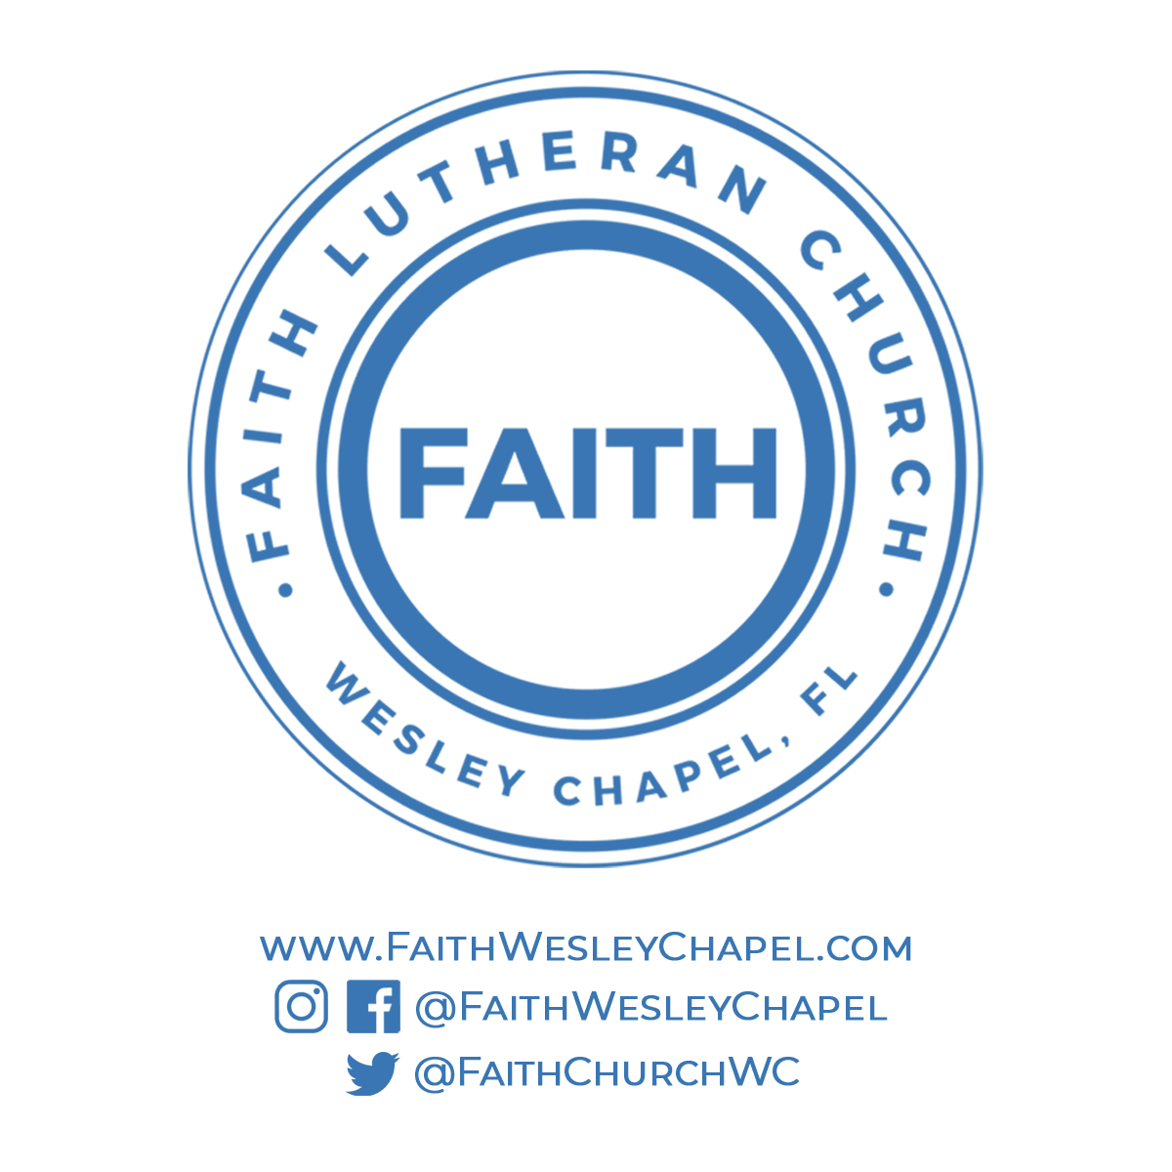**@FaithWesleyChapel**

**@FaithWesleyChapel**

**@FaithChurchWC**