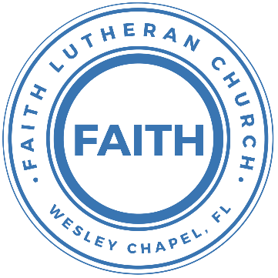

**Leading our community into a deep connection in Christ**

**Worship Service for December 4, 2022, at 11 AM**

**Welcome**

**Invocation**

**Confession and Forgiveness:**

**P:** We have come here today to worship the Lord.  In worship we hear the Word of God, we receive God's blessings, and respond with thanks and praise.  We begin by seeking God's blessing of forgiveness.  He has promised to remove the guilt and shame of our sin through the sacrifice of Jesus Christ on the cross.

*(a time of silence to reflect and personally confess our sins)*

**P:** Let us confess our sins to the Lord.

**P:** Heavenly Father,  
**C:** Heavenly Father,

**P:** I have done things that were wrong.  
**C:** I have done things that were wrong.  
  
**P:** I have been mean to others.  
**C:** I have been mean to others.

**P:** I have not obeyed my parents.  
**C:** I have not obeyed my parents.

**P:** I have not obeyed You, God.  
**C:** I have not obeyed You, God.

**P:** But I am very sorry.  
**C:** But I am very sorry.

**P:** Please forgive me.  
**C:** Please forgive me.

**P:** I love You very much.  
**C:** I love You very much.

**P:** And I know You love me, too.  
**C:** And I know You love me, too.

**P:** God has heard your apology.  He loves you very much.  God has told us that when we believe and trust in Him, He makes us His children.  As far as the east is from the west, so far does he remove our sins from us. He has told me to tell you that you are forgiven.  So, as His servant, I forgive you in the name of the Father and of the Son and of the Holy Spirit.

**C:** Amen.

**Song:**Away in a Manger

Verse 1:

Away in a manger, No crib for a bed,

The little Lord Jesus, Lay down his sweet head.

The stars in the sky, Looked down where he lay

The little Lord Jesus, Asleep on the hay.

Verse 2:

The cattle are lowing, the baby awakes;

But little Lord Jesus, No crying he makes.

I love thee, Lord Jesus, Look down from the sky,

And stay by my cradle, 'Till morning is nigh.

Verse 3:

Be near me Lord Jesus, I ask thee to stay,

Close by me forever, and love me I pray.

Bless all the dear children, in thy tender care,

And take us to heaven, to live with thee there.

**First Reading –**Matthew 3:4

Now John wore a garment of camel's hair and a leather belt around his waist, and his food was locusts and wild honey.  
  
**Reader:** This is the Gospel of the Lord.  
**C:** Praise be to You, o Christ.

**Children's Message**"This Strange Man"

**Song:**Joy to The World

Joy to the World , the Lord is come!

Let earth receive her King

Let every heart

Prepare Him room

And Heaven and nature sing

And Heaven and nature sing

And Heaven, and Heaven, and nature sing.

He rules the world with truth and grace

And makes the nations prove

The glories of,

His righteousness

And wonders of His love

And wonders of His love

And wonders, wonders, of His love!  
  
**Second Reading –**Matthew 3:1-3

In those days John the Baptist came preaching in the wilderness of Judea, “Repent, for the kingdom of heaven is at hand.” For this is he who was spoken of by the prophet Isaiah when he said,

“The voice of one crying in the wilderness:

‘Prepare the way of the Lord;

make his paths straight.’”

**Reader:** This is the Gospel of the Lord.  
**C:** Praise be to You, o Christ.

**Children's Message**"Prepare the Way!"

**Sermon Song:**On Jordan’s Bank the Baptist’s Cry

Verse 1:

On Jordan's bank the Baptist’s cry

Announces that the Lord is nigh.

Awake and harken, for He brings

Glad tidings of the King of Kings!

Verse 3:

We hail you as our Savior, Lord,

Our refuge and our great reward.

Without Your grace we waste away

Like flowers that wither and decay.

Verse 4:

All praise to You, eternal Son,

Whose advent has our freedom won,

Whom with the Father we adore,

And Holy Spirit, evermore.

**Sermon –**"Prophecy - A Messenger Will Prepare the Way"  
  
**Sermon Text- Matthew 3:1-12**

In those days John the Baptist came preaching in the wilderness of Judea, “Repent, for the kingdom of heaven is at hand.” For this is he who was spoken of by the prophet Isaiah when he said,

“The voice of one crying in the wilderness:

‘Prepare the way of the Lord;

make his paths straight.’”

Now John wore a garment of camel's hair and a leather belt around his waist, and his food was locusts and wild honey. Then Jerusalem and all Judea and all the region about the Jordan were going out to him, and they were baptized by him in the river Jordan, confessing their sins.

But when he saw many of the Pharisees and Sadducees coming to his baptism, he said to them, “You brood of vipers! Who warned you to flee from the wrath to come? Bear fruit in keeping with repentance. And do not presume to say to yourselves, ‘We have Abraham as our father,’ for I tell you, God is able from these stones to raise up children for Abraham. Even now the axe is laid to the root of the trees. Every tree therefore that does not bear good fruit is cut down and thrown into the fire.

“I baptize you with water for repentance, but he who is coming after me is mightier than I, whose sandals I am not worthy to carry. He will baptize you with the Holy Spirit and fire. His winnowing fork is in his hand, and he will clear his threshing floor and gather his wheat into the barn, but the chaff he will burn with unquenchable fire.”  
  
**P:** This is the Gospel of the Lord.  
**C:** Praise be to You, Christ.

**Prayers:** *Text in prayer requests to (813) 326-5255*

**The Lord's Prayer**

Our Father who art in heaven, hallowed be Thy name, Thy kingdom come, Thy will be done on earth as it is in heaven.  Give us this day our daily bread; and forgive us our trespasses as we forgive those who trespass against us; and lead us not into temptation, but deliver us from evil.  For Thine is the kingdom and the power and the glory forever and ever.  Amen

**Offering**

**Words of Institution**

**Peace**

**P:** The peace of the Lord be with you all.  
**C:** And also, with you.  
**P:** We greet each other in the peace of Christ.

**Distribution**

**Prayer**

**Benediction**

**Closing Song:**Angels From The Realms of Glory(Emmanuel)

Verse 1:

Angels from the realms of glory Wing your flight o'er all the earth

You who sang creation's story Now proclaim Messiah's birth

Come and worship Come and worship

Worship Christ the newborn King

Verse 2:

Shepherds in the field abiding Watching o'er your flocks by night

God with man is now residing Yonder shines the infant light

Come and worship, Come and worship

Worship Christ the newborn King

Chorus:

Emmanuel Emmanuel

You are the God who saves us Worthy of all our praises

Emmanuel Emmanuel

Come have Your way among us We welcome You here, Lord Jesus

Come have Your way among us We welcome You here, Lord Jesus

Oh... oh... oh... oh Oh... oh... oh... (No "oh"s second time)

Come and worship Worship Christ the newborn King

God is with us even now His love is here

(Repeat)

His love is here

Chorus

Emmanuel Emmanuel Emmanuel Emmanuel

**Sermon Notes:**

**_______________________________________________**

**_______________________________________________**

**_______________________________________________**

**_______________________________________________**

**_______________________________________________**

**_______________________________________________**

**_______________________________________________**

**_______________________________________________**

**_______________________________________________**

**_______________________________________________**

**_______________________________________________**

**_______________________________________________**

**_______________________________________________**

**_______________________________________________**

**_______________________________________________**

**_______________________________________________**

**_______________________________________________**

**_______________________________________________**

**_______________________________________________**

**_______________________________________________**

**_______________________________________________**

**_______________________________________________**

**_______________________________________________**

**Upcoming Events**

**December 13, 7 PM - Growth Group Bible Study**Location – Wesley Chapel District Park – Monarch A

**December 17, 6-10 PM – Christmas Open House**  
The Chmiel’s home - 29708 Weybridge Way  
Wesley Chapel, FL 33545 – Gate: #8419

**December 18, 1-3 PM – Youth Christmas Party**Location – Song and Dance  
Food – Fun – White Elephant Gifts – Games

**December 24, 6 PM – Christmas Eve Service**Song and Dance

**December 25, 11 AM – Christmas Service**Streamed Online (A brief Christmas message)

**--------------------------- Faith’s Financial Update ---------------------------**

November’s Budgeted Expenses: $6,875

November’s General Fund Gifts and Offerings: $???

December’s Budgeted Expenses: $6,475

**----------------------------------------------------------------------------------------**

**www.FaithWesleyChapel.com**

**Faith YouTube**

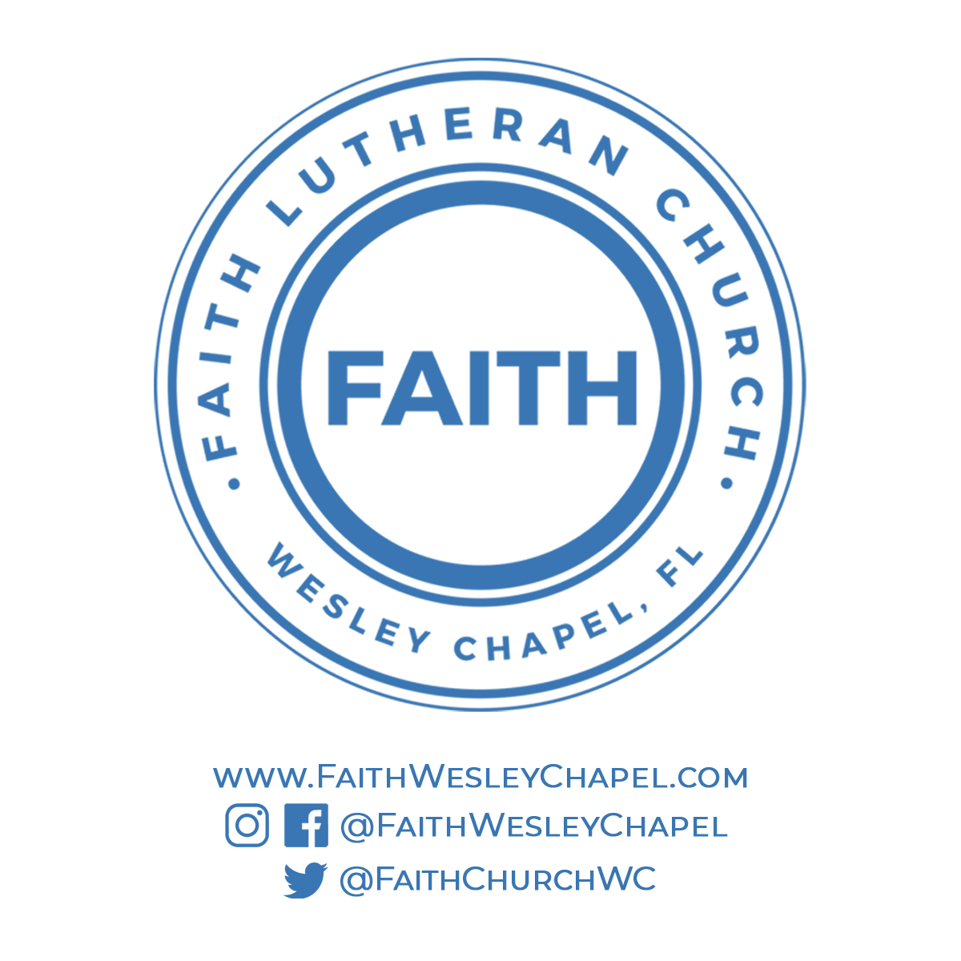**@FaithWesleyChapel**

**@FaithWesleyChapel**

**@FaithChurchWC**