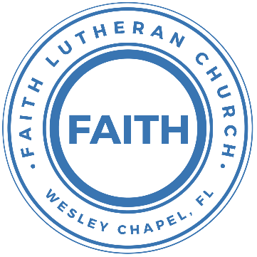

**Leading our community into a deep connection in Christ**

**Worship Service for December 11, 2022 at 11 AM**

**Welcome**

**Pray for the Food** - **People get food**

**Opening Song –** He Has Come For Us (God Rest Ye Merry Gentlemen

Verse 1:

God rest ye merry gentlemen let nothing you dismay

Remember Christ our Savior was born on Christmas day

To save us all from Satan's power when we were gone astray

Oh tidings of comfort and joy, comfort and joy

Oh tidings of comfort and joy

Chorus:

He has come for us, this Jesus

He's the hope for all mankind

He has come for us, the Messiah

Born to give us life (He is born to give us life)

Verse 2:

From God our heavenly Father a blessed angel came

And unto certain shepherds brought tidings of the same

How that in Bethleham was born the Son of God by name

Oh tidings of comfort and joy, comfort and joy

Oh tidings of comfort and joy

(Chorus)

**Invocation**

**Confession and Forgiveness:**

**P:** As we gather, today, let us cleanse our hearts and our consciences by confessing our sin to God.

*(Time of silence for reflection and confession)*

**P:** Let us confess our sins together.

**C:** Heavenly Father, we confess that we are sinful and unclean. We have sinned against you and against our neighbor in our thoughts, words, and actions.  We are truly sorry for our sins and sincerely repent of them. We ask for Your mercy. For the sake of Jesus Christ's bitter suffering and death, please forgive us and renew us that we may walk in Your Spirit to the glory of Your holy name. Amen

**P:** The Lord has heard your confession. Therefore, as a called and ordained servant of the Lord, in the stead and by the command of my Lord, Jesus Christ, I forgive you all your sins in the name of the Father and of the Son and of the Holy Spirit.

**C:** Amen

**Old Testament Reading:**Isaiah 35:4-10

Say to those who have an anxious heart,

“Be strong; fear not!

Behold, your God

will come with vengeance,

with the recompense of God.

He will come and save you.”

Then the eyes of the blind shall be opened,

and the ears of the deaf unstopped;

then shall the lame man leap like a deer,

and the tongue of the mute sing for joy.

For waters break forth in the wilderness,

and streams in the desert;

the burning sand shall become a pool,

and the thirsty ground springs of water;

in the haunt of jackals, where they lie down,

the grass shall become reeds and rushes.

And a highway shall be there,

and it shall be called the Way of Holiness;

the unclean shall not pass over it.

It shall belong to those who walk on the way;

even if they are fools, they shall not go astray.

No lion shall be there,

nor shall any ravenous beast come up on it;

they shall not be found there,

but the redeemed shall walk there.

And the ransomed of the Lord shall return

and come to Zion with singing;

everlasting joy shall be upon their heads;

they shall obtain gladness and joy,

and sorrow and sighing shall flee away.

**Reader:** This is the Word of the Lord.  
**C:** Thanks be to God.

**Gospel Reading:**Matthew 11:2-15

Now when John heard in prison about the deeds of the Christ, he sent word by his disciples and said to him, “Are you the one who is to come, or shall we look for another?” And Jesus answered them, “Go and tell John what you hear and see: the blind receive their sight and the lame walk, lepers are cleansed and the deaf hear, and the dead are raised up, and the poor have good news preached to them. And blessed is the one who is not offended by me.”

As they went away, Jesus began to speak to the crowds concerning John: “What did you go out into the wilderness to see? A reed shaken by the wind? What then did you go out to see? A man dressed in soft clothing? Behold, those who wear soft clothing are in kings' houses. What then did you go out to see? A prophet? Yes, I tell you, and more than a prophet. This is he of whom it is written,

“‘Behold, I send my messenger before your face,

who will prepare your way before you.’

Truly, I say to you, among those born of women there has arisen no one greater than John the Baptist. Yet the one who is least in the kingdom of heaven is greater than he. From the days of John the Baptist until now the kingdom of heaven has suffered violence, and the violent take it by force. For all the Prophets and the Law prophesied until John, and if you are willing to accept it, he is Elijah who is to come. He who has ears to hear, let him hear.

**P:** This is the Gospel of the Lord.  
**C:** Praise be to You, o Christ.

**Sermon Song** “O Come, O Come, Emmanuel   
Verse 1:

O come, O come, Emmanuel And ransom captive Israel

That mourns in lonely exile here Until the Son of God appear

Chorus:

Rejoice! Rejoice! Emmanuel Shall come to thee O Israel

Verse 5:

O come, Though Key of David, come, And open wide our heav’nly home

Make safe the way that leads on high, And close the path to misery

Chorus

Verse 6:

O come, Thou Dayspring, come and cheer

Our spirits by Thine advent here

And drive away the shades of night

And pierce the clouds and bring us light

Chorus

Verse 7:

O come, Desire of nations, bind All people in one heart and mind

Bid envy strife and quarrels cease

Fill all the world with heaven's peace

Chorus

**Sermon** – "Prophecy - The Messiah Will Do Miracles"

**Prayers:**

**Apostles' Creed**

I believe in God, the Father almighty, maker of heaven and earth,  
And in Jesus Christ, his only Son, our Lord,  
who was conceived by the Holy Spirit,  
born of the Virgin Mary, suffered under Pontius Pilate,  
was crucified, died and was buried. He descended into hell.  
The third day he rose again from the dead.  
He ascended into heaven and sits at the right hand of God  
the Father almighty.  
From there he will come to judge the living and the dead.  
I believe in the Holy Spirit, the holy Christian Church,  
the communion of saints, the forgiveness of sins,  
the resurrection of the body, and the life everlasting. Amen.

**The Lord's Prayer**

Our Father who art in heaven, hallowed be Thy name, Thy kingdom come, Thy will be done on earth as it is in heaven.  Give us this day our daily bread; and forgive us our trespasses as we forgive those who trespass against us; and lead us not into temptation, but deliver us from evil.  For Thine is the kingdom and the power and the glory forever and ever.  Amen

**Offering**

**Words of Institution**

**Distribution**

**Prayer**

**Benediction**

**Closing Song: “**The First Noel”

Verse 1:

The first Noel the angel did say

Was to certain poor Shepherds in fields as they lay:

In fields where they lay a keeping their sheep

On a cold winter's night that was so deep.

Chorus:

Noel, Noel, Noel, Noel, Born is the King of Israel.

**Sermon Notes:**

**_______________________________________________**

**_______________________________________________**

**_______________________________________________**

**_______________________________________________**

**_______________________________________________**

**_______________________________________________**

**_______________________________________________**

**_______________________________________________**

**_______________________________________________**

**_______________________________________________**

**_______________________________________________**

**_______________________________________________**

**_______________________________________________**

**_______________________________________________**

**_______________________________________________**

**_______________________________________________**

**_______________________________________________**

**_______________________________________________**

**_______________________________________________**

**_______________________________________________**

**_______________________________________________**

**_______________________________________________**

**_______________________________________________**

**Upcoming Events**

**December 13, 7 PM - Growth Group Bible Study**Location – Wesley Chapel District Park – Monarch A

**December 17, 6-10 PM – Christmas Open House**  
The Chmiel’s home - 29708 Weybridge Way  
Wesley Chapel, FL 33545 – Gate: #8419

**December 18, 1-3 PM – Youth Christmas Party**Location – Song and Dance  
Food – Fun – White Elephant Gifts – Games

**December 24, 6 PM – Christmas Eve Service**Song and Dance

**December 25, 11 AM – Christmas Service**Streamed Online (A brief Christmas message)

**--------------------------- Faith’s Financial Update ---------------------------**

December’s Budgeted Expenses: $6,475

December’s General Fund Gifts and Offerings to Date: $???

**----------------------------------------------------------------------------------------**

**www.FaithWesleyChapel.com**

**Faith YouTube**

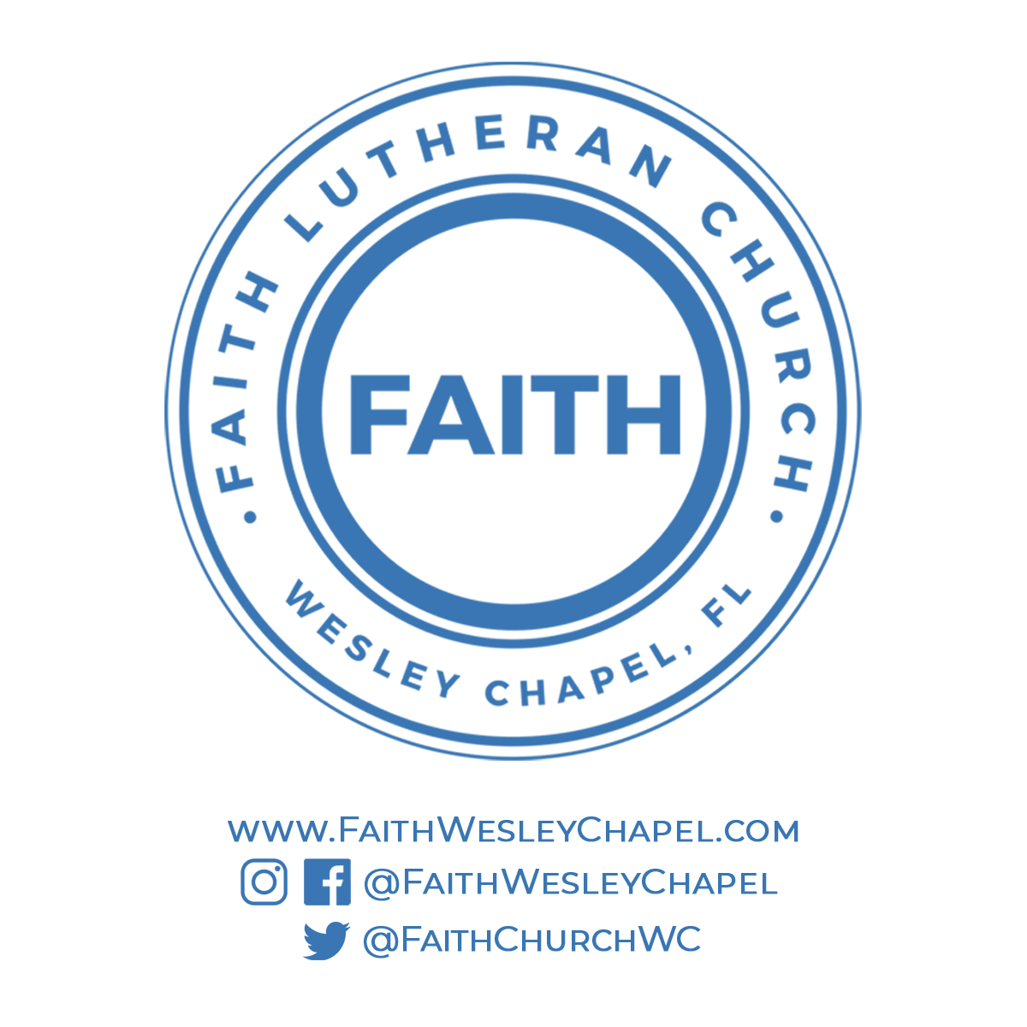**@FaithWesleyChapel**

**@FaithWesleyChapel**

**@FaithChurchWC**