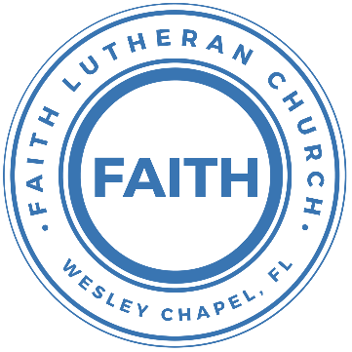

**Leading our community into a deep connection in Christ**

**Worship Service for December 18, 2022, at 11 AM**

**Welcome**

**Opening Songs –** Come Thou Long Expected Jesus, Angels We Have Heard on High

Verse 1:

Come thou long-expected Jesus, Born to set thy people free

From our fears and sins release us; let us find our rest in thee.

Israel’s strength and consolation, Hope of all the earth thou art,

Dear desire of ev’ry nation, joy of every longing heart.

Angels we have heard on high, Sweetly singing o’er the plains,

And the mountains in reply, Echoing their joyous strains.

Gloria, in excelsis Deo;

Gloria, in excelsis Deo;

Shepherds why this jubilee? Why your joyous strains prolong?

What the gladsome tidings be Which inspire your heavenly song?

Gloria, in excelsis Deo;

Gloria, in excelsis Deo;

Come to Bethlehem and see Him whose birth the angels sing;

Come adore on bended knee Christ the Lord the newborn King.

Gloria, in excelsis Deo;

Gloria, in excelsis Deo;

**Invocation**

**Confession and Forgiveness:**

**P:** Our Heavenly Father asks us to come into His presence.  
**C:** But we are sinful and unworthy.

**P:** Yes, all have sinned and fall short of the glory of God, but Jesus Christ died on the cross that we may be forgiven and washed clean of all our sins by His blood spilled on the cross.  
**C:** Lord, if You wash us, we will certainly be clean and pure.

**P:** We take a moment to bow before the His cross and silently reflect on our lives and confess our sins.

(Time of silence for reflection and confession)

**P:** Let us confess, together, our sins to God our Father.  
**C:** Heavenly Father, we confess that we are sinners.  We have sinned against you and our neighbors. We have not loved you with our whole heart and we have not loved our neighbors as ourselves. We have not lived out our faith in our community. We justly deserve Your punishment.  For the sake of Your Son, Jesus Christ, have mercy on us.  Forgive us, renew us, and lead us, so that we may delight in Your will and walk in Your ways to the glory of Your holy name.  Amen.

**P:** Almighty God in His mercy has given His Son to die for you and for His sake forgives you all your sins.  As a called and ordained servant of Christ, and by His authority, I, therefore, forgive you all your sins in the name of the Father and of the Son and of the Holy Spirit.  
**C:** Amen

**Song of Praise and Thanksgiving:** Emmanuel (Hallowed Manger Ground)

Verse 1:

What hope we hold this starlit night

a King is born in Bethlehem

Our journey long, we seek the light

that leads to the hallowed manger ground

Verse 2:

What fear we felt in the silent age

four hundred years can he be found

But broken by a baby's cry

rejoice in the hallowed manger ground

Chorus:

- manuel, manuel

God incarnate here to dwell

- manuel, manuel

Praise His name – Manuel

Verse 3: (Lighter)

The son of God Here, born to bleed

A crown of thorns Would pierce His brow

And we beheld this offering

(Start Harmony)

Exalted now, the King of kings

Praise God For the hallowed manger ground

Chorus

Praise His name -manuel

**Epistle Reading –**Romans 1:1-7

Paul, a servant of Christ Jesus, called to be an apostle, set apart for the gospel of God, which he promised beforehand through his prophets in the holy Scriptures, concerning his Son, who was descended from David according to the flesh and was declared to be the Son of God in power according to the Spirit of holiness by his resurrection from the dead, Jesus Christ our Lord, through whom we have received grace and apostleship to bring about the obedience of faith for the sake of his name among all the nations, including you who are called to belong to Jesus Christ,

To all those in Rome who are loved by God and called to be saints:

Grace to you and peace from God our Father and the Lord Jesus Christ.

**Reader:** This is the Word of the Lord.  
**C:** Thanks be to God.

**Gospel Reading** – Matthew 1:18-25

Now the birth of Jesus Christ took place in this way. When his mother Mary had been betrothed to Joseph, before they came together she was found to be with child from the Holy Spirit. And her husband Joseph, being a just man and unwilling to put her to shame, resolved to divorce her quietly. But as he considered these things, behold, an angel of the Lord appeared to him in a dream, saying, “Joseph, son of David, do not fear to take Mary as your wife, for that which is conceived in her is from the Holy Spirit. She will bear a son, and you shall call his name Jesus, for he will save his people from their sins.” All this took place to fulfill what the Lord had spoken by the prophet:

“Behold, the virgin shall conceive and bear a son,

and they shall call his name Immanuel”

(which means, God with us). When Joseph woke from sleep, he did as the angel of the Lord commanded him: he took his wife, but knew her not until she had given birth to a son. And he called his name Jesus.

**P:** This is the Gospel of the Lord.  
**C:** Praise be to You, o Christ.

**Children's Message** *(Children dismissed to Children's Church)*

**Sermon Hymn***–*Silent Night

VERSE 1:

Silent night! Holy night! All is calm all is bright

Round yon virgin mother and child Holy infant so tender and mild

Sleep in heavenly peace! Sleep in heavenly peace!

VERSE 2:

Silent night! Holy night! Shepherds quake at the sight

Glories stream from heaven afar Heavenly hosts sing Hallelujah

Christ the Saviour is born! Christ the Saviour is born!

VERSE 3:

Silent night! Holy night! Son of God love's pure light

Radiant beams from Thy holy face With the dawn of redeeming grace

Jesus Lord at Thy birth! Jesus Lord at Thy birth!

**Sermon** - "Prophecy - He Will Be Born of a Virgin"

Isaiah 7:10-16

Again the Lord spoke to Ahaz: “Ask a sign of the Lord your God; let it be deep as Sheol or high as heaven.” But Ahaz said, “I will not ask, and I will not put the Lord to the test.” And he said, “Hear then, O house of David! Is it too little for you to weary men, that you weary my God also? Therefore the Lord himself will give you a sign. Behold, the virgin shall conceive and bear a son, and shall call his name Immanuel. He shall eat curds and honey when he knows how to refuse the evil and choose the good. For before the boy knows how to refuse the evil and choose the good, the land whose two kings you dread will be deserted.

**P:** This is the Word of the Lord.  
**C:** Thanks be to God.

**Prayers:** *Text in prayer requests to (813) 326-5255*

**Nicene Creed**

I believe in one God, the Father Almighty, maker of heaven and earth and of all things visible and invisible.

And in one Lord Jesus Christ, the only-begotten Son of God, begotten of His Father before all worlds, God of God, Light of Light, very God of very God, begotten, not made, being of one substance with the Father, by whom all things were made; who for us men and for our salvation came down from heaven and was incarnate by the Holy Spirit of the virgin Mary and was made man; and was crucified also for us under Pontius Pilate. He suffered and was buried. And the third day He rose again according to the Scriptures and ascended into heaven and sits at the right hand of the Father. And He will come again with glory to judge both the living and the dead, whose kingdom will have no end.

And I believe in the Holy Spirit, the Lord and Giver of Life, who proceeds from the Father and the Son, who with the Father and the Son together is worshiped and glorified, who spoke by the prophets. And I believe in one holy Christian and apostolic Church, I acknowledge one Baptism for the remission of sins, and I look for the resurrection of the dead and the life of the world to come. Amen.

**The Lord's Prayer**

Our Father who art in heaven, hallowed be Thy name, Thy kingdom come, Thy will be done on earth as it is in heaven.  Give us this day our daily bread; and forgive us our trespasses as we forgive those who trespass against us; and lead us not into temptation, but deliver us from evil.  For Thine is the kingdom and the power and the glory forever and ever.  Amen

**Offering**

**Words of Institution**

**Peace**

P: The peace of the Lord be with you all.  
C: And also, with you.  
P: We greet each other in the peace of Christ.

**Distribution**

**Prayer**

**Benediction**

**Closing Song:**It Came Upon The Midnight Clear

Verse 1:

It came upon a midnight clear.

That glorious song of old

From angels bending near the earth

To touch their harps of gold

"Peace on the earth, good will to men

From heaven's all gracious King;"

The world in solemn stillness lay,   
To hear the angels sing

Verse 2:

Still through the cloven skies they come

With peaceful wings unfurled

And still their heavenly music floats

O'er all the weary world;

Above its sad and lowly plains

They bend on hovering wing.

And ever o'er its Babel sounds

The blessed angels sing.

Verse 4:

For lo! the days are hastening on, By prophet bards foretold,

When, with the ever-circling years, Shall come the Age of Gold;

When peace shall over all the earth Its ancient splendors fling,

And all the world give back the song Which now the angels sing.

**Sermon Notes:**

**_______________________________________________**

**_______________________________________________**

**_______________________________________________**

**_______________________________________________**

**_______________________________________________**

**_______________________________________________**

**_______________________________________________**

**_______________________________________________**

**Upcoming Events**

**December 24, 6 PM – Christmas Eve Service**Song and Dance

**December 25, 11 AM – Christmas Service**Streamed Online (A brief Christmas message)

**--------------------------- Faith’s Financial Update ---------------------------**

December’s Budgeted Expenses: $6,475

December’s General Fund Gifts and Offerings to Date: $???

**----------------------------------------------------------------------------------------**

**www.FaithWesleyChapel.com**

**Faith YouTube**

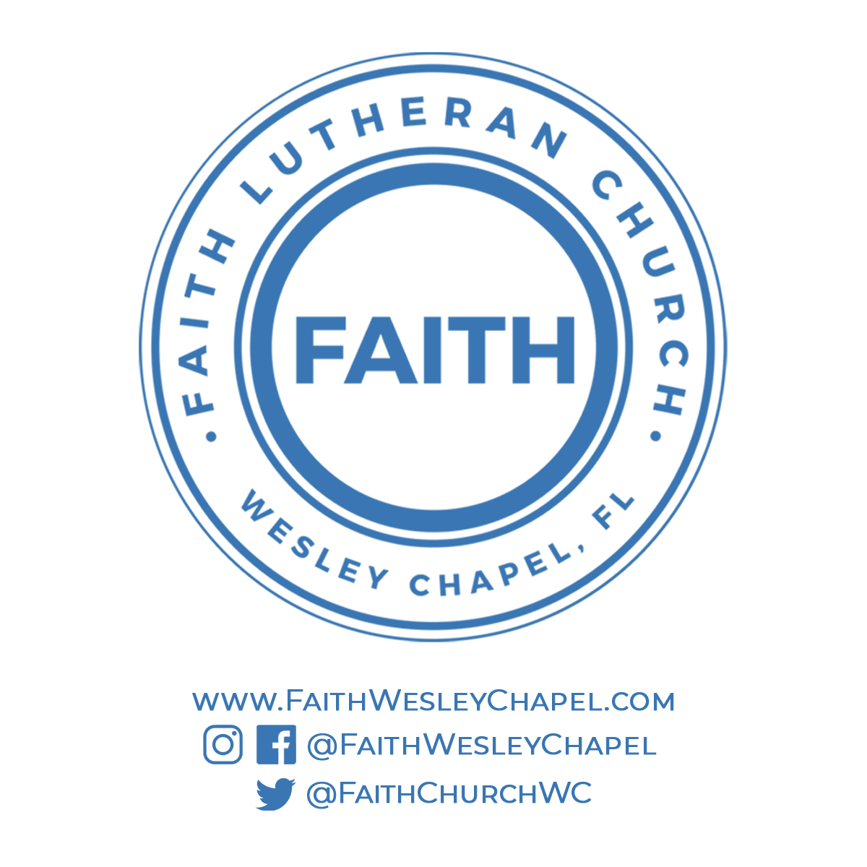**@FaithWesleyChapel**

**@FaithWesleyChapel**

**@FaithChurchWC**