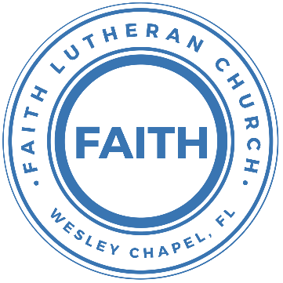

**Leading our community into a deep connection in Christ**

**Worship Service for December 24, 2022 at 6 PM**

**Welcome**

**Opening Song:**O Come All Ye Faithful / Angels We Have Heard on High (Medley)

Oh come all ye faithful, joyful and triumphant!  
Oh come ye oh come ye to Bethlehem;  
Come and behold him Born the King of angels  
Oh come let us adore him, Oh come let us adore him  
Oh come let us adore him Christ the Lord!

Angels we have heard on high, sweetly singing o’er the plains,  
And the mountains in reply, echoing their joyous strains.  
Gloria, in excelsis Deo; Gloria, in excelsis Deo

Come to Bethlehem and see Him whose birth the angels sing;  
Come adore on bended knee Christ the Lord the newborn King.  
Gloria, in excelsis Deo; Gloria, in excelsis Deo

Yea Lord we greet Thee Born this happy morning;  
Jesus to Thee be glory giv’n!  
Word of the Father now in flesh appearing!  
Oh come let us adore him, Oh come let us adore him  
Oh come let us adore him Christ the Lord!

**Invocation**

**P:** In the stillness of this night,

**C:** A gift is given.

**P:** Wrapped in swaddling cloth, coming to us as a little baby,

**C:** God’s greatest gift is given.

**P:** In the miracle and mystery of God’s Son born in human flesh,

**C:** God has given us his salvation.

**Confession and Forgiveness:**

**P:** As we gather to celebrate the coming of our Lord Jesus Christ, let us pray in repentant faith and seek God’s mercy for our sins.

(a time of silence to reflect and personally confess our sins)

**P:** In our Christmas joy, let us confess our sins.  
**C:** Mighty God, on this day of celebration, we confess our sin to You. We are by nature sinful. Without Your help, we are powerless to overcome it. We confess our impatience with You and with others, our seeking after worldly passions, and our self-indulgent ways of life. By our sin, we have hurt others, ourselves, and You. We plead with You to forgive our sins for the sake of Christ and to transform our broken lives.

**P:** The people who walked in darkness have seen a great light, and the light shines on them. The grace of God has appeared through the birth of our Savior Jesus Christ, bringing salvation to all people. I, a called and ordained servant of Christ, by His authority, forgive you all your sins in the name of the Father and of the Son and of the Holy Spirit.  
**C:** Amen.

**Song of Praise and Thanksgiving:** Hark! The Herald Angels Sing

Hark the herald angels sing "Glory to the new born King  
Peace on earth and mercy mild, God and sinners reconciled"  
Joyful all ye nations rise. Join the triumph of the skies  
With angelic host proclaim "Christ is born in Bethlehem"  
Hark the herald angels sing "Glory to the new born King"

Christ, by highest heaven adored; Christ the everlasting Lord;  
Late in time behold him come, Offspring of the Virgin’s womb.  
Veiled in flesh, the God-head see; hail the incarnate Deity  
Pleased as man with men to dwell, Jesus, our Immanuel  
Hark the herald angels sing, "Glory to the new born King"

Hail! the heaven-born Prince of Peace.   
Hail the son of Righteousness  
Light and life to all He brings, risen with healing in His wings  
Mild He lays His glory by, born that man no more may die  
Born to raise each child of earth, born to Give them second birth  
Hark the herald angels sing, "Glory to the new born King"  
Hark the herald angels sing, "Glory to the new born King"

**The Christmas Story**

**Song***–*Away in a Manger

Away in a manger, No crib for a bed,  
The little Lord Jesus, Lay down his sweet head.  
The stars in the sky, looked down where he lay  
The little Lord Jesus, Asleep on the hay.

Be near me Lord Jesus, I ask thee to stay,  
Close by me forever, and love me I pray.  
Bless all the dear children, in thy tender care,  
And take us to heaven, to live with thee there.

**Gospel Reading -**Luke 2:1–20

In those days a decree went out from Caesar Augustus that all the world should be registered. This was the first registration when Quirinius was governor of Syria. And all went to be registered, each to his own town. And Joseph also went up from Galilee, from the town of Nazareth, to Judea, to the city of David, which is called Bethlehem, because he was of the house and lineage of David, to be registered with Mary, his betrothed, who was with child. And while they were there, the time came for her to give birth. And she gave birth to her firstborn son and wrapped him in swaddling cloths and laid him in a manger, because there was no place for them in the inn.

And in the same region there were shepherds out in the field, keeping watch over their flock by night. And an angel of the Lord appeared to them, and the glory of the Lord shone around them, and they were filled with great fear. And the angel said to them, “Fear not, for behold, I bring you good news of great joy that will be for all the people. For unto you is born this day in the city of David a Savior, who is Christ the Lord. And this will be a sign for you: you will find a baby wrapped in swaddling cloths and lying in a manger.” And suddenly there was with the angel a multitude of the heavenly host praising God and saying,

“Glory to God in the highest,  
 and on earth peace among those with whom he is pleased!”

When the angels went away from them into heaven, the shepherds said to one another, “Let us go over to Bethlehem and see this thing that has happened, which the Lord has made known to us.” And they went with haste and found Mary and Joseph, and the baby lying in a manger. And when they saw it, they made known the saying that had been told them concerning this child. And all who heard it wondered at what the shepherds told them. But Mary treasured up all these things, pondering them in her heart. And the shepherds returned, glorifying and praising God for all they had heard and seen, as it had been told them.

**P:** This is the Gospel of the Lord.  
**C:** Praise be to You, o Christ.

**Youth Message**

**Sermon Hymn***–*It Came Upon a Midnight Clear

It came upon a midnight clear. That glorious song of old

From angels bending near the earth To touch their harps of gold

"Peace on the earth, good will to men from heaven's all gracious King;"

The world in solemn stillness lay, To hear the angels sing

Yet with the woes of sin and strife The world hath suffered long;

Beneath the angel-strain have rolled Two thousand years of wrong;

And man, at war with man, hears not The love song which they bring:

O hush the noise, ye men of strife, And hear the angels sing.

For lo! the days are hastening on, By prophet bards foretold,

When, with the ever-circling years, Shall come the Age of Gold;

When peace shall over all the earth Its ancient splendors fling,

And all the world give back the song Which now the angels sing.

**Sermon** - "We Have Seen a Great Light!"

Isaiah 9:2-7

The people who walked in darkness have seen a great light;

those who dwelt in a land of deep darkness,

on them has light shone.

You have multiplied the nation; you have increased its joy;

they rejoice before you as with joy at the harvest,

as they are glad when they divide the spoil.

For the yoke of his burden, and the staff for his shoulder,

the rod of his oppressor,

you have broken as on the day of Midian.

For every boot of the tramping warrior in battle tumult

and every garment rolled in blood

will be burned as fuel for the fire.

For to us a child is born, to us a son is given;

and the government shall be upon his shoulder,

and his name shall be called

Wonderful Counselor, Mighty God,

Everlasting Father, Prince of Peace.

Of the increase of his government and of peace

there will be no end,

on the throne of David and over his kingdom,

to establish it and to uphold it

with justice and with righteousness

from this time forth and forevermore.

The zeal of the Lord of hosts will do this.

**Reader:** This is the Word of the Lord.  
**C:** Thanks be to God.

**Prayers**

**Apostles' Creed**

I believe in God, the Father almighty, maker of heaven and earth,

And in Jesus Christ, his only Son, our Lord, who was conceived by the Holy Spirit, born of the Virgin Mary, suffered under Pontius Pilate, was crucified, died and was buried. He descended into hell. The third day he rose again from the dead. He ascended into heaven and sits at the right hand of God the Father almighty. From there he will come to judge the living and the dead.

I believe in the Holy Spirit, the holy Christian Church, the communion of saints, the forgiveness of sins, the resurrection of the body, and the life everlasting. Amen.

**The Lord's Prayer**

Our Father who art in heaven, hallowed be Thy name, Thy kingdom come, Thy will be done on earth as it is in heaven.  Give us this day our daily bread; and forgive us our trespasses as we forgive those who trespass against us; and lead us not into temptation, but deliver us from evil.  For Thine is the kingdom and the power and the glory forever and ever.  Amen

**Offering** (Special Music: O Holy Night)

**Words of Institution**

**Peace**

P: The peace of the Lord be with you all.

C: And also with you.

P: We greet each other in the peace of Christ.

**Distribution**

**Prayer**

**Silent Night**

Silent night! Holy night! All is calm all is bright  
Round yon virgin mother and child Holy infant so tender and mild  
Sleep in heavenly peace! Sleep in heavenly peace!

Silent night! Holy night! Shepherds quake at the sight  
Glories stream from heaven afar Heavenly hosts sing Hallelujah  
Christ the Savior is born! Christ the Savior is born!

Silent night! Holy night! Son of God love's pure light  
Radiant beams from Thy holy face  
With the dawn of redeeming grace  
Jesus Lord at Thy birth! Jesus Lord at Thy birth!

**Benediction**

**Closing Song:**Joy To the World (Unspeakable Joy)

Joy to the world, the Lord is come Let earth receive her king  
Let every heart prepare Him room And Heaven and nature sing  
And Heaven and nature sing  
And Heaven, and Heaven and nature sing

Joy to the world, the Savior reigns That all their songs employ  
While fields and floods, rocks, hills and plains  
Repeat the sounding joy. Repeat the sounding joy  
Repeat, repeat the sounding joy

*Chorus*  
Joy, unspeakable joy an overflowing well no tongue can tell  
Joy, unspeakable joy Rises in my soul, never lets me go

He rules the world with truth and grace

And makes the nations prove  
The glories of His righteousness And wonders of His love  
And wonders of His love And wonders, wonders of His love

*Chorus*  
Joy, unspeakable joy An overflowing well no tongue can tell  
Joy, unspeakable joy Rises in my soul, never lets me go.

**Upcoming Events**

**December 25, 11 AM – Christmas Service**Streamed Online (A brief Christmas message)

**January 1, 11am – Worship Service**  
Song and Dance

**January 8, 11am – Worship Service**New Series – “A New Beginning – New Year/New You!”  
Song and Dance

**Communion**

God provides us wonderful blessings in Communion, including forgiveness of sins, real community with each other, and strength for living the Christian life. He also warns us, though, that to take Communion improperly can be harmful to us. Here are some questions to ask yourself to know if you should take Communion:

* Do I believe in Jesus and agree with the Apostles’ Creed?
* Am I repentant (truly sorry) for my sins?
* Do I believe Jesus’ body and blood are truly present?

Pastor will give further instructions before Communion.

**www.FaithWesleyChapel.com**

**Faith YouTube**

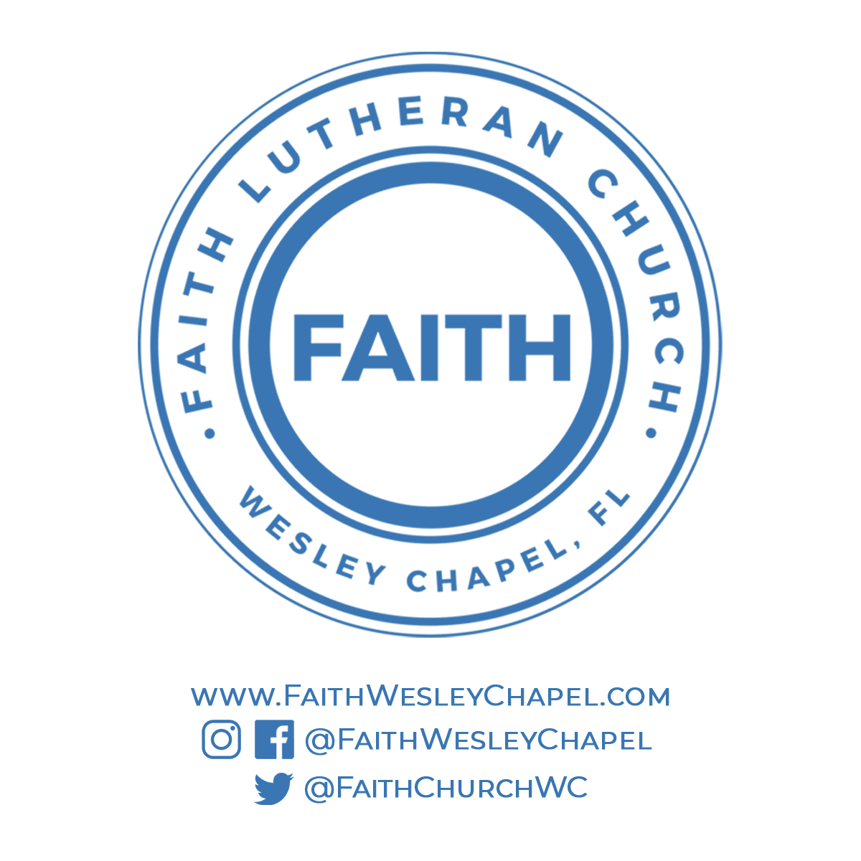**@FaithWesleyChapel**

**@FaithWesleyChapel**

**@FaithChurchWC**