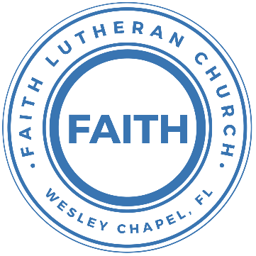

**Leading our community into a deep connection in Christ**

**Worship Service for January 1, 2023 at 11 AM**

**Welcome**

**Opening Song:**The Hippopotamus Song

In the beginning God made the sea *(make a wave motion)*

And the forest filled with trees *(wave your hands)*

He made the mountains up so high *(making a point with your hands)*

Above it all He placed the sky *(Motion like you are throwing the sky up)*

God's fingerprints are everywhere *(touch things with your fingers)*

Just to show how much He cares *(hug yourself)*

Along the way He had some fun *(swoop your fist in front of you)*

He made a hippo that weighed a ton *(when you say "ton," put your arms away from your sides making something look big)*

Hip-Hip-Hippopotamus *(same motion and use a deep voice)*

Hip-Hip-Hurray, God made all of us *(Wave your hands in the air and use a high voice, guys in falsetto)*

Hip-Hip-Hippopotamus

Hip-Hip-Hurray, God made all of us

**Invocation**

**Confession and Forgiveness:**

**P:** We have come here today to worship the Lord.  In worship we hear the Word of God, we receive God's blessings, and respond with thanks and praise.  We begin by seeking God's blessing of forgiveness.  He has promised to remove the guilt and shame of our sin through the sacrifice of Jesus Christ on the cross.

*(a time of silence to reflect and personally confess our sins)*

**P:** Let us confess our sins to the Lord.

**P:** Heavenly Father,  
**C:** Heavenly Father,

**P:** I have done things that were wrong.  
**C:** I have done things that were wrong.  
  
**P:** I have been mean to others.  
**C:** I have been mean to others.

**P:** I have not obeyed my parents.  
**C:** I have not obeyed my parents.

**P:** I have not obeyed You, God.  
**C:** I have not obeyed You, God.

**P:** But I am very sorry.  
**C:** But I am very sorry.

**P:** Please forgive me.  
**C:** Please forgive me.

**P:** I love You very much.  
**C:** I love You very much.

**P:** And I know You love me, too.  
**C:** And I know You love me, too.

**P:** Amen.  
**C:** Amen.

**P:** God has heard your apology.  He loves you very much.  God has told us that when we believe and trust in Him, He makes us His children.  As far as the east is from the west, so far does he remove our sins from us. He has told me to tell you that you are forgiven.  So, as His servant, I forgive you in the name of the Father and of the Son and of the Holy Spirit.

**C:** Amen.

**Song:**Jesus Loves Me

Verse 1:

Jesus loves me this I know, For the Bible tells me so.

Little ones to Him belong, They are weak, but He is strong.

Chorus:

Yes, Jesus loves me, Yes, Jesus loves me,

Yes, Jesus loves me, The Bible tells me so.

Verse 2:

Jesus loves me, He who died. Heaven's gates to open wide.

He will wash away my sin, Let His little child come in.

**First Reading -**James 1:17

Everything good comes from God. Every perfect gift is from him. These good gifts come down from the Father who made all the lights in the sky. But God never changes like the shadows from those lights. He is always the same.

**Reader:** This is the Word of the Lord.  
**C:** Thanks be to God.

**Children's Message** "Everything Good Comes from God"

**Song:**Give Thanks

Verse:

Give thanks with a grateful heart

Give thanks to the holy one

Give thanks because he's given

Jesus Christ, His son.

(repeat)

Chorus:

And now let the weak say I am strong

Let the poor say I am rich.

Because of what the Lord has done for us

(repeat)

Ending:

Give thanks. Give thanks. We give thanks.

**Second Reading -**Philippians 4:6

Do not be anxious about anything, but in every situation, by prayer and petition, with thanksgiving, present your requests to God.

**Reader:** This is the Word of the Lord.  
**C:** Thanks be to God.

**Children's Message** "Bring Everything to God with Thanksgiving"

**Song:**I See You

God of love, God of all glory, Every day I see new mercy

Great is Your faithfulness

God of love, God of my story, You never fail. You never forsake me

Great is Your faithfulness

Chorus:

I see You in the morning light. I feel You in the fire by night

I hear You say, “Child, I am with you. Everything will be alright.”

I see You in the tears that run. I feel You when the healing comes

I hear You say, “Beloved one, I am with you.”  
Every moment of my life

I see You. I see You. I see You. God, I see You

God of love, God of new vision, Every blessing You have given

Great is Your faithfulness! Oh how great is Your faithfulness

Chorus:

Bridge:

I will worship through the storm,  
Through the storm, Through the storm

All my hope is in You Lord, In You Lord, In You Lord

I see You in the morning light

I feel You in the fire by night

I hear You say, “Child, I am with you.

Everything will be alright.”

Chorus

**Sermon –**“Praying in the New Year”

**Time of Prayer:** *Text in prayer requests to (813) 326-5255*

**The Lord's Prayer**

Our Father who art in heaven, hallowed be Thy name, Thy kingdom come, Thy will be done on earth as it is in heaven.  Give us this day our daily bread; and forgive us our trespasses as we forgive those who trespass against us; and lead us not into temptation, but deliver us from evil.  For Thine is the kingdom and the power and the glory forever and ever.  Amen

**Offering**

**Words of Institution**

**Peace**

**P:** The peace of the Lord be with you all.  
**C:** And also, with you.  
**P:** We greet each other in the peace of Christ.

**Distribution**

**Prayer**

**Benediction**

**Closing Song:**Go My Children With My Blessing

Verse 1:

Go, My children, with My blessing, Never alone.

Waking, sleeping, I am with you; You are My own.

In My love’s baptismal river I have made you Mine forever.

Go, My children, with My blessing, You are My own.

Verse 2:

Go, My children, sins forgiven, At peace and pure.

Here you learned how much I love you, What I can cure.

Here you heard My dear Son’s story;  
Here you touched Him, saw His glory.

Go, My children, sins forgiven, At peace and pure.

Verse 3:

Go, My children, fed and nourished, Closer to Me;

Grow in love and love by serving, Joyful and free.

Here My Spirit’s power-filled you;  
Here His tender comfort stilled you.

Go, My children, fed and nourished, Joyful and free.

**Sermon Notes:**

**_______________________________________________**

**_______________________________________________**

**_______________________________________________**

**_______________________________________________**

**_______________________________________________**

**_______________________________________________**

**_______________________________________________**

**_______________________________________________**

**_______________________________________________**

**_______________________________________________**

**_______________________________________________**

**_______________________________________________**

**_______________________________________________**

**_______________________________________________**

**_______________________________________________**

**_______________________________________________**

**_______________________________________________**

**_______________________________________________**

**_______________________________________________**

**_______________________________________________**

**_______________________________________________**

**_______________________________________________**

**_______________________________________________**

**Hey Youth!!**Do you know any worship songs you’d like to sing as part of our youth service? Let Pastor Kurt know.

Do you want to sing or play an instrument? Let Pastor Kurt know.

We want you to be a part of the service.

**Upcoming Events**

**January 8, 11am – Worship Service**New Series – “A New Beginning – New Year/New You!”  
Song and Dance

**January 17, 7 PM Council Meeting**  
Zoom

**www.FaithWesleyChapel.com**

**Faith YouTube**

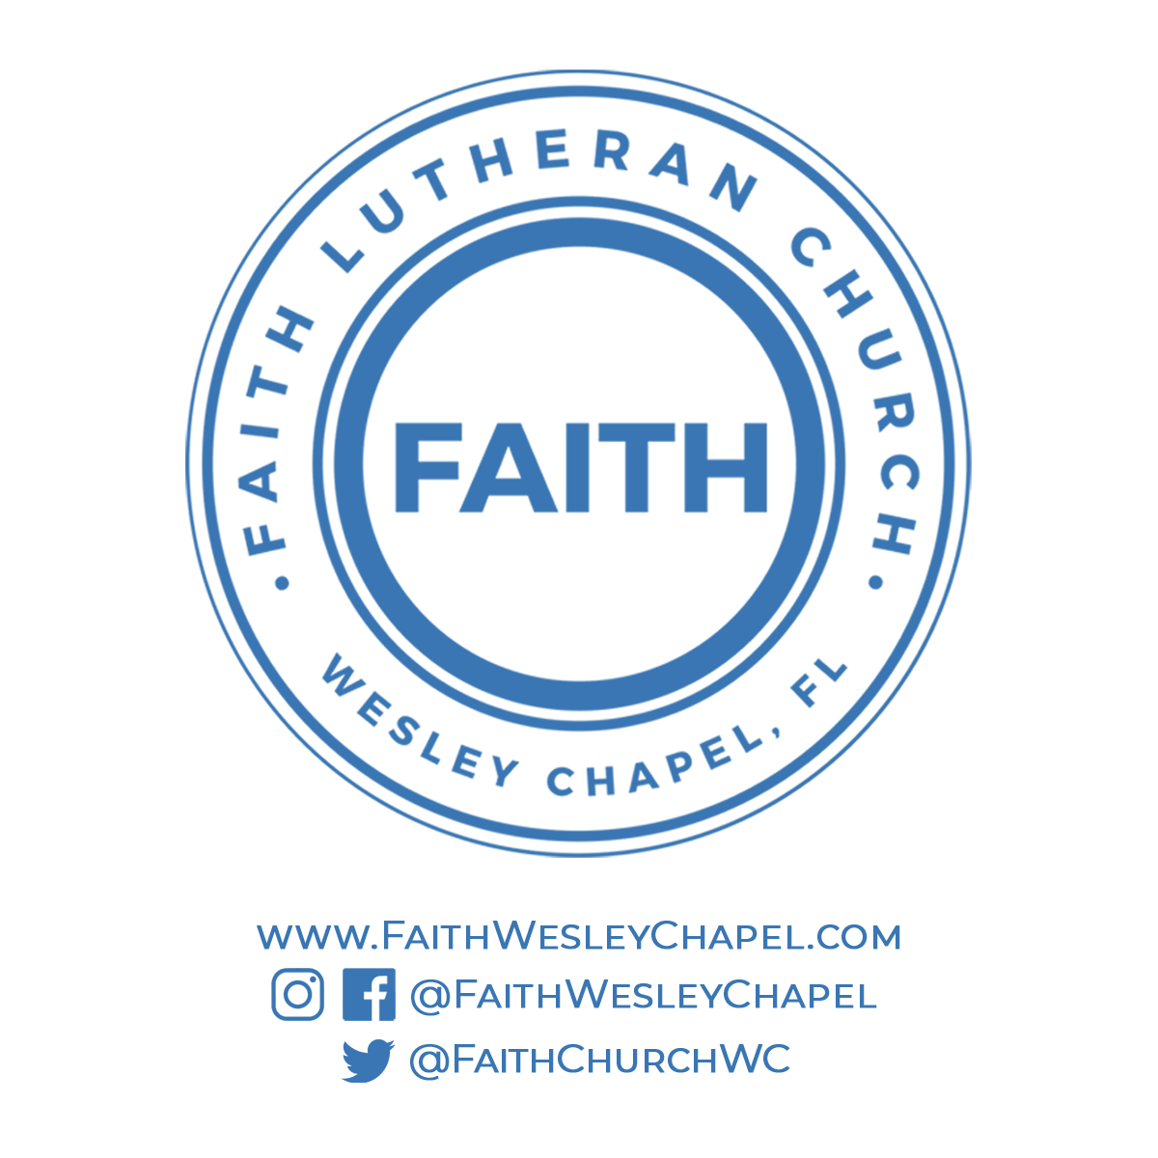**@FaithWesleyChapel**

**@FaithWesleyChapel**

**@FaithChurchWC**