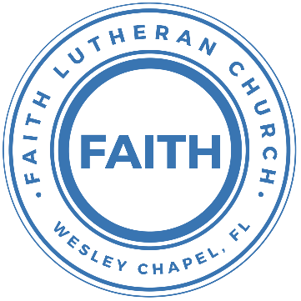

**Leading our community into a deep connection in Christ**

**Worship Service for January 15, 2023, at 11 AM**

**Welcome**

**Opening Song –** Alleluia Let Praises Ring

Verse 1:

Alleluia! Let praises ring!

To God the Father let us bring Our songs of adoration.

To Him through everlasting days

Be worship, honor, pow'r, and praise,

Whose hand sustains creation.

Singing, ringing: Holy, holy, God is holy; Spread the story

Of our God, the Lord of glory.

Verse 2:

Alleluia! Let praises ring!

Unto the Lamb of God we sing, In whom we are elected.

He bought His Church with His own blood,

He cleansed her in that blessed flood, And as His Bride selected.

Holy, holy Is our union And communion. His befriending

Gives us joy and peace unending.

Verse 3:

Alleluia! Let praises ring!

Unto the Holy Ghost we sing For our regeneration.

The saving faith in us He wrought

And us unto the Bridegroom brought. Made us His chosen nation.

Glory! Glory! Joy eternal, Bliss supernal; There is manna

And an endless, glad hosanna.

**Invocation**

**Confession and Forgiveness:**

**P:** Our Heavenly Father asks us to come into His presence.  
**C:** But we are sinful and unworthy.

**P:** Yes, all have sinned and fall short of the glory of God, but Jesus Christ died on the cross that we may be forgiven and washed clean of all our sins by His blood spilled on the cross.  
**C:** Lord, if You wash us, we will certainly be clean and pure.

**P:** We take a moment to bow before the His cross and silently reflect on our lives and confess our sins.

*(Time of silence for reflection and confession)*

**P:** Let us confess, together, our sins to God our Father.  
**C:** Heavenly Father, we confess that we are sinners.  We have sinned against you and our neighbors. We have not loved you with our whole heart and we have not loved our neighbors as ourselves. We have not lived out our faith in our community. We justly deserve Your punishment.  For the sake of Your Son, Jesus Christ, have mercy on us.  Forgive us, renew us, and lead us, so that we may delight in Your will and walk in Your ways to the glory of Your holy name.  Amen.

**P:** Almighty God in His mercy has given His Son to die for you and for His sake forgives you all your sins.  As a called and ordained servant of Christ, and by His authority, I, therefore, forgive you all your sins in the name of the Father and of the Son and of the Holy Spirit.  
**C:** Amen

**Song of Praise and Thanksgiving:** 10,000 Reasons (Bless The Lord)

Chorus:

Bless the Lord, O my soul, O my soul,

Worship His holy name.

Sing like never before, 0 my soul.

I'll worship Your holy name. (last time end with and go to tag)

Verse 1:

The sun comes up, it's a new day dawning;

It's time to sing Your song again.

Whatever may pass, and whatever lies before me,

Let me be singing when the evening comes.

(Chorus)

Verse 2:

You're rich in love, and You're slow to anger.

Your name is great, and Your heart is kind.

For all Your goodness, I will keep on singing;

Ten thousand reasons for my heart to find.

(Chorus)

Verse 3:

And on that day when my strength is failing,

The end draws near, and my time has come;

Still my soul will sing Your praise unending:

Ten thousand years and then forevermore! Forevermore

(Chorus)

I'll worship Your holy name. Yes, I'll worship Your holy name.

**Old Testament Reading –**Joshua 1:1-9

After the death of Moses the servant of the Lord, the Lord said to Joshua the son of Nun, Moses' assistant, “Moses my servant is dead. Now therefore arise, go over this Jordan, you and all this people, into the land that I am giving to them, to the people of Israel. Every place that the sole of your foot will tread upon I have given to you, just as I promised to Moses. From the wilderness and this Lebanon as far as the great river, the river Euphrates, all the land of the Hittites to the Great Sea toward the going down of the sun shall be your territory. No man shall be able to stand before you all the days of your life. Just as I was with Moses, so I will be with you. I will not leave you or forsake you. Be strong and courageous, for you shall cause this people to inherit the land that I swore to their fathers to give them. Only be strong and very courageous, being careful to do according to all the law that Moses my servant commanded you. Do not turn from it to the right hand or to the left, that you may have good success wherever you go. This Book of the Law shall not depart from your mouth, but you shall meditate on it day and night, so that you may be careful to do according to all that is written in it. For then you will make your way prosperous, and then you will have good success. Have I not commanded you? Be strong and courageous. Do not be frightened, and do not be dismayed, for the Lord your God is with you wherever you go.”

**Reader:** This is the Word of the Lord.  
**C:** Thanks be to God.

**Epistle Reading** -Romans 11:33-12:2

Oh, the depth of the riches and wisdom and knowledge of God! How unsearchable are his judgments and how inscrutable his ways!

“For who has known the mind of the Lord,

or who has been his counselor?”

“Or who has given a gift to him

that he might be repaid?”

For from him and through him and to him are all things. To him be glory forever. Amen.

I appeal to you therefore, brothers, by the mercies of God, to present your bodies as a living sacrifice, holy and acceptable to God, which is your spiritual worship. Do not be conformed to this world, but be transformed by the renewal of your mind, that by testing you may discern what is the will of God, what is good and acceptable and perfect.  
**Reader:** This is the Word of the Lord.  
**C:** Thanks be to God.

**Gospel Reading** -John 17:14-21

I have given them your word, and the world has hated them because they are not of the world, just as I am not of the world. I do not ask that you take them out of the world, but that you keep them from the evil one. They are not of the world, just as I am not of the world. Sanctify them in the truth; your word is truth. As you sent me into the world, so I have sent them into the world. And for their sake I consecrate myself, that they also may be sanctified in truth.

“I do not ask for these only, but also for those who will believe in me through their word, that they may all be one, just as you, Father, are in me, and I in you, that they also may be in us, so that the world may believe that you have sent me.

**P:** This is the Gospel of the Lord.  
**C:** Praise be to You, o Christ.

**Children's Message** *(Children dismissed to Children's Church)*

**Sermon Hymn***–*Thy Strong Word

Verse 1:

Thy strong word did cleave the darkness;

At Thy speaking it was done.

For created light we thank Thee,

While Thine ordered seasons run.

Alleluia, alleluia! Praise to Thee who light dost send!

Alleluia, alleluia! Alleluia without end!

Verse 2:

Lo, on those who dwelt in darkness,

Dark as night and deep as death,

Broke the light of thy salvation,

Breathed thine own life-giving breath.

Alleluia, alleluia! Praise to Thee who light dost send!

Alleluia, alleluia! Alleluia without end!

Verse 3:

Thy strong Word be- speaks us righteous;

Bright with thine own holiness,

Glorious now, we press toward glory,

And our lives our hope confess.

Alleluia, alleluia! Praise to Thee who light dost send!

Alleluia, alleluia! Alleluia without end!

Verse 5:

Give us lips to sing thy glory, Tongues thy mercy to proclaim,

Throats to shout the hope that fills us,

Mouths to speak thy holy name.

Alleluia, alleluia! Praise to Thee who light dost send!

Alleluia, alleluia! Alleluia without end!

**Sermon** - "A New Mind"  
Series: "A New Beginning"

**P:** This is the Word of the Lord.  
**C:** Thanks be to God.

**Prayers:** *Text in prayer requests to (813) 326-5255*

**Nicene Creed**

I believe in one God, the Father Almighty, maker of heaven and earth and of all things visible and invisible.

And in one Lord Jesus Christ, the only-begotten Son of God, begotten of His Father before all worlds, God of God, Light of Light, very God of very God, begotten, not made, being of one substance with the Father, by whom all things were made; who for us men and for our salvation came down from heaven and was incarnate by the Holy Spirit of the virgin Mary and was made man; and was crucified also for us under Pontius Pilate. He suffered and was buried. And the third day He rose again according to the Scriptures and ascended into heaven and sits at the right hand of the Father. And He will come again with glory to judge both the living and the dead, whose kingdom will have no end.

And I believe in the Holy Spirit, the Lord and Giver of Life, who proceeds from the Father and the Son, who with the Father and the Son together is worshiped and glorified, who spoke by the prophets. And I believe in one holy Christian and apostolic Church, I acknowledge one Baptism for the remission of sins, and I look for the resurrection of the dead and the life of the world to come. Amen.

**The Lord's Prayer**

Our Father who art in heaven, hallowed be Thy name, Thy kingdom come, Thy will be done on earth as it is in heaven.  Give us this day our daily bread; and forgive us our trespasses as we forgive those who trespass against us; and lead us not into temptation, but deliver us from evil.  For Thine is the kingdom and the power and the glory forever and ever.  Amen

**Offering**

**Words of Institution**

**Peace**

**P:** The peace of the Lord be with you all.  
**C:** And also, with you.  
**P:** We greet each other in the peace of Christ.

**Distribution**

**Prayer**

**Benediction**

**Closing Song:**This is Amazing Grace

Who breaks the power of sin and darkness

Whose love is mighty and so much stronger

The King of Glory, the King above all kings

Who shakes the whole earth with holy thunder

Who leaves us breathless in awe and wonder

The King of Glory, the King above all kings

Chorus:

This is amazing grace

This is unfailing love

That You would take my place

That You would bear my cross

You would lay down Your life

That I would be set free

Jesus, I sing for

All that You've done for me

Chorus

Who brings our chaos back into order

Who makes the orphan a son and daughter

The King of Glory, The King of Glory

Who rules the nations with truth and justice

Shines like the sun in all of its brilliance

The King of Glory, the King above all kings

Chorus

Bridge:

Worthy is the Lamb who was slain

Worthy is the King who conquered the grave

Worthy is the Lamb who was slain

Worthy is the King who conquered the grave

Worthy is the Lamb who was slain

Worthy is the King who conquered the grave

Worthy is the Lamb who was slain. Worthy! Worthy! Worthy!

Chorus:

This is amazing grace

This is unfailing love

That You would take my place

That You would bear my cross

You would lay down Your life

That I would be set free

Jesus, I sing for

All that You've done for me

Oh, Jesus, I sing for

All that You've done for me

**Sermon Notes:**

**_______________________________________________**

**_______________________________________________**

**_______________________________________________**

**_______________________________________________**

**_______________________________________________**

**_______________________________________________**

**_______________________________________________**

**_______________________________________________**

**_______________________________________________**

**_______________________________________________**

**_______________________________________________**

**_______________________________________________**

**_______________________________________________**

**_______________________________________________**

**_______________________________________________**

**_______________________________________________**

**_______________________________________________**

**_______________________________________________**

**_______________________________________________**

**_______________________________________________**

**_______________________________________________**

**_______________________________________________**

**_______________________________________________**

**Upcoming Events**

**Today, After the Service, Confirmation**Faith Lutheran Church

**Jan 17, 7 PM, Council Meeting**  
The Chmiels

**Jan 22, 1 PM Bowling (whole church)**Pin Chasers - 6816 Gall Blvd. Zephyrhills, FL 33542

**Jan 24, 7 PM, Growth Group Bible Study**Renee Martin’s 3436 Chapel Creek Cir. Wesley Chapel, FL 33544

**New Beginning Challenge!**We will not only learn from this series but will grow together in our New Beginning Challenge! This will be an opportunity for all of us to put into practice what we are learning each week.

**Sign up for this challenge right now**

**Text the word “begin” to (813) 602-0694.**

It will send you 2-3 text messages and 2-3 emails a week with more about the series. The goal is to help you grow deeper in your faith throughout the week!

**www.FaithWesleyChapel.com**

**Faith YouTube**

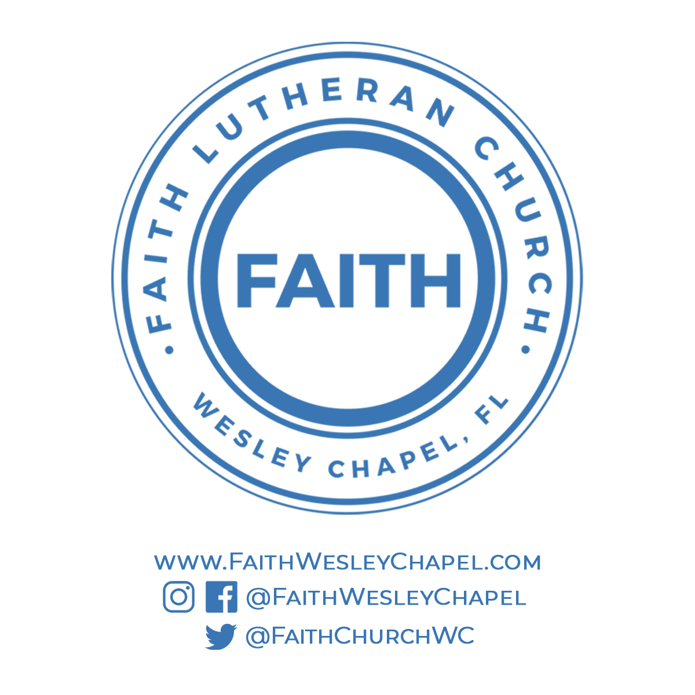**@FaithWesleyChapel**

**@FaithWesleyChapel**

**@FaithChurchWC**