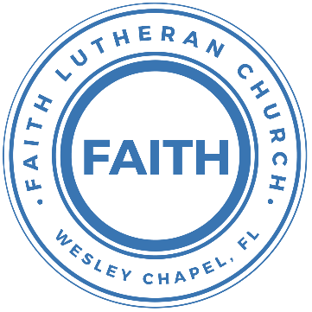

**Leading our community into a deep connection in Christ**

**Worship Service for February 5, 2023, at 11 AM**

**Welcome**

**Opening Song:**I Just Wanna Be A Sheep

Chorus:

I just wanna be a sheep, baa baa baa baa.  
I just wanna be a sheep, baa baa baa baa.  
I pray the Lord my soul to keep,   
I just wanna be a sheep, baa baa baa baa.

Verse: 1  
Don't wanna be a goat...nope! Don't wanna be a goat...nope!  
Haven't got any hope...nope! Don't wanna be a goat...nope!

Verse: 4  
Don't wanna be a Sadducee. Don't wanna be a Sadducee  
'Cause they're so sad you see. Don't wanna be a Sadducee

Chorus

Verse: 5  
Just wanna be a child of God. Just wanna be a child of God  
Walkin' the same path He trod. Just wanna be a child of God

Chorus

**Invocation**

**Confession and Forgiveness:**

**P:** We have come here today to worship the Lord.  In worship we hear the Word of God, we receive God's blessings, and respond with thanks and praise.  We begin by seeking God's blessing of forgiveness.  He has promised to remove the guilt and shame of our sin through the sacrifice of Jesus Christ on the cross.

*(a time of silence to reflect and personally confess our sins)*

**P:** Let us confess our sins to the Lord.

**P:** Heavenly Father,  
**C:** Heavenly Father,

**P:** I have done things that were wrong.  
**C:** I have done things that were wrong.  
  
**P:** I have been mean to others.  
**C:** I have been mean to others.

**P:** I have not obeyed my parents.  
**C:** I have not obeyed my parents.

**P:** I have not obeyed You, God.  
**C:** I have not obeyed You, God.

**P:** But I am very sorry.  
**C:** But I am very sorry.

**P:** Please forgive me.  
**C:** Please forgive me.

**P:** I love You very much.  
**C:** I love You very much.

**P:** And I know You love me, too.  
**C:** And I know You love me, too.

**P:** God has heard your apology.  He loves you very much.  God has told us that when we believe and trust in Him, He makes us His children.  As far as the east is from the west, so far does he remove our sins from us. He has told me to tell you that you are forgiven.  So, as His servant, I forgive you in the name of the Father and of the Son and of the Holy Spirit.

**C:** Amen.

**Song:**Jesus Loves Me

Verse 1:

Jesus loves me this I know, For the Bible tells me so.

Little ones to Him belong, They are weak, but He is strong.

Chorus:

Yes, Jesus loves me, Yes, Jesus loves me,

Yes, Jesus loves me, The Bible tells me so.

Verse 2:

Jesus loves me, He who died. Heaven's gates to open wide.

He will wash away my sin, Let His little child come in.

**First Reading –**Acts 9:3-5

So Saul went to Damascus. When he came near the city, a very bright light from heaven suddenly shined around him. He fell to the ground and heard a voice saying to him, “Saul, Saul! Why are you persecuting me?”

Saul said, “Who are you, Lord?”

The voice answered, “I am Jesus, the one you are persecuting.

**Reader:** This is the Word of the Lord.  
**C:** Thanks be to God.

**Children's Message**"The Story of Saul’s Conversion"

**Song:**Way Maker

Verse 1:  
You are here Moving in our midst. I worship you. I worship you  
You are here Moving in this place. I worship you. I worship you  
You are here Moving in our midst. I worship you. I worship you  
You are here Moving in this place. I worship you. I worship you

Chorus:  
Way maker, miracle worker  
Promise keeper, light in the darkness,  
My God, that is who you are

(Repeat)

Verse 2:  
You are here Touching every heart. I worship you. I worship you  
You are here Healing every heart. I worship you. I worship you  
You are here Turning lives around. I worship you. I worship you  
You are here Mending every heart. I worship you. I worship you

(Chorus)

Tag:  
That is who You are. That is who You are.  
That is who You are. That is who You are.

Bridge:  
Even when I don't see it, You're working  
Even when I don't feel it, You're working  
You never stop, You never stop working  
You never stop, You never stop working

(Repeat)

(Chorus)

(Tag)

**Second Reading –**Acts 9:10-15

There was a follower of Jesus in Damascus named Ananias. In a vision the Lord said to him, “Ananias!”

Ananias answered, “Here I am, Lord.”

The Lord said to him, “Get up and go to the street called Straight Street. Find the house of Judas and ask for a man named Saul from the city of Tarsus. He is there now, praying. He has seen a vision in which a man named Ananias came and laid his hands on him so that he could see again.”

But Ananias answered, “Lord, many people have told me about this man. They told me about the many bad things he did to your holy people in Jerusalem. Now he has come here to Damascus. The leading priests have given him the power to arrest all people who trust in you.”

But the Lord Jesus said to Ananias, “Go! I have chosen Saul for an important work. I want him to tell other nations, their rulers, and the people of Israel about me.

**Reader:** This is the Word of the Lord.  
**C:** Thanks be to God.

**Children's Message**"Stepping Out"

**Gospel Reading –**Matthew 28:18-20

So he came to them and said, “All authority in heaven and on earth is given to me. So go and make followers of all people in the world. Baptize them in the name of the Father and the Son and the Holy Spirit. Teach them to obey everything that I have told you to do. You can be sure that I will be with you always. I will continue with you until the end of time.”

**P:** This is the Gospel of the Lord.  
**C:** Praise be to You, o Christ.

**Sermon Hymn:**Take My Life And Let It Be

Verse 1:  
Take my life and let it be Consecrated, Lord, to Thee;  
Take my moments and my days, Let them flow in ceaseless praise.

Verse 2:  
Take my hands and let them move At the im- pulse of Thy love;  
Take my feet and let them be Swift and beautiful for Thee.

Verse 5:  
Take my will and make it Thine, It shall be no longer mine;  
Take my heart, it is Thine own, It shall be Thy royal throne.

Verse 6:  
Take my love, my Lord, I pour At Thy feet its treasure store;  
Take my - self, and I will be - ver, only, all for Thee.

**Sermon –**“A New Beginning”

**Prayers:** *Text in prayer requests to (813) 602-1104‬*

**The Lord's Prayer**

Our Father who art in heaven, hallowed be Thy name, Thy kingdom come, Thy will be done on earth as it is in heaven.  Give us this day our daily bread; and forgive us our trespasses as we forgive those who trespass against us; and lead us not into temptation, but deliver us from evil.  For Thine is the kingdom and the power and the glory forever and ever.  Amen

**Offering**

**Words of Institution**

**Peace**

**P:** The peace of the Lord be with you all.  
**C:** And also, with you.  
**P:** We greet each other in the peace of Christ.

**Distribution**

**Prayer**

**Benediction**

**Closing Song:**I Will Follow

Intro Chorus:

Where You go, I’ll go Where You stay, I’ll stay

When You move, I’ll move I will follow...

Verse 1:

All Your ways are good All Your ways are sure

I will trust in You alone

Higher than my sight High above my life

I will trust in You alone

Chorus:

Where You go, I’ll go Where You stay, I’ll stay

When You move, I’ll move I will follow You

Who You love, I'll love How You serve I'll serve

If this life I lose, I will follow You, Yeah.

I will follow You

Verse 2:

Light unto the world Light unto my life

I will live for You alone

You're the one I seek Knowing I will find

All I need in You alone, in You alone

Chorus

Bridge:

In You there's life everlasting

In You there's freedom for my soul

In You there's joy, unending joy

and I will follow

Chorus 2x

**Hey Youth!!**Do you know any worship songs you’d like to sing as part of our youth service? Let Pastor Kurt know.

Do you want to sing or play an instrument? Let Pastor Kurt know.

We want you to be a part of the service.

**Upcoming Events**

**Feb 12, After the Service, God Squad (Youth Group)**Faith Lutheran Church

**www.FaithWesleyChapel.com**

**Faith YouTube**

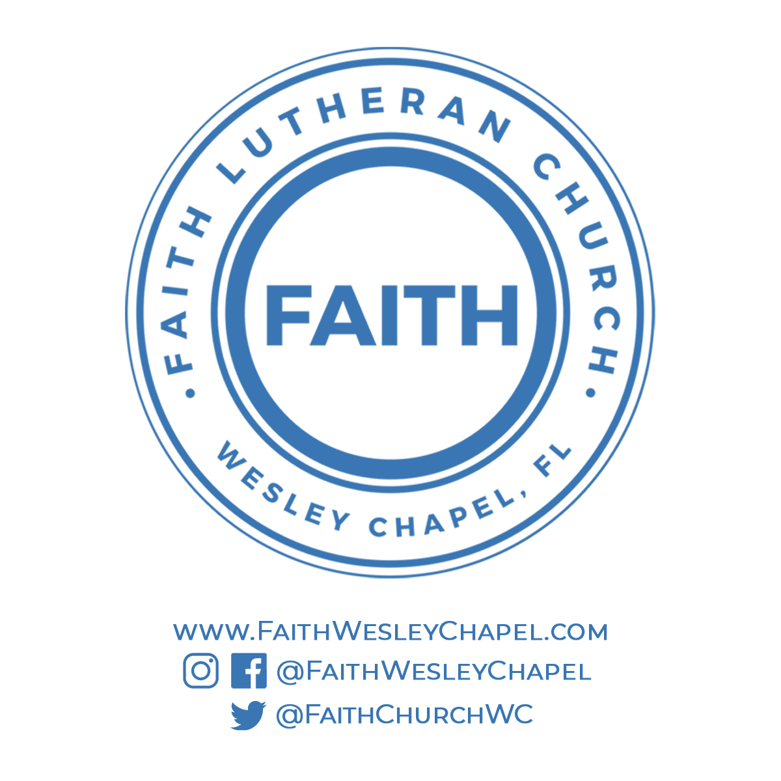**@FaithWesleyChapel**

**@FaithWesleyChapel**

**@FaithChurchWC**