

**Leading our community into a deep connection in Christ**

**Worship Service for June 4, 2023, at 11 AM**

**Welcome**

**Opening Song:**The Fruit of the Spirit Song

Oh, the fruit of the Spirit's not a coconut.  
Oh, the fruit of the Spirit's not a coconut.  
If you want to be a coconut, (Banana, Watermelon, Lemon)  
You might as well hear it. You can't be a fruit of the Spirit.

Chorus:  
'Cause the Fruit is...love, joy, peace, patience,  
Kindness, goodness, faithfulness, gentleness and self-control.  
Love, joy, peace, patience,  
Kindness, goodness, faithfulness, gentleness and self-control.

**Invocation**

**Confession and Forgiveness:**

**P:** We have come here today to worship the Lord.  In worship we hear the Word of God, we receive God's blessings, and respond with thanks and praise.  We begin by seeking God's blessing of forgiveness.  He has promised to remove the guilt and shame of our sin through the sacrifice of Jesus Christ on the cross.

*(a time of silence to reflect and personally confess our sins)*

**P:** Let us confess our sins to the Lord.

**P:** Heavenly Father,  
**C:** Heavenly Father,

**P:** I have done things that were wrong.  
**C:** I have done things that were wrong.

**P:** I have been mean to others.  
**C:** I have been mean to others.

**P:** I have not obeyed my parents.  
**C:** I have not obeyed my parents.

**P:** I have not obeyed You, God.  
**C:** I have not obeyed You, God.

**P:** But I am very sorry.  
**C:** But I am very sorry.

**P:** Please forgive me.  
**C:** Please forgive me.

**P:** I love You very much.  
**C:** I love You very much.

**P:** And I know You love me, too.  
**C:** And I know You love me, too.

**P:** Amen.  
**C:** Amen.

**P:** God has heard your apology.  He loves you very much.  God has told us that when we believe and trust in Him, He makes us His children.  As far as the east is from the west, so far does he remove our sins from us. He has told me to tell you that you are forgiven.  So, as His servant, I forgive you in the name of the Father and of the Son and of the Holy Spirit.   
**C:** Amen.

**Song:**Amazing Grace

Amazing grace, how sweet the sound that saved a wretch like me.

I once was lost, but now am found. Was blind but now I see.

T'was grace that taught my heart to fear,

And grace my fears relieved.

How precious did that grace appear, the hour I first believed.

When we've been there ten thousand years,  
bright shining as the sun,

we've no less days to sing God’s praise,  
than when we've first begun. © Public Domain

**First Reading -**Matthew 28:19

Go therefore and make disciples of all nations, baptizing them in the name of the Father and of the Son and of the Holy Spirit,

**P:** This is the Gospel of the Lord.  
**C:** Praise be to You, o Christ.

**Children's Message**"God is Trinity"

**Song:**Living Hope

How great the chasm that lay between us.

How high the mountain I could not climb.

In desperation, I turned to heaven,  
And spoke Your name into the night.

Then through the darkness Your loving kindness,

Tore through the shadows of my soul.

The work is finished, the end is written,  
Jesus Christ, my Living Hope.

Who could imagine so great a mercy.

What heart could fathom such boundless grace.

The God of ages stepped down from glory,  
To wear my sin and bear my shame.

The cross has spoken. I am forgiven.

The King of Kings calls me His own.

Beautiful Savior I’m Yours forever,

Jesus Christ, my Living Hope.

Chorus:

Hallelujah, praise the one who set me free!

Hallelujah, death has lost its grip on me!

You have broken every chain. There’s salvation in Your Name,

Jesus Christ, my Living Hope.

Verse 3:

Then came the morning that sealed the promise,

Your buried body began to breathe.

Out of the silence the roaring Lion,

Declared the grave has no claim on me.

*(Repeat)*

Jesus, Yours is the victory!

*(Chorus 2x)* © Bethel Music Publishing and Remaining portion is unaffiliated

**Second Reading -**Matthew 28:16–20

Now the eleven disciples went to Galilee, to the mountain to which Jesus had directed them. And when they saw him they worshiped him, but some doubted. And Jesus came and said to them, “All authority in heaven and on earth has been given to me. Go therefore and make disciples of all nations, baptizing them in the name of the Father and of the Son and of the Holy Spirit, teaching them to observe all that I have commanded you. And behold, I am with you always, to the end of the age.”

**P:** This is the Gospel of the Lord.  
**C:** Praise be to You, o Christ.

**Children's Message**"Jesus Sent the Doubters"

**Sermon Hymn:**Now All The Vault Of Heaven Resounds

Now all the vault of Heav'n resounds,

In praise of love that still abound,

“Christ has triumphed! He is living!"

Sing, choirs of angels, loud and clear.

Repeat their song of glory here.

“Christ has triumphed! Christ has triumphed!

Alleluia, alleluia, alleluia.”

Eternal is the gift He brings.

Therefore, our heart with rapture sings,

“Christ has triumphed! He is living!"

Now, still, He comes to give us life,

And by His presence stills all strife.

Christ has triumphed! He is living!

Alleluia, alleluia, alleluia.

Adoring praises now we bring

And with the heavenly blessed sing,

“Christ has triumphed, Alleluia!

Be to the Father, and our Lord,

To Spirit blest, most holy God,

All the glory, never-ending!

Alleluia, alleluia, alleluia.“ © 1989,1994 Lorenz Publishing Company

**Sermon –**"Sent to Bring"

Sermon Reading: Romans 1:1-6

Paul, a servant of Christ Jesus, called to be an apostle, set apart for the gospel of God, which he promised beforehand through his prophets in the holy Scriptures, concerning his Son, who was descended from David according to the flesh and was declared to be the Son of God in power according to the Spirit of holiness by his resurrection from the dead, Jesus Christ our Lord, through whom we have received grace and apostleship to bring about the obedience of faith for the sake of his name among all the nations, including you who are called to belong to Jesus Christ,

**Prayers:** *Text in prayer requests to (813) 602-1104‬*

**The Lord's Prayer**

Our Father who art in heaven, hallowed be Thy name, Thy kingdom come, Thy will be done on earth as it is in heaven.  Give us this day our daily bread; and forgive us our trespasses as we forgive those who trespass against us; and lead us not into temptation, but deliver us from evil.  For Thine is the kingdom and the power and the glory forever and ever.  Amen

**Offering**

**Words of Institution**

**Peace**

**P:** The peace of the Lord be with you all.  
**C:** And also, with you.  
**P:** We greet each other in the peace of Christ.

**Distribution**

**Prayer**

**Benediction**

**Closing Song:**God So Loved

Verse 1:  
Come all you weary. Come all you thirsty.

Come to the well that never runs dry.

Drink of the Water. Come and thirst no more.

Verse 2:  
Come all you sinners. Come find His mercy.

Come to the table. He Will satisfy.

Taste of His goodness. Find what you’re looking for.

Chorus 1:

For God so loved the World that He gave us,

His one and only Son to save us.

Whoever believes in Him, will live forever.

Verse 3:  
Bring all your failures. Bring your addictions.

Come lay them down at the Foot of the cross.

Jesus is waiting there with open arms.

*(Chorus 1)*

Chorus 2:

The power of Hell forever defeated.

Now, it is well. I’m Walking in freedom.

For God so loved, God so loved the world.

Bridge:

Praise God! Praise God from whom all blessings flow.

Praise Him! Praise Him for the wonders of His love.

*(Repeat)*

His amazing love!

*(Chorus 1)*

*(Chorus 2)*

*(Verse 3)*

© 2019 Andrew Bergthold Designee (Admin. by Capitol CMG Publishing), Capitol CMG Genesis (Admin. by Capitol CMG Publishing), Capitol CMG

Paragon (Admin. by Capitol CMG Publishing), We The Kingdom ASCAP Designee (Admin. by Capitol CMG Publishing), and We The Kingdom Music

(Admin. by Capitol CMG Publishing)

|  |  |
| --- | --- |
| **Serving This Week** | |
|  | |
| **1st Reader:** Kaylee Steinbrueck | **Children’s Church Teacher:** |
| **2nd Reader:** Katelyn Shuck | N/A – No Children’s Church |
| **Acolyte:** Griffin Frost | **Children’s Church Assistant:** |
| **Com. Asst:** Larry Chmiel | N/A – No Children’s Church |
|  | |
| **Serving Next Week** | |
|  | |
| **O.T. Reader:** Melissa Steinbrueck | **Children’s Church Teacher:** |
| **Epistle Reader:** N/A | Melissa Steinbrueck |
| **Acolyte:** Kaylee Steinbrueck | **Children’s Church Assistant:** |
| **Com. Asst:** Larry Chmiel | Kaylee Steinbrueck |

**Hey Youth!!**Do you know any worship songs you’d like to sing as part of our youth service? Let Pastor Kurt know.

Do you want to sing or play an instrument? Let Pastor Kurt know.

We want you to be a part of the service.

**Upcoming Events**

**June 11, 11 AM – Regular Service (no meal)**  
Faith Lutheran Church

**June 11, After the Service – Vision Re-Launch Party**  
Pastor Kurt’s House

**June 24, 6 PM - Youth Game Night**  
The Frost’s Home

**June 25, After the Service – “God Squad” Youth Group**  
Faith Lutheran Church

**July 17-19 – Summer Mission Trip**  
Metropolitan Ministries

**August 5, 10 AM - 7 PM – End of the Summer Water Park Trip**  
Adventure Island

[**www.FaithWesleyChapel.com**](http://www.FaithWesleyChapel.com)

 **Faith YouTube**

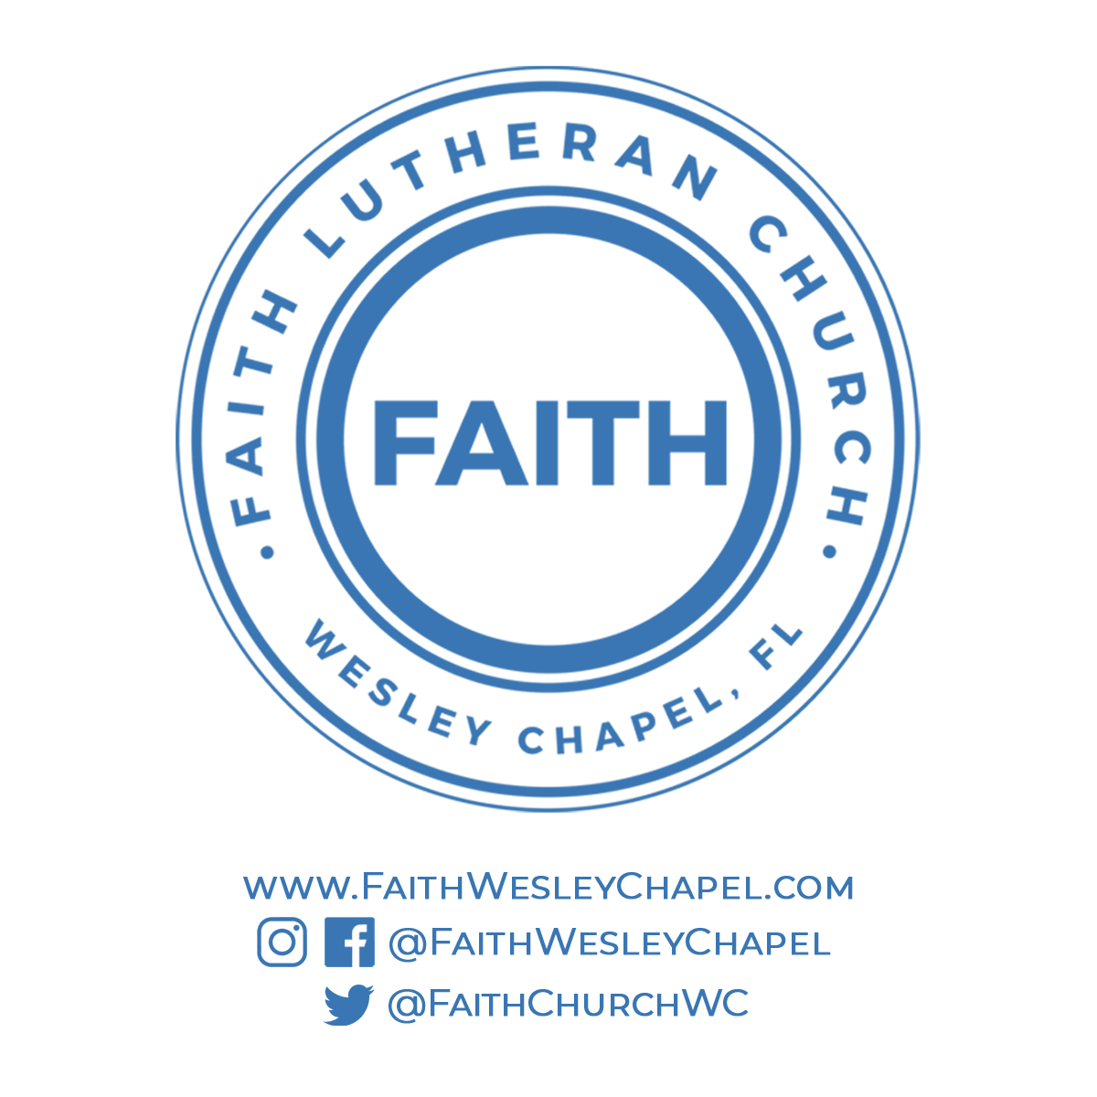**@FaithWesleyChapel**

**@FaithWesleyChapel**

**@FaithChurchWC**