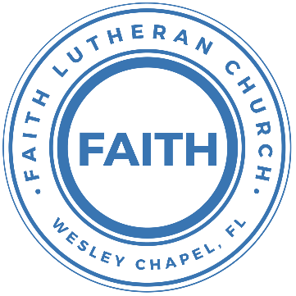

**Leading our community into a deep connection in Christ**

**Worship Service for June 11, 2023, at 11 AM**

**Welcome**

**Invocation**

**Confession and Forgiveness:**

**P:** When we come into the presence of God we cannot help but see our sinfulness. God does not require us to cleanse our own sin and be perfect of our own power for, surely, we could never achieve this. Instead, He tells us to come as we are and receive His great mercy.

**Song:** Come As You Are

Verse 1:

Come out of sadness, from wherever you've been.

Come broken hearted, let rescue begin.

Come find your mercy, oh sinner come kneel.

Earth has no sorrow that Heaven can't heal.

Earth has no sorrow that Heaven can't heal.

Chorus:

So, lay down your burdens, lay down your shame.

All who are broken, lift up your face.

Oh, wanderer come home. You're not too far.

So, lay down your hurt. Lay down your heart.

Come as you are.

Verse 2:

There's hope for the hopeless, and all those who've strayed,

Come sit at the table, Come taste of the grace,

There's rest for the weary, rest that endures.

Earth has no sorrow that Heaven can't cure.

Chorus:

So, lay down your burdens, lay down your shame.

All who are broken, lift up your face.

Oh, wanderer come home. You're not too far.

So, lay down your hurt. Lay down your heart.

Come as you are.

Bridge:

Come as you are. Fall in his arms. Come as you are.

*(a time of silence to reflect and personally confess our sins)*

**C:** Heavenly Father, we confess that we have sinned against you and each other. We are truly sorry and we humbly repent. For the sake of your Son Jesus Christ and His suffering and death on the cross, please forgive us and help us to live according to Your ways. Amen

Verse 3:

There's joy for the morning, Oh, sinner be still.

Earth has no sorrow that Heaven can't heal.

Earth has no sorrow that Heaven can't heal.

*(Chorus)* *© 2014 9 © t One Songs (Admin. by EMI Christian Music Publishing)*

**Words of Forgiveness**  
**C:** Amen.

**Song of Praise and Thanksgiving -** The Wonderful Cross

When I survey the wondrous cross,

On which the prince of glory died,

My richest gain I count but loss,

And pour contempt on all my pride.

Forbid it, Lord, that I should boast,

Save in the death of Christ my God.

All the vain things that charm me most,

I sacrifice them to His blood.

Chorus:

O the wonderful cross, O the wonderful cross,

Bids me come and die and find that I may truly live.

O the wonderful cross, O the wonderful cross,

All who gather here by grace draw near and bless Your name.

See from his head, His hands, His feet,

Sorrow and love flow mingled down.

Did e’er such love and sorrow meet,

Or thorns compose so rich a crown.

Chorus:

O the wonderful cross, O the wonderful cross,

Bids me come and die and find that I may truly live.

O the wonderful cross, O the wonderful cross,

All who gather here by grace draw near and bless Your name.

Were the whole realm of nature mine,

That were a present far too small.

Love so amazing so divine, demands my soul, my life, my all.

*(Chorus)* © 2000 worshiptogether.com Songs (ASCAP)/sixsteps Music (ASCAP) (both admin. by EMI CMG PUblishing)

**Old Testament Reading -** Hosea 5:15-6:6

I will return again to my place, until they acknowledge their guilt and seek my face, and in their distress earnestly seek me. “Come, let us return to the Lord; for he has torn us, that he may heal us; he has struck us down, and he will bind us up. After two days he will revive us; on the third day he will raise us up, that we may live before him. Let us know; let us press on to know the Lord; his going out is sure as the dawn; he will come to us as the showers, as the spring rains that water the earth.”

What shall I do with you, O Ephraim? What shall I do with you, O Judah? Your love is like a morning cloud, like the dew that goes early away. Therefore I have hewn them by the prophets; I have slain them by the words of my mouth, and my judgment goes forth as the light. For I desire steadfast love and not sacrifice, the knowledge of God rather than burnt offerings.

**Reader:** This is the Word of the Lord.  
**C:** Thanks be to God.

**Gospel Reading -** Matthew 9:9-13

As Jesus passed on from there, he saw a man called Matthew sitting at the tax booth, and he said to him, “Follow me.” And he rose and followed him.

And as Jesus reclined at table in the house, behold, many tax collectors and sinners came and were reclining with Jesus and his disciples. And when the Pharisees saw this, they said to his disciples, “Why does your teacher eat with tax collectors and sinners?” But when he heard it, he said, “Those who are well have no need of a physician, but those who are sick. Go and learn what this means: ‘I desire mercy, and not sacrifice.’ For I came not to call the righteous, but sinners.”

**P:** This is the Gospel of the Lord.  
**C:** Praise be to You, o Christ.

**Children's Message** *(Children dismissed to Children's Church)*

**Sermon Hymn -** No Other Name

One Name holds weight above them all.

His fame outlasts the earth He formed.

His praise resounds beyond the stars,

And echoes in our hearts, the greatest One of all.

His face shines brighter than the sun,

His grace as boundless as His love.

He reigns with healing in His wings,

The King above all kings, the greatest One of all.

Chorus:

Lift up our eyes see the King has come,

Light of the world reaching out for us.

There is no other name. There is no other name,

Jesus Christ our God. Whoa oh.

Seated on high, the undefeated One.

Mountains bow down as we lift Him up.

There is no other name. There is no other name,

Jesus Christ our God. Whoa oh.

Find hope when all the world seems lost.

Behold the triumph of the cross.

His power has trampled death and grave,

Our life found in His name, the greatest name of all.

*(Chorus)*

Bridge:

The earth will shake and tremble before Him.

Chains will break as heaven and earth sing,

“Holy is the name! Holy is the name of Jesus, Jesus, Jesus!

*(Repeat Bridge)*

Chorus:

Lift up our eyes see the King has come,

Light of the world reaching out for us.

There is no other name. There is no other name,

Jesus Christ our God. Whoa oh.

Seated on high, the undefeated One.

Mountains bow down as we lift Him up.

There is no other name. There is no other name,

Jesus Christ our God. Whoa oh.

© 2014 © Hillsong Music Publishing (Admin. by EMI Christian Music Publishing)

**Sermon -** "The Promise Received By Faith"

Romans 4:13-25

For the promise to Abraham and his offspring that he would be heir of the world did not come through the law but through the righteousness of faith. For if it is the adherents of the law who are to be the heirs, faith is null and the promise is void. For the law brings wrath, but where there is no law there is no transgression.

That is why it depends on faith, in order that the promise may rest on grace and be guaranteed to all his offspring—not only to the adherent of the law but also to the one who shares the faith of Abraham, who is the father of us all, as it is written, “I have made you the father of many nations”—in the presence of the God in whom he believed, who gives life to the dead and calls into existence the things that do not exist. In hope he believed against hope, that he should become the father of many nations, as he had been told, “So shall your offspring be.” He did not weaken in faith when he considered his own body, which was as good as dead (since he was about a hundred years old), or when he considered the barrenness of Sarah's womb. No unbelief made him waver concerning the promise of God, but he grew strong in his faith as he gave glory to God, fully convinced that God was able to do what he had promised. That is why his faith was “counted to him as righteousness.” But the words “it was counted to him” were not written for his sake alone, but for ours also. It will be counted to us who believe in him who raised from the dead Jesus our Lord, who was delivered up for our trespasses and raised for our justification.

**P:** This is the Gospel of the Lord.  
**C:** Praise be to You, o Christ.

**Prayers:** *Text in prayer requests to (813) 326-5255‬*

**Apostles' Creed**

I believe in God, the Father almighty, maker of heaven and earth,

And in Jesus Christ, his only Son, our Lord,  
who was conceived by the Holy Spirit,  
born of the Virgin Mary, suffered under Pontius Pilate,  
was crucified, died and was buried. He descended into hell.  
The third day he rose again from the dead.  
He ascended into heaven and sits at the right hand of God  
the Father almighty.  
From there he will come to judge the living and the dead.

I believe in the Holy Spirit, the holy Christian Church,  
the communion of saints, the forgiveness of sins,  
the resurrection of the body, and the life everlasting. Amen.

**The Lord's Prayer**

Our Father who art in heaven, hallowed be Thy name, Thy kingdom come, Thy will be done on earth as it is in heaven.  Give us this day our daily bread; and forgive us our trespasses as we forgive those who trespass against us; and lead us not into temptation, but deliver us from evil.  For Thine is the kingdom and the power and the glory forever and ever.  Amen

**Offering**

*(The online service is concluded. A video of the closing song is available on the Livestream page of FaithWesleyChapel.com)*

**Words of Institution**

**Peace**

**P:** The peace of the Lord be with you all.  
**C:** And also, with you.  
**P:** We greet each other in the peace of Christ.

**Distribution**

**Prayer**s and **Benediction**

**Closing Song -**All Glory, Laud, and Honor

Refrain:  
All glory, laud, and honor to You, Redeemer, King,  
To whom the lips of children made sweet hosannas ring.

You are the King of Israel and David’s royal Son,  
Now in the Lord’s Name coming, our King and Blessed One.  
*(Refrain)*

The company of angels is praising You on high,  
And we with all creation in chorus make reply.  
*(Refrain)*

As You received their praises, accept the prayers we bring,  
O Source of ev'ry blessing, our good and gracious King.  
*(Refrain)* *© Public Domain*

|  |  |
| --- | --- |
| **Serving This Week** | |
|  | |
| **O.T. Reader:** Gretchen Pifer | **Children’s Church Teacher:** |
| **Epistle Reader:** N/A | Melissa Steinbrueck |
| **Acolyte:** Griffin Frost | **Children’s Church Assistant:** |
| **Com. Asst:** Larry Chmiel | Kaylee Steinbrueck |
|  | |
| **Serving Next Week** | |
|  | |
| **O.T. Reader:** Vanessa Frost | **Children’s Church Teacher:** |
| **Epistle Reader:** N/A | Halston and Ben |
| **Acolyte:** Kaylee Steinbrueck | **Children’s Church Assistant:** |
| **Com. Asst:** Larry Chmiel | N/A |

**Upcoming Events**

**June 11, After the Service – Vision Re-Launch Party**  
Pastor Kurt’s House

**June 24, 6 PM - Youth Game Night**  
The Frost’s Home

**June 25, After the Service – “God Squad” Youth Group**  
Faith Lutheran Church

**July 17-19 – Summer Mission Trip**  
Metropolitan Ministries

**August 5, 10 AM - 7 PM – End of the Summer Water Park Trip**  
Adventure Island

[**www.FaithWesleyChapel.com**](http://www.FaithWesleyChapel.com)

 **Faith YouTube**

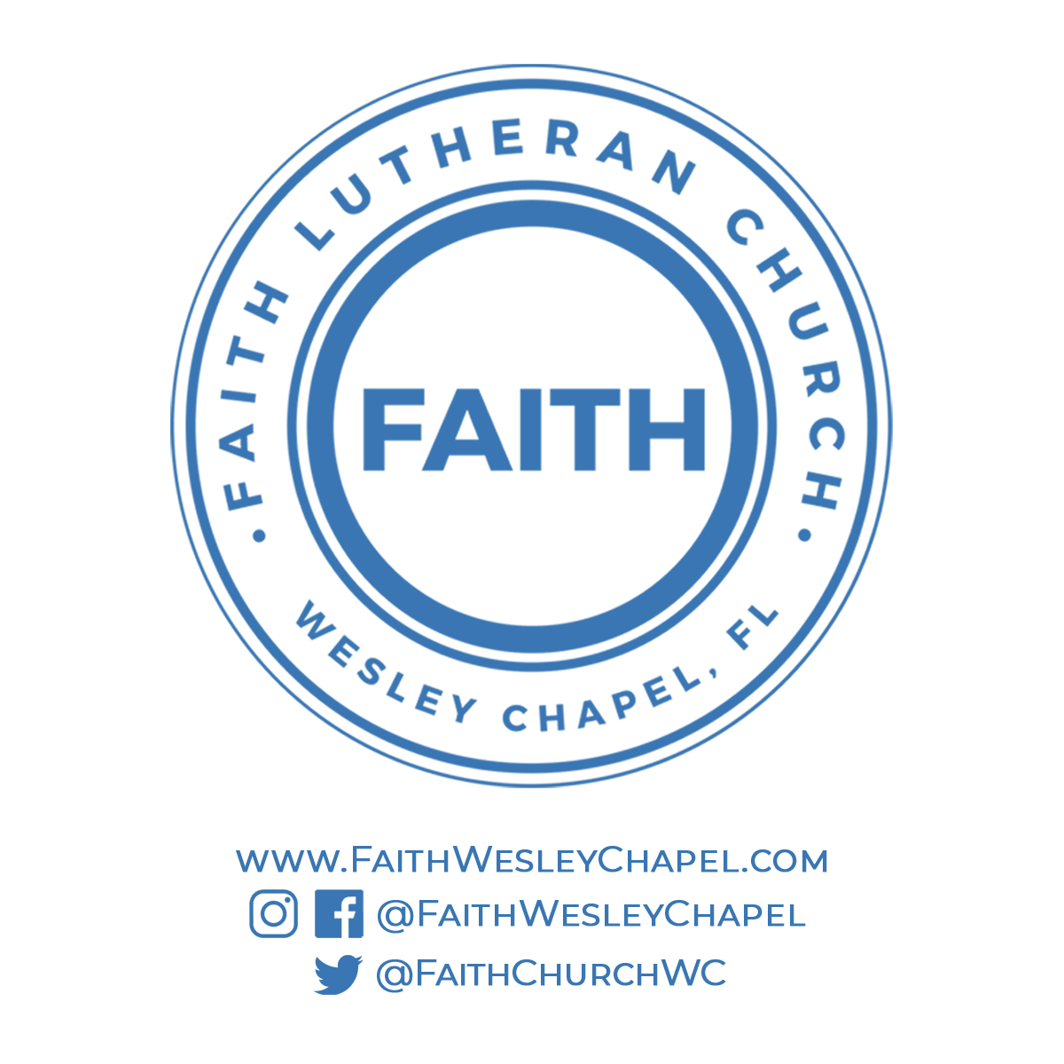**@FaithWesleyChapel**

**@FaithWesleyChapel**

**@FaithChurchWC**