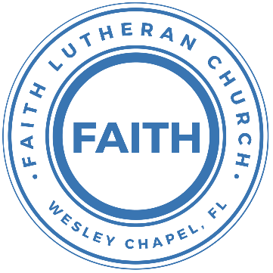

**Leading our community into a deep connection in Christ**

**Worship Service for June 18, 2023 at 11 AM**

**Welcome**

**Opening Song -** Love Divine All Loves Excelling

Love divine, all loves excelling, Joy of heav'n, to earth come down!  
Fix in us Thy humble dwelling, all Thy faithful mercies crown.  
Jesus, Thou art all compassion, pure, unbounded love Thou art;  
Visit us with Thy salvation, enter ev'ry trembling heart.

Breathe, O breathe Thy loving Spirit into ev'ry troubled breast;  
Let us all in Thee inherit; let us find Thy promised rest.  
Take away the love of sinning; Alpha and Omega be;  
End of faith, as its beginning, set our hearts at liberty.

Come, Almighty, to deliver. Let us all Thy life receive.  
Suddenly return, and never, nevermore Thy temples leave.  
Thee we would be always blessing. Serve Thee as Thy hosts above.  
Pray and praise Thee without ceasing. Glory in Thy perfect love.

Finish then Thy new creation, pure and spotless let us be;  
Let us see Thy great salvation perfectly restored in Thee,  
Changed from glory into glory, till in heav'n we take our place,  
Till we cast our crowns before Thee,  
Lost in wonder, love, and praise! © Public Domain

**Invocation**

**Confession and Forgiveness:**

**P:** Our Heavenly Father asks us to come into His presence.  
**C:** But we are sinful and unworthy.

**P:** Yes, all have sinned and fall short of the glory of God, but Jesus Christ died on the cross that we may be forgiven and washed clean of all our sins by His blood spilled on the cross.  
**C:** Lord, if You wash us, we will certainly be clean and pure.

**P:** We take a moment to bow before the His cross and silently reflect on our lives and confess our sins.

*(Time of silence for reflection and confession)*

**P:** Let us confess, together, our sins to God our Father.  
**C:** Heavenly Father, we confess that we are sinners.  We have sinned against you and our neighbors. We have not loved you with our whole heart and we have not loved our neighbors as ourselves. We have not lived out our faith in our community. We justly deserve Your punishment.  For the sake of Your Son, Jesus Christ, have mercy on us.  Forgive us, renew us, and lead us, so that we may delight in Your will and walk in Your ways to the glory of Your holy name.  Amen.

**P:** Almighty God in His mercy has given His Son to die for you and for His sake forgives you all your sins.  As a called and ordained servant of Christ, and by His authority, I, therefore, forgive you all your sins in the name of the Father and of the Son and of the Holy Spirit.  
**C:** Amen

**Song of Praise and Thanksgiving:** Were You There

Were you there when they crucified my Lord?  
Were you there when they crucified my Lord?  
Oh, sometimes it causes me to tremble, tremble, tremble.  
Were you there when they crucified my Lord?

Were you there when they nailed him to the tree?  
Were you there when they nailed him to the tree?  
Oh, sometimes it causes me to tremble, tremble, tremble.  
Were you there when they nailed him to the tree?

Were you there when they laid him in the tomb?  
Were you there when they laid him in the tomb?  
Oh, sometimes it causes me to tremble, tremble, tremble.  
Were you there when they laid him in the tomb?

Were you there when God raised him from the tomb?  
Were you there when God raised him from the tomb?  
Oh, sometimes it causes me to tremble, tremble, tremble  
Were you there when God raised him from the tomb? © Public Domain

**Old Testament Reading -**Exodus 19:2-8

They set out from Rephidim and came into the wilderness of Sinai, and they encamped in the wilderness. There Israel encamped before the mountain, while Moses went up to God. The Lord called to him out of the mountain, saying, “Thus you shall say to the house of Jacob, and tell the people of Israel: ‘You yourselves have seen what I did to the Egyptians, and how I bore you on eagles' wings and brought you to myself. Now therefore, if you will indeed obey my voice and keep my covenant, you shall be my treasured possession among all peoples, for all the earth is mine; and you shall be to me a kingdom of priests and a holy nation.’ These are the words that you shall speak to the people of Israel.” So Moses came and called the elders of the people and set before them all these words that the Lord had commanded him. All the people answered together and said, “All that the Lord has spoken we will do.” And Moses reported the words of the people to the Lord.

**Reader:** This is the Word of the Lord. **C:** Thanks be to God.

**Gospel Reading** - Matthew 9:35-10:8

And Jesus went throughout all the cities and villages, teaching in their synagogues and proclaiming the gospel of the kingdom and healing every disease and every affliction. When he saw the crowds, he had compassion for them, because they were harassed and helpless, like sheep without a shepherd. Then he said to his disciples, “The harvest is plentiful, but the laborers are few; therefore pray earnestly to the Lord of the harvest to send out laborers into his harvest.” And he called to him his twelve disciples and gave them authority over unclean spirits, to cast them out, and to heal every disease and every affliction. The names of the twelve apostles are these: first, Simon, who is called Peter, and Andrew his brother; James the son of Zebedee, and John his brother; Philip and Bartholomew; Thomas and Matthew the tax collector; James the son of Alphaeus, and Thaddaeus; Simon the Zealot, and Judas Iscariot, who betrayed him.

These twelve Jesus sent out, instructing them, “Go nowhere among the Gentiles and enter no town of the Samaritans, but go rather to the lost sheep of the house of Israel. And proclaim as you go, saying, ‘The kingdom of heaven is at hand.’ Heal the sick, raise the dead, cleanse lepers, cast out demons. You received without paying; give without pay.

**P:** This is the Gospel of the Lord. **C:** Praise be to You, o Christ.

**Children's Message** *(Children dismissed to Children's Church)*

**Sermon Hymn***–*How Deep The Father’s Love For Us

How deep the Father's love for us, how vast beyond all measure

That He should give His only Son, to make a wretch His treasure

How great the pain of searing loss, the Father turned His face away

As wounds which mar the Chosen One, bring many sons to glory

Behold the Man upon a cross, my sin upon His shoulders

Ashamed, I hear my mocking voice call out among the scoffers

It was my sin that held Him there until it was accomplished

His dying breath has brought me life; I know that it is finished

I will not boast in anything: no gifts, no power, no wisdom

But I will boast in Jesus Christ; his death and resurrection

Why should I gain from His reward? I cannot give an answer

But this I know with all my heart: His wounds have paid my ransom

But this I know with all my heart: His wounds have paid my ransom

© 1995 Thankyou Music

**Sermon** - "Jesus Died for the Ungodly"

Romans 5:6-15

For while we were still weak, at the right time Christ died for the ungodly. For one will scarcely die for a righteous person—though perhaps for a good person one would dare even to die — but God shows his love for us in that while we were still sinners, Christ died for us. Since, therefore, we have now been justified by his blood, much more shall we be saved by him from the wrath of God. For if while we were enemies we were reconciled to God by the death of his Son, much more, now that we are reconciled, shall we be saved by his life. More than that, we also rejoice in God through our Lord Jesus Christ, through whom we have now received reconciliation.

Therefore, just as sin came into the world through one man, and death through sin, and so death spread to all men because all sinned — for sin indeed was in the world before the law was given, but sin is not counted where there is no law. Yet death reigned from Adam to Moses, even over those whose sinning was not like the transgression of Adam, who was a type of the one who was to come.

But the free gift is not like the trespass. For if many died through one man's trespass, much more have the grace of God and the free gift by the grace of that one man Jesus Christ abounded for many.

**P:** This is the Word of the Lord. **C:** Thanks be to God.

**Installation of the Church Secretary**

**Prayers:** *Text in prayer requests to (813) 326-5255*

**Nicene Creed**

I believe in one God, the Father Almighty, maker of heaven and earth and of all things visible and invisible.

And in one Lord Jesus Christ, the only-begotten Son of God, begotten of His Father before all worlds, God of God, Light of Light, very God of very God, begotten, not made, being of one substance with the Father, by whom all things were made; who for us men and for our salvation came down from heaven and was incarnate by the Holy Spirit of the virgin Mary and was made man; and was crucified also for us under Pontius Pilate. He suffered and was buried. And the third day He rose again according to the Scriptures and ascended into heaven and sits at the right hand of the Father. And He will come again with glory to judge both the living and the dead, whose kingdom will have no end.

And I believe in the Holy Spirit, the Lord and Giver of Life, who proceeds from the Father and the Son, who with the Father and the Son together is worshiped and glorified, who spoke by the prophets. And I believe in one holy Christian and apostolic Church, I acknowledge one Baptism for the remission of sins, and I look for the resurrection of the dead and the life of the world to come. Amen.

**The Lord's Prayer**

Our Father who art in heaven, hallowed be Thy name, Thy kingdom come, Thy will be done on earth as it is in heaven.  Give us this day our daily bread; and forgive us our trespasses as we forgive those who trespass against us; and lead us not into temptation, but deliver us from evil.  For Thine is the kingdom and the power and the glory forever and ever.  Amen

**Offering**

**Words of Institution**

**Peace**

**P:** The peace of the Lord be with you all.  
**C:** And also, with you.

**Distribution**

**Prayer**

**Benediction**

**Closing Song:**Who You Say I Am

Who am I that the highest King would welcome me?

I was lost but He brought me in. Oh, His love for me.

Oh, His love for me.

Chorus 1:

Who the Son sets free, Oh is free indeed.

I'm a child of God, Yes I am.

Free at last He has ransomed me. His grace runs deep.

While I was a slave to sin Jesus died for me. Yes, He died for me.

Chorus 2:

Who the Son sets free, oh is free indeed.

I'm a child of God, Yes I am.

In my Father's house there's a place for me.

I'm a child of God, Yes I am.

I am chosen, not forsaken. I am who You say I am

You are for me, not against me. I am who You say I am  
I am chosen, not forsaken. I am who You say I am

You are for me, not against me. I am who You say I am

I am who You say I am

*(Chorus 2)*

*(Chorus 2 second half, "In my Father's house...")* © 2017 Hillsong Music Publishing (Admin. by Capitol CMG Publishing)

|  |  |
| --- | --- |
| **Serving This Week** | |
|  | |
| **O.T. Reader:** Melissa Steinbrueck | **Children’s Church Teacher:** |
| **Epistle Reader:** N/A | Halston and Ben |
| **Acolyte:** Kaylee Steinbrueck | **Children’s Church Assistant:** |
| **Com. Asst:** Larry Chmiel | N/A |
|  | |
| **Serving Next Week** | |
|  | |
| **O.T. Reader:** Vanessa Frost | **Children’s Church Teacher:** |
| **Epistle Reader:** N/A | Melissa Steinbrueck |
| **Acolyte:** Gunnar Torgrimson | **Children’s Church Assistant:** |
| **Com. Asst:** Larry Chmiel | Kaylee Steinbrueck |

**Upcoming Events**

**June 24, 6 PM - Youth Game Night**  
The Frost’s Home

**June 25, After the Service – “God Squad” Youth Group**  
Faith Lutheran Church

**July 17-19 – Summer Mission Trip**  
Metropolitan Ministries

**August 5, 10 AM - 7 PM – End of the Summer Water Park Trip**  
Adventure Island

**www.FaithWesleyChapel.com**

**Faith YouTube**

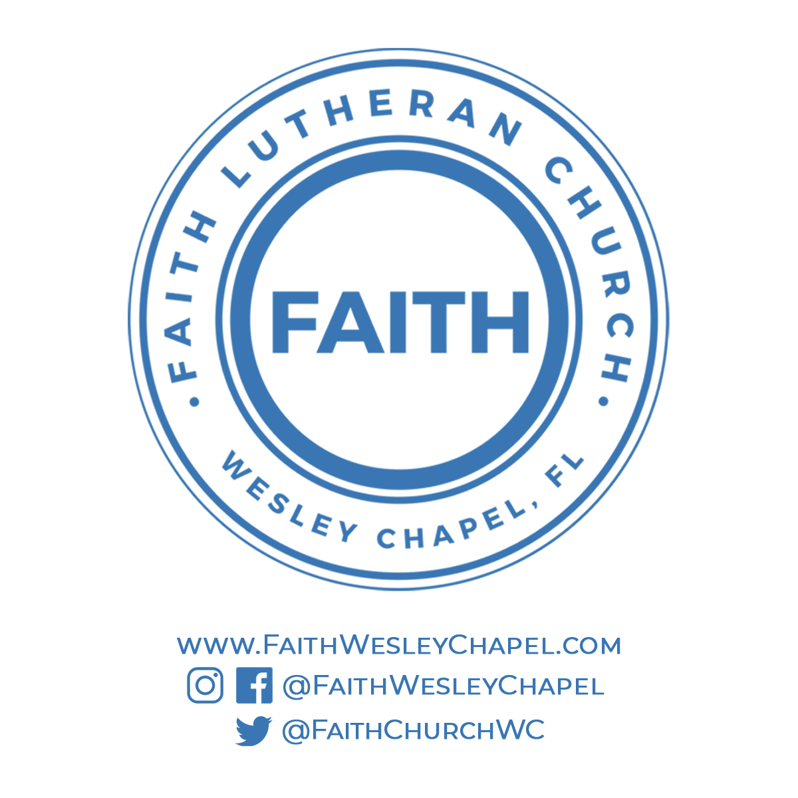**@FaithWesleyChapel**

**@FaithWesleyChapel**

**@FaithChurchWC**