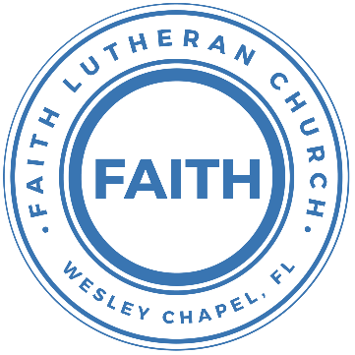

**Leading our community into a deep connection in Christ**

**Worship Service for June 25, 2023, at 11 AM**

**Welcome**

**Opening Song:**Holy, Holy, Holy

Holy, holy, holy, Lord God almighty:  
Early in the morning our song shall rise to Thee.  
Holy, holy, holy, merciful and mighty,  
God in three persons blessed Trinity.

Holy, holy, holy, all the saints adore Thee,  
Casting down their golden crowns around the glassy sea.  
Cherubim and Seraphim falling down before Thee,  
Which wert and art and evermore shall be.

Holy, holy, holy, though the darkness hide Thee,  
Though the eye of sinful man Thy glory may not see,  
Only Thou art holy there is none beside Thee,  
Perfect in pow’r, in love, and purity.

Holy, holy, holy, Lord God almighty!  
All Thy works shall praise Thy name in earth and sky and sea.  
Holy, holy, holy, merciful and mighty,  
God in three persons blessed Trinity.  
God in three persons blessed Trinity. © Public Domain

**Invocation**

**Confession and Forgiveness:**

**P:** Come into the presence of the Lord our God.  
**C:** Have mercy, O Lord. If you, Lord, kept a record of sins, Lord, who could stand; but if we confess our sins, he is faithful and just to forgive us our sins and to cleanse us from all unrighteousness.

*(A time of silence to reflect and personally confess our sins)*

**P:** I said, "I will confess my transgressions to the LORD." And you forgave the guilt of my sin. Let us confess our sin before the Lord. Let us confess together.  
**C:** Heavenly Father, we confess that we are sinners.  We have sinned against you and our neighbors. We have not loved you with our whole heart and we have not loved our neighbors as ourselves. We justly deserve Your punishment.  For the sake of Your Son, Jesus Christ, have mercy on us.  Forgive us, renew us, and lead us, so that we may delight in Your will and walk in Your ways to the glory of Your holy name.  Amen.

**P:** The Lord is gracious and merciful. He promises to forgive our sins. Therefore, upon this, your confession, as a called and ordained servant of the Lord, in the stead and by the command of my Lord, Jesus Christ, I forgive you all your sins in the name of the Father and of the Son and of the Holy Spirit.  
**C:** Amen.

**Song of Praise and Thanksgiving -** Chief Of Sinners Though I Be

Chief of sinners though I be, Jesus shed His blood for me.

Died that I might live on high, lived that I might never die.

As the branch is to the vine, I am His and He is mine.

Oh, the height of Jesus' love, higher than the heav'ns above,

Deeper than the depths of sea, lasting as eternity!

Love that found me wondrous thought!

Found me when I sought Him not.

Only Jesus can impart, balm to heal the wounded heart,

Peace that flows from sin forgiv'n, joy that lifts the soul to heav'n.

Faith and hope to walk with God, in the way that Enoch trod.

O my Savior, help afford, by Your Spirit and Your Word!

When my wayward heart would stray,  
Keep me in the narrow way. Grace in time of need supply,  
While I live and when I die. © Public Domain

**Old Testament Reading -** Psalm 91:1–10

He who dwells in the shelter of the Most High will abide in the shadow of the Almighty. I will say to the Lord, “My refuge and my fortress, my God, in whom I trust.”

For he will deliver you from the snare of the fowler and from the deadly pestilence. He will cover you with his pinions, and under his wings you will find refuge; his faithfulness is a shield and buckler. You will not fear the terror of the night, nor the arrow that flies by day, nor the pestilence that stalks in darkness, nor the destruction that wastes at noonday.

A thousand may fall at your side, ten thousand at your right hand, but it will not come near you. You will only look with your eyes and see the recompense of the wicked.

Because you have made the Lord your dwelling place—the Most High, who is my refuge—no evil shall be allowed to befall you, no plague come near your tent.

**Reader:** This is the Word of the Lord.  
**C:** Thanks be to God.

**Gospel Reading -** Matthew 10:5, 21–33

These twelve Jesus sent out, instructing them, “Go nowhere among the Gentiles and enter no town of the Samaritans,...

...Brother will deliver brother over to death, and the father his child, and children will rise against parents and have them put to death, and you will be hated by all for my name's sake. But the one who endures to the end will be saved. When they persecute you in one town, flee to the next, for truly, I say to you, you will not have gone through all the towns of Israel before the Son of Man comes.

“A disciple is not above his teacher, nor a servant above his master. It is enough for the disciple to be like his teacher, and the servant like his master. If they have called the master of the house Beelzebul, how much more will they malign those of his household.

“So have no fear of them, for nothing is covered that will not be revealed, or hidden that will not be known. What I tell you in the dark, say in the light, and what you hear whispered, proclaim on the housetops. And do not fear those who kill the body but cannot kill the soul. Rather fear him who can destroy both soul and body in hell. Are not two sparrows sold for a penny? And not one of them will fall to the ground apart from your Father. But even the hairs of your head are all numbered. Fear not, therefore; you are of more value than many sparrows. So everyone who acknowledges me before men, I also will acknowledge before my Father who is in heaven, but whoever denies me before men, I also will deny before my Father who is in heaven.

**P:** This is the Gospel of the Lord.  
**C:** Praise be to You, o Christ.

**Children's Message**

**Sermon Hymn -** No Longer Slaves

You unravel me, with a melody. You surround me with a song,  
Of deliverance, from my enemies till all my fears are gone.

Chorus:  
I’m no longer a slave to fear. I am a child of God.  
I’m no longer a slave to fear. I am a child of God.

From my mother’s womb You have chosen me.   
Love has called my name.  
I’ve been born again, into your family.  
Your blood flows through my veins.

Chorus:  
I’m no longer a slave to fear. I am a child of God.  
I’m no longer a slave to fear. I am a child of God.

Bridge:  
You split the sea so I could walk right through it.  
My fears are drowned in perfect love.  
You rescued me and I will stand and sing, “I am a child of God!”  
*Repeat*

I am a child of God . . .

*(Chorus)* © 2014 © Bethel Music Publishing

**Sermon -** "You Are a Slave…But to Whom?"

Romans 6:12–23

Let not sin therefore reign in your mortal body, to make you obey its passions. Do not present your members to sin as instruments for unrighteousness, but present yourselves to God as those who have been brought from death to life, and your members to God as instruments for righteousness. For sin will have no dominion over you, since you are not under law but under grace.

What then? Are we to sin because we are not under law but under grace? By no means! Do you not know that if you present yourselves to anyone as obedient slaves, you are slaves of the one whom you obey, either of sin, which leads to death, or of obedience, which leads to righteousness? But thanks be to God, that you who were once slaves of sin have become obedient from the heart to the standard of teaching to which you were committed, and, having been set free from sin, have become slaves of righteousness. I am speaking in human terms, because of your natural limitations. For just as you once presented your members as slaves to impurity and to lawlessness leading to more lawlessness, so now present your members as slaves to righteousness leading to sanctification.

For when you were slaves of sin, you were free in regard to righteousness. But what fruit were you getting at that time from the things of which you are now ashamed? For the end of those things is death. But now that you have been set free from sin and have become slaves of God, the fruit you get leads to sanctification and its end, eternal life. For the wages of sin is death, but the free gift of God is eternal life in Christ Jesus our Lord.

**Reader:** This is the Word of the Lord.  
**C:** Thanks be to God.

**Prayers:** *Text in prayer requests to (813) 326-5255‬*

**Apostles' Creed**

I believe in God, the Father almighty, maker of heaven and earth,

And in Jesus Christ, his only Son, our Lord,  
who was conceived by the Holy Spirit,  
born of the Virgin Mary, suffered under Pontius Pilate,  
was crucified, died and was buried. He descended into hell.  
The third day he rose again from the dead.  
He ascended into heaven and sits at the right hand of God  
the Father almighty.  
From there he will come to judge the living and the dead.

I believe in the Holy Spirit, the holy Christian Church,  
the communion of saints, the forgiveness of sins,  
the resurrection of the body, and the life everlasting. Amen.

**The Lord's Prayer**

Our Father who art in heaven, hallowed be Thy name, Thy kingdom come, Thy will be done on earth as it is in heaven.  Give us this day our daily bread; and forgive us our trespasses as we forgive those who trespass against us; and lead us not into temptation, but deliver us from evil.  For Thine is the kingdom and the power and the glory forever and ever.  Amen

**Offering**

**Words of Institution**

**Peace**

**P:** The peace of the Lord be with you all.  
**C:** And also, with you.  
**P:** We greet each other in the peace of Christ.

**Distribution**

**Prayer** and **Benediction**

**Closing Song -**As For Me and My House

Let our foundation be built on your majesty.  
Let every word you speak fill this home.  
Jesus our cornerstone, the anchor for our souls,  
Your glory will be shown by our love.

Chorus:  
As for me and my house, as for me and my house,  
We will serve you. We will serve you.  
As for me and my house, as for me and my house,  
We will serve you. We will serve you.

We stand on Holy Ground. This is where lost get found.  
Your goodness all around, it’s pouring out.  
Your presence is new wine. The old is left behind.  
There’s nothing but new life to be found.

*(Chorus)*

Bridge:  
This is a house where idols fall.  
This is a house where dead man walk.  
This is a house where freedoms calls.  
Can you hear it now, hear it now?  
*(Repeat)*

*(Chorus 2x)* © Integrity's Alleluia! Music

|  |  |
| --- | --- |
| **Serving This Week** | |
|  | |
| **O.T. Reader:** Vanessa Frost | **Children’s Church Teacher:** |
| **Epistle Reader:** N/A | Melissa Steinbrueck |
| **Acolyte:** Gunnar Torgrimson | **Children’s Church Assistant:** |
| **Com. Asst:** Larry Chmiel | Kaylee Steinbrueck |
|  | |
| **Serving Next Week** | |
|  | |
| **1st Reader:** Kaylee Steinbrueck | **Children’s Church Teacher:** |
| **2nd Reader:** Emily Shuck | N/A – Youth Service |
| **Acolyte:** Katelyn Shuck | **Children’s Church Assistant:** |
| **Com. Asst:** Larry Chmiel | N/A – Youth Service |

**Upcoming Events**

**June 25, After the Service – “God Squad” Youth Group**  
Faith Lutheran Church

**July 17-19 – Summer Mission Trip**  
Metropolitan Ministries

**August 5, 10 AM - 7 PM – End of the Summer Water Park Trip**  
Adventure Island

[**www.FaithWesleyChapel.com**](http://www.FaithWesleyChapel.com)

 **Faith YouTube**

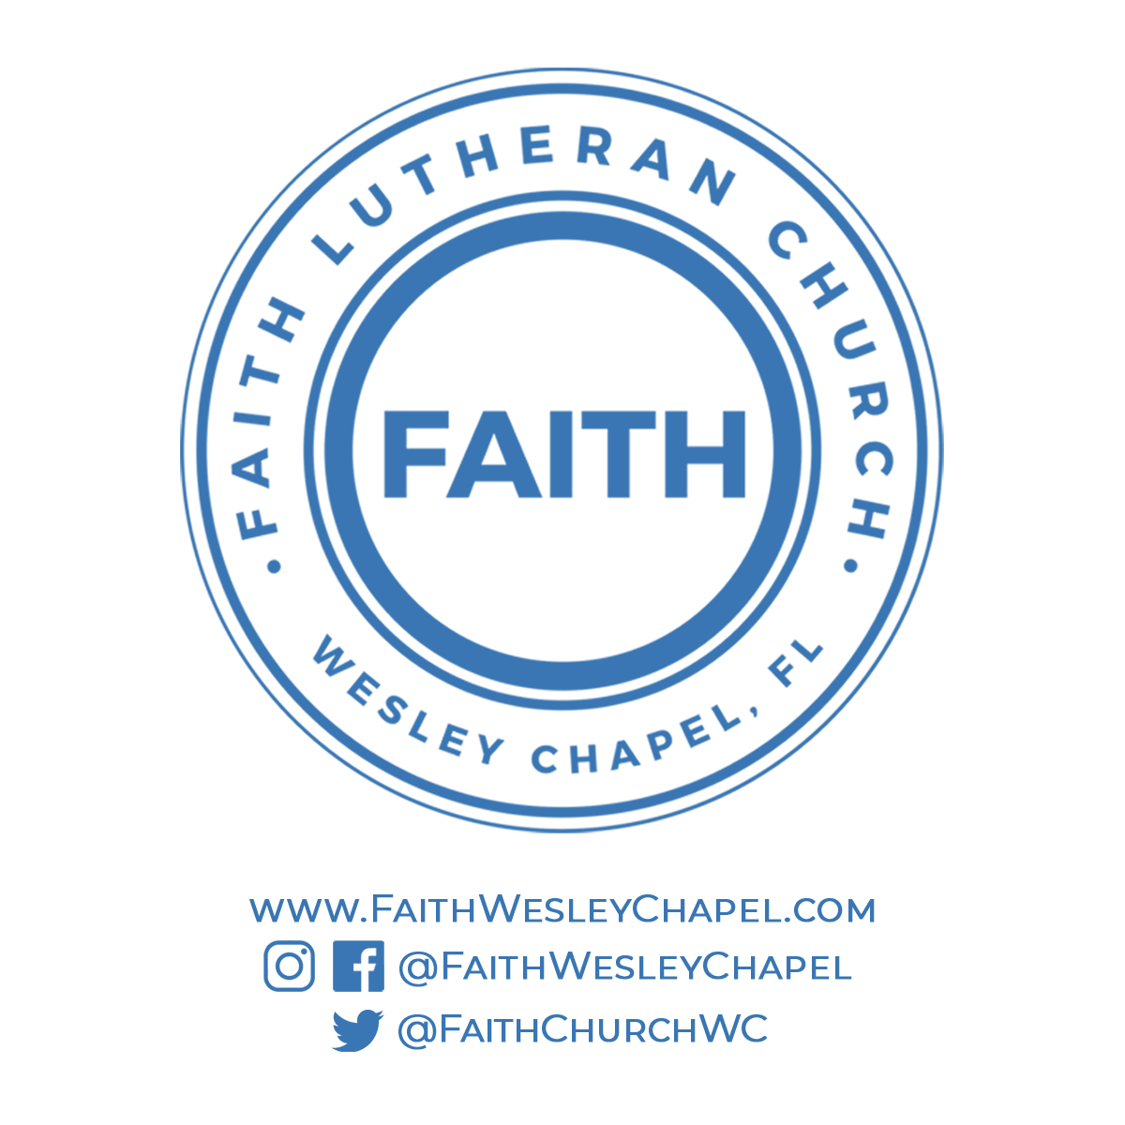**@FaithWesleyChapel**

**@FaithWesleyChapel**

**@FaithChurchWC**