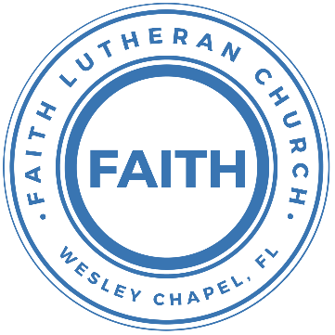

**Leading our community into a deep connection in Christ**

**Worship Service for June 2, 2023 at 11 AM**

**Welcome**

**Opening Song:**Father Abraham

Father Abraham had many sons. Many sons had Father Abraham.

I am one of them and so are you. So, let's just praise the Lord!

Right arm  
Left arm  
Right foot  
Left foot  
Chin up  
Turn around  
Sit down © Public Domain

**Invocation**

**Confession and Forgiveness:**

**P:** We have come here today to worship the Lord.  In worship we hear the Word of God, we receive God's blessings, and respond with thanks and praise.  We begin by seeking God's blessing of forgiveness.  He has promised to remove the guilt and shame of our sin through the sacrifice of Jesus Christ on the cross.

*(a time of silence to reflect and personally confess our sins)*

**P:** Let us confess our sins to the Lord.

**P:** Heavenly Father,  
**C:** Heavenly Father,

**P:** I have done things that were wrong.  
**C:** I have done things that were wrong.  
  
**P:** I have been mean to others.  
**C:** I have been mean to others.

**P:** I have not obeyed my parents.  
**C:** I have not obeyed my parents.

**P:** I have not obeyed You, God.  
**C:** I have not obeyed You, God.

**P:** But I am very sorry.  
**C:** But I am very sorry.

**P:** Please forgive me.  
**C:** Please forgive me.

**P:** I love You very much.  
**C:** I love You very much.

**P:** And I know You love me, too.  
**C:** And I know You love me, too.

**P:** Amen.  
**C:** Amen.

**P:** God has heard your apology.  He loves you very much.  God has told us that when we believe and trust in Him, He makes us His children.  As far as the east is from the west, so far does he remove our sins from us. He has told me to tell you that you are forgiven.  So, as His servant, I forgive you in the name of the Father and of the Son and of the Holy Spirit.   
**C:** Amen.

**Song:**God Is So Good

God is so good. God is so good.  
God is so good. He's so good to me.

He died for me. He died for me so.  
He died for me. He's so good to me.

He loves me so. He loves me so.  
He loves me so. He's so good to me. © Public Domain

**First Reading -**Romans 7:1

I am speaking to those who know the law.

**Reader:** This is the Word of the Lord.  
**C:** Thanks be to God.

**Children's Message**"What Do We Mean By, ‘The Law’"

**Song:**Children Of The Heavenly Father

Verse 1:

Children of the Heavenly Father safely in His bosom gather.

Nestling bird nor star in heaven such a refuge e’er was given.

Verse 2:

God His own doth tend and nourish.  
In His holy courts they flourish.

From all evil things He spares them.  
In His mighty arms He bears them.

Chorus:

Precious children, You have called us. Making us heirs with Your Son.

“Abba Father”, now we call You. In Your presence, now we come.

Verse 3:

Neither life nor death shall ever from the Lord His children sever.

Unto them His grace He showeth,  
And their sorrows all He knoweth.

*(Chorus)*

Verse 4:

Though he giveth or He taketh, God His children ne’er forsaketh;

His the loving purpose solely to preserve them pure and holy.

© Public Domain

**Second Reading -**Romans 7:6

In the past the law held us as prisoners, but our old selves died, and we were made free from the law. So now we serve God in a new way, not in the old way, with the written rules. Now we serve God in the new way, with the Spirit.

**Reader:** This is the Word of the Lord.  
**C:** Thanks be to God.

**Children's Message**"Do I Have To?"

**Gospel Reading -**Matthew 10:34-42

“Do not think that I have come to bring peace to the earth. I have not come to bring peace, but a sword. For I have come to set a man against his father, and a daughter against her mother, and a daughter-in-law against her mother-in-law. And a person's enemies will be those of his own household. Whoever loves father or mother more than me is not worthy of me, and whoever loves son or daughter more than me is not worthy of me. And whoever does not take his cross and follow me is not worthy of me. Whoever finds his life will lose it, and whoever loses his life for my sake will find it.

“Whoever receives you receives me, and whoever receives me receives him who sent me. The one who receives a prophet because he is a prophet will receive a prophet's reward, and the one who receives a righteous person because he is a righteous person will receive a righteous person's reward. And whoever gives one of these little ones even a cup of cold water because he is a disciple, truly, I say to you, he will by no means lose his reward.”

**P:** This is the Gospel of the Lord.  
**C:** Praise be to You, o Christ.

**Sermon Hymn** Your Grace Is Enough

Great is Your faithfulness oh God.  
You wrestle with the sinner's restless heart.  
You lead us by still waters into mercy,  
And nothing can keep us apart.

Pre-chorus:  
So, remember Your people. Remember Your children.  
Remember Your promise, Oh God.

Chorus:  
Your grace is enough. Your grace is enough.  
Your grace is enough for me.

Great is Your love and justice God of Jacob.  
You use the weak to lead the strong.  
You lead us in the song of Your salvation,  
And all Your people sing along.

*(Pre-chorus)*

*(Chorus 2x)* © 2003 spiritandsong.com and Thankyou Music

**Sermon –**“The Role of the Law in the Life of the Christian”

Romans 7:1-6

Or do you not know, brothers—for I am speaking to those who know the law—that the law is binding on a person only as long as he lives? For a married woman is bound by law to her husband while he lives, but if her husband dies she is released from the law of marriage. Accordingly, she will be called an adulteress if she lives with another man while her husband is alive. But if her husband dies, she is free from that law, and if she marries another man she is not an adulteress.

Likewise, my brothers, you also have died to the law through the body of Christ, so that you may belong to another, to him who has been raised from the dead, in order that we may bear fruit for God. For while we were living in the flesh, our sinful passions, aroused by the law, were at work in our members to bear fruit for death. But now we are released from the law, having died to that which held us captive, so that we serve in the new way of the Spirit and not in the old way of the written code.

**Prayers:** *Text in prayer requests to (813) 326-5255‬*

**The Lord's Prayer**

Our Father who art in heaven, hallowed be Thy name, Thy kingdom come, Thy will be done on earth as it is in heaven.  Give us this day our daily bread; and forgive us our trespasses as we forgive those who trespass against us; and lead us not into temptation, but deliver us from evil.  For Thine is the kingdom and the power and the glory forever and ever.  Amen

**Offering**

**Benediction**

**The online service ends** *while the in-person service continues with Communion.*

*Please scroll down on the online bulletin page for a YouTube video of the closing song.*

*Note: Communion is celebrated every week in-person*

**Closing Song:**Joy of the Lord

Though the tears may fall my song will rise,  
My song will rise to You.  
Though my heart may fail my song will rise,   
My song will rise to You.  
While there's breath in my lungs, I will praise You Lord!  
In the dead of night I’ll lift my eyes, I’ll lift my eyes to You.  
Though the waters rise I’ll lift my eyes, I’ll lift my eyes to You.  
While there's hope in this heart, I will praise You Lord!

Chorus:

The joy of the Lord is my strength.  
The joy of the Lord is my strength.

In the darkness I’ll dance. In the shadows I’ll sing.

The joy of the Lord is my strength!

Verse 2:

When I cannot see You with my eyes, let faith arise to You.

When I cannot feel Your hand in mine, let faith arise to You.

God of mercy and love, I will praise You Lord!

How You shine with glory Lord of light, I feel alive with You.

In Your presence now I come alive, I am alive with You.

There is strength when I say "I will praise You Lord!"

*(Chorus)*

When sorrow comes my way, You are the shield around me.

Always You remain my courage in the fight.

I hear You call my name. Jesus I am coming,

Walking on the waves, reaching for Your light.

*(Chorus)*

© Thankyou Music (Admin. by Capitol CMG Publishing) and Alletrop Music (Admin. by Music Services, Inc.)

|  |  |
| --- | --- |
| **Serving This Week** | |
|  | |
| **1st Reader:** Kaylee Steinbrueck | **Children’s Church Teacher:** |
| **2nd Reader:** Emily Shuck | N/A – Youth Service |
| **Acolyte:** Katelyn Shuck | **Children’s Church Assistant:** |
| **Com. Asst:** Larry Chmiel | N/A – Youth Service |
|  | |
| **Serving Next Week** | |
|  | |
| **O.T Reader:** N/A | **Children’s Church Teacher:** |
| **2nd Reader:** N/A | Melissa Steinbrueck |
| **Acolyte:** Kaylee Steinbrueck | **Children’s Church Assistant:** |
| **Com. Asst:** Larry Chmiel | Kaylee Steinbrueck |

**Hey Youth!!**Do you know any worship songs you’d like to sing as part of our youth service? Let Pastor Kurt know.

Do you want to sing or play an instrument? Let Pastor Kurt know.

We want you to be a part of the service.

**Upcoming Events**

**July 17-19 – Summer Mission Trip**  
Metropolitan Ministries

**August 5, 10 AM - 7 PM – End of the Summer Water Park Trip**  
Adventure Island

**www.FaithWesleyChapel.com**

**Faith YouTube**

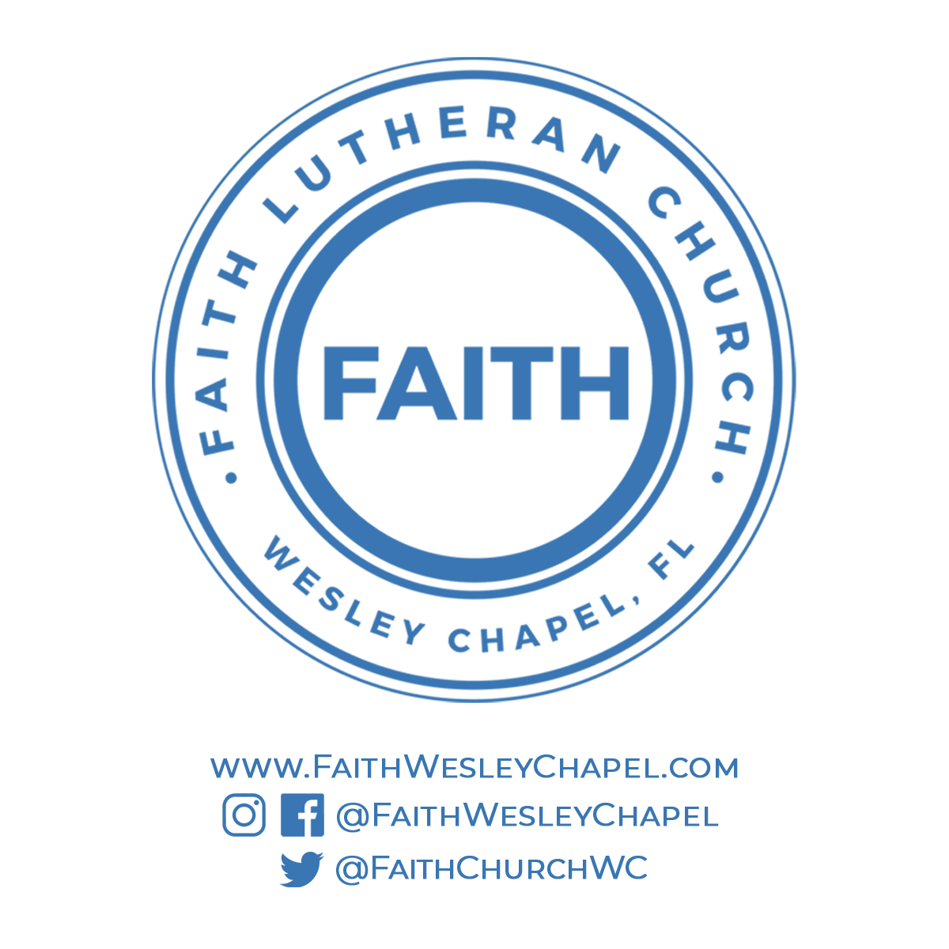**@FaithWesleyChapel**

**@FaithWesleyChapel**

**@FaithChurchWC**