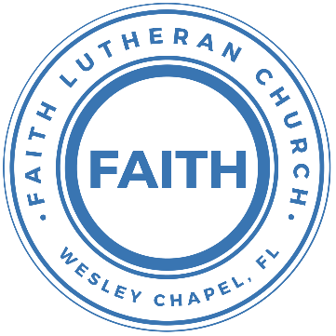

**Leading our community into a deep connection in Christ**

**Worship Service for July 9, 2023, at 11 AM**

**Welcome**

**Invocation**

**Confession and Forgiveness:**

**P:** As we gather, today, let us cleanse our hearts and our consciences by confessing our sin to God.

*(Time of silence for reflection and confession)*

**C:** Heavenly Father, we confess that we are sinful and unclean. We have sinned against you and against our neighbor in our thoughts, words, and actions.  We are truly sorry for our sins and sincerely repent of them. We ask for Your mercy. For the sake of Jesus Christ's bitter suffering and death, please forgive us and renew us that we may walk in Your Spirit to the glory of Your holy name. Amen

**P:** The Lord has heard your confession. Therefore, as a called and ordained servant of the Lord, in the stead and by the command of my Lord, Jesus Christ, I forgive you all your sins in the name of the Father and of the Son and of the Holy Spirit.  
**C:** Amen

**Songs of Praise and Thanksgiving – Rock of Ages**

Rock of Ages, cleft for me, let me hide myself in Thee;  
Let the water and the blood,  
From thy wounded side which flowed,  
Be of sin the double cure; cleanse me from its guilt and power.

Not the labors of my hands can fulfill Thy law's demands;  
Could my zeal no respite know,  
Could my tears forever flow,  
All for sin could not atone; Thou must save, and Thou alone.

Nothing in my hand I bring, simply to Thy cross I cling;  
Naked, come to Thee for dress;  
Helpless, look to Thee for grace;  
Foul, I to the fountain fly; wash me, Savior, or I die.

While I draw this fleeting breath,  
When mine eyelids close in death,  
When I soar to worlds unknown,  
See Thee on thy judgment throne,  
Rock of Ages, cleft for me, let me hide myself in Thee; © Public Domain

**Gospel Reading** - Matthew 11:25-30

At that time Jesus declared, “I thank you, Father, Lord of heaven and earth, that you have hidden these things from the wise and understanding and revealed them to little children; yes, Father, for such was your gracious will. All things have been handed over to me by my Father, and no one knows the Son except the Father, and no one knows the Father except the Son and anyone to whom the Son chooses to reveal him. Come to me, all who labor and are heavy laden, and I will give you rest. Take my yoke upon you, and learn from me, for I am gentle and lowly in heart, and you will find rest for your souls. For my yoke is easy, and my burden is light.”

**P:** This is the Gospel of the Lord.  
**C:** Praise be to You, o Christ.

**Sermon Song –** Cornerstone

My hope is built on nothing less,   
Than Jesus' blood and righteousness.  
I dare not trust the sweetest frame,   
But wholly trust in Jesus' name.

Chorus:

Christ alone, Cornerstone, Weak made strong in the Savior's love.

Through the storm He is Lord, Lord of all.

Verse 2:

When darkness seems to hide His face,

I rest on His unchanging grace.

In every high and stormy gale My anchor holds within the veil.

My anchor holds within the veil.

*(Chorus)*

He is Lord. Lord of all.

Verse 3:

When He shall come with trumpet sound,

Oh, may I then in Him be found,

Dressed in His righteousness alone,

Faultless, stand before the throne.

*(Chorus)*  © 2011 Hillsong Music Publishing

**Sermon** – The Conflicted Life of the Christian

Romans 7:14-25

**14**For we know that the law is spiritual, but I am of the flesh, sold under sin. **15**For I do not understand my own actions. For I do not do what I want, but I do the very thing I hate. **16**Now if I do what I do not want, I agree with the law, that it is good. **17**So now it is no longer I who do it, but sin that dwells within me. **18**For I know that nothing good dwells in me, that is, in my flesh. For I have the desire to do what is right, but not the ability to carry it out. **19**For I do not do the good I want, but the evil I do not want is what I keep on doing. **20**Now if I do what I do not want, it is no longer I who do it, but sin that dwells within me.

**21**So I find it to be a law that when I want to do right, evil lies close at hand. **22**For I delight in the law of God, in my inner being, **23**but I see in my members another law waging war against the law of my mind and making me captive to the law of sin that dwells in my members. **24**Wretched man that I am! Who will deliver me from this body of death? **25**Thanks be to God through Jesus Christ our Lord! So then, I myself serve the law of God with my mind, but with my flesh I serve the law of sin.

**P:** This is the Word of the Lord.  
**C:** Thanks be to God.

**Prayers**

**Apostles' Creed**

I believe in God, the Father almighty, maker of heaven and earth,  
And in Jesus Christ, his only Son, our Lord,  
who was conceived by the Holy Spirit,  
born of the Virgin Mary, suffered under Pontius Pilate,  
was crucified, died and was buried. He descended into hell.  
The third day he rose again from the dead.  
He ascended into heaven and sits at the right hand of God  
the Father almighty.  
From there he will come to judge the living and the dead.  
I believe in the Holy Spirit, the holy Christian Church,  
the communion of saints, the forgiveness of sins,  
the resurrection of the body, and the life everlasting. Amen.

**The Lord's Prayer**

Our Father who art in heaven, hallowed be Thy name, Thy kingdom come, Thy will be done on earth as it is in heaven.  Give us this day our daily bread; and forgive us our trespasses as we forgive those who trespass against us; and lead us not into temptation, but deliver us from evil.  For Thine is the kingdom and the power and the glory forever and ever.  Amen

**Offering**

**Benediction**

**Closing Song:** Praise God From Whom All Blessings Flow

Praise God from Whom all blessings flow.  
Praise Him all creatures here below.  
Praise Him above, ye heavenly hosts.  
Praise Father, Son and Holy Ghost.  
Amen © Public Domain

|  |  |
| --- | --- |
| **Serving This Week** | |
|  | |
| **O.T Reader:** N/A | **Children’s Church Teacher:** |
| **2nd Reader:** N/A | Melissa Steinbrueck |
| **Acolyte:** Kaylee Steinbrueck | **Children’s Church Assistant:** |
| **Com. Asst:** Larry Chmiel | Kaylee Steinbrueck |
|  | |
| **Serving Next Week** | |
|  | |
| **O.T Reader:** Vanessa Frost | **Children’s Church Teacher:** |
| **2nd Reader:** N/A | Terrell Jordan |
| **Acolyte:** Katelyn Shuck | **Children’s Church Assistant:** |
| **Com. Asst:** Larry Chmiel | TBD |

**Upcoming Events**

**July 17-19 – Summer Mission Trip**  
Metropolitan Ministries

**August 5, 10 AM - 7 PM – End of the Summer Water Park Trip**  
Adventure Island

**--------------------------- Faith’s Financial Update ---------------------------**

July’s Budgeted Expenses: $6,425  
July’s Total General Fund Gifts and Offerings to Date: $437.00

[**www.FaithWesleyChapel.com**](http://www.FaithWesleyChapel.com)

 **Faith YouTube**

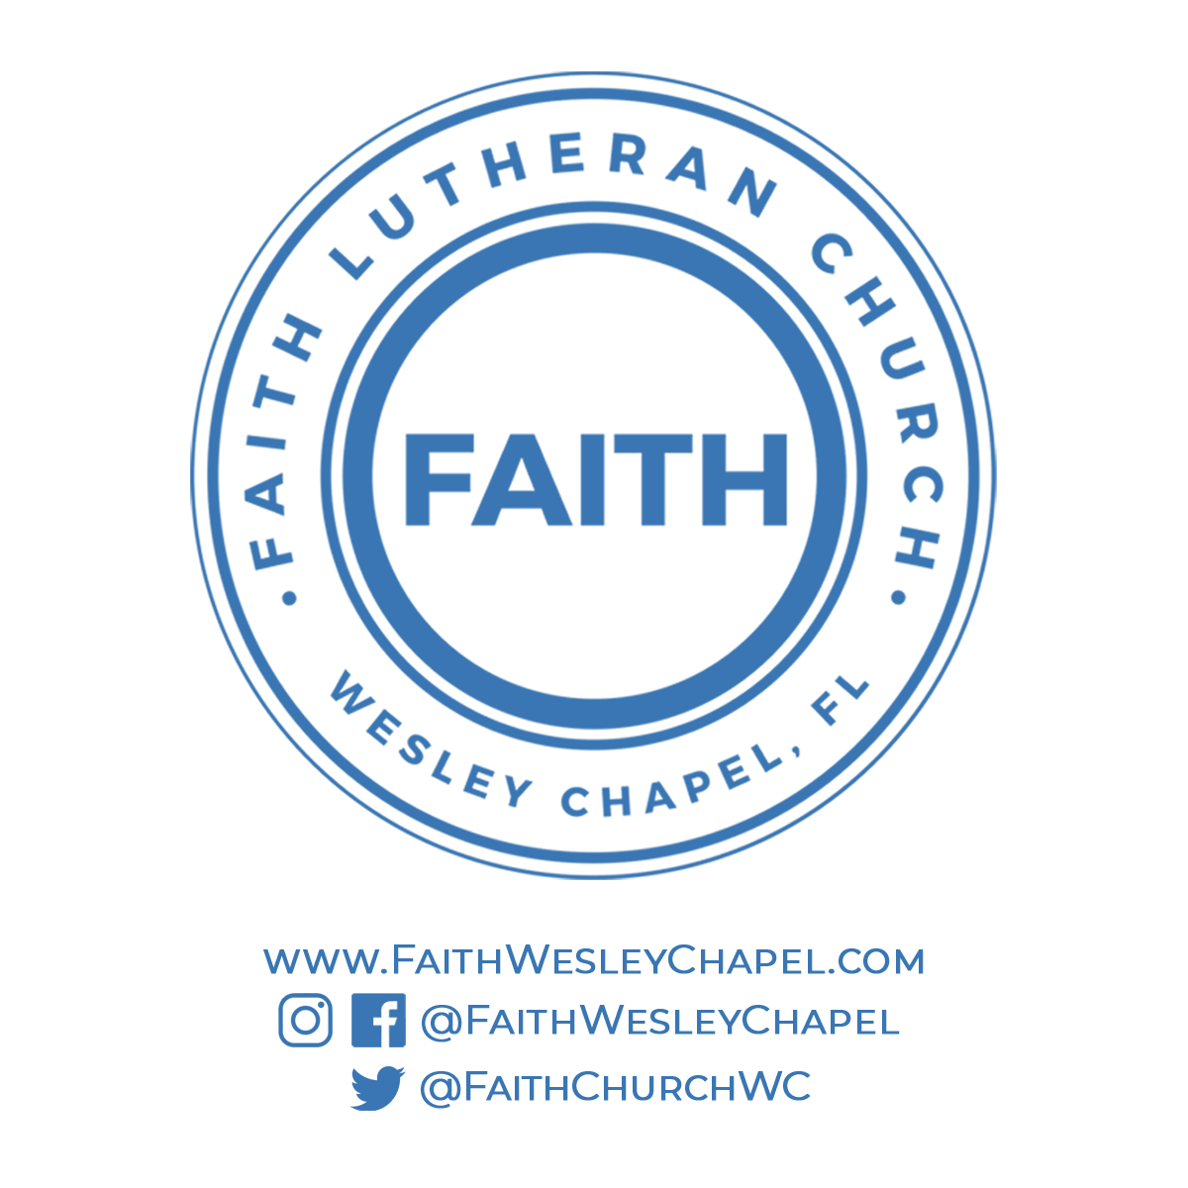**@FaithWesleyChapel**

**@FaithWesleyChapel**

**@FaithChurchWC**