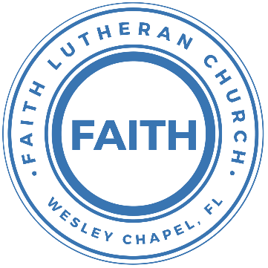

**Leading our community into a deep connection in Christ**

**Worship Service for July 16, 2023, at 11 AM**

**Welcome**

**Opening Song -** By Grace I'm Saved

By grace I'm saved, grace free and boundless.  
My soul, believe and doubt it not.  
Why stagger at this word of promise?  
Has Scripture ever falsehood taught?  
No! Then this word must true remain;  
By grace you too will life obtain.

By grace God's Son, our only Savior,

Came down to earth to bear our sin.

Was it because of your own merit,

That Jesus died your soul to win?

No, it was grace, and grace alone,

That brought Him from His heav'nly throne.

By grace! On this I'll rest when dying.

In Jesus' promise I rejoice!

For though I know my heart's condition,

I also know my Savior's voice.

My heart is glad, all grief has flown,

Since I am saved by grace alone. © Public Domain

**Invocation**

**Confession and Forgiveness:**

**P:** Our Heavenly Father asks us to come into His presence.  
**C:** But we are sinful and unworthy.

**P:** Yes, all have sinned and fall short of the glory of God, but Jesus Christ died on the cross that we may be forgiven and washed clean of all our sins by His blood spilled on the cross.  
**C:** Lord, if You wash us, we will certainly be clean and pure.

**P:** We take a moment to bow before the His cross and silently reflect on our lives and confess our sins.

*(Time of silence for reflection and confession)*

**P:** Let us confess, together, our sins to God our Father.  
**C:** Heavenly Father, we confess that we are sinners.  We have sinned against you and our neighbors. We have not loved you with our whole heart and we have not loved our neighbors as ourselves. We have not lived out our faith in our community. We justly deserve Your punishment.  For the sake of Your Son, Jesus Christ, have mercy on us.  Forgive us, renew us, and lead us, so that we may delight in Your will and walk in Your ways to the glory of Your holy name.  Amen.

**Words of Forgiveness**  
**C:** Amen

**Song of Praise:** Amazing Grace (My Chains Are Gone)

Amazing grace how sweet the sound That saved a wretch like me

I once was lost, but now I'm found Was blind but now I see

’Twas grace that taught my heart to fear,  
And grace my fears relieved;

How precious did that grace appear, The hour I first believed!

Chorus:

My chains are gone, I've been set free.

My God, My Savior has ransomed me.

And like a flood his mercy reigns. Unending love, amazing grace

The Lord has promised good to me, His word my hope secures;

He will my shield and portion be, As long as life endures.

*(Chorus x 2)*

The earth shall soon dissolve like snow, The sun forbear to shine;

But God, who call’d me here below, Will be forever mine...

Will be forever mine... You are forever mine. © 2006 Vamos Publishing

**Old Testament Reading -**Isaiah 55:10-13

“For as the rain and the snow come down from heaven and do not return there but water the earth, making it bring forth and sprout, giving seed to the sower and bread to the eater, so shall my word be that goes out from my mouth; it shall not return to me empty, but it shall accomplish that which I purpose, and shall succeed in the thing for which I sent it.

“For you shall go out in joy and be led forth in peace; the mountains and the hills before you shall break forth into singing, and all the trees of the field shall clap their hands. Instead of the thorn shall come up the cypress; instead of the brier shall come up the myrtle; and it shall make a name for the Lord, an everlasting sign that shall not be cut off.”

**Reader:** This is the Word of the Lord. **C:** Thanks be to God.

**Gospel Reading** - Matthew 13:1-9, 18–23

That same day Jesus went out of the house and sat beside the sea. And great crowds gathered about him, so that he got into a boat and sat down. And the whole crowd stood on the beach. And he told them many things in parables, saying: “A sower went out to sow. And as he sowed, some seeds fell along the path, and the birds came and devoured them. Other seeds fell on rocky ground, where they did not have much soil, and immediately they sprang up, since they had no depth of soil, but when the sun rose they were scorched. And since they had no root, they withered away. Other seeds fell among thorns, and the thorns grew up and choked them. Other seeds fell on good soil and produced grain, some a hundredfold, some sixty, some thirty. He who has ears, let him hear.”...

...“Hear then the parable of the sower: When anyone hears the word of the kingdom and does not understand it, the evil one comes and snatches away what has been sown in his heart. This is what was sown along the path. As for what was sown on rocky ground, this is the one who hears the word and immediately receives it with joy, yet he has no root in himself, but endures for a while, and when tribulation or persecution arises on account of the word, immediately he falls away. As for what was sown among thorns, this is the one who hears the word, but the cares of the world and the deceitfulness of riches choke the word, and it proves unfruitful. As for what was sown on good soil, this is the one who hears the word and understands it. He indeed bears fruit and yields, in one case a hundredfold, in another sixty, and in another thirty.”

**P:** This is the Gospel of the Lord. **C:** Praise be to You, o Christ.

**Children's Message** *(Children dismissed to Children's Church)*

**Sermon Hymn***–*In Christ Alone

In Christ alone my hope is found.   
He is my light, my strength, my song.  
This Cornerstone, this solid ground,  
Firm through the fiercest drought and storm.  
What heights of love, what depths of peace,  
When fears are stilled, when strivings cease.  
My Comforter, my All in All. Here in the love of Christ I stand.

In Christ alone, who took on flesh,   
Fullness of God in helpless babe.  
This gift of love and righteousness,   
Scorned by the ones He came to save.  
‘Til on that cross as Jesus died,   
The wrath of God was satisfied.  
For every sin on Him was laid, Here in the death of Christ I live.

There in the ground His body lay,   
Light of the world by darkness slain.  
Then bursting forth in glorious Day,   
Up from the grave He rose again.  
And as He stands in victory,   
Sin’s curse has lost its grip on me.  
For I am His and He is mine,   
Bought with the precious blood of Christ.

No guilt in life, no fear in death,   
This is the power of Christ in me.  
From life’s first cry to final breath,   
Jesus commands my destiny.  
No power of hell, no scheme of man,   
Can ever pluck me from His hand.  
‘Til He returns or calls me home,   
Here in the power of Christ I’ll stand.  
No power of hell, no scheme of man,   
Can ever pluck me from His hand.  
‘Til He returns or calls me home,   
Here in the power of Christ I’ll stand. © 2001 Thankyou Music

**Sermon** - "Don’t Look to Your Obedience"

Romans 8:12-17  
So then, brothers, we are debtors, not to the flesh, to live according to the flesh. For if you live according to the flesh you will die, but if by the Spirit you put to death the deeds of the body, you will live. For all who are led by the Spirit of God are sons of God. For you did not receive the spirit of slavery to fall back into fear, but you have received the Spirit of adoption as sons, by whom we cry, “Abba! Father!” The Spirit himself bears witness with our spirit that we are children of God, and if children, then heirs—heirs of God and fellow heirs with Christ, provided we suffer with him in order that we may also be glorified with him.

**P:** This is the Word of the Lord. **C:** Thanks be to God.

**Installation of the Church Treasurer**

**Prayers:** *Text in prayer requests to (813) 326-5255*

**Nicene Creed**

I believe in one God, the Father Almighty, maker of heaven and earth and of all things visible and invisible.

And in one Lord Jesus Christ, the only-begotten Son of God, begotten of His Father before all worlds, God of God, Light of Light, very God of very God, begotten, not made, being of one substance with the Father, by whom all things were made; who for us men and for our salvation came down from heaven and was incarnate by the Holy Spirit of the virgin Mary and was made man; and was crucified also for us under Pontius Pilate. He suffered and was buried. And the third day He rose again according to the Scriptures and ascended into heaven and sits at the right hand of the Father. And He will come again with glory to judge both the living and the dead, whose kingdom will have no end.

And I believe in the Holy Spirit, the Lord and Giver of Life, who proceeds from the Father and the Son, who with the Father and the Son together is worshiped and glorified, who spoke by the prophets. And I believe in one holy Christian and apostolic Church, I acknowledge one Baptism for the remission of sins, and I look for the resurrection of the dead and the life of the world to come. Amen.

**The Lord's Prayer**

Our Father who art in heaven, hallowed be Thy name, Thy kingdom come, Thy will be done on earth as it is in heaven.  Give us this day our daily bread; and forgive us our trespasses as we forgive those who trespass against us; and lead us not into temptation, but deliver us from evil.  For Thine is the kingdom and the power and the glory forever and ever.  Amen

**Offering**

**Words of Institution**

**Peace**

**P:** The peace of the Lord be with you all.  
**C:** And also, with you.

**Distribution**

**Prayer**

**Benediction**

**Closing Song:**This Is Amazing Grace

Who breaks the power of sin and darkness

Whose love is mighty and so much stronger

The King of Glory, the King above all kings

Who shakes the whole earth with holy thunder

Who leaves us breathless in awe and wonder

The King of Glory, the King above all kings

Chorus:

This is amazing grace. This is unfailing love

That You would take my place. That You would bear my cross

You would lay down Your life, that I would be set free

Jesus, I sing for all that You've done for me

Who brings our chaos back into order

Who makes the orphan a son and daughter

The King of Glory, The King of Glory

Who rules the nations with truth and justice

Shines like the sun in all of its brilliance

The King of Glory, the King above all kings

*(Chorus)*

Bridge:

Worthy is the Lamb who was slain

Worthy is the King who conquered the grave

*(Repeat 2x)*

Worthy is the Lamb who was slain. Worthy! Worthy! Worthy!

*(Chorus) © 2012 Bethel Music, Seems Like Music, Sing My Songs, Phil Wickham Music, and Warner Chappell Music*

|  |  |
| --- | --- |
| **Serving This Week** | |
|  | |
| **O.T Reader:** Vanessa Frost | **Children’s Church Teacher:** |
| **2nd Reader:** N/A | Melissa Steinbrueck |
| **Acolyte:** Katelyn Shuck | **Children’s Church Assistant:** |
| **Com. Asst:** Larry Chmiel | TBD |
|  | |
| **Serving Next Week** | |
|  | |
| **O.T Reader:** Vanessa Frost | **Children’s Church Teacher:** |
| **Epistle Reader:** Terrell Jordan | Halston and Ben |
| **Acolyte:** Griffin Frost | **Children’s Church Assistant:** |
| **Com. Asst:** Larry Chmiel | N/A |

**Upcoming Events**

**July 17-19 – Summer Mission Trip**  
Metropolitan Ministries

**August 5, 10 AM - 7 PM – End of the Summer Water Park Trip**  
Adventure Island

**August 6, 11 AM – School Supplies for Those in Need**  
Faith Lutheran Church

[**www.FaithWesleyChapel.com**](http://www.FaithWesleyChapel.com)

 **Faith YouTube**

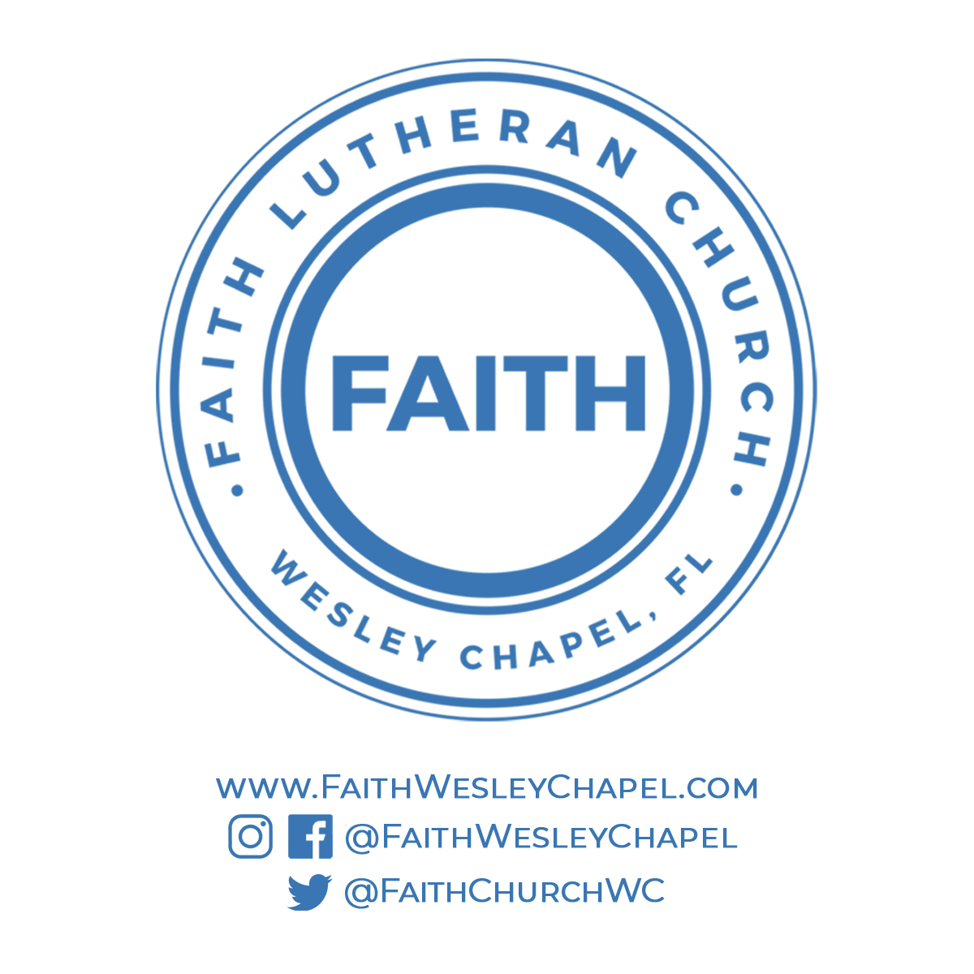**@FaithWesleyChapel**

**@FaithWesleyChapel**

**@FaithChurchWC**