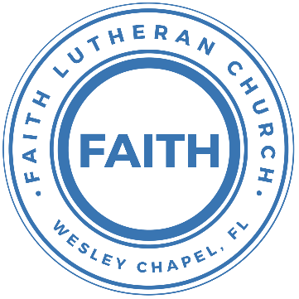

**Leading our community into a deep connection in Christ**

**Worship Service for July 30, 2023, at 11 AM**

**Welcome**

**Opening Song:**The Wonderful Cross

When I survey the wondrous cross, on which the prince of glory died,

My richest gain I count but loss, and pour contempt on all my pride.

Forbid it, Lord, that I should boast, save in the death of Christ my God.

All the vain things that charm me most, I sacrifice them to His blood.

Chorus:

O the wonderful cross, O the wonderful cross,

Bids me come and die and find that I may truly live.

O the wonderful cross, O the wonderful cross,

All who gather here by grace draw near and bless Your name.

See from his head, His hands, His feet,

Sorrow and love flow mingled down.

Did e’er such love and sorrow meet, or thorns compose so rich a crown.

*(Chorus)*

Were the whole realm of nature mine, that were a present far too small

Love so amazing so divine, demands my soul, my life, my all.

*(Chorus)*

© 2000 worshiptogether.com Songs (ASCAP)/sixsteps Music (ASCAP) (both admin. by EMI CMG PUblishing)

**Invocation**

**Confession and Forgiveness:**

**P:** Come into the presence of God. It is God, Himself, who bids us to come to Him in prayer, especially when we have sinned, so that we may receive His forgiveness. So, we enter His courts with confidence that if we confess our sins, He will forgive us as He promised.

*(A time of silence to reflect and personally confess our sins)*

**C:** Heavenly Father, we confess that we have sinned against you in thought, word, and deed. We have not loved you with our whole heart and have not loved our neighbor as ourselves. We are truly sorry and we humbly repent. For the sake of your Son Jesus Christ and His suffering and death on the cross, have mercy on us and forgive us; that we may delight in your will, and walk in your ways, to the glory of your Name. Amen

**P:** The Lord our God is merciful and gracious, longsuffering, and abounding in goodness and truth, keeping mercy for thousands, forgiving iniquity and transgression and sin. Therefore I announce unto you the grace of our Lord Jesus Christ. In His stead and by the command of my Lord Jesus Christ, I forgive you all your sins in the name of the Father and of the Son and of the Holy Spirit.

**C:** Amen.

**Song of Praise and Thanksgiving -** Living Hope

How great the chasm that lay between us.

How high the mountain I could not climb.

In desperation, I turned to heaven,  
And spoke Your name into the night.

Then through the darkness Your loving kindness,

Tore through the shadows of my soul.

The work is finished, the end is written,  
Jesus Christ, my Living Hope.

Who could imagine so great a mercy.

What heart could fathom such boundless grace.

The God of ages stepped down from glory,  
To wear my sin and bear my shame.

The cross has spoken. I am forgiven.

The King of Kings calls me His own.

Beautiful Savior I’m Yours forever,

Jesus Christ, my Living Hope.

Chorus:

Hallelujah, praise the one who set me free!

Hallelujah, death has lost its grip on me!

You have broken every chain. There’s salvation in Your Name,

Jesus Christ, my Living Hope.

Then came the morning that sealed the promise,

Your buried body began to breathe.

Out of the silence the roaring Lion,

Declared the grave has no claim on me.

*(Repeat)*

Jesus, Yours is the victory!

Chorus: (2x)

Hallelujah, praise the one who set me free!

Hallelujah, death has lost its grip on me!

You have broken every chain. There’s salvation in Your Name,

Jesus Christ, my Living Hope. © Bethel Music Publishing and Remaining portion is unaffiliated

**Old Testament Reading -** Deuteronomy 7:6-9

“For you are a people holy to the Lord your God. The Lord your God has chosen you to be a people for his treasured possession, out of all the peoples who are on the face of the earth. It was not because you were more in number than any other people that the Lord set his love on you and chose you, for you were the fewest of all peoples, but it is because the Lord loves you and is keeping the oath that he swore to your fathers, that the Lord has brought you out with a mighty hand and redeemed you from the house of slavery, from the hand of Pharaoh king of Egypt. Know therefore that the Lord your God is God, the faithful God who keeps covenant and steadfast love with those who love him and keep his commandments, to a thousand generations,

**Reader:** This is the Word of the Lord.  
**C:** Thanks be to God.

**Epistle Reading -** Romans 8:28-39

And we know that for those who love God all things work together for good, for those who are called according to his purpose. For those whom he foreknew he also predestined to be conformed to the image of his Son, in order that he might be the firstborn among many brothers. And those whom he predestined he also called, and those whom he called he also justified, and those whom he justified he also glorified.

What then shall we say to these things? If God is for us, who can be against us? He who did not spare his own Son but gave him up for us all, how will he not also with him graciously give us all things? Who shall bring any charge against God's elect? It is God who justifies. Who is to condemn? Christ Jesus is the one who died—more than that, who was raised—who is at the right hand of God, who indeed is interceding for us. Who shall separate us from the love of Christ? Shall tribulation, or distress, or persecution, or famine, or nakedness, or danger, or sword? As it is written,

“For your sake we are being killed all the day long;  
 we are regarded as sheep to be slaughtered.”

No, in all these things we are more than conquerors through him who loved us. For I am sure that neither death nor life, nor angels nor rulers, nor things present nor things to come, nor powers, nor height nor depth, nor anything else in all creation, will be able to separate us from the love of God in Christ Jesus our Lord.

**Reader:** This is the Word of the Lord.  
**C:** Thanks be to God.

**Gospel Reading -** Matthew 13:44-52

“The kingdom of heaven is like treasure hidden in a field, which a man found and covered up. Then in his joy he goes and sells all that he has and buys that field.

“Again, the kingdom of heaven is like a merchant in search of fine pearls, who, on finding one pearl of great value, went and sold all that he had and bought it.

“Again, the kingdom of heaven is like a net that was thrown into the sea and gathered fish of every kind. When it was full, men drew it ashore and sat down and sorted the good into containers but threw away the bad. So it will be at the end of the age. The angels will come out and separate the evil from the righteous and throw them into the fiery furnace. In that place there will be weeping and gnashing of teeth.

“Have you understood all these things?” They said to him, “Yes.” And he said to them, “Therefore every scribe who has been trained for the kingdom of heaven is like a master of a house, who brings out of his treasure what is new and what is old.”

**P:** This is the Gospel of the Lord.  
**C:** Praise be to You, o Christ.

**Children's Message** *(Children dismissed to Children's Church)*

**Sermon Hymn -** Mighty To Save

Everyone needs compassion, a Love that's never failing.

Let mercy fall on me.

Everyone needs forgiveness, the kindness of a savior.

The hope of nations

Chorus:

Savior, He can move the mountains.

My God is mighty to save. He is mighty to save.

Forever, author of salvation,

He rose and conquered the grave. Jesus conquered the grave.

So take me as you find me, all my fears and failures,

And fill my life again.

I give my life to follow everything I believe in.

Now I surrender. (I surrender)

Chorus:

Savior, He can move the mountains.

My God is mighty to save. He is mighty to save.

Forever, author of salvation,

He rose and conquered the grave. Jesus conquered the grave.

Bridge:

Shine your light and let the whole world see singing,

For the glory of the risen king, Jesus.

Shine your light and let the whole world see singing,

For the glory of the risen king

*(Chorus 2x)* © 2006 Hillsong Publishing

**Sermon -** "Insider Information"

**Prayer of the Church**

**Nicene Creed**

I believe in one God, the Father Almighty, maker of heaven and earth and of all things visible and invisible.

And in one Lord Jesus Christ, the only-begotten Son of God, begotten of His Father before all worlds, God of God, Light of Light, very God of very God, begotten, not made, being of one substance with the Father, by whom all things were made; who for us men and for our salvation came down from heaven and was incarnate by the Holy Spirit of the virgin Mary and was made man; and was crucified also for us under Pontius Pilate. He suffered and was buried. And the third day He rose again according to the Scriptures and ascended into heaven and sits at the right hand of the Father. And He will come again with glory to judge both the living and the dead, whose kingdom will have no end.

And I believe in the Holy Spirit, the Lord and Giver of Life, who proceeds from the Father and the Son, who with the Father and the Son together is worshiped and glorified, who spoke by the prophets. And I believe in one holy Christian and apostolic Church, I acknowledge one Baptism for the remission of sins, and I look for the resurrection of the dead and the life of the world to come. Amen.

**The Lord's Prayer**

Our Father who art in heaven, hallowed be Thy name, Thy kingdom come, Thy will be done on earth as it is in heaven.  Give us this day our daily bread; and forgive us our trespasses as we forgive those who trespass against us; and lead us not into temptation, but deliver us from evil.  For Thine is the kingdom and the power and the glory forever and ever.  Amen

**Offering**

**Words of Institution**

**Peace**

**P:** The peace of the Lord be with you all.  
**C:** And also, with you.  
**P:** We greet each other in the peace of Christ.

**Distribution**

**Prayer**

**Benediction**

**Closing Song -**Your Grace Is Enough

Great is Your faithfulness oh God.  
You wrestle with the sinner's restless heart.  
You lead us by still waters into mercy,  
And nothing can keep us apart.

Pre-chorus:  
So, remember Your people. Remember Your children.  
Remember Your promise, Oh God.

Chorus:  
Your grace is enough. Your grace is enough.  
Your grace is enough for me.

Great is Your love and justice God of Jacob.  
You use the weak to lead the strong.  
You lead us in the song of Your salvation,  
And all Your people sing along.

*(Pre-chorus)*

*(Chorus 2x)* © 2003 spiritandsong.com and Thankyou Music

|  |  |
| --- | --- |
| **Serving This Week** | |
|  | |
| **O.T Reader:** Vanessa Frost | **Children’s Church Teacher:** |
| **Epistle Reader:** Terrell Jordan | Aaron Shuck |
| **Acolyte:** Emily Shuck | **Children’s Church Assistant:** |
| **Com. Asst:** Larry Chmiel | Katelyn Shuck |
|  | |
| **Serving Next Week** | |
|  | |
| **1st Reader:** Kaylee Steinbrueck | **Children’s Church Teacher:** |
| **2nd Reader:** Katelyn Shuck | N/A |
| **Acolyte:** Griffin Frost | **Children’s Church Assistant:** |
| **Com. Asst:** Larry Chmiel | N/A |

**Upcoming Events**

**August 5, 10 AM - 7 PM – End of the Summer Water Park Trip**  
Adventure Island

**August 6, 11 AM – School Supplies for Those in Need**  
Faith Lutheran Church

**August 13, After the Service – “God Squad” Youth Group**  
We’ll do a shorter God Squad and then plan the Fall.  
Faith Lutheran Church

[**www.FaithWesleyChapel.com**](http://www.FaithWesleyChapel.com)

 **Faith YouTube**

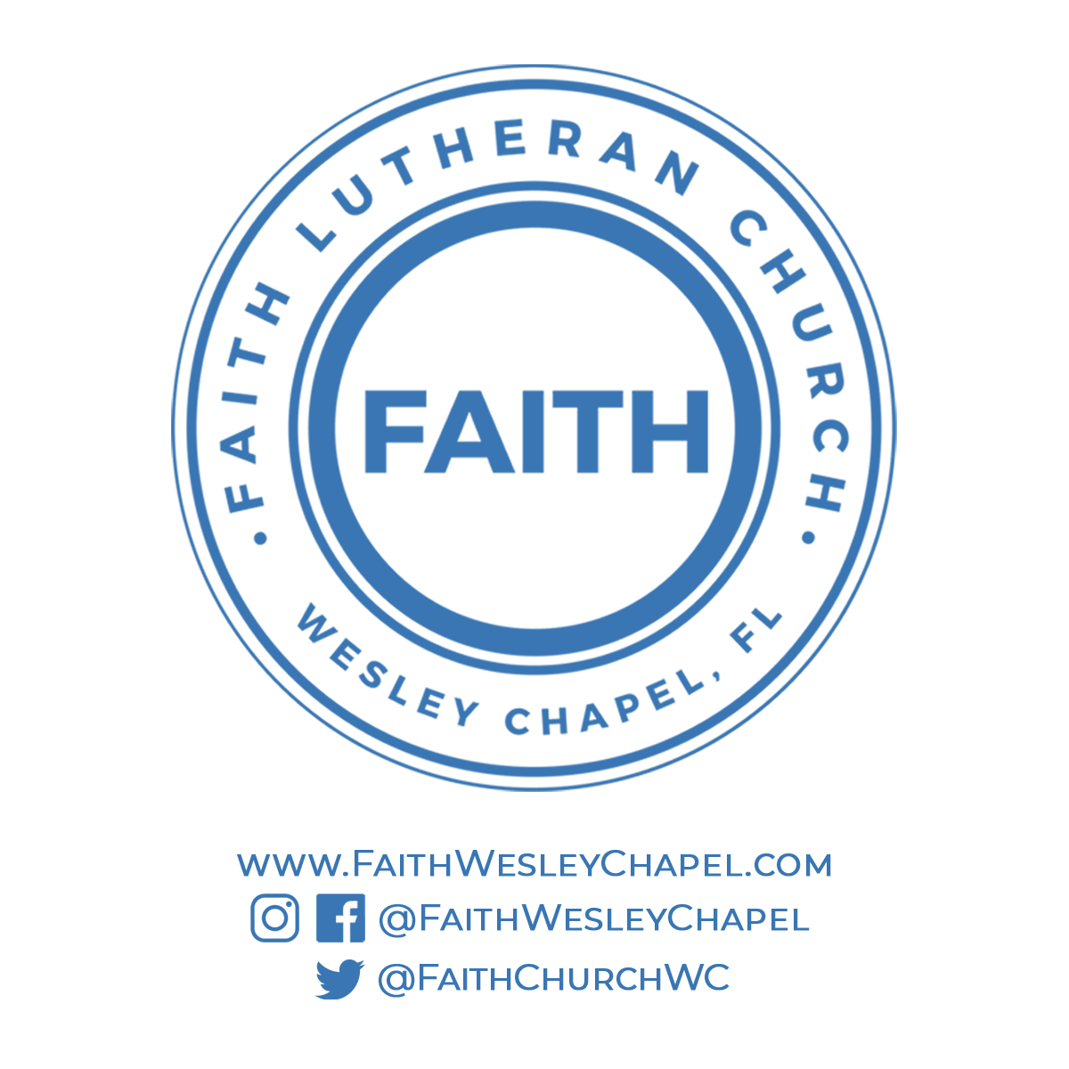**@FaithWesleyChapel**

**@FaithWesleyChapel**

**@FaithChurchWC**