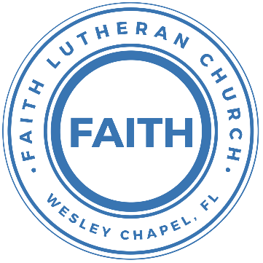

**Leading our community into a deep connection in Christ**

**Worship Service for August 6, 2023, at 11 AM**

**Welcome**

**Opening Song:**Father Abraham

Father Abraham had many sons. Many sons had Father Abraham.

I am one of them and so are you. So, let's just praise the Lord!

Right arm  
Left arm  
Right foot  
Left foot  
Chin up  
Turn around  
Sit down © Public Domain

**Invocation**

**Confession and Forgiveness:**

**P:** We have come here today to worship the Lord.  In worship we hear the Word of God, we receive God's blessings, and respond with thanks and praise.  We begin by seeking God's blessing of forgiveness.  He has promised to remove the guilt and shame of our sin through the sacrifice of Jesus Christ on the cross.

*(a time of silence to reflect and personally confess our sins)*

**P:** Let us confess our sins to the Lord.

**P:** Heavenly Father,  
**C:** Heavenly Father,

**P:** I have done things that were wrong.  
**C:** I have done things that were wrong.  
  
**P:** I have been mean to others.  
**C:** I have been mean to others.

**P:** I have not obeyed my parents.  
**C:** I have not obeyed my parents.

**P:** I have not obeyed You, God.  
**C:** I have not obeyed You, God.

**P:** But I am very sorry.  
**C:** But I am very sorry.

**P:** Please forgive me.  
**C:** Please forgive me.

**P:** I love You very much.  
**C:** I love You very much.

**P:** And I know You love me, too.  
**C:** And I know You love me, too.

**P:** Amen.  
**C:** Amen.

**P:** God has heard your apology.  He loves you very much.  God has told us that when we believe and trust in Him, He makes us His children.  As far as the east is from the west, so far does he remove our sins from us. He has told me to tell you that you are forgiven.  So, as His servant, I forgive you in the name of the Father and of the Son and of the Holy Spirit.   
**C:** Amen.

**Song:**Jesus Loves Me

Jesus loves me this I know, For the Bible tells me so.

Little ones to Him belong, They are weak, but He is strong.

Chorus:

Yes, Jesus loves me, Yes, Jesus loves me,

Yes, Jesus loves me, The Bible tells me so.

Jesus loves me, He who died. Heaven's gates to open wide.

He will wash away my sin, Let His little child come in.

*(Chorus)* © Public Domain

**First Reading -**Romans 9:8

This means that it is not the children of the flesh who are the children of God, but the children of the promise are counted as offspring.

**Reader:** This is the Word of the Lord.  
**C:** Thanks be to God.

**Children's Message**"Who Are the Children of God?"

**Closing Song:**God So Loved

Come all you weary. Come all you thirsty.

Come to the well that never runs dry.

Drink of the Water. Come and thirst no more.

Come all you sinners. Come find His mercy.

Come to the table. He Will satisfy.

Taste of His goodness. Find what you’re looking for.

Chorus 1:

For God so loved the World that He gave us,

His one and only Son to save us.

Whoever believes in Him, will live forever.

Bring all your failures. Bring your addictions.

Come lay them down at the Foot of the cross.

Jesus is waiting there with open arms.

Chorus 1:

For God so loved the World that He gave us,

His one and only Son to save us.

Whoever believes in Him, will live forever.

Chorus 2:

The power of Hell forever defeated.

Now, it is well. I’m Walking in freedom.

For God so loved, God so loved the world.

Bridge:

Praise God! Praise God from whom all blessings flow.

Praise Him! Praise Him for the wonders of His love.

*(Repeat)*

His amazing love!

*(Chorus 1 and Chorus 2)*

*(Verse 3)*

© 2019 Andrew Bergthold Designee (Admin. by Capitol CMG Publishing) Capitol CMG Genesis (Admin. by Capitol CMG Publishing), Capitol CMG Paragon (Admin. by Capitol CMG Publishing), We The Kingdom ASCAP Designee (Admin. by Capitol CMG Publishing), and We The Kingdom Music(Admin. by Capitol CMG Publishing)

**Second Reading -**Romans 9:9-13

Here is what God said in that promise: “About this time next year I will come back, and Sarah will have a son.”

And that is not all. Rebecca also had sons, and they had the same father. He is our father Isaac. But before the two sons were born, God told Rebecca, “The older son will serve the younger.” This was before the boys had done anything good or bad. God said this before they were born so that the boy he wanted would be chosen because of God’s own plan. He was chosen because he was the one God wanted to call, not because of anything the boys did. As the Scriptures say, “I loved Jacob, but I hated Esau.”

**Reader:** This is the Word of the Lord.  
**C:** Thanks be to God.

**Children's Message**"Isaac, Jacob, and Esau. Oh my! What Is this Talking about?"

**Gospel Reading -**Matthew 14:13-21

Now when Jesus heard this, he withdrew from there in a boat to a desolate place by himself. But when the crowds heard it, they followed him on foot from the towns. When he went ashore he saw a great crowd, and he had compassion on them and healed their sick. Now when it was evening, the disciples came to him and said, “This is a desolate place, and the day is now over; send the crowds away to go into the villages and buy food for themselves.” But Jesus said, “They need not go away; you give them something to eat.” They said to him, “We have only five loaves here and two fish.” And he said, “Bring them here to me.” Then he ordered the crowds to sit down on the grass, and taking the five loaves and the two fish, he looked up to heaven and said a blessing. Then he broke the loaves and gave them to the disciples, and the disciples gave them to the crowds. And they all ate and were satisfied. And they took up twelve baskets full of the broken pieces left over. And those who ate were about five thousand men, besides women and children.

**P:** This is the Gospel of the Lord.  
**C:** Praise be to You, o Christ.

**Sermon Hymn:**No Longer Slaves

You unravel me, with a melody. You surround me with a song,  
Of deliverance, from my enemies till all my fears are gone.

Chorus:  
I’m no longer a slave to fear. I am a child of God.  
I’m no longer a slave to fear. I am a child of God.

From my mother’s womb You have chosen me.   
Love has called my name.  
I’ve been born again, into your family.  
Your blood flows through my veins.

*(Chorus)*

Bridge:  
You split the sea so I could walk right through it.  
My fears are drowned in perfect love.  
You rescued me and I will stand and sing, “I am a child of God!”  
*Repeat*

I am a child of God . . .

Chorus:  
I’m no longer a slave to fear. I am a child of God.  
I’m no longer a slave to fear. I am a child of God.

© 2014 © Bethel Music Publishing

**Sermon –**“The Children of God”

**Prayers:** *Text in prayer requests to (813) 602-1104‬*

**The Lord's Prayer**

Our Father who art in heaven, hallowed be Thy name, Thy kingdom come, Thy will be done on earth as it is in heaven.  Give us this day our daily bread; and forgive us our trespasses as we forgive those who trespass against us; and lead us not into temptation, but deliver us from evil.  For Thine is the kingdom and the power and the glory forever and ever.  Amen

**Offering**

**Words of Institution**

**Peace**

**P:** The peace of the Lord be with you all.  
**C:** And also, with you.  
**P:** We greet each other in the peace of Christ.

**Distribution**

**Prayer**

**Benediction**

**Closing Song:**Go My Children With My Blessing

Go, My children, with My blessing, never alone.

Waking, sleeping, I am with you. You are My own.

In My love’s baptismal river I have made you Mine forever.

Go, My children, with My blessing. You are My own.

Go, My children, sins forgiven, at peace and pure.

Here you learned how much I love you, what I can cure.

Here you heard My dear Son’s story.  
Here you touched Him, saw His glory.

Go, My children, sins forgiven, at peace and pure.

Go, My children, fed and nourished, closer to Me;

Grow in love and love by serving, joyful and free.

Here My Spirit’s power filled you.  
Here His tender comfort stilled you.

Go, My children, fed and nourished, joyful and free.

I the Lord will bless and keep you and give you peace.

I the Lord will smile upon you and give you peace.

I the Lord will be your Father, Savior, Comforter, and Brother.

Go, My children; I will keep you and give you peace.

© 1983, 1987 MorningStar Music Publishers, Concordia Publishing House, and Music: MorningStar Music Publishers

|  |  |
| --- | --- |
| **Serving This Week** | |
|  | |
| **1st Reader:** Kaylee Steinbrueck | **Children’s Church Teacher:** |
| **2nd Reader:** Katelyn Shuck | N/A |
| **Acolyte:** Griffin Frost | **Children’s Church Assistant:** |
| **Com. Asst:** Larry Chmiel | N/A |
|  | |
| **Serving Next Week** | |
|  | |
| **O.T. Reader:** TBD | **Children’s Church Teacher:** |
| **Epistle Reader:** N/A | Melissa Steinbrueck |
| **Acolyte:** Jakob Torgrimson | **Children’s Church Assistant:** |
| **Com. Asst:** Larry Chmiel | Kaylee Steinbrueck |

**Hey Youth!!**Do you know any worship songs you’d like to sing as part of our youth service? Let Pastor Kurt know.

Do you want to sing or play an instrument? Let Pastor Kurt know.

We want you to be a part of the service.

**Upcoming Events**

**August 6, 11 AM – School Supplies for Those in Need**  
Faith Lutheran Church

**August 8, 7 PM – Growth Group**  
Renee’s Home

**August 13, After the Service – “God Squad” Youth Group**  
We’ll do a shorter God Squad and then plan the Fall.  
Faith Lutheran Church

[**www.FaithWesleyChapel.com**](http://www.FaithWesleyChapel.com)

 **Faith YouTube**

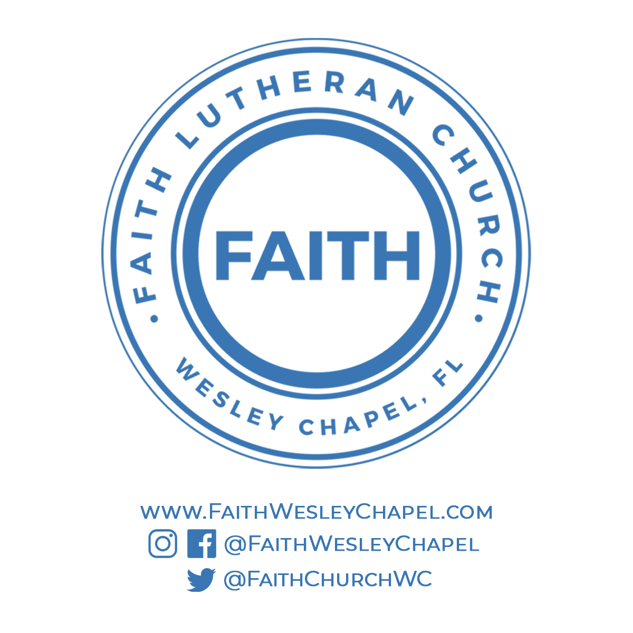**@FaithWesleyChapel**

**@FaithWesleyChapel**

**@FaithChurchWC**