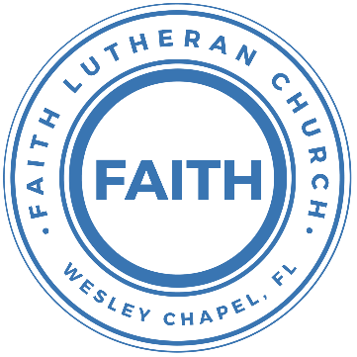

**Leading our community into a deep connection in Christ**

**Worship Service for August 13, 2023, at 11 AM**

**Welcome**

**Invocation**

**Responsive Psalm - Psalm 18**

**P:** I love you, O Lord, my strength.  
**C:** The Lord is my rock and my fortress and my deliverer,

**P:** My God, my rock, in whom I take refuge,  
**C:** My shield, and the horn of my salvation, my stronghold.

**P:** I call upon the Lord, who is worthy to be praised,  
**C:** And I am saved from my enemies.

**P:** The cords of death encompassed me; the torrents of destruction assailed me;  
**C:** The cords of Sheol entangled me; the snares of death confronted me.

**P:** In my distress I called upon the Lord; to my God I cried for help.  
**C:** From his temple he heard my voice, and my cry to him reached his ears.

**P:** I love you, O Lord, my strength.

**All:** The Lord is my rock and my fortress and my deliverer,

**Confession and Forgiveness:**

**P:** As we gather, today, let us cleanse our hearts and our consciences by confessing our sin to God.

*(Time of silence for reflection and confession)*

**C:** Heavenly Father, we confess that we are sinful and unclean. We have sinned against you and against our neighbor in our thoughts, words, and actions.  We are truly sorry for our sins and sincerely repent of them. We ask for Your mercy. For the sake of Jesus Christ's bitter suffering and death, please forgive us and renew us that we may walk in Your Spirit to the glory of Your holy name. Amen

**P:** The Lord has heard your confession. Therefore, as a called and ordained servant of the Lord, in the stead and by the command of my Lord, Jesus Christ, I forgive you all your sins in the name of the Father and of the Son and of the Holy Spirit.  
**C:** Amen

**Songs of Praise and Thanksgiving –** What a Friend

Everybody has trials and temptations.  
Everybody knows heartbreak, isolation.

Pre-Chorus:  
But we can lay our burdens down. Lay our burdens down.

Chorus:  
What a friend we have in Jesus. East to west my sins are gone.  
I see grace on every horizon.  
And forever and ever His heart is my home.

Everybody has fears, everybody got worries.  
Everybody knows sorrow, devastation.

(Pre-Chorus)  
(Chorus)

Bridge:  
No more betrayal, for He is faithful.  
He fills me up and my cup runneth over.  
No more betrayal, for He is faithful.  
How He has proven it over and over.  
(Repeat)

Chorus: (2x)

What a friend we have in Jesus. East to west my sins are gone.  
I see grace on every horizon.  
And forever and ever His heart is my home.

© All Essential Music (Admin. by Essential Music Publishing LLC)

**Gospel Reading** - Matthew 14:22-33

Immediately he made the disciples get into the boat and go before him to the other side, while he dismissed the crowds. And after he had dismissed the crowds, he went up on the mountain by himself to pray. When evening came, he was there alone, but the boat by this time was a long way from the land, beaten by the waves, for the wind was against them. And in the fourth watch of the night he came to them, walking on the sea. But when the disciples saw him walking on the sea, they were terrified, and said, “It is a ghost!” and they cried out in fear. But immediately Jesus spoke to them, saying, “Take heart; it is I. Do not be afraid.”

And Peter answered him, “Lord, if it is you, command me to come to you on the water.” He said, “Come.” So Peter got out of the boat and walked on the water and came to Jesus. But when he saw the wind, he was afraid, and beginning to sink he cried out, “Lord, save me.” Jesus immediately reached out his hand and took hold of him, saying to him, “O you of little faith, why did you doubt?” And when they got into the boat, the wind ceased. And those in the boat worshiped him, saying, “Truly you are the Son of God.”

**P:** This is the Gospel of the Lord.  
**C:** Praise be to You, o Christ.

**Sermon Song –** This I Believe

Our Father everlasting, the all creating One, God almighty,  
Through Your Holy Spirit conceiving Christ the Son,  
Jesus our Savior.

Chorus:  
I believe in God our Father. I believe in Christ the Son.  
I believe in the Holy Spirit. Our God is three in one.  
I believe in the resurrection, that we will rise again.  
For I believe in the name of Jesus.

Verse 2:  
Our Judge and our Defender, suffered and crucified,  
Forgiveness is in You.  
Descended into darkness, You rose in glorious life,  
Forever seated high.

Chorus

Bridge: (2x)  
I believe in You. I believe You rose again.  
I believe that Jesus Christ is Lord.

Chorus 2:  
I believe in life eternal. I believe in the virgin birth.  
I believe in the saints' communion and in Your holy church.  
I believe in the resurrection, when Jesus comes again.  
For I believe in the name of Jesus.  
For I believe in the name of Jesus.

© 2014 © Hillsong Music Publishing (Admin. by EMI Christian Music Publishing)

**Sermon** – “If You Believe in Your Heart and Confess with Your Mouth”

Romans 10:5-17

For Moses writes about the righteousness that is based on the law, that the person who does the commandments shall live by them. But the righteousness based on faith says, “Do not say in your heart, ‘Who will ascend into heaven?’” (that is, to bring Christ down) “or ‘Who will descend into the abyss?’” (that is, to bring Christ up from the dead). But what does it say? “The word is near you, in your mouth and in your heart” (that is, the word of faith that we proclaim); because, if you confess with your mouth that Jesus is Lord and believe in your heart that God raised him from the dead, you will be saved. For with the heart one believes and is justified, and with the mouth one confesses and is saved. For the Scripture says, “Everyone who believes in him will not be put to shame.” For there is no distinction between Jew and Greek; for the same Lord is Lord of all, bestowing his riches on all who call on him. For “everyone who calls on the name of the Lord will be saved.”

How then will they call on him in whom they have not believed? And how are they to believe in him of whom they have never heard? And how are they to hear without someone preaching? And how are they to preach unless they are sent? As it is written, “How beautiful are the feet of those who preach the good news!” But they have not all obeyed the gospel. For Isaiah says, “Lord, who has believed what he has heard from us?” So faith comes from hearing, and hearing through the word of Christ.

**P:** This is the Word of the Lord.  
**C:** Thanks be to God.

**Prayer of the Church**

**Apostles' Creed**

I believe in God, the Father almighty, maker of heaven and earth,  
And in Jesus Christ, his only Son, our Lord,  
who was conceived by the Holy Spirit,  
born of the Virgin Mary, suffered under Pontius Pilate,  
was crucified, died and was buried. He descended into hell.  
The third day he rose again from the dead.  
He ascended into heaven and sits at the right hand of God  
the Father almighty.  
From there he will come to judge the living and the dead.  
I believe in the Holy Spirit, the holy Christian Church,  
the communion of saints, the forgiveness of sins,  
the resurrection of the body, and the life everlasting. Amen.

**The Lord's Prayer**

Our Father who art in heaven, hallowed be Thy name, Thy kingdom come, Thy will be done on earth as it is in heaven.  Give us this day our daily bread; and forgive us our trespasses as we forgive those who trespass against us; and lead us not into temptation, but deliver us from evil.  For Thine is the kingdom and the power and the glory forever and ever.  Amen

**Benediction**

**Closing Song:** Praise God From Whom All Blessings Flow

Praise God from Whom all blessings flow.  
Praise Him all creatures here below.  
Praise Him above, ye heavenly hosts.  
Praise Father, Son and Holy Ghost.  
Amen

**Offering**

**Upcoming Events**

**Today, After the Service – “God Squad” Youth Group**  
We’ll do a shorter God Squad and then plan the Fall.  
Faith Lutheran Church

**August 15, 7 PM Council Meeting**  
The Shucks

**August 22, 7 PM – Growth Group**  
Renee’s Home

[**www.FaithWesleyChapel.com**](http://www.FaithWesleyChapel.com)

 **Faith YouTube**

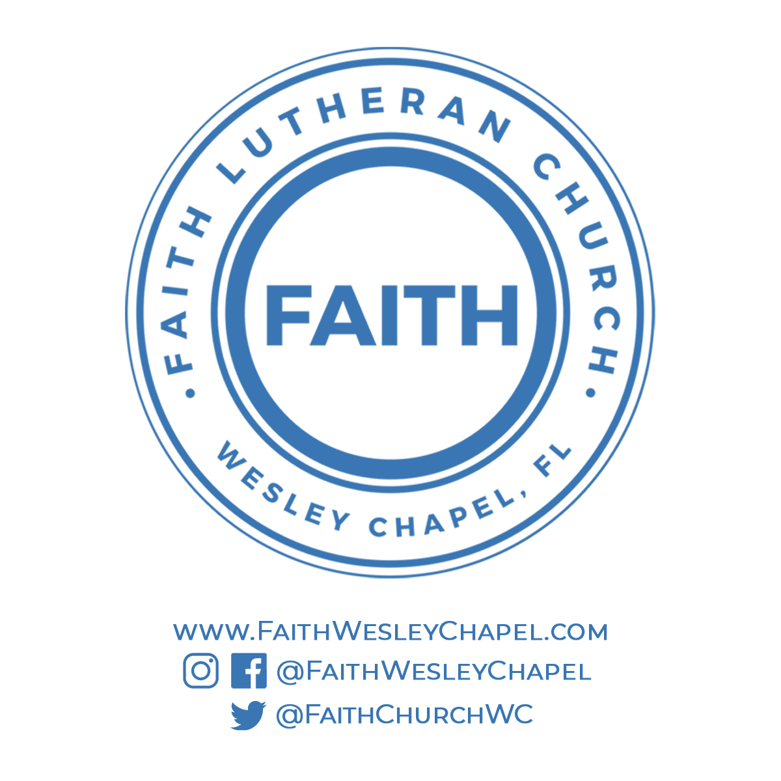**@FaithWesleyChapel**

**@FaithWesleyChapel**

**@FaithChurchWC**