

**Leading our community into a deep connection in Christ**

**Worship Service for August 20, 2023 at 11 AM**

**Welcome**

**Opening Song -** Holy, Holy, Holy

Holy, holy, holy, Lord God almighty:  
Early in the morning our song shall rise to Thee.  
Holy, holy, holy, merciful and mighty,  
God in three persons blessed Trinity.

Holy, holy, holy, all the saints adore Thee,  
Casting down their golden crowns around the glassy sea.  
Cherubim and Seraphim falling down before Thee,  
Which wert and art and evermore shall be.

Holy, holy, holy, though the darkness hide Thee,  
Though the eye of sinful man Thy glory may not see,  
Only Thou art holy there is none beside Thee,  
Perfect in pow’r, in love, and purity.

Holy, holy, holy, Lord God almighty!  
All Thy works shall praise Thy name in earth and sky and sea.  
Holy, holy, holy, merciful and mighty,  
God in three persons blessed Trinity.  
God in three persons blessed Trinity. © Public Domain

**Invocation**

**Confession and Forgiveness:**

**P:** Our Heavenly Father asks us to come into His presence.  
**C:** But we are sinful and unworthy.

**P:** Yes, all have sinned and fall short of the glory of God, but Jesus Christ died on the cross that we may be forgiven and washed clean of all our sins by His blood spilled on the cross.  
**C:** Lord, if You wash us, we will certainly be clean and pure.

**P:** We take a moment to bow before the His cross and silently reflect on our lives and confess our sins.

*(Time of silence for reflection and confession)*

**P:** Let us confess, together, our sins to God our Father.  
**C:** Heavenly Father, we confess that we are sinners.  We have sinned against you and our neighbors. We have not loved you with our whole heart and we have not loved our neighbors as ourselves. We have not lived out our faith in our community. We justly deserve Your punishment.  For the sake of Your Son, Jesus Christ, have mercy on us.  Forgive us, renew us, and lead us, so that we may delight in Your will and walk in Your ways to the glory of Your holy name.  Amen.

**P:** Almighty God in His mercy has given His Son to die for you and for His sake forgives you all your sins.  As a called and ordained servant of Christ, and by His authority, I, therefore, forgive you all your sins in the name of the Father and of the Son and of the Holy Spirit.  
**C:** Amen

**Song of Praise and Thanksgiving:** Christ Is Risen

Let no one caught in sin remain inside the lie of inward shame.  
We fix our eyes upon the cross and run to Him who showed great love  
And bled for us. Freely You've bled for us.

Chorus:  
Christ is risen from the dead, trampling over death by death.  
Come awake, come awake, come and rise up from the grave.  
Christ is risen from the dead, we are one with Him again.  
Come awake, come awake, come and rise up from the grave.

Beneath the weight of all our sin You bowed to none but Heaven's will  
No scheme of Hell, no scoffer's crown,   
No burden great can hold You down.  
In strength You reign. Forever let Your church proclaim.

*(Chorus)*

O death, where is your sting? O hell, where is your victory?  
O church, come stand in the light.  
The glory of God has defeated the night!  
O death, where is your sting? O hell, where is your victory?  
O church, come stand in the light.  
Our God is not dead. He is alive! He is alive!

*(Chorus)* © 2009 Thankyou Music, spiritandsong.com, Unknown, and SHOUT! Publishing

**Old Testament Reading -**Isaiah 56:1, 6–8

Thus says the Lord: “Keep justice, and do righteousness, for soon my salvation will come, and my righteousness be revealed.

“And the foreigners who join themselves to the Lord, to minister to him, to love the name of the Lord, and to be his servants, everyone who keeps the Sabbath and does not profane it, and holds fast my covenant— these I will bring to my holy mountain, and make them joyful in my house of prayer; their burnt offerings and their sacrifices will be accepted on my altar; for my house shall be called a house of prayer for all peoples.” The Lord God, who gathers the outcasts of Israel, declares, “I will gather yet others to him besides those already gathered.”

**Reader:** This is the Word of the Lord.  
**C:** Thanks be to God.

**Gospel Reading** - Matthew 15:21-28

And Jesus went away from there and withdrew to the district of Tyre and Sidon. And behold, a Canaanite woman from that region came out and was crying, “Have mercy on me, O Lord, Son of David; my daughter is severely oppressed by a demon.” But he did not answer her a word. And his disciples came and begged him, saying, “Send her away, for she is crying out after us.” He answered, “I was sent only to the lost sheep of the house of Israel.” But she came and knelt before him, saying, “Lord, help me.” And he answered, “It is not right to take the children's bread and throw it to the dogs.” She said, “Yes, Lord, yet even the dogs eat the crumbs that fall from their masters' table.” Then Jesus answered her, “O woman, great is your faith! Be it done for you as you desire.” And her daughter was healed instantly.

**P:** This is the Gospel of the Lord.  
**C:** Praise be to You, o Christ.

**Children's Message** *(Children dismissed to Children's Church)*

**Sermon Hymn***–*The Church’s One Foundation

The church's one foundation is Jesus Christ, her Lord;

she is his new creation by water and the Word:

from heav'n he came and sought her to be his holy bride;

with his own blood he bought her, and for her life he died.

Elect from ev’ry nation, yet one o'er all the earth,

her charter of salvation one Lord, one faith, one birth;

one holy name she blesses, partakes one holy food,

and to one hope she presses, with ev'ry grace endued.

Through toil and tribulation, and tumult of her war,

she waits the consummation of peace forevermore;

till with the vision glorious her longing eyes are blest,

and the great church victorious shall be the church at rest.

Yet she on earth hath union with God the Three in One,

and mystic sweet communion with those whose rest is won:

O blessed heav'nly chorus! Lord, save us by Your grace,

that we, like saints before us, may see You face to face.

© Public Domain

**Sermon** - "What Will Happen to Israel?"

Romans 11:1–2a, 13–15, 28–32

I ask, then, has God rejected his people? By no means! For I myself am an Israelite, a descendant of Abraham, a member of the tribe of Benjamin. 2 God has not rejected his people whom he foreknew. Do you not know what the Scripture says of Elijah, how he appeals to God against Israel?...

13 ...Now I am speaking to you Gentiles. Inasmuch then as I am an apostle to the Gentiles, I magnify my ministry 14 in order somehow to make my fellow Jews jealous, and thus save some of them. 15 For if their rejection means the reconciliation of the world, what will their acceptance mean but life from the dead?...

25 …Lest you be wise in your own sight, I do not want you to be unaware of this mystery, brothers: a partial hardening has come upon Israel, until the fullness of the Gentiles has come in. 26 And in this way all Israel, will be saved, as it is written, “The Deliverer will come from Zion, he will banish ungodliness from Jacob”; 27 “and this will be my covenant with them when I take away their sins.”

As regards the gospel, they are enemies for your sake. But as regards election, they are beloved for the sake of their forefathers. 29 For the gifts and the calling of God are irrevocable. 30 For just as you were at one time disobedient to God but now have received mercy because of their disobedience, 31 so they too have now been disobedient in order that by the mercy shown to you they also may now receive mercy. 32 For God has consigned all to disobedience, that he may have mercy on all.

**P:** This is the Word of the Lord.  
**C:** Thanks be to God.

**Prayers:** *Text in prayer requests to (813) 326-5255*

**Nicene Creed** *(stand)*

I believe in one God, the Father Almighty, maker of heaven and earth and of all things visible and invisible.

And in one Lord Jesus Christ, the only-begotten Son of God, begotten of His Father before all worlds, God of God, Light of Light, very God of very God, begotten, not made, being of one substance with the Father, by whom all things were made; who for us men and for our salvation came down from heaven and was incarnate by the Holy Spirit of the virgin Mary and was made man; and was crucified also for us under Pontius Pilate. He suffered and was buried. And the third day He rose again according to the Scriptures and ascended into heaven and sits at the right hand of the Father. And He will come again with glory to judge both the living and the dead, whose kingdom will have no end.

And I believe in the Holy Spirit, the Lord and Giver of Life, who proceeds from the Father and the Son, who with the Father and the Son together is worshiped and glorified, who spoke by the prophets. And I believe in one holy Christian and apostolic Church, I acknowledge one Baptism for the remission of sins, and I look for the resurrection of the dead and the life of the world to come. Amen.

**The Lord's Prayer** *(stand)*

Our Father who art in heaven, hallowed be Thy name, Thy kingdom come, Thy will be done on earth as it is in heaven.  Give us this day our daily bread; and forgive us our trespasses as we forgive those who trespass against us; and lead us not into temptation, but deliver us from evil.  For Thine is the kingdom and the power and the glory forever and ever.  Amen

**Offering** *(sit)*

**Online Service Ends** – A Video of the closing song is available online.

**Closing Song:**The Blessing *(stand)*

Verse:  
The Lord bless you and keep you,  
Make His face shine upon you and be gracious to you.  
The Lord turn His face toward you and give you peace.

Chorus:  
Amen. Amen. Amen.  
*(Repeat)*

*(Verse)*

*(Chorus)*

Bridge:  
May His favor be upon you and a thousand generations,  
And your family and your children,  
And their children and their children.  
*(Repeat)*

Bridge 2:  
May His presence go before you and behind you and beside you,  
All around you and within you. He is with you. He is with you.  
In the morning, in the evening, in your coming and your going,  
In your weeping and rejoicing He is with you. He is with you.  
He is for you. He is for you. He is for you. He is for you.  
He is for you. He is for you

*(Chorus) (Bridge 2)* 2020 Music by Elevation Worship Publishing

|  |  |
| --- | --- |
| **Serving This Week** | |
|  | |
| **O.T. Reader:** Terrell Jordan | **Children’s Church Teacher:** |
| **Epistle Reader:** N/A | Melissa Steinbrueck |
| **Acolyte:** Lawrence Finnerty | **Children’s Church Assistant:** |
| **Com. Asst:** Larry Chmiel | TBD |
|  | |
| **Serving Next Week** | |
|  | |
| **O.T. Reader:** Vanessa Frost | **Children’s Church Teacher:** |
| **Epistle Reader:** N/A | Terrell Jordan |
| **Acolyte:** Griffin Frost | **Children’s Church Assistant:** |
| **Com. Asst:** Larry Chmiel | Emily Shuck |

**Upcoming Events**

**Today, 5:45 PM – Multi-Church Youth Social**  
The Flying Squirrel

**August 22, 7 PM – Growth Group**  
Renee’s Home - 3436 Chapel Creek Cir. Wesley Chapel, FL 33544. Gate: #7369 (Ch 1 of the book, A Week in the Life of Corinth)

**September 10, 11 AM – Faith and Food Worship Service**  
Faith Lutheran Church

**September 10, 11 AM – Service and Outreach Planning**  
Faith Lutheran Church

**September 10, After the Service – “God Squad” Youth Group**  
Faith Lutheran Church

**September 12, 7 PM – Growth Group**  
Renee’s Home – (See address above)

**September 17, After the Service – Confirmation**  
Faith Lutheran Church

**www.FaithWesleyChapel.com**

**Faith YouTube**

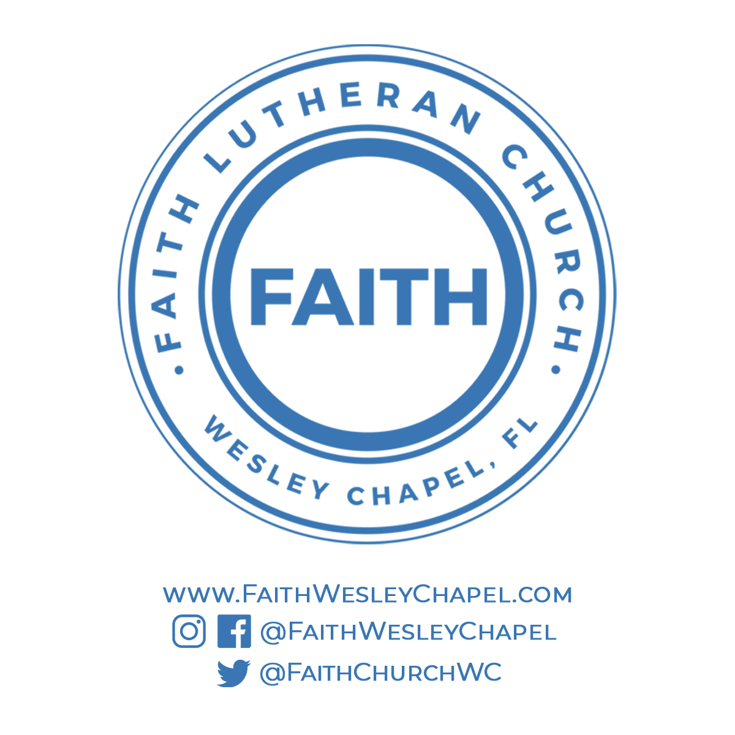**@FaithWesleyChapel**

**@FaithWesleyChapel**

**@FaithChurchWC**