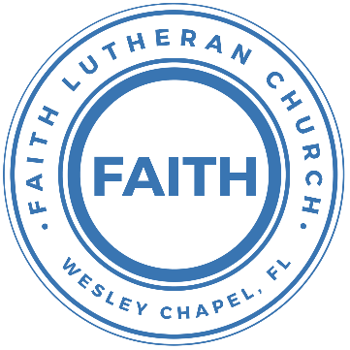

**Leading our community into a deep connection in Christ**

**Worship Service for September 3, 2023, at 11 AM**

**Welcome**

**Opening Song:**The Hippopotamus Song

In the beginning God made the sea, *(make a wave motion)*

And the forest filled with trees. *(wave your hands)*

He made the mountains up so high, *(making a point with your hands)*

Above it all He placed the sky. *(Motion like you are throwing the sky up)*

God's fingerprints are everywhere, *(touch things with your fingers)*

Just to show how much He cares. *(hug yourself)*

Along the way He had some fun. *(swoop your fist in front of you)*

He made a hippo that weighed a ton. *(when you say "ton," put your arms away from your sides making something look big)*

Hip-Hip-Hippopotamus. *(same motion and use a deep voice)*

Hip-Hip-Hurray, God made all of us! *(Wave your hands in the air and use a high voice, guys in falsetto)*

Hip-Hip-Hippopotamus.

Hip-Hip-Hurray, God made all of us! © 1988 Big Steps 4 U

**Invocation**

**Confession and Forgiveness:**

**P:** We have come here today to worship the Lord.  In worship we hear the Word of God, we receive God's blessings, and respond with thanks and praise.  We begin by seeking God's blessing of forgiveness.  He has promised to remove the guilt and shame of our sin through the sacrifice of Jesus Christ on the cross.

*(a time of silence to reflect and personally confess our sins)*

**P:** Let us confess our sins to the Lord.

**P:** Heavenly Father,  
**C:** Heavenly Father,

**P:** I have done things that were wrong.  
**C:** I have done things that were wrong.  
  
**P:** I have been mean to others.  
**C:** I have been mean to others.

**P:** I have not obeyed my parents.  
**C:** I have not obeyed my parents.

**P:** I have not obeyed You, God.  
**C:** I have not obeyed You, God.

**P:** But I am very sorry.  
**C:** But I am very sorry.

**P:** Please forgive me.  
**C:** Please forgive me.

**P:** I love You very much.  
**C:** I love You very much.

**P:** And I know You love me, too.  
**C:** And I know You love me, too.

**P:** Amen.  
**C:** Amen.

**P:** God has heard your apology.  He loves you very much.  God has told us that when we believe and trust in Him, He makes us His children.  As far as the east is from the west, so far does he remove our sins from us. He has told me to tell you that you are forgiven.  So, as His servant, I forgive you in the name of the Father and of the Son and of the Holy Spirit.   
**C:** Amen.

**Song:**God Is So Good

God is so good. God is so good.  
God is so good. He's so good to me.

He died for me. He died for me so.  
He died for me. He's so good to me.

He loves me so. He loves me so.  
He loves me so. He's so good to me. © Public Domain

**First Reading -**Romans 12:9

Love is genuine. Hate what is evil. Do only what is good.

**Reader:** This is the Word of the Lord.  
**C:** Thanks be to God.

**Children's Message**"How Can You Show Real Love?"

**Song:**I See You

God of love, God of all glory, every day I see new mercy.

Great is Your faithfulness!

God of love, God of my story, You never fail. You never forsake me

Great is Your faithfulness!

Chorus:

I see You in the morning light. I feel You in the fire by night.

I hear You say, “Child, I am with you. Everything will be alright.”

I see You in the tears that run. I feel You when the healing comes.

I hear You say, “Beloved one, I am with you,”  
Every moment of my life.

I see You. I see You. I see You. God, I see You.

God of love, God of new vision, every blessing You have given.

Great is Your faithfulness! Oh how great is Your faithfulness!

Chorus:

I see You in the morning light. I feel You in the fire by night.

I hear You say, “Child, I am with you. Everything will be alright.”

I see You in the tears that run. I feel You when the healing comes.

I hear You say, “Beloved one, I am with you,”  
Every moment of my life.

I see You. I see You. I see You. God, I see You.

Bridge:

I will worship through the storm,  
Through the storm, Through the storm.

All my hope is in You Lord, In You Lord, In You Lord.

I see You in the morning light. I feel You in the fire by night.

I hear You say, “Child, I am with you. Everything will be alright.”

*(Chorus)* © 2021 Capitol CMG Paragon

**Second Reading -**Romans 12:10

Be devoted to one another with mutual love, showing eagerness in honoring one another.

**Reader:** This is the Word of the Lord.  
**C:** Thanks be to God.

**Children's Message**"Giving Honor First"

**Gospel Reading -**Matthew 16:21-28

From that time Jesus began to show his disciples that he must go to Jerusalem and suffer many things from the elders and chief priests and scribes, and be killed, and on the third day be raised. And Peter took him aside and began to rebuke him, saying, “Far be it from you, Lord! This shall never happen to you.” But he turned and said to Peter, “Get behind me, Satan! You are a hindrance to me. For you are not setting your mind on the things of God, but on the things of man.” Then Jesus told his disciples, “If anyone would come after me, let him deny himself and take up his cross and follow me. For whoever would save his life will lose it, but whoever loses his life for my sake will find it. For what will it profit a man if he gains the whole world and forfeits his soul? Or what shall a man give in return for his soul? For the Son of Man is going to come with his angels in the glory of his Father, and then he will repay each person according to what he has done. Truly, I say to you, there are some standing here who will not taste death until they see the Son of Man coming in his kingdom.”

**P:** This is the Gospel of the Lord.  
**C:** Praise be to You, o Christ.

**Sermon Hymn:**Canvas And Clay

In my mother’s womb, You formed me with Your hands.  
Known and loved by You before I took a breath.

When I doubt it, Lord, remind me I’m wonderfully made.  
You’re an artist and a potter. I’m the canvas and the clay.

Chorus:  
You make all things work together for my future and for my good.  
You make all things work together for Your glory & for Your name.

There’s a healing light Just beyond the clouds.  
Though I’ve walked through fire, I see clearly now.

I know nothing has been wasted, no failure or mistake.  
You’re an artist and a potter. I’m the canvas and the clay.

*(Chorus 2x)* © Capitol CMG Genesis

**Sermon –**“Be Real”

Romans 12:9–21

Let love be genuine. Abhor what is evil; hold fast to what is good. Love one another with brotherly affection. Outdo one another in showing honor. Do not be slothful in zeal, be fervent in spirit, serve the Lord. Rejoice in hope, be patient in tribulation, be constant in prayer. Contribute to the needs of the saints and seek to show hospitality. Bless those who persecute you; bless and do not curse them. Rejoice with those who rejoice, weep with those who weep. Live in harmony with one another. Do not be haughty, but associate with the lowly. Never be wise in your own sight. Repay no one evil for evil, but give thought to do what is honorable in the sight of all. If possible, so far as it depends on you, live peaceably with all. Beloved, never avenge yourselves, but leave it to the wrath of God, for it is written, “Vengeance is mine, I will repay, says the Lord.” To the contrary, “if your enemy is hungry, feed him; if he is thirsty, give him something to drink; for by so doing you will heap burning coals on his head.” Do not be overcome by evil, but overcome evil with good.

**Prayers:** *Text in prayer requests to (813) 326-5255*

**The Lord's Prayer**

Our Father who art in heaven, hallowed be Thy name, Thy kingdom come, Thy will be done on earth as it is in heaven.  Give us this day our daily bread; and forgive us our trespasses as we forgive those who trespass against us; and lead us not into temptation, but deliver us from evil.  For Thine is the kingdom and the power and the glory forever and ever.  Amen

**Offering**

**Benediction** *– The online service ends. The closing hymn video is on the online bulletin at FaithWesleyChapel.com with lyrics below. See announcements below as well.*

**Closing Song:**As For Me and My House *(sit)*

Let our foundation be built on your majesty. Let every word you speak fill this home.  
Jesus our cornerstone, the anchor for our souls, Your glory will be shown by our love.

Chorus:  
As for me and my house, as for me and my house,  
We will serve you. We will serve you.  
As for me and my house, as for me and my house,  
We will serve you. We will serve you.

We stand on Holy Ground. This is where lost get found.  
Your goodness all around, it’s pouring out.  
Your presence is new wine. The old is left behind.  
There’s nothing but new life to be found.

*(Chorus)*

Bridge:  
This is a house where idols fall.  
This is a house where dead man walk.  
This is a house where freedoms calls.  
Can you hear it now, hear it now?  
*(Repeat)*

*(Chorus 2x)* © Integrity's Alleluia! Music

|  |  |
| --- | --- |
| **Serving This Week** | |
|  | |
| **1st Reader:** Thomas Horness | **Children’s Church Teacher:** |
| **2nd Reader:** Kelsey Torgrimson | N/A – Youth Service |
| **Acolyte:** Lawrence Finnerty | **Children’s Church Assistant:** |
| **Com. Asst:** Larry Chmiel | N/A – Youth Service |
|  | |
| **Serving Next Week** | |
|  | |
| **O.T. Reader:** N/A | **Children’s Church Teacher:** |
| **Epistle Reader:** Halston Dunn | Terrell Jordan |
| **Acolyte:** Lawrence Finnerty | **Children’s Church Assistant:** |
| **Com. Asst:** Larry Chmiel | Emily Shuck |

**Hey Youth!!**Do you know any worship songs you’d like to sing as part of our youth service? Let Pastor Kurt know.

Do you want to sing or play an instrument? Let Pastor Kurt know.

We want you to be a part of the service.

**Upcoming Events**

**September 10, 11 AM – Faith and Food Worship Service**  
Faith Lutheran Church

**September 10, 11 AM – Service and Outreach Planning**  
Faith Lutheran Church

**September 10, After the Service – “God Squad” Youth Group**  
Faith Lutheran Church

**September 12, 7 PM – Growth Group**  
Renee’s Home - (Ch 2-3 of the book, A Week in the Life of Corinth)

**September 17, After the Service – Confirmation**  
Faith Lutheran Church

[**www.FaithWesleyChapel.com**](http://www.FaithWesleyChapel.com)

 **Faith YouTube**

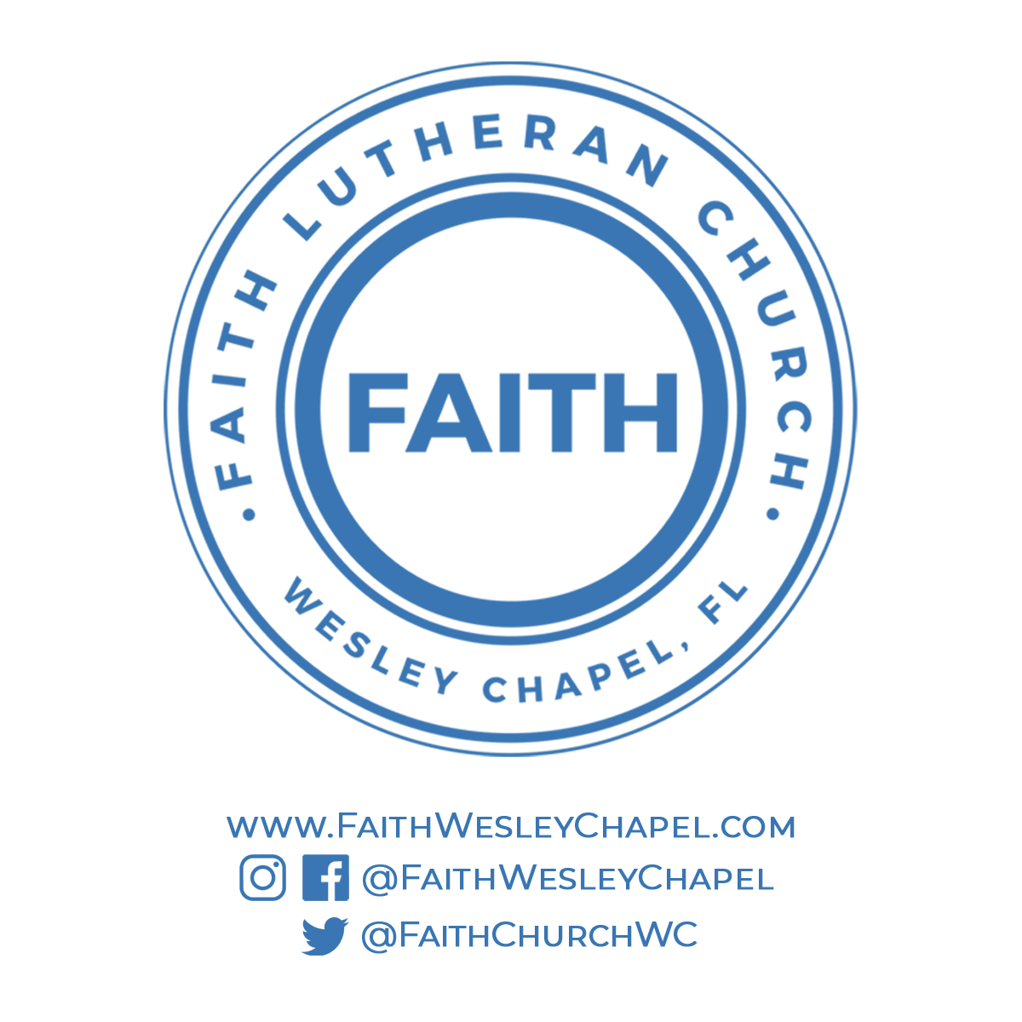**@FaithWesleyChapel**

**@FaithWesleyChapel**

**@FaithChurchWC**