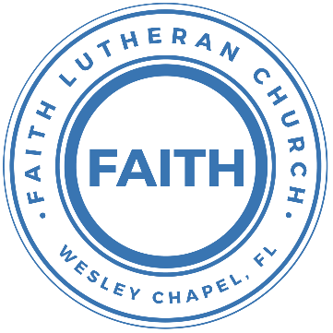

**Leading our community into a deep connection in Christ**

**Worship Service for September 17, 2023, at 11 AM**

**Welcome**

**Opening Song -** The Wonderful Cross

When I survey the wondrous cross, on which the prince of glory died,

My richest gain I count but loss, and pour contempt on all my pride.

Chorus:

O the wonderful cross, O the wonderful cross,

Bids me come and die and find that I may truly live.

O the wonderful cross, O the wonderful cross,

All who gather here by grace draw near and bless Your name.

See from his head, His hands, His feet,

Sorrow and love flow mingled down.

Did e’er such love and sorrow meet, or thorns compose so rich a crown.

*(Chorus)*

Were the whole realm of nature mine, that were a present far too small

Love so amazing so divine, demands my soul, my life, my all.

*(Chorus)* © 2000 worshiptogether.com Songs

**Invocation**

**Responsive Psalm (32)**

**P:** Blessed is the one whose transgression is forgiven, whose sin is covered.  
**C:** Blessed is the man against whom the Lord counts no iniquity, and in whose spirit there is no deceit.

**P:** For when I kept silent, my bones wasted away through my groaning all day long.  
**C:** For day and night Your hand was heavy upon me; my strength was dried up as by the heat of summer.

**P:** I acknowledged my sin to You, and I did not cover my iniquity;  
**C:** I said, “I will confess my transgressions to the Lord,” and You forgave the iniquity of my sin.

**P:** Therefore let everyone who is godly offer prayer to You at a time when You may be found;  
**C:** Surely in the rush of great waters, they shall not reach Him.

**P:** You are a hiding place for me; You preserve me from trouble; You surround me with shouts of deliverance.  
**C:** Blessed is the one whose transgression is forgiven, whose sin is covered.

**Confession and Forgiveness:**

**P:** Let us not keep silent. Let us acknowledge our sin to God our Father for this is a time when God has promised He can be found. Surely, He will forgive the iniquity of our sins as we repent in faith.

*(Time of silence for reflection and confession)*

**P:** Let us confess, together, our transgressions to the Lord.  
**C:** Heavenly Father, we confess that we are sinners.  We have sinned against you and our neighbors. We have not loved you with our whole heart and we have not loved our neighbors as ourselves. We have not lived out our faith in our community. We justly deserve Your punishment.  For the sake of Your Son, Jesus Christ, have mercy on us.  Forgive us, renew us, and lead us, so that we may delight in Your will and walk in Your ways to the glory of Your holy name.  Amen.

**P:** Almighty God in His mercy has given His Son to die for you and for His sake forgives you all your sins.  As a called and ordained servant of Christ, and by His authority, I, therefore, forgive you all your sins in the name of the Father and of the Son and of the Holy Spirit. He is your hiding place; He preserves you from trouble; He surround you with shouts of deliverance.  
**C:** Amen

**Song of Praise and Thanksgiving:** O Praise The Name (Anástasis)

I cast my mind to Calvary Where Jesus bled and died for me.  
I see His wounds, His hands, His feet.   
My Savior on that cursed tree.

His body bound and drenched in tears.

They laid Him down in Joseph's tomb.

The entrance sealed by heavy stone, Messiah still and all alone.

Chorus:

O praise the Name of the Lord our God.

O praise His Name forevermore.

For endless days, we will sing Your praise,

Oh Lord, oh Lord our God.

Then on the third, at break of dawn,

The Son of heaven rose again.

O trampled death, where is your sting.

The angels roar for Christ the King.

Chorus:

O praise the Name of the Lord our God.

O praise His Name forevermore.

For endless days, we will sing Your praise,

Oh Lord, oh Lord our God.

He shall return in robes of white.

The blazing sun shall pierce the night.

And I will rise among the saints, My gaze transfixed on Jesus' face.

*(Chorus 2x)* © 2015 © Hillsong Music Publishing

**Old Testament Reading -**Genesis 50:15-21

When Joseph's brothers saw that their father was dead, they said, “It may be that Joseph will hate us and pay us back for all the evil that we did to him.” So they sent a message to Joseph, saying, “Your father gave this command before he died: ‘Say to Joseph, “Please forgive the transgression of your brothers and their sin, because they did evil to you.”’ And now, please forgive the transgression of the servants of the God of your father.” Joseph wept when they spoke to him. His brothers also came and fell down before him and said, “Behold, we are your servants.” But Joseph said to them, “Do not fear, for am I in the place of God? As for you, you meant evil against me, but God meant it for good, to bring it about that many people should be kept alive, as they are today. So do not fear; I will provide for you and your little ones.” Thus he comforted them and spoke kindly to them.

**Reader:** This is the Word of the Lord.  
**C:** Thanks be to God.

**Gospel Reading** - Matthew 18:21-22

Then Peter came up and said to him, “Lord, how often will my brother sin against me, and I forgive him? As many as seven times?” Jesus said to him, “I do not say to you seven times, but seventy-seven times.

**P:** This is the Gospel of the Lord.  
**C:** Praise be to You, o Christ.

**Children's Message** *(Children dismissed to Children's Church)*

**Sermon Hymn***–*They'll Know We Are Christians By Our Love

Verse 1:  
We are one in the Spirit, we are one in the Lord;  
We are one in the Spirit, we are one in the Lord;  
And we pray that all unity will one day be restored.

Chorus:  
And they'll know we are Christians by our love, by our love,  
yes, they'll know we are Christians by our love.

Verse 2:  
We will walk with each other, we will walk hand in hand;  
We will walk with each other, we will walk hand in hand;  
And together we'll spread the news that God is in our land.

*(Chorus)*

Verse 3:  
We Will work with each other, we will work side by side;  
We will work with each other, we will work side by side;  
And we'll guard each one's dignity and save each other's pride.

*(Chorus)* © 1966 F.E.L. Publications. Assigned 1991 Lorenz Publishing Company

**Sermon** - "Do We Have to Do That?"

Romans 14:15-15:3

For if your brother is grieved by what you eat, you are no longer walking in love. By what you eat, do not destroy the one for whom Christ died. 16 So do not let what you regard as good be spoken of as evil. 17 For the kingdom of God is not a matter of eating and drinking but of righteousness and peace and joy in the Holy Spirit. 18 Whoever thus serves Christ is acceptable to God and approved by men. 19 So then let us pursue what makes for peace and for mutual upbuilding.

20 Do not, for the sake of food, destroy the work of God. Everything is indeed clean, but it is wrong for anyone to make another stumble by what he eats. 21 It is good not to eat meat or drink wine or do anything that causes your brother to stumble. 22 The faith that you have, keep between yourself and God. Blessed is the one who has no reason to pass judgment on himself for what he approves. 23 But whoever has doubts is condemned if he eats, because the eating is not from faith. For whatever does not proceed from faith is sin.

15 We who are strong have an obligation to bear with the failings of the weak, and not to please ourselves. 2 Let each of us please his neighbor for his good, to build him up. 3 For Christ did not please himself, but as it is written, “The reproaches of those who reproached you fell on me.”

**P:** This is the Word of the Lord.  
**C:** Thanks be to God.

**Prayers:** *Text in prayer requests to (813) 326-5255*

**Nicene Creed** *(stand)*

I believe in one God, the Father Almighty, maker of heaven and earth and of all things visible and invisible.

And in one Lord Jesus Christ, the only-begotten Son of God, begotten of His Father before all worlds, God of God, Light of Light, very God of very God, begotten, not made, being of one substance with the Father, by whom all things were made; who for us men and for our salvation came down from heaven and was incarnate by the Holy Spirit of the virgin Mary and was made man; and was crucified also for us under Pontius Pilate. He suffered and was buried. And the third day He rose again according to the Scriptures and ascended into heaven and sits at the right hand of the Father. And He will come again with glory to judge both the living and the dead, whose kingdom will have no end.

And I believe in the Holy Spirit, the Lord and Giver of Life, who proceeds from the Father and the Son, who with the Father and the Son together is worshiped and glorified, who spoke by the prophets. And I believe in one holy Christian and apostolic Church, I acknowledge one Baptism for the remission of sins, and I look for the resurrection of the dead and the life of the world to come. Amen.

**The Lord's Prayer** *(stand)*

Our Father who art in heaven, hallowed be Thy name, Thy kingdom come, Thy will be done on earth as it is in heaven.  Give us this day our daily bread; and forgive us our trespasses as we forgive those who trespass against us; and lead us not into temptation, but deliver us from evil.  For Thine is the kingdom and the power and the glory forever and ever.  Amen

**Offering** *(sit)*

**Benediction** *– The online service ends. The closing hymn video is on the Livestream page bulletin at FaithWesleyChapel.com with lyrics below. See announcements below as well.*

**Closing Song:**Now All The Vault Of Heaven Resounds *(sit)*

Now all the vault of Heav'n resounds,

In praise of love that still abound,

“Christ has triumphed! He is living!"

Sing, choirs of angels, loud and clear.

Repeat their song of glory here.

“Christ has triumphed! Christ has triumphed!

Alleluia, alleluia, alleluia.”

Eternal is the gift He brings.

Therefore, our heart with rapture sings,

“Christ has triumphed! He is living!"

Now, still, He comes to give us life,

And by His presence stills all strife.

Christ has triumphed! He is living!

Alleluia, alleluia, alleluia.

Adoring praises now we bring

And with the heavenly blessed sing,

“Christ has triumphed, Alleluia!

Be to the Father, and our Lord,

To Spirit blest, most holy God,

All the glory, never-ending!

Alleluia, alleluia, alleluia.“ © 1989,1994 Lorenz Publishing Company

|  |  |
| --- | --- |
| **Serving This Week** | |
|  | |
| **O.T. Reader:** Ginger Torgrimson | **Children’s Church Teacher:** |
| **Epistle Reader:** N/A | Melissa Steinbrueck |
| **Acolyte:** Jakob Torgrimson | **Children’s Church Assistant:** |
| **Com. Asst:** Larry Chmiel | Griffin Frost |
|  | |
| **Serving Next Week** | |
|  | |
| **O.T. Reader:** Josh Strasheim | **Children’s Church Teacher:** |
| **Epistle Reader:** N/A | Halston and Ben |
| **Acolyte:** Griffin Frost | **Children’s Church Assistant:** |
| **Com. Asst:** Larry Chmiel | N/A |

**Upcoming Events**

**Today, After the Service – Confirmation**  
Faith Lutheran Church

**September 19, 7 PM – Council Meeting**  
The Chmiel’s Home

**September 26, 7 PM – Growth Group**  
Renee’s Home - (Ch 2-3 of the book, A Week in the Life of Corinth)

[**www.FaithWesleyChapel.com**](http://www.FaithWesleyChapel.com)

 **Faith YouTube**

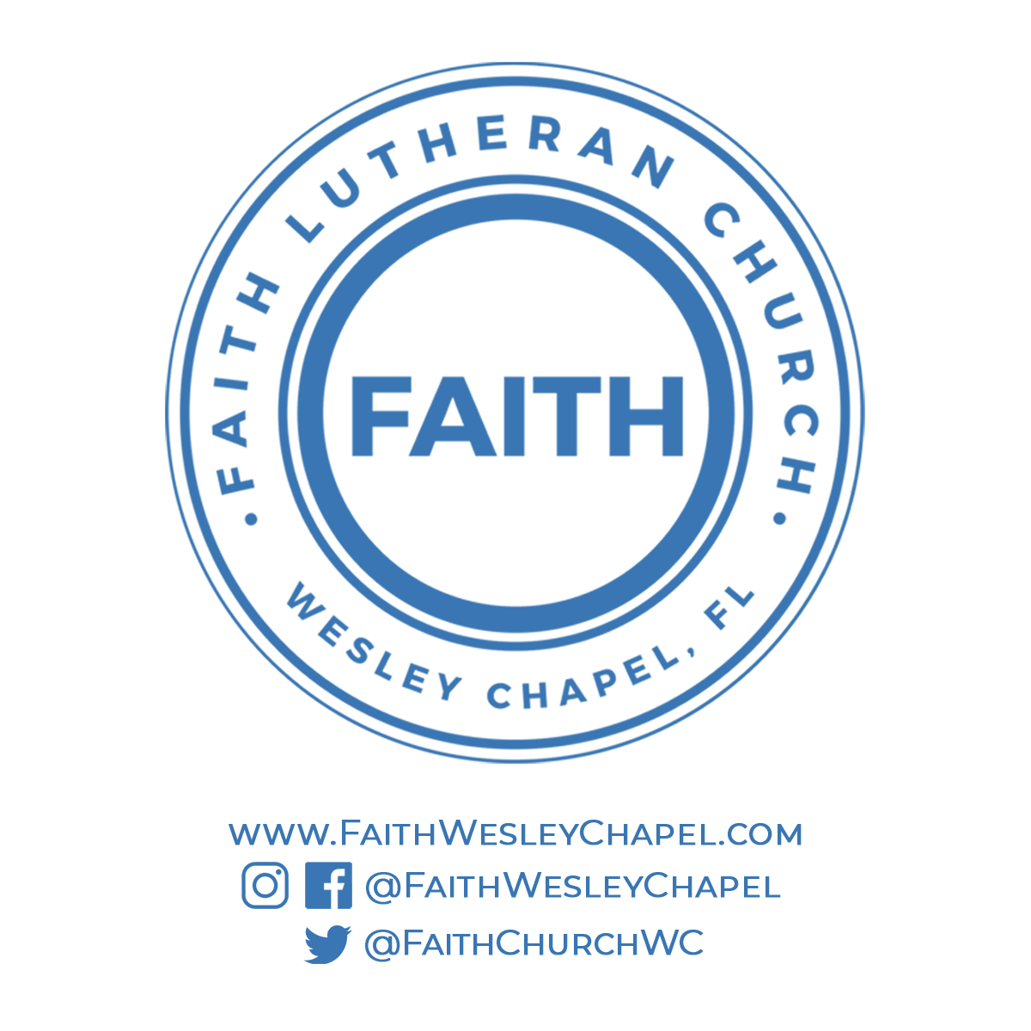**@FaithWesleyChapel**

**@FaithWesleyChapel**

**@FaithChurchWC**