

**Leading our community into a deep connection in Christ**

**Worship Service for September 24, 2023 at 11 AM**

**Invocation**

**Confession and Forgiveness:**

**P:** When we come into the presence of God we cannot help but see our sinfulness. God does not require us to cleanse our own sin and be perfect of our own power for, surely, we could never achieve this. Instead, He tells us to come just as we are to be cleansed and receive His great mercy.

**Song:** Just As I Am

Just as I am, without one plea,  
But that Thy blood was shed for me,  
And that Thou bidd'st me come to Thee,   
O Lamb of God, I come! I come!

Just as I am, and waiting not,  
To rid my soul of one dark blot,  
To Thee whose blood can cleanse each spot,  
O Lamb of God, I come! I come!

Just as I am, though tossed about,  
With many a conflict, many a doubt,  
Fightings and fears within, without, Lamb of God, I come! I come!

*(a time of silence to reflect and personally confess our sins)*

**C:** Heavenly Father, we confess that we have sinned against you and each other. We are truly sorry and we humbly repent. For the sake of your Son Jesus Christ and His suffering and death on the cross, please forgive us and help us to live according to Your ways. Amen

**Just As I Am Verse 4:**Just as I am, Thou wilt receive,  
Wilt welcome, pardon, cleanse, relieve,  
Because Thy promise I believe,  
O Lamb of God, I come! I come! © Public Domain

**P:** The Lord our God is merciful and gracious, longsuffering, and abounding in goodness and truth, keeping mercy for thousands, forgiving iniquity and transgression and sin. Therefore I announce unto you the grace of our Lord Jesus Christ. In His stead and by the command of my Lord Jesus Christ, I forgive you all your sins in the name of the Father and of the Son and of the Holy Spirit.  
**C:** Amen.

**Old Testament Reading -** Isaiah 55:6–9

“Seek the Lord while he may be found; call upon him while he is near; let the wicked forsake his way, and the unrighteous man his thoughts; let him return to the Lord, that he may have compassion on him, and to our God, for he will abundantly pardon.

For my thoughts are not your thoughts, neither are your ways my ways, declares the Lord. For as the heavens are higher than the earth, so are my ways higher than your ways and my thoughts than your thoughts.

**Reader:** This is the Word of the Lord.  
**C:** Thanks be to God.

**Gospel Reading -** Matthew 20:1-16

“For the kingdom of heaven is like a master of a house who went out early in the morning to hire laborers for his vineyard. After agreeing with the laborers for a denarius a day, he sent them into his vineyard. And going out about the third hour he saw others standing idle in the marketplace, and to them he said, ‘You go into the vineyard too, and whatever is right I will give you.’ So they went. Going out again about the sixth hour and the ninth hour, he did the same. And about the eleventh hour he went out and found others standing. And he said to them, ‘Why do you stand here idle all day?’ They said to him, ‘Because no one has hired us.’ He said to them, ‘You go into the vineyard too.’ And when evening came, the owner of the vineyard said to his foreman, ‘Call the laborers and pay them their wages, beginning with the last, up to the first.’ And when those hired about the eleventh hour came, each of them received a denarius. Now when those hired first came, they thought they would receive more, but each of them also received a denarius. And on receiving it they grumbled at the master of the house, saying, ‘These last worked only one hour, and you have made them equal to us who have borne the burden of the day and the scorching heat.’ But he replied to one of them, ‘Friend, I am doing you no wrong. Did you not agree with me for a denarius? Take what belongs to you and go. I choose to give to this last worker as I give to you. Am I not allowed to do what I choose with what belongs to me? Or do you begrudge my generosity?’ So the last will be first, and the first last.”

**P:** This is the Gospel of the Lord.  
**C:** Praise be to You, o Christ.

**Children's Message**

**Sermon Hymn -** I Will Follow

Where You go, I’ll go. Where You stay, I’ll stay.

When You move, I’ll move. I will follow...

All Your ways are good. All Your ways are sure.

I will trust in You alone.

Higher than my sight, high above my life, I will trust in You alone.

Chorus:

Where You go, I’ll go. Where You stay, I’ll stay.

When You move, I’ll move. I will follow You.

Who You love, I'll love. How You serve I'll serve.

If this life I lose, I will follow You, Yeah.

I will follow You.

Light unto the world, Light unto my life

I will live for You alone.

You're the one I seek knowing I will find,

All I need in You alone, in You alone.

*(Chorus)*

Bridge:

In You there's life everlasting. In You there's freedom for my soul.

In You there's joy, unending joy, and I will follow.

*(Chorus 2x)* *© 2010 SHOUT! Publishing, Vamos Publishing, and So Essential Tunes*

**Sermon -** "Same Gospel, Different Callings"

Romans 15:8-20

For I tell you that Christ became a servant to the circumcised to show God's truthfulness, in order to confirm the promises given to the patriarchs, and in order that the Gentiles might glorify God for his mercy.

As it is written, “Therefore I will praise you among the Gentiles, and sing to your name.”

And again it is said, “Rejoice, O Gentiles, with his people.”

And again, “Praise the Lord, all you Gentiles, and let all the peoples extol him.”

And again Isaiah says, “The root of Jesse will come, even he who arises to rule the Gentiles; in him will the Gentiles hope.”

May the God of hope fill you with all joy and peace in believing, so that by the power of the Holy Spirit you may abound in hope.

I myself am satisfied about you, my brothers, that you yourselves are full of goodness, filled with all knowledge and able to instruct one another. But on some points I have written to you very boldly by way of reminder, because of the grace given me by God to be a minister of Christ Jesus to the Gentiles in the priestly service of the gospel of God, so that the offering of the Gentiles may be acceptable, sanctified by the Holy Spirit. In Christ Jesus, then, I have reason to be proud of my work for God. For I will not venture to speak of anything except what Christ has accomplished through me to bring the Gentiles to obedience—by word and deed, by the power of signs and wonders, by the power of the Spirit of God—so that from Jerusalem and all the way around to Illyricum I have fulfilled the ministry of the gospel of Christ; and thus I make it my ambition to preach the gospel, not where Christ has already been named, lest I build on someone else's foundation,

**Reader:** This is the Word of the Lord.  
**C:** Thanks be to God.

**Prayers:** *Text in prayer requests to (813) 326-5255‬*

**Apostles' Creed** *(stand)*

I believe in God, the Father almighty, maker of heaven and earth,  
And in Jesus Christ, his only Son, our Lord,  
who was conceived by the Holy Spirit,  
born of the Virgin Mary, suffered under Pontius Pilate,  
was crucified, died and was buried. He descended into hell.  
The third day he rose again from the dead.  
He ascended into heaven and sits at the right hand of God  
the Father almighty.  
From there he will come to judge the living and the dead.  
I believe in the Holy Spirit, the holy Christian Church,  
the communion of saints, the forgiveness of sins,  
the resurrection of the body, and the life everlasting. Amen.

**The Lord's Prayer** *(stand)*

Our Father who art in heaven, hallowed be Thy name, Thy kingdom come, Thy will be done on earth as it is in heaven.  Give us this day our daily bread; and forgive us our trespasses as we forgive those who trespass against us; and lead us not into temptation, but deliver us from evil.  For Thine is the kingdom and the power and the glory forever and ever.  Amen

**Offering** *(sit)*

**Benediction** *– The online service ends. The closing hymn video is on the Livestream page bulletin at FaithWesleyChapel.com with lyrics below. See announcements below as well.*

**Closing Song -**We Are *(sit)*

Every secret, every shame, every fear, every pain,

Live inside the dark, but that’s not who we are.

We are children of the day.

Pre-Chorus:

So wake up sleeper, lift your head.

We were meant for more than this

Fight the shadows conquer death.

Make the most of the time we have left

Chorus:

We are the light of the world. We are the city on a hill

We are the light of the world

We gotta, we gotta, we gotta let the light shine

*(Repeat)*  
Let the light shine, let the light shine

We are called to the spread the news.  
Tell the world the simple truth.  
Jesus came to save. There’s freedom in His Name.  
So let it all break through

Chorus:

We are the light of the world. We are the city on a hill

We are the light of the world

We gotta, we gotta, we gotta let the light shine

*(Repeat)*  
Let the light shine, let the light shine

Bridge:  
We are the light we are the light we are the light  
So let your light shine brighter  
We the light we are the light we are the light... Jesus  
You are the light you are the light you are the light.  
We will lift you high and Shine, shine, shine

*(Chorus)* © 2011 Alletrop Music, Centricity Music Publishing

|  |  |
| --- | --- |
| **Serving This Week** | |
|  | |
| **O.T. Reader:** Josh Strasheim | **Children’s Church Teacher:** |
| **Epistle Reader:** N/A | Halston and Ben |
| **Acolyte:** Griffin Frost | **Children’s Church Assistant:** |
| **Com. Asst:** Larry Chmiel | N/A |
|  | |
| **Serving Next Week** | |
|  | |
| **1st Reader:** Kaylee Steinbrueck | **Children’s Church Teacher:** |
| **2nd Reader:** Katelyn Shuck | N/A – No Children’s Church |
| **Acolyte:** Lawrence Finerty | **Children’s Church Assistant:** |
| **Com. Asst:** Larry Chmiel | N/A – No Children’s Church |

**Upcoming Events**

**September 26, 7 PM – Growth Group**  
Renee’s Home - 3436 Chapel Creek Cir. Wesley Chapel, FL 33544. Gate: #7369 (Ch 2-3 of the book, A Week in the Life of Corinth)

**October 1, After the Service – Confirmation** *(Lessons 1 & 2)*  
Faith Lutheran Church

**October 8, After the Service – God Squad youth Group**  
Faith Lutheran Church

**October 28 & 29, 11 AM – 8 PM – Wesley Chapel Fall Festival**  
Tampa Premium Outlets (We’ll have a booth)

**www.FaithWesleyChapel.com**

**Faith YouTube**

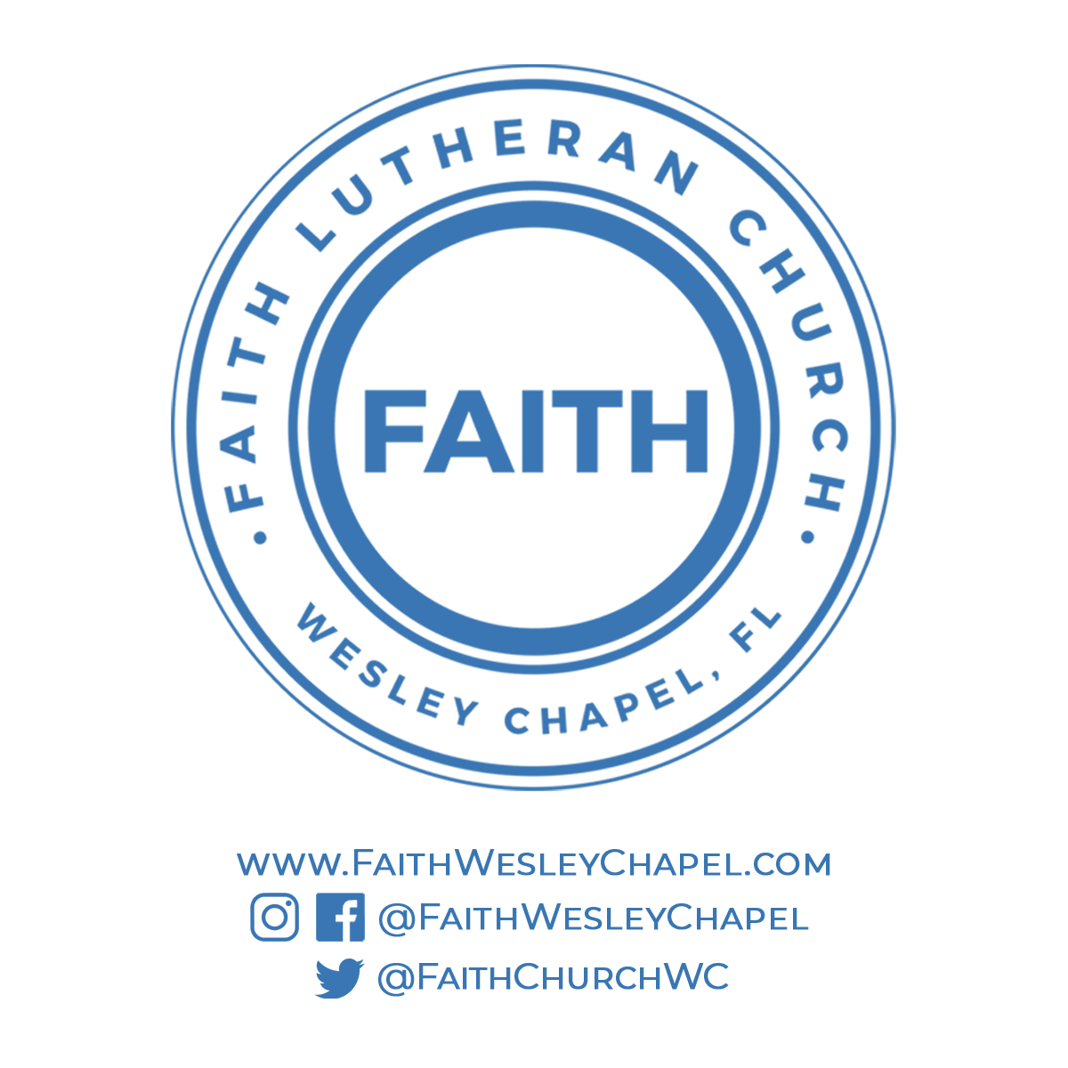**@FaithWesleyChapel**

**@FaithWesleyChapel**

**@FaithChurchWC**