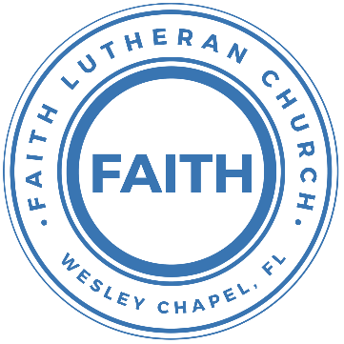

**Leading our community into a deep connection in Christ**

**Worship Service for October 1, 2023, at 11 AM**

**Opening Song:**Down In My Heart

I’ve got the joy, joy, joy, joy down in my heart, (where?)  
Down in my heart, (where?), down in my heart.  
I’ve got the joy, joy, joy, joy down in my heart, (where?)  
Down in my heart to stay.

Chorus:  
And I’m so happy, so very happy.   
I’ve got the love of Jesus in my heart.  
And I’m so happy, so very happy.   
I’ve got the love of Jesus in my heart

I’ve got the peace that passes understanding down in my heart…

*(Chorus)*

I’ve got the love of Jesus, love of Jesus, down in my heart…

*(Chorus)*

I’ve got the wonderful love of my blessed redeemer way down in the depths of my heart…

*(Chorus)* © Public Domain

**Invocation**

**Confession and Forgiveness:**

**P:** We have come here today to worship the Lord.  In worship we hear the Word of God, we receive God's blessings, and respond with thanks and praise.  We begin by seeking God's blessing of forgiveness.  He has promised to remove the guilt and shame of our sin through the sacrifice of Jesus Christ on the cross.

*(a time of silence to reflect and personally confess our sins)*

**P:** Let us confess our sins to the Lord.

**P:** Heavenly Father,  
**C:** Heavenly Father,

**P:** I have done things that were wrong.  
**C:** I have done things that were wrong.  
  
**P:** I have been mean to others.  
**C:** I have been mean to others.

**P:** I have not obeyed my parents.  
**C:** I have not obeyed my parents.

**P:** I have not obeyed You, God.  
**C:** I have not obeyed You, God.

**P:** But I am very sorry.  
**C:** But I am very sorry.

**P:** Please forgive me.  
**C:** Please forgive me.

**P:** I love You very much.  
**C:** I love You very much.

**P:** And I know You love me, too.  
**C:** And I know You love me, too.

**P:** Amen.  
**C:** Amen.

**P:** God has heard your apology.  He loves you very much.  God has told us that when we believe and trust in Him, He makes us His children.  As far as the east is from the west, so far does he remove our sins from us. He has told me to tell you that you are forgiven.  So, as His servant, I forgive you in the name of the Father and of the Son and of the Holy Spirit.   
**C:** Amen.

**Song:**Jesus Loves Me

Verse 1:

Jesus loves me this I know, For the Bible tells me so.

Little ones to Him belong, They are weak, but He is strong.

Chorus:

Yes, Jesus loves me, Yes, Jesus loves me,

Yes, Jesus loves me, The Bible tells me so.

Verse 2:

Jesus loves me, He who died. Heaven's gates to open wide.

He will wash away my sin, Let His little child come in.

*(Chorus)* © Public Domain

**First Reading -**Romans 16:17a (TLB)

And now there is one more thing to say before I end this letter. Stay away from those who cause divisions.

**Reader:** This is the Word of the Lord.  
**C:** Thanks be to God.

**Children's Message**"Remaining Friends"

**Song:**What a Friend

Everybody has trials and temptations.  
Everybody knows heartbreak, isolation.

Pre-Chorus:  
But we can lay our burdens down. Lay our burdens down.

Chorus:  
What a friend we have in Jesus. East to west my sins are gone.  
I see grace on every horizon.  
And forever and ever His heart is my home.

Everybody has fears, everybody got worries.  
Everybody knows sorrow, devastation.

Pre-Chorus:  
But we can lay our burdens down. Lay our burdens down.

(Chorus)

Bridge:  
No more betrayal, for He is faithful.  
He fills me up and my cup runneth over.  
No more betrayal, for He is faithful.  
How He has proven it over and over.  
(Repeat)

Chorus: (2x) © All Essential Music (Admin. by Essential Music Publishing LLC)

**Second Reading -**Romans 16:17 (ERV)

Brothers and sisters, I want you to be very careful of those who cause arguments and hurt people’s faith by teaching things that are against what you learned.

**Reader:** This is the Word of the Lord.  
**C:** Thanks be to God.

**Children's Message**"Love and Truth"

**Gospel Reading -**Matthew 21:23-27

And when he entered the temple, the chief priests and the elders of the people came up to him as he was teaching, and said, “By what authority are you doing these things, and who gave you this authority?” Jesus answered them, “I also will ask you one question, and if you tell me the answer, then I also will tell you by what authority I do these things. The baptism of John, from where did it come? From heaven or from man?” And they discussed it among themselves, saying, “If we say, ‘From heaven,’ he will say to us, ‘Why then did you not believe him?’ But if we say, ‘From man,’ we are afraid of the crowd, for they all hold that John was a prophet.” So they answered Jesus, “We do not know.” And he said to them, “Neither will I tell you by what authority I do these things.

**P:** This is the Gospel of the Lord.  
**C:** Praise be to You, o Christ.

**Sermon Hymn:**A Mighty Fortress Is Our God

A mighty fortress is our God, a bulwark never failing;

Our helper He, amid the flood of mortal ills prevailing.

For still our ancient foe does seek to work us woe;

His craft and power are great and armed with cruel hate.

On earth is not his equal.

Did we in our own strength confide our striving would be losing.

Were not the right Man on our side,  
The Man of God's own choosing.

You ask who that may be? Christ Jesus, it is he;

Lord Sabaoth His name, from age to age the same;

And He must win the battle.

And though this world, with devils filled, should threaten to undo us.

We will not fear, for God has willed,  
His truth to triumph through us.

The prince of darkness grim, we tremble not for him.

His rage we can endure, for lo! his doom is sure.

One little word shall fell him.

That Word above all earthly powers no thanks to them abideth;

The Spirit and the gifts are ours through Him who with us sideth.

Let goods and kindred go, this mortal life also.

The body they may kill: God's truth abideth still!

His kingdom is forever. © Public Domain

**Sermon –**“Guarding the Church Against Division and False Teachings”

**Prayers:** *Text in prayer requests to (813) 326-5255*

**The Lord's Prayer**

Our Father who art in heaven, hallowed be Thy name, Thy kingdom come, Thy will be done on earth as it is in heaven.  Give us this day our daily bread; and forgive us our trespasses as we forgive those who trespass against us; and lead us not into temptation, but deliver us from evil.  For Thine is the kingdom and the power and the glory forever and ever.  Amen

**Offering** *(sit)*

**Benediction** *– The online service ends. The closing hymn video is on the Livestream page bulletin at FaithWesleyChapel.com with lyrics below. See announcements below as well.*

**Closing Song:**Echo *(sit)*

When night has fallen, when fear is common,

Still You're calling me. When faith is lost and,

My hope exhausted, You will be my strength.

Pre-Chorus:

When my mind says I'm not good enough, God,  
You're enough for me.

I've decided I'm not giving up 'cause You won't give up on me.

You won't give up on me!

Chorus:

Your love is holding on and it won't let go.

I feel it breaking out like an echo.  
Your love is holding on and it won't let go.  
I feel it breaking out like an echo.

Post-Chorus:

Echo in my so-o-o-o-oul, So-o-o-o-oul.

Echo in my so-o-o-o-oul, So-o-o-o-oul.

Verse 2:

In every season You keep repeating promises to me.

Now there's no stopping what you have started,

Until it is complete.

Pre-Chorus:

When my mind says I'm not good enough, God,  
You're enough for me.

I've decided I'm not giving up 'cause You won't give up on me.

You won't give up on me!

Chorus:

Your love is holding on and it won't let go.

I feel it breaking out like an echo.  
Your love is holding on and it won't let go.  
I feel it breaking out like an echo.

Post-Chorus:

Echo in my so-o-o-o-oul, So-o-o-o-oul.

Echo in my so-o-o-o-oul, So-o-o-o-oul. © Elevation Worship Publishing

|  |  |
| --- | --- |
| **Serving This Week** | |
|  | |
| **1st Reader:** Kaylee Steinbrueck | **Children’s Church Teacher:** |
| **2nd Reader:** Katelyn Shuck | N/A – No Children’s Church |
| **Acolyte:** Lawrence Finerty | **Children’s Church Assistant:** |
| **Com. Asst:** Larry Chmiel | N/A – No Children’s Church |
|  | |
| **Serving Next Week** | |
|  | |
| **O.T. Reader:** Josh Strasheim | **Children’s Church Teacher:** |
| **Epistle Reader:** N/A | Halston and Ben |
| **Acolyte:** Griffin Frost | **Children’s Church Assistant:** |
| **Com. Asst:** Larry Chmiel | N/A |

**Hey Youth!!**Do you know any worship songs you’d like to sing as part of our youth service? Let Pastor Kurt know.

Do you want to sing or play an instrument? Let Pastor Kurt know.

We want you to be a part of the service.

**Upcoming Events**

**Today, After the Service – Confirmation** *(Lessons 1 & 2)*  
Faith Lutheran Church

**Oct. 8, 11 AM – Faith and Food Worship Service (Octoberfest)**  
Faith Lutheran Church

**Oct. 8, After the Service – God Squad youth Group**  
Faith Lutheran Church

**Oct. 10, 7 PM – Growth Group**  
Renee’s Home - (Ch 4-6 of the book, A Week in the Life of Corinth)

**Oct. 28 & 29, 11 AM – 8 PM – Wesley Chapel Fall Festival**  
Tampa Premium Outlets (We’ll have a booth)  
Sign-up for a time to man the booth.

**Nov. 5, After the Service – Faith’s 5-yr Birthday Celebration!**  
The Frosts

[**www.FaithWesleyChapel.com**](http://www.FaithWesleyChapel.com)

 **Faith YouTube**

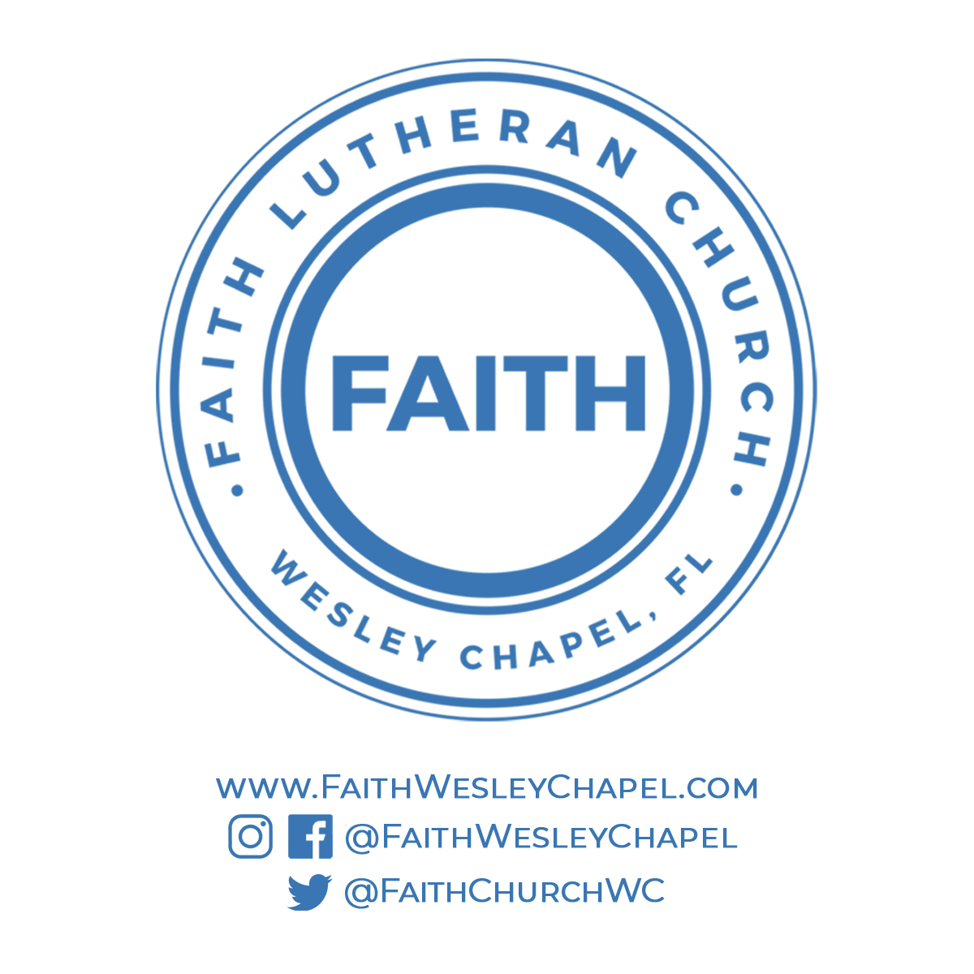**@FaithWesleyChapel**

**@FaithWesleyChapel**

**@FaithChurchWC**