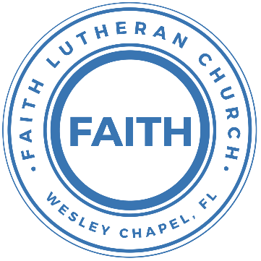

**Leading our community into a deep connection in Christ**

**Worship Service for October 8, 2023 at 11 AM**

**Welcome**

**Invocation** *(stand)*

**Confession and Forgiveness:** *(stand)*

**P:** As we gather, today, let us cleanse our hearts and our consciences by confessing our sin to God.

*(Time of silence for reflection and confession)*

**C:** Heavenly Father, we confess that we are sinful and unclean. We have sinned against you and against our neighbor in our thoughts, words, and actions.  We are truly sorry for our sins and sincerely repent of them. We ask for Your mercy. For the sake of Jesus Christ's bitter suffering and death, please forgive us and renew us that we may walk in Your Spirit to the glory of Your holy name. Amen

**P:** The Lord has heard your confession. Therefore, as a called and ordained servant of the Lord, in the stead and by the command of my Lord, Jesus Christ, I forgive you all your sins in the name of the Father and of the Son and of the Holy Spirit.  
**C:** Amen

**Song of Praise and Thanksgiving – Rock of Ages** *(sit)*

Rock of Ages, cleft for me, let me hide myself in Thee;  
Let the water and the blood,  
From thy wounded side which flowed,  
Be of sin the double cure; cleanse me from its guilt and power.

Not the labors of my hands can fulfill Thy law's demands;  
Could my zeal no respite know,  
Could my tears forever flow,  
All for sin could not atone; Thou must save, and Thou alone.

Nothing in my hand I bring, simply to Thy cross I cling;  
Naked, come to Thee for dress;  
Helpless, look to Thee for grace;  
Foul, I to the fountain fly; wash me, Savior, or I die.

While I draw this fleeting breath,  
When mine eyelids close in death,  
When I soar to worlds unknown,  
See Thee on thy judgment throne,  
Rock of Ages, cleft for me, let me hide myself in Thee. © Public Domain

**Epistle or Old Testament Reading:**Philippians 3:4-14

though I myself have reason for confidence in the flesh also. If anyone else thinks he has reason for confidence in the flesh, I have more: circumcised on the eighth day, of the people of Israel, of the tribe of Benjamin, a Hebrew of Hebrews; as to the law, a Pharisee; as to zeal, a persecutor of the church; as to righteousness under the law, blameless. But whatever gain I had, I counted as loss for the sake of Christ. Indeed, I count everything as loss because of the surpassing worth of knowing Christ Jesus my Lord. For his sake I have suffered the loss of all things and count them as rubbish, in order that I may gain Christ and be found in him, not having a righteousness of my own that comes from the law, but that which comes through faith in Christ, the righteousness from God that depends on faith—that I may know him and the power of his resurrection, and may share his sufferings, becoming like him in his death, that by any means possible I may attain the resurrection from the dead.

Not that I have already obtained this or am already perfect, but I press on to make it my own, because Christ Jesus has made me his own. Brothers, I do not consider that I have made it my own. But one thing I do: forgetting what lies behind and straining forward to what lies ahead, I press on toward the goal for the prize of the upward call of God in Christ Jesus.

**Reader:** This is the Word of the Lord.  
**C:** Thanks be to God.

**Sermon Song –** Cornerstone

My hope is built on nothing less,   
Than Jesus' blood and righteousness.  
I dare not trust the sweetest frame,   
But wholly trust in Jesus' name.

Chorus:

Christ alone, Cornerstone, Weak made strong in the Savior's love.

Through the storm He is Lord, Lord of all.

Verse 2:

When darkness seems to hide His face,

I rest on His unchanging grace.

In every high and stormy gale My anchor holds within the veil.

My anchor holds within the veil.

Chorus:

Christ alone, Cornerstone, Weak made strong in the Savior's love.

Through the storm He is Lord, Lord of all.

He is Lord. Lord of all.

Verse 3:

When He shall come with trumpet sound,

Oh, may I then in Him be found,

Dressed in His righteousness alone,

Faultless, stand before the throne.

*(Chorus)*  © 2011 Hillsong Music Publishing

**Sermon** – You Can be Broken or Crushed, but Never Unchanged

Matthew 21:33-46

“Hear another parable. There was a master of a house who planted a vineyard and put a fence around it and dug a winepress in it and built a tower and leased it to tenants, and went into another country. When the season for fruit drew near, he sent his servants to the tenants to get his fruit. And the tenants took his servants and beat one, killed another, and stoned another. Again he sent other servants, more than the first. And they did the same to them. Finally he sent his son to them, saying, ‘They will respect my son.’ But when the tenants saw the son, they said to themselves, ‘This is the heir. Come, let us kill him and have his inheritance.’ And they took him and threw him out of the vineyard and killed him. When therefore the owner of the vineyard comes, what will he do to those tenants?” They said to him, “He will put those wretches to a miserable death and let out the vineyard to other tenants who will give him the fruits in their seasons.”

Jesus said to them, “Have you never read in the Scriptures:

“‘The stone that the builders rejected  
 has become the cornerstone;  
this was the Lord's doing,  
 and it is marvelous in our eyes’?

Therefore I tell you, the kingdom of God will be taken away from you and given to a people producing its fruits. And the one who falls on this stone will be broken to pieces; and when it falls on anyone, it will crush him.”

When the chief priests and the Pharisees heard his parables, they perceived that he was speaking about them. And although they were seeking to arrest him, they feared the crowds, because they held him to be a prophet.

**P:** This is the Gospel of the Lord.  
**C:** Praise be to You, o Christ.

**Prayers**

**Apostles' Creed** *(stand)*

I believe in God, the Father almighty, maker of heaven and earth,  
And in Jesus Christ, his only Son, our Lord,  
who was conceived by the Holy Spirit,  
born of the Virgin Mary, suffered under Pontius Pilate,  
was crucified, died and was buried. He descended into hell.  
The third day he rose again from the dead.  
He ascended into heaven and sits at the right hand of God  
the Father almighty.  
From there he will come to judge the living and the dead.  
I believe in the Holy Spirit, the holy Christian Church,  
the communion of saints, the forgiveness of sins,  
the resurrection of the body, and the life everlasting. Amen.

**The Lord's Prayer** *(stand)*

Our Father who art in heaven, hallowed be Thy name, Thy kingdom come, Thy will be done on earth as it is in heaven.  Give us this day our daily bread; and forgive us our trespasses as we forgive those who trespass against us; and lead us not into temptation, but deliver us from evil.  For Thine is the kingdom and the power and the glory forever and ever.  Amen

**Benediction** *(stand)*

**Closing Song:** Praise God From Whom All Blessings Flow *(stand)*

Praise God from Whom all blessings flow.  
Praise Him all creatures here below.  
Praise Him above, ye heavenly hosts.  
Praise Father, Son and Holy Ghost.  
Amen © Public Domain

**Offering** *(sit)*

**Sermon Notes:**

**_______________________________________________**

**_______________________________________________**

**_______________________________________________**

**_______________________________________________**

**_______________________________________________**

**_______________________________________________**

**_______________________________________________**

**_______________________________________________**

**_______________________________________________**

**_______________________________________________**

**_______________________________________________**

**_______________________________________________**

**_______________________________________________**

**_______________________________________________**

|  |  |
| --- | --- |
| **Serving This Week** | |
|  | |
| **O.T. Reader:** N/A | **Children’s Church Teacher:** |
| **Epistle Reader:** Josh Strasheim | Halston and Ben |
| **Acolyte:** Griffin Frost | **Children’s Church Assistant:** |
| **Com. Asst:** Larry Chmiel | N/A |
|  | |
| **Serving Next Week** | |
|  | |
| **O.T. Reader:** Vanessa Frost | **Children’s Church Teacher:** |
| **Epistle Reader:** Terrell Jordan | Melissa Steinbrueck |
| **Acolyte:** Emily Shuck | **Children’s Church Assistant:** |
| **Com. Asst:** Larry Chmiel | Kaylee Steinbrueck |

**Upcoming Events**

**Oct. 8, After the Service – God Squad Youth Group**  
Faith Lutheran Church

**Oct. 10, 7 PM – Growth Group**  
Renee’s Home (Ch 4-6 of the book, A Week in the Life of Corinth)

**Oct. 15, After the Service – Confirmation** *(Lessons 3 & 4)*  
Faith Lutheran Church

**Oct. 17, 7 PM – Council Meeting**  
The Strasheims’ Home

**Oct. 28 & 29, 11 AM – 8 PM – Wesley Chapel Fall Festival**  
Tampa Premium Outlets (We’ll have a booth)  
Sign-up for a time to man the booth.

**Nov. 5, After the Service – Faith’s 5-yr Birthday Celebration!**  
The Frosts

**Dec. 2, 6 PM – Christmas at the Park (Save the Date!)**  
Wesley Chapel District Park

**www.FaithWesleyChapel.com**

**Faith YouTube**

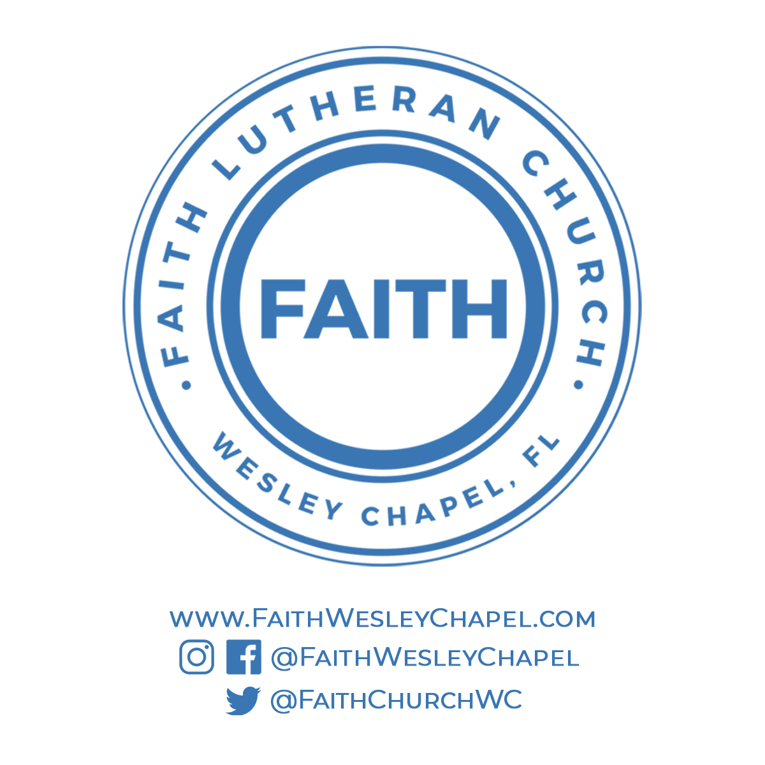**@FaithWesleyChapel**

**@FaithWesleyChapel**

**@FaithChurchWC**