

**Leading our community into a deep connection in Christ**

**Worship Service for October 15, 2023 at 11 AM**

**Welcome**

**Opening Song -** This Is My Father's World

This is my Father's world, and to my listening ears,  
All nature sings, and round me rings the music of the spheres.  
This is my Father's world. I rest me in the thought,  
Of rocks and trees, of skies and seas;  
His hand the wonders wrought.

This is my Father's world. The birds their carols raise.  
The morning light, the lily white, declare their Maker's praise.   
This is my Father's world. He shines in all that's fair.  
In the rustling grass I hear Him pass. He speaks to me everywhere.

This is my Father's world. O let me ne'er forget,  
That though the wrong seems oft so strong, God is the ruler yet. This is my Father's world. Why should my heart be sad?   
The Lord is King; let the heavens ring!   
God reigns; let the earth be glad!

This is my Father's world. Why should my heart be sad?   
The Lord is King; let the heavens ring!   
God reigns; let the earth be glad!

*(Repeat last 2 lines)* © 2005 Maranatha! Music, Nickeldimeus Music, and LAVIKMUSIC

**Invocation**

**Confession and Forgiveness:**

**P:** Our Heavenly Father asks us to come into His presence.  
**C:** But we are sinful and unworthy.

**P:** Yes, all have sinned and fall short of the glory of God, but Jesus Christ died on the cross that we may be forgiven and washed clean of all our sins by His blood.  
**C:** Lord, if You wash us, we will certainly be clean and pure.

*(Time of silence for reflection and confession)*

**P:** Let us confess, together, our sins to God our Father.  
**C:** Heavenly Father, we confess that we are sinners.  We have sinned against you and our neighbors. We have not loved you with our whole heart and we have not loved our neighbors as ourselves. We have not lived out our faith in our community. We justly deserve Your punishment.  For the sake of Your Son, Jesus Christ, have mercy on us.  Forgive us, renew us, and lead us, so that we may delight in Your will and walk in Your ways to the glory of Your holy name.  Amen.

**P:** Almighty God in His mercy has given His Son to die for you and for His sake forgives you all your sins.  As a called and ordained servant of Christ, and by His authority, I, therefore, forgive you all your sins in the name of the Father and of the Son and of the Holy Spirit.  
**C:** Amen

**Song of Praise and Thanksgiving:** This Is the Feast

Refrain:  
This is the feast of victory for our God. Alleluia, alleluia, alleluia.

Worthy is Christ, the Lamb who was slain,  
Whose blood set us free to be people of God.   
*(Refrain)*

Power, riches, wisdom, and strength,  
And honor, blessing, and glory are His. *(Refrain)*

Sing with all the people of God,  
And join in the hymn of all creation;

“Blessing, honor, glory, and might,  
Be to God and the Lamb forever. Amen.”   
*(Refrain)*

For the Lamb who was slain has begun his reign. Alleluia!  
*(Refrain)* © 2008 Sharon Dennis, Doris Au MacDonald, and Lutheran Book of Worship

**Epistle Reading** - Philippians 4:4-7

Rejoice in the Lord always; again I will say, rejoice. Let your reasonableness be known to everyone. The Lord is at hand; do not be anxious about anything, but in everything by prayer and supplication with thanksgiving let your requests be made known to God. And the peace of God, which surpasses all understanding, will guard your hearts and your minds in Christ Jesus.

**Reader:** This is the Word of the Lord.  
**C:** Thanks be to God.

**Gospel Reading** - Matthew 22:1-14

And again Jesus spoke to them in parables, saying, “The kingdom of heaven may be compared to a king who gave a wedding feast for his son, and sent his servants to call those who were invited to the wedding feast, but they would not come. Again he sent other servants, saying, ‘Tell those who are invited, “See, I have prepared my dinner, my oxen and my fat calves have been slaughtered, and everything is ready. Come to the wedding feast.”’ But they paid no attention and went off, one to his farm, another to his business, while the rest seized his servants, treated them shamefully, and killed them. The king was angry, and he sent his troops and destroyed those murderers and burned their city. Then he said to his servants, ‘The wedding feast is ready, but those invited were not worthy. Go therefore to the main roads and invite to the wedding feast as many as you find.’ And those servants went out into the roads and gathered all whom they found, both bad and good. So the wedding hall was filled with guests.

“But when the king came in to look at the guests, he saw there a man who had no wedding garment. And he said to him, ‘Friend, how did you get in here without a wedding garment?’ And he was speechless. Then the king said to the attendants, ‘Bind him hand and foot and cast him into the outer darkness. In that place there will be weeping and gnashing of teeth.’ For many are called, but few are chosen.”

**P:** This is the Gospel of the Lord.  
**C:** Praise be to You, o Christ.

**Children's Message** *(Children dismissed to Children's Church)*

**Sermon Hymn***–*How Great Thou Art

O Lord my God when I in awesome wonder,

Consider all the works Thy hand has made.

I see the stars. I hear the rolling thunder.

Your power throughout the universe displayed.

Chorus:

Then sings my soul, my Savior God to Thee.

How great Thou art! How great Thou art!

Then sings my soul, my Savior God to Thee.

How great Thou art! How great Thou art!

And when I think that God His Son not sparing;

Sent Him to die. I scarce can take it in;

That on the Cross, my burden gladly bearing,

He bled and died to take away my sin.

*(Chorus)*

When Christ shall come with shout of acclamation,

And take me home, what joy shall fill my heart.

Then I shall bow in humble adoration,

And then proclaim: "My God, how great Thou art!"

*(Chorus)* © 1949 and 1953 Manna Music, Inc.

**Sermon** - "You're Invited to a Great Feast"

Isaiah 25:6–9

On this mountain the Lord of hosts will make for all peoples  
 a feast of rich food, a feast of well-aged wine,  
 of rich food full of marrow, of aged wine well refined.  
And he will swallow up on this mountain  
 the covering that is cast over all peoples,  
 the veil that is spread over all nations.  
He will swallow up death forever;  
and the Lord God will wipe away tears from all faces,  
 and the reproach of his people he will take away from all the earth,  
 for the Lord has spoken.  
It will be said on that day,  
 “Behold, this is our God; we have waited for him, that he might save us.  
 This is the Lord; we have waited for him;  
 let us be glad and rejoice in his salvation.”

**P:** This is the Word of the Lord.  
**C:** Thanks be to God.

**Prayers:** *Text in prayer requests to (813) 326-5255*

**Nicene Creed** *(stand)*

I believe in one God, the Father Almighty, maker of heaven and earth and of all things visible and invisible.

And in one Lord Jesus Christ, the only-begotten Son of God, begotten of His Father before all worlds, God of God, Light of Light, very God of very God, begotten, not made, being of one substance with the Father, by whom all things were made; who for us men and for our salvation came down from heaven and was incarnate by the Holy Spirit of the virgin Mary and was made man; and was crucified also for us under Pontius Pilate. He suffered and was buried. And the third day He rose again according to the Scriptures and ascended into heaven and sits at the right hand of the Father. And He will come again with glory to judge both the living and the dead, whose kingdom will have no end.

And I believe in the Holy Spirit, the Lord and Giver of Life, who proceeds from the Father and the Son, who with the Father and the Son together is worshiped and glorified, who spoke by the prophets. And I believe in one holy Christian and apostolic Church, I acknowledge one Baptism for the remission of sins, and I look for the resurrection of the dead and the life of the world to come. Amen.

**The Lord's Prayer** *(stand)*

Our Father who art in heaven, hallowed be Thy name, Thy kingdom come, Thy will be done on earth as it is in heaven.  Give us this day our daily bread; and forgive us our trespasses as we forgive those who trespass against us; and lead us not into temptation, but deliver us from evil.  For Thine is the kingdom and the power and the glory forever and ever.  Amen

**Offering** *(sit)*

**Words of Institution** *(stand)*

**Peace** *(stand)*

**P:** The peace of the Lord be with you all.  
**C:** And also, with you.  
**P:** We greet each other in the peace of Christ.

**Distribution**

**Prayer** *(stand)*

**Benediction** *(stand)*

**Closing Song:**King Of Kings *(sit)*

In the darkness we were waiting, without hope, without light,

Till from heaven You came running. There was mercy in Your eyes.

To fulfil the law and prophets, to a virgin came the Word;

From a throne of endless glory to a cradle in the dirt.

Chorus:

Praise the Father, Praise the Son, Praise the Spirit, Three in One!

God of glory, Majesty. Praise forever to the King of Kings!

To reveal the kingdom coming and to reconcile the lost,

To redeem the whole creation, You did not despise the cross.

For even in your suffering You saw to the other side.

Knowing this was our salvation, Jesus, for our sake, You died

*(Chorus)*

And the morning that You rose all of heaven held its breath,

Till that stone was moved for good; for the Lamb had conquered death.

And the dead rose from their tombs. And the angels stood in awe, For the souls of all who'd come to the Father are restored.

And the church of Christ was born. Then, the Spirit lit the flame.

Now this Gospel truth of old shall not kneel, shall not faint.

By His blood and in His name, in His freedom, I am free;

For the love of Jesus Christ who has resurrected me.

*(Chorus 2x)* © 2018 Hillsong Music Publishing

|  |  |
| --- | --- |
| **Serving This Week** | |
|  | |
| **O.T. Reader:** N/A | **Children’s Church Teacher:** |
| **Epistle Reader:** Terrell Jordan | Melissa Steinbrueck |
| **Acolyte:** Emily Shuck | **Children’s Church Assistant:** |
| **Com. Asst:** Larry Chmiel | Kaylee Steinbrueck |
|  | |
| **Serving Next Week** | |
|  | |
| **O.T. Reader:** Vanessa Frost | **Children’s Church Teacher:** |
| **Epistle Reader:** Ginger Dunn | Terrell Jordan |
| **Acolyte:** Kaylee Steinbrueck | **Children’s Church Assistant:** |
| **Com. Asst:** Larry Chmiel | Emily Shuck |

**Upcoming Events**

**Today, After the Service – Confirmation** *(Lessons 3 & 4)*  
Faith Lutheran Church

**Oct. 17, 7 PM – Council Meeting**  
The Strasheims’ Home

**Oct 22, After the Service – Voter Meeting**  
Faith Lutheran Church

**Oct. 24, 7 PM – Growth Group**  
Renee’s Home (Ch 7-9 of the book, A Week in the Life of Corinth)

**Oct. 28 & 29, 11 AM – 8 PM – Wesley Chapel Fall Festival**  
Tampa Premium Outlets (We’ll have a booth)  
Sign-up for a time to volunteer at the booth.

**Nov. 5, After the Service – Faith’s 5-yr Birthday Celebration!**  
The Frosts

**Dec. 2, 6 PM – Christmas at the Park (Save the Date!)**  
Wesley Chapel District Park

**www.FaithWesleyChapel.com**

**Faith YouTube**

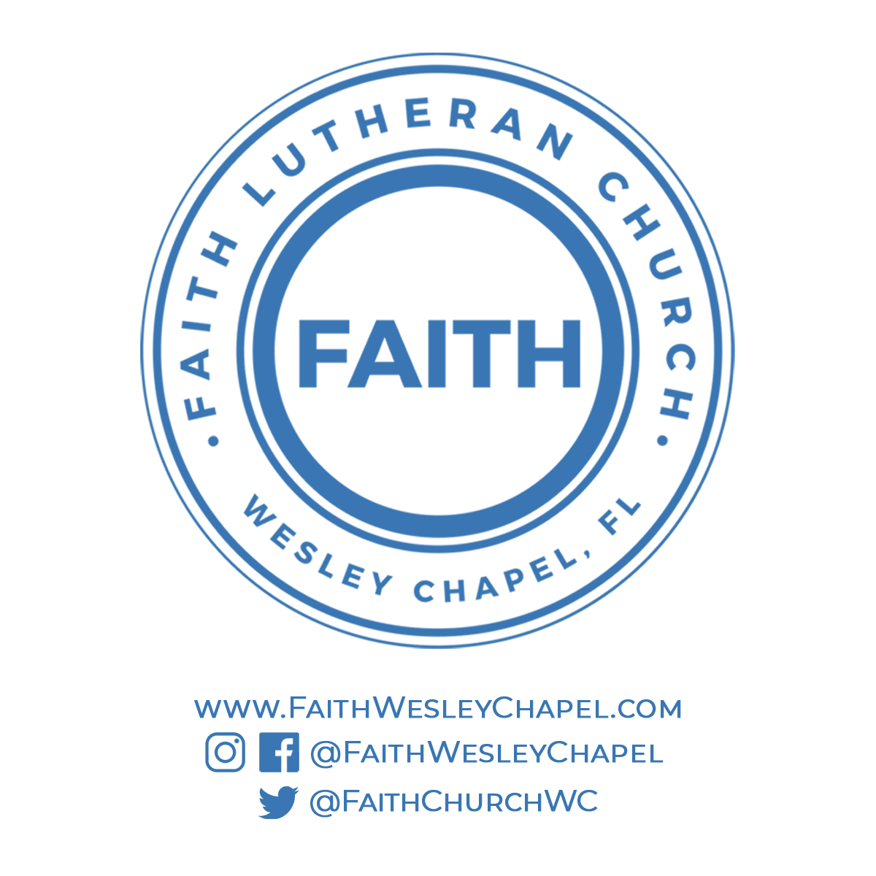**@FaithWesleyChapel**

**@FaithWesleyChapel**

**@FaithChurchWC**