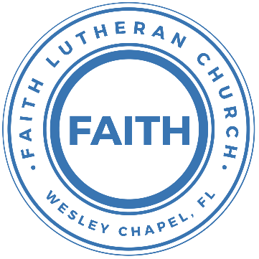

**Leading our community into a deep connection in Christ**

**Worship Service for October 22, 2023, at 11 AM**

**Welcome**

**Invocation**

**Confession and Forgiveness:**

**P:** When we come into the presence of God we cannot help but see our sinfulness. God does not require us to cleanse our own sin and be perfect of our own power for, surely, we could never achieve this. Instead, He tells us to come as we are and receive His great mercy.

**Song:** Come As You Are

Verse 1:

Come out of sadness from wherever you've been.

Come broken hearted let rescue begin.

Come find your mercy. Oh, sinner come kneel.

Earth has no sorrow that Heaven can't heal.

Earth has no sorrow that Heaven can't heal.

Chorus:

So, lay down your burdens, lay down your shame.

All who are broken, lift up your face.

Oh, wanderer come home. You're not too far.

So, lay down your hurt. Lay down your heart.

Come as you are.

Verse 2:

There's hope for the hopeless, and all those who've strayed.

Come sit at the table. Come taste of the grace.

There's rest for the weary, rest that endures.

Earth has no sorrow that Heaven can't cure.

Chorus:

So, lay down your burdens, lay down your shame.

All who are broken, lift up your face.

Oh, wanderer come home. You're not too far.

So, lay down your hurt. Lay down your heart.

Come as you are.

Bridge:

Come as you are. Fall in his arms. Come as you are.

*(a time of silence to reflect and personally confess our sins)*

**C:** Heavenly Father, we confess that we have sinned against you and each other. We are truly sorry and we humbly repent. For the sake of your Son Jesus Christ and His suffering and death on the cross, please forgive us and help us to live according to Your ways. Amen

Verse 3:

There's joy for the morning. Oh, sinner be still.

Earth has no sorrow that Heaven can't heal.

Earth has no sorrow that Heaven can't heal.

*(Chorus)* *© 2014 9 © t One Songs (Admin. by EMI Christian Music Publishing)*

**P:** The Lord our God is merciful and gracious, longsuffering, and abounding in goodness and truth, keeping mercy for thousands, forgiving iniquity and transgression and sin. Therefore, I announce unto you the grace of our Lord Jesus Christ. In His stead and by the command of my Lord Jesus Christ, I forgive you all your sins in the name of the Father and of the Son and of the Holy Spirit.  
**C:** Amen.

**Song of Praise and Thanksgiving -** 10,000 Reasons (Bless The Lord)

Chorus:

Bless the Lord, O my soul, O my soul, Worship His holy name.

Sing like never before, 0 my soul. I'll worship Your holy name.

The sun comes up, it's a new day dawning;

It's time to sing Your song again.

Whatever may pass, and whatever lies before me,

Let me be singing when the evening comes.

*(Chorus)*

You're rich in love, and You're slow to anger.

Your name is great, and Your heart is kind.

For all Your goodness, I will keep on singing;

Ten thousand reasons for my heart to find.

Chorus:

Bless the Lord, O my soul, O my soul, Worship His holy name.

Sing like never before, 0 my soul. I'll worship Your holy name.

And on that day when my strength is failing,

The end draws near, and my time has come;

Still my soul will sing Your praise unending:

Ten thousand years and then forevermore! Forevermore!  
*(Chorus)*

I'll worship Your holy name. Yes, I'll worship Your holy name. © 2011 Thankyou Music

**Old Testament Reading -** Isaiah 45:1–7

Thus says the Lord to his anointed, to Cyrus,  
 whose right hand I have grasped,  
to subdue nations before him  
 and to loose the belts of kings,  
to open doors before him  
 that gates may not be closed:  
“I will go before you  
 and level the exalted places,  
I will break in pieces the doors of bronze  
 and cut through the bars of iron,  
I will give you the treasures of darkness  
 and the hoards in secret places,  
that you may know that it is I, the Lord,  
 the God of Israel, who call you by your name.  
For the sake of my servant Jacob,  
 and Israel my chosen,  
I call you by your name,  
 I name you, though you do not know me.  
I am the Lord, and there is no other,  
 besides me there is no God;  
 I equip you, though you do not know me,  
that people may know, from the rising of the sun  
 and from the west, that there is none besides me;  
 I am the Lord, and there is no other.  
I form light and create darkness;  
 I make well-being and create calamity;  
 I am the Lord, who does all these things.

**Reader:** This is the Word of the Lord.  
**C:** Thanks be to God.

**Epistle Reading -** 1 Thessalonians 1

Paul, Silvanus, and Timothy,

To the church of the Thessalonians in God the Father and the Lord Jesus Christ: Grace to you and peace.

We give thanks to God always for all of you, constantly mentioning you in our prayers, remembering before our God and Father your work of faith and labor of love and steadfastness of hope in our Lord Jesus Christ. For we know, brothers loved by God, that he has chosen you, because our gospel came to you not only in word, but also in power and in the Holy Spirit and with full conviction. You know what kind of men we proved to be among you for your sake. And you became imitators of us and of the Lord, for you received the word in much affliction, with the joy of the Holy Spirit, so that you became an example to all the believers in Macedonia and in Achaia. For not only has the word of the Lord sounded forth from you in Macedonia and Achaia, but your faith in God has gone forth everywhere, so that we need not say anything. For they themselves report concerning us the kind of reception we had among you, and how you turned to God from idols to serve the living and true God, and to wait for his Son from heaven, whom he raised from the dead, Jesus who delivers us from the wrath to come.

**Reader:** This is the Word of the Lord.  
**C:** Thanks be to God.

**Children's Message**

**Sermon Hymn -** Give Thanks

Give thanks with a grateful heart. Give thanks to the Holy One.

Give thanks because He's given Jesus Christ, His son.

(repeat)

And now let the weak say I am strong, let the poor say I am rich,

Because of what the Lord has done for us.

(repeat)

Give thanks. Give thanks. We give thanks. © 1978 Integrity's Hosanna! Music

**Sermon -** " Render Unto God What Is God's"

Matthew 22:15-22

Then the Pharisees went and plotted how to entangle him in his words. And they sent their disciples to him, along with the Herodians, saying, “Teacher, we know that you are true and teach the way of God truthfully, and you do not care about anyone's opinion, for you are not swayed by appearances. Tell us, then, what you think. Is it lawful to pay taxes to Caesar, or not?” But Jesus, aware of their malice, said, “Why put me to the test, you hypocrites? Show me the coin for the tax.” And they brought him a denarius. And Jesus said to them, “Whose likeness and inscription is this?” They said, “Caesar's.” Then he said to them, “Therefore render to Caesar the things that are Caesar's, and to God the things that are God's.” When they heard it, they marveled. And they left him and went away.

**P:** This is the Gospel of the Lord.  
**C:** Praise be to You, O Christ.

**Prayers:** *Text in prayer requests to (813) 326-5255‬*

**Apostles' Creed** *(stand)*

I believe in God, the Father almighty, maker of heaven and earth,  
And in Jesus Christ, his only Son, our Lord,  
who was conceived by the Holy Spirit,  
born of the Virgin Mary, suffered under Pontius Pilate,  
was crucified, died and was buried. He descended into hell.  
The third day he rose again from the dead.  
He ascended into heaven and sits at the right hand of God  
the Father almighty.  
From there he will come to judge the living and the dead.  
I believe in the Holy Spirit, the holy Christian Church,  
the communion of saints, the forgiveness of sins,  
the resurrection of the body, and the life everlasting. Amen.

**The Lord's Prayer** *(stand)*

Our Father who art in heaven, hallowed be Thy name, Thy kingdom come, Thy will be done on earth as it is in heaven.  Give us this day our daily bread; and forgive us our trespasses as we forgive those who trespass against us; and lead us not into temptation, but deliver us from evil.  For Thine is the kingdom and the power and the glory forever and ever.  Amen

**Offering** *(sit)*

**Words of Institution** *(stand)*

**Peace** *(stand)*

**P:** The peace of the Lord be with you all.  
**C:** And also, with you.  
**P:** We greet each other in the peace of Christ.

**Distribution**

**Prayer** *(stand)*

**Benediction** *(stand)*

**Closing Song -**The Earth is the Lord’s *(sit)*

The earth is the Lord’s and the fullness thereof.

Redemption reminds us, O God, of your love.

By grace we are learning, as year leads to year.

We’re called to be stewards, your caretakers here.

Too often, O God, we abuse your good earth.

We fail to remember its beauty and worth.

We take from creation much more than we need,

We threaten your mission through excess and greed.

May we be good stewards of all that you give

Extending your Gospel wherever we live.

May we be a church that renews and restores

And lovingly cares for these gifts that are yours. © Public Domain

|  |  |
| --- | --- |
| **Serving This Week** | |
|  | |
| **O.T. Reader:** Vanessa Frost | **Children’s Church Teacher:** |
| **Epistle Reader:** Ginger Dunn | Terrell Jordan |
| **Acolyte:** Kaylee Steinbrueck | **Children’s Church Assistant:** |
| **Com. Asst:** Larry Chmiel | Emily Shuck |
|  | |
| **Serving Next Week** | |
|  | |
| **O.T. Reader:** Josh Strasheim | **Children’s Church Teacher:** |
| **Epistle Reader:** Terrell Jordan | Melissa Steinbrueck |
| **Acolyte:** Lawrence Finnerty | **Children’s Church Assistant:** |
| **Com. Asst:** Larry Chmiel | Kaylee Steinbrueck |

**Upcoming Events**

**Today, After the Service – Voter Meeting**  
Faith Lutheran Church

**Oct. 24, 7 PM – Growth Group**  
Renee’s Home - (Ch 7-9 of the book, A Week in the Life of Corinth)

**Oct. 28 & 29, 11 AM – 8 PM – Wesley Chapel Fall Festival**  
Tampa Premium Outlets (We’ll have a booth)  
Sign-up for a time to volunteer at the booth.

**Nov. 5, After the Service – Faith’s 5-yr Birthday Celebration!**  
The Frosts

**Dec. 2, 6 PM – Christmas at the Park (Save the Date!)**  
Wesley Chapel District Park

[**www.FaithWesleyChapel.com**](http://www.FaithWesleyChapel.com)

 **Faith YouTube**

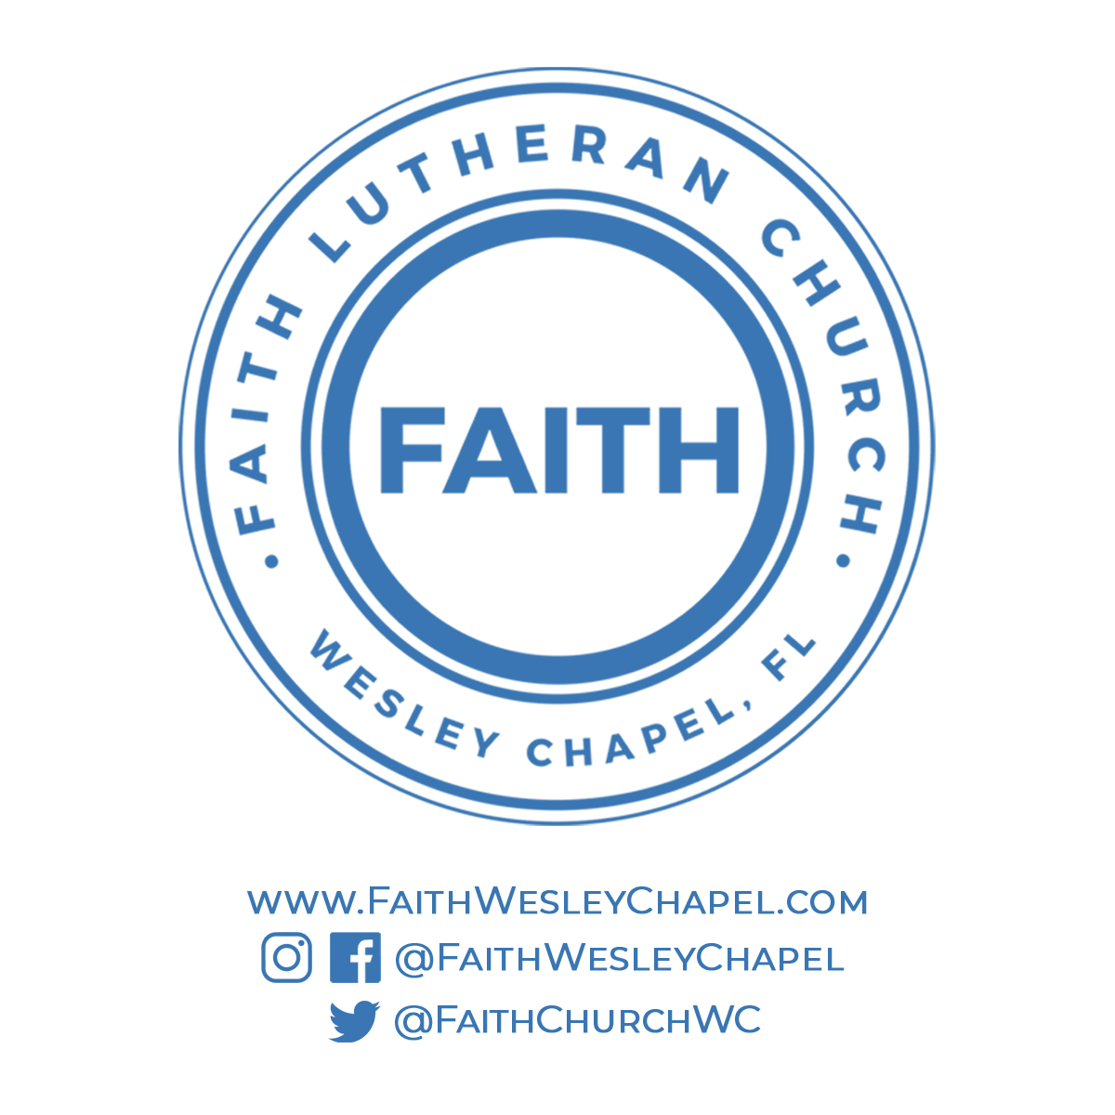**@FaithWesleyChapel**

**@FaithWesleyChapel**

**@FaithChurchWC**