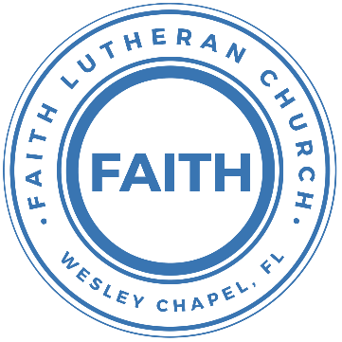

**Leading our community into a deep connection in Christ**

**Worship Service for October 29, 2023 at 11 AM**

**Welcome**

**Opening Song:**God So Loved

Come all you weary. Come all you thirsty.

Come to the well that never runs dry.

Drink of the Water. Come and thirst no more.

Come all you sinners. Come find His mercy.

Come to the table. He Will satisfy.

Taste of His goodness. Find what you’re looking for.

Chorus 1:

For God so loved the World that He gave us,

His one and only Son to save us.

Whoever believes in Him, will live forever.

Bring all your failures. Bring your addictions.

Come lay them down at the Foot of the cross.

Jesus is waiting there with open arms.

*(Chorus 1)*

Chorus 2:

The power of Hell forever defeated.

Now, it is well. I’m Walking in freedom.

For God so loved, God so loved the world.

Bridge:

Praise God! Praise God from whom all blessings flow.

Praise Him! Praise Him for the wonders of His love.

*(Repeat)*

His amazing love!

Chorus 1:

For God so loved the World that He gave us,

His one and only Son to save us.

Whoever believes in Him, will live forever.

Chorus 2:

The power of Hell forever defeated.

Now, it is well. I’m Walking in freedom.

For God so loved, God so loved the world.

Bring all your failures. Bring your addictions.

Come lay them down at the Foot of the cross.

Jesus is waiting there with open arms. © 2019 Andrew Bergthold Designee

**Invocation**

**Confession and Forgiveness:**

**P:** Come into the presence of God. It is God, Himself, who bids us to come to Him in prayer, especially when we have sinned, so that we may receive His forgiveness. So, we enter His courts with confidence that if we confess our sins, He will forgive us as He promised.

*(A time of silence to reflect and personally confess our sins)*

**C:** Heavenly Father, we confess that we have sinned against you in thought, word, and deed. We have not loved you with our whole heart and have not loved our neighbor as ourselves. We are truly sorry and we humbly repent. For the sake of your Son Jesus Christ and His suffering and death on the cross, have mercy on us and forgive us; that we may delight in your will, and walk in your ways, to the glory of your Name. Amen

**P:** The Lord our God is merciful and gracious, longsuffering, and abounding in goodness and truth, keeping mercy for thousands, forgiving iniquity and transgression and sin. Therefore, I announce unto you the grace of our Lord Jesus Christ. In His stead and by the command of my Lord Jesus Christ, I forgive you all your sins in the name of the Father and of the Son and of the Holy Spirit.

**C:** Amen.

**Song of Praise and Thanksgiving -** Amazing Grace

Amazing grace, how sweet the sound that saved a wretch like me.

I once was lost, but now am found. Was blind but now I see.

T'was grace that taught my heart to fear,

And grace my fears relieved.

How precious did that grace appear, the hour I first believed.

When we've been there ten thousand years,  
bright shining as the sun,

we've no less days to sing God’s praise,  
than when we've first begun. © Public Domain

**First Reading -** Revelation 14:6-7

Then I saw another angel flying directly overhead, with an eternal gospel to proclaim to those who dwell on earth, to every nation and tribe and language and people. And he said with a loud voice, “Fear God and give him glory, because the hour of his judgment has come, and worship him who made heaven and earth, the sea and the springs of water.”

**Reader:** This is the Word of the Lord.  
**C:** Thanks be to God.

**Second Reading -** Romans 3:19-28

Now we know that whatever the law says it speaks to those who are under the law, so that every mouth may be stopped, and the whole world may be held accountable to God. For by works of the law no human being will be justified in his sight, since through the law comes knowledge of sin.

But now the righteousness of God has been manifested apart from the law, although the Law and the Prophets bear witness to it — the righteousness of God through faith in Jesus Christ for all who believe. For there is no distinction: for all have sinned and fall short of the glory of God, and are justified by his grace as a gift, through the redemption that is in Christ Jesus, whom God put forward as a propitiation by his blood, to be received by faith. This was to show God's righteousness, because in his divine forbearance he had passed over former sins. It was to show his righteousness at the present time, so that he might be just and the justifier of the one who has faith in Jesus.

Then what becomes of our boasting? It is excluded. By what kind of law? By a law of works? No, but by the law of faith. For we hold that one is justified by faith apart from works of the law.

**Reader:** This is the Word of the Lord.  
**C:** Thanks be to God.

**Children's Message** *(Children dismissed to Children's Church)*

**Sermon Hymn -** The Church’s One Foundation

The church's one foundation is Jesus Christ, her Lord;

she is his new creation by water and the Word:

from heav'n he came and sought her to be his holy bride;

with his own blood he bought her, and for her life he died.

Elect from ev’ry nation, yet one o'er all the earth,

her charter of salvation one Lord, one faith, one birth;

one holy name she blesses, partakes one holy food,

and to one hope she presses, with ev'ry grace endued.

Though with a scornful wonder the world sees her oppressed,

by schisms rent asunder, by here-sies distressed,

yet saints their watch are keeping, their cry goes up, "How long?"

And soon the night of weeping shall be the morn of song.

Yet she on earth hath union with God the Three in One,

and mystic sweet communion with those whose rest is won:

O blessed heav'nly chorus! Lord, save us by Your grace,

that we, like saints before us, may see You face to face.

© Public Domain

**Sermon -** " The Truth, the Whole Truth, and Nothing but the Truth"

John 8:31–36

So Jesus said to the Jews who had believed him, “If you abide in my word, you are truly my disciples, and you will know the truth, and the truth will set you free.” They answered him, “We are offspring of Abraham and have never been enslaved to anyone. How is it that you say, ‘You will become free’?”

Jesus answered them, “Truly, truly, I say to you, everyone who practices sin is a slave to sin. The slave does not remain in the house forever; the son remains forever. So if the Son sets you free, you will be free indeed.

**P:** This is the Gospel of the Lord.  
**C:** Praise be to You, o Christ.

**Prayers:** *Text in prayer requests to (813) 326-5255‬*

**Nicene Creed** *(stand)*

I believe in one God, the Father Almighty, maker of heaven and earth and of all things visible and invisible.

And in one Lord Jesus Christ, the only-begotten Son of God, begotten of His Father before all worlds, God of God, Light of Light, very God of very God, begotten, not made, being of one substance with the Father, by whom all things were made; who for us men and for our salvation came down from heaven and was incarnate by the Holy Spirit of the virgin Mary and was made man; and was crucified also for us under Pontius Pilate. He suffered and was buried. And the third day He rose again according to the Scriptures and ascended into heaven and sits at the right hand of the Father. And He will come again with glory to judge both the living and the dead, whose kingdom will have no end.

And I believe in the Holy Spirit, the Lord and Giver of Life, who proceeds from the Father and the Son, who with the Father and the Son together is worshiped and glorified, who spoke by the prophets. And I believe in one holy Christian and apostolic Church, I acknowledge one Baptism for the remission of sins, and I look for the resurrection of the dead and the life of the world to come. Amen.

**The Lord's Prayer** *(stand)*

Our Father who art in heaven, hallowed be Thy name, Thy kingdom come, Thy will be done on earth as it is in heaven.  Give us this day our daily bread; and forgive us our trespasses as we forgive those who trespass against us; and lead us not into temptation, but deliver us from evil.  For Thine is the kingdom and the power and the glory forever and ever.  Amen

**Offering** *(sit)*

**Benediction** *– The online service ends. The closing hymn video is on the Livestream page bulletin at FaithWesleyChapel.com with lyrics below. See announcements below as well.*

**Closing Song -**Your Grace Is Enough *(sit)*

Great is Your faithfulness oh God.  
You wrestle with the sinner's restless heart.  
You lead us by still waters into mercy,  
And nothing can keep us apart.

Pre-chorus:  
So, remember Your people. Remember Your children.  
Remember Your promise, Oh God.

Chorus:  
Your grace is enough. Your grace is enough.  
Your grace is enough for me.

Great is Your love and justice God of Jacob.  
You use the weak to lead the strong.  
You lead us in the song of Your salvation,  
And all Your people sing along.

*(Pre-chorus)*

*(Chorus 2x)* © 2003 spiritandsong.com and Thankyou Music

|  |  |
| --- | --- |
| **Serving This Week** | |
|  | |
| **First Reader:** Josh Strasheim | **Children’s Church Teacher:** |
| **Second Reader:** Terrell Jordan | Melissa Steinbrueck |
| **Acolyte:** Lawrence Finnerty | **Children’s Church Assistant:** |
| **Com. Asst:** Larry Chmiel | Kaylee Steinbrueck |
|  | |
| **Serving Next Week** | |
|  | |
| **1st Reader:** Jakob Torgrimson | **Children’s Church Teacher:** |
| **2nd Reader:** Kaylee Steinbrueck | N/A |
| **Acolyte:** Griffin Frost | **Children’s Church Assistant:** |
| **Com. Asst:** Larry Chmiel | N/A |

**Upcoming Events**

**Nov. 5, After the Service – Faith’s 5-yr Birthday Celebration!**  
The Frosts

**Nov. 12, 11 AM – Faith and Food Worship Service**  
Faith Lutheran Church – (Theme: Thanksgiving)

**Nov. 12, After the Service – God Squad Youth Group**  
Faith Lutheran Church

**Nov. 14, 7 PM – Growth Group**  
Renee’s Home (Ch 10-12 of the book, A Week in the Life of Corinth)

**Dec. 2, 6 PM – Christmas at the Park (Save the Date!)**  
Wesley Chapel District Park

**www.FaithWesleyChapel.com**

**Faith YouTube**

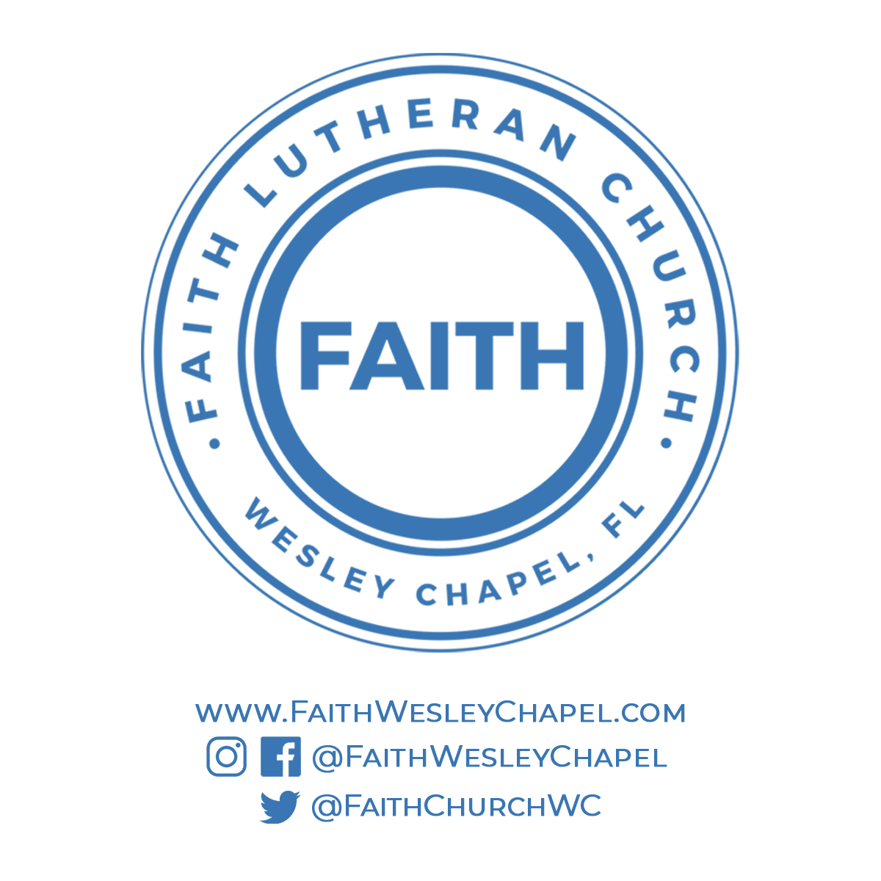**@FaithWesleyChapel**

**@FaithWesleyChapel**

**@FaithChurchWC**