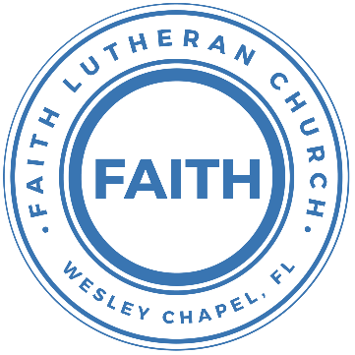

**Leading our community into a deep connection in Christ**

**Worship Service for November 5, 2023 at 11 AM**

**Welcome**

**Opening Song:**Oh, You Can't Get to Heaven

Oh, you can't get to heaven, (Oh, you can't get to heaven,)  
On roller skates. (On roller skates.)  
Oh, you can't get to heaven, (Oh, you can't get to heaven,)  
On roller skates.  
Oh, you can't get to heaven on roller skates,  
'Cause you'd roll right past those pearly gates.  
All my sins are washed away. I've been redeemed.

Oh, you can't get to heaven in a rocking chair…  
'Cause a rocking chair won't get you there.

Oh, you can't get to heaven in a limousine…  
'Cause the Lord don't sell no gasoline.

Oh, you can't get to Heaven in dirty jeans…  
'Cause heaven ain’t got no washing machines.

If you wanna get to heaven believe in Jesus name…  
'Cause it's by His name that we are saved. © Public Domain

**Invocation**

**Confession and Forgiveness:**

**P:** We have come here today to worship the Lord.  In worship we hear the Word of God, we receive God's blessings, and respond with thanks and praise.  We begin by seeking God's blessing of forgiveness.  He has promised to remove the guilt and shame of our sin through the sacrifice of Jesus Christ on the cross.

*(a time of silence to reflect and personally confess our sins)*

**P:** Let us confess our sins to the Lord.

**P:** Heavenly Father,  
**C:** Heavenly Father,

**P:** I have done things that were wrong.  
**C:** I have done things that were wrong.  
  
**P:** I have been mean to others.  
**C:** I have been mean to others.

**P:** I have not obeyed my parents.  
**C:** I have not obeyed my parents.

**P:** I have not obeyed You, God.  
**C:** I have not obeyed You, God.

**P:** But I am very sorry.  
**C:** But I am very sorry.

**P:** Please forgive me.  
**C:** Please forgive me.

**P:** I love You very much.  
**C:** I love You very much.

**P:** And I know You love me, too.  
**C:** And I know You love me, too.

**P:** Amen.  
**C:** Amen.

**P:** God has heard your apology.  He loves you very much.  God has told us that when we believe and trust in Him, He makes us His children.  As far as the east is from the west, so far does he remove our sins from us. He has told me to tell you that you are forgiven.  So, as His servant, I forgive you in the name of the Father and of the Son and of the Holy Spirit.   
**C:** Amen.

**Song:**God Is So Good

God is so good. God is so good.  
God is so good. He's so good to me.

He died for me. He died for me so.  
He died for me. He's so good to me.

He loves me so. He loves me so.  
He loves me so. He's so good to me. © Public Domain

**First Reading -**Revelation 7:9-10

After this I looked, and behold, a great multitude that no one could number, from every nation, from all tribes and peoples and languages, standing before the throne and before the Lamb, clothed in white robes, with palm branches in their hands, and crying out with a loud voice, “Salvation belongs to our God who sits on the throne, and to the Lamb!”

**Reader:** This is the Word of the Lord.  
**C:** Thanks be to God.

**Children's Message**"The Great Celebration!"

**Song:**Living Hope

How great the chasm that lay between us.

How high the mountain I could not climb.

In desperation, I turned to heaven,  
And spoke Your name into the night.

Then through the darkness Your loving kindness,

Tore through the shadows of my soul.

The work is finished, the end is written,  
Jesus Christ, my Living Hope.

Who could imagine so great a mercy.

What heart could fathom such boundless grace.

The God of ages stepped down from glory,  
To wear my sin and bear my shame.

The cross has spoken. I am forgiven.

The King of Kings calls me His own.

Beautiful Savior I’m Yours forever,

Jesus Christ, my Living Hope.

Chorus:

Hallelujah, praise the one who set me free!

Hallelujah, death has lost its grip on me!

You have broken every chain. There’s salvation in Your Name,

Jesus Christ, my Living Hope.

Then came the morning that sealed the promise,

Your buried body began to breathe.

Out of the silence the roaring Lion,

Declared the grave has no claim on me.

*(Repeat)*

Jesus, Yours is the victory!

*(Chorus 2x)* © Bethel Music Publishing and Remaining portion is unaffiliated

**Second Reading -**1 John 3:3

And everyone who hopes in him purifies himself as he is pure.

**Reader:** This is the Word of the Lord.  
**C:** Thanks be to God.

**Children's Message**"Becoming Worthy of Heaven"

**Gospel Reading -**Matthew 5:1-12

Seeing the crowds, he went up on the mountain, and when he sat down, his disciples came to him.

And he opened his mouth and taught them, saying:

“Blessed are the poor in spirit, for theirs is the kingdom of heaven.  
“Blessed are those who mourn, for they shall be comforted.  
“Blessed are the meek, for they shall inherit the earth.  
“Blessed are those who hunger and thirst for righteousness, for they shall be satisfied.  
“Blessed are the merciful, for they shall receive mercy.  
“Blessed are the pure in heart, for they shall see God.  
“Blessed are the peacemakers, for they shall be called sons of God.  
“Blessed are those who are persecuted for righteousness' sake, for theirs is the kingdom of heaven.

“Blessed are you when others revile you and persecute you and utter all kinds of evil against you falsely on my account. Rejoice and be glad, for your reward is great in heaven, for so they persecuted the prophets who were before you.

**P:** This is the Gospel of the Lord.  
**C:** Praise be to You, o Christ.

**Sermon Hymn:**For All The Saints

For all the saints who from their labors rest,  
Who Thee by faith before the world confessed,  
Thy name, O Jesus, be forever blest. Alleluia! Alleluia!

Thou wast their rock, their fortress, and their might;  
Thou, Lord, their captain in the well-fought fight;  
Thou, in the darkness drear, their one true light. Alleluia! Alleluia!

Oh, may Thy soldiers, faithful, true, and bold,  
Fight as the saints who nobly fought of old;  
And win with them the victor's crown of gold! Alleluia! Alleluia!

The golden ev'ning brightens in the west.  
Soon, soon to faithful warriors cometh rest.  
Sweet is the calm of paradise the blest. Alleluia! Alleluia!

But lo, there breaks a yet more glorious day;  
The saints triumphant rise in bright array;  
The King of Glory passes on His way. Alleluia! Alleluia!

From earth's wide bounds, from ocean's farthest coast,  
Through gates of pearl streams in the countless host,  
Singing to Father, Son, and Holy Ghost: Alleluia! Alleluia!   
 © Public Domain

**Sermon –**“Our Sure Hope”

**Prayers:** *Text in prayer requests to (813) 326-5255*

**The Lord's Prayer**

Our Father who art in heaven, hallowed be Thy name, Thy kingdom come, Thy will be done on earth as it is in heaven.  Give us this day our daily bread; and forgive us our trespasses as we forgive those who trespass against us; and lead us not into temptation, but deliver us from evil.  For Thine is the kingdom and the power and the glory forever and ever.  Amen

**Offering**

**Benediction** *– The online service ends. The closing hymn video is on the Livestream page bulletin at FaithWesleyChapel.com with lyrics below. See announcements below as well.*

**Closing Song:**Revelation Song *(sit)*

Worthy is the Lamb who was slain. Holy, Holy is He.

Sing a new song to him who sits on Heaven's mercy seat.

Chorus:

Holy, Holy, Holy is the Lord God Almighty,  
Who was and is and is to come.

With all creation I sing, praise to the King of Kings.

You are my everything and I will adore You.

Clothed in rainbows of living color,

Flashes of lightning rolls of thunder.

Blessing and honor, strength and glory and power be,

To You the only wise King.

Chorus:

Holy, Holy, Holy is the Lord God Almighty,  
Who was and is and is to come.

With all creation I sing, praise to the King of Kings.

You are my everything and I will adore You.

Filled with wonder, awestruck wonder, at the mention of Your name

Jesus Your name is power, breath and living water,

Such a marvelous mystery.

*(Chorus 2x)* © 2004 Gateway Create Publishing

|  |  |
| --- | --- |
| **Serving This Week** | |
|  | |
| **1st Reader:** Jakob Torgrimson | **Children’s Church Teacher:** |
| **2nd Reader:** Kaylee Steinbrueck | N/A |
| **Acolyte:** Griffin Frost | **Children’s Church Assistant:** |
| **Com. Asst:** Larry Chmiel | N/A |
|  | |
| **Serving Next Week** | |
|  | |
| **O.T. Reader:** N/A | **Children’s Church Teacher:** |
| **Epistle Reader:** N/A | Terrell Jordan |
| **Acolyte:** Kaylee Steinbrueck | **Children’s Church Assistant:** |
| **Com. Asst:** Larry Chmiel | Griffin Frost |

**Hey Youth!!**Do you know any worship songs you’d like to sing as part of our youth service? Let Pastor Kurt know.

Do you want to sing or play an instrument? Let Pastor Kurt know.

We want you to be a part of the service.

**Upcoming Events**

**Today, After the Service – Faith’s 5-yr Birthday Celebration!**  
The Frosts

**Nov. 12, 11 AM – Faith and Food Worship Service**  
Faith Lutheran Church – (Theme: Thanksgiving)

**Nov. 12, After the Service – God Squad Youth Group**  
Faith Lutheran Church

**Nov. 14, 7 PM – Growth Group**  
Renee’s Home - Ch 10-12 of the book, A Week in the Life of Corinth

**Dec. 2, 6 PM – Christmas at the Park**  
Wesley Chapel District Park

**www.FaithWesleyChapel.com**

**Faith YouTube**

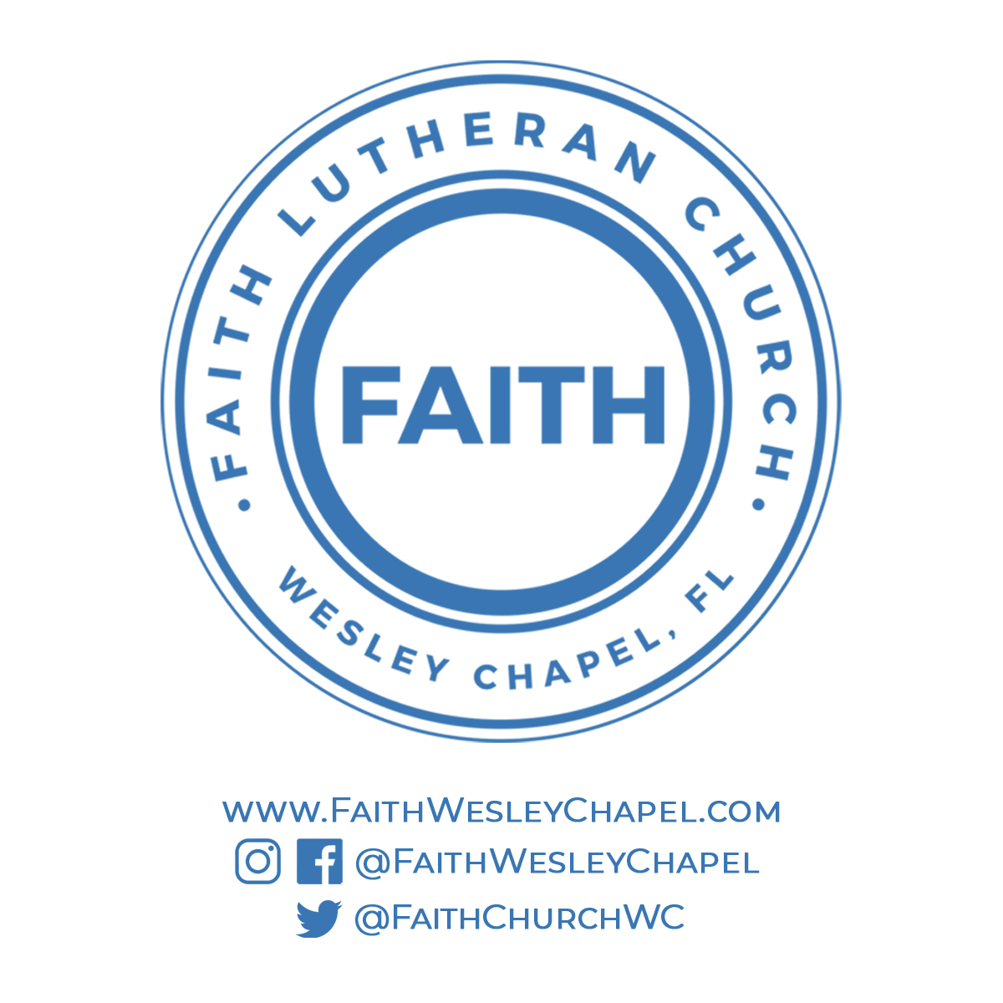**@FaithWesleyChapel**

**@FaithWesleyChapel**

**@FaithChurchWC**