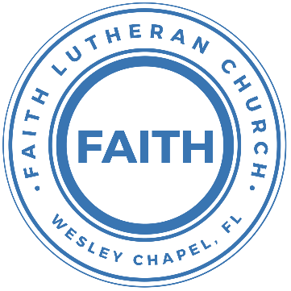

**Leading our community into a deep connection in Christ**

**Worship Service for November 19, 2023 at 11 AM**

**Welcome**

**Opening Song -** I See YouGod of love, God of all glory, every day I see new mercy.Great is Your faithfulness!God of love, God of my story, You never fail. You never forsake meGreat is Your faithfulness!

Chorus:

I see You in the morning light. I feel You in the fire by night.

I hear You say, “Child, I am with you. Everything will be alright.”

I see You in the tears that run. I feel You when the healing comes.

I hear You say, “Beloved one, I am with you,” Every moment of my life.

I see You. I see You. I see You. God, I see You.

God of love, God of new vision, every blessing You have given.

Great is Your faithfulness! Oh, how great is Your faithfulness!

*(Chorus)*

Bridge:

I will worship through the storm,  
Through the storm, Through the storm.

All my hope is in You Lord, In You Lord, In You Lord.

I see You in the morning light. I feel You in the fire by night.

I hear You say, “Child, I am with you. Everything will be alright.”  
*(Chorus)* © 2021 Capitol CMG Paragon

**Invocation**

**Responsive Psalm - Psalm 95:1-7**

**P:** Oh come, let us sing to the Lord;  
**C:** Let us make a joyful noise to the rock of our salvation!

**P:** Let us come into his presence with thanksgiving;  
**C:** Let us make a joyful noise to him with songs of praise!

**P:** For the Lord is a great God,  
**C:** And a great King above all gods.

**P:** In his hand are the depths of the earth;  
**C:** The heights of the mountains are his also.

**P:** The sea is his, for he made it,  
**C:** And his hands formed the dry land.

**P:** Oh come, let us worship and bow down;  
**C:** Let us kneel before the Lord, our Maker!

**P:** For he is our God,  
**C:** And we are the people of his pasture, and the sheep of his hand.

**Confession and Forgiveness:**

**P:** Our Heavenly Father asks us to come into His presence.  
**C:** But we are sinful and unworthy.

**P:** Yes, all have sinned and fall short of the glory of God, but Jesus Christ died on the cross that we may be forgiven and washed clean of all our sins by His blood spilled on the cross.  
**C:** Lord, if You wash us, we will certainly be clean and pure.

**P:** We take a moment to consider Jesus death upon the cross and silently reflect on our lives and confess our sins.

*(Time of silence for reflection and confession)*

**P:** Let us confess, together, our sins to God our Father.  
**C:** Heavenly Father, we confess that we are sinners.  We have sinned against you and our neighbors. We have not loved you with our whole heart and we have not loved our neighbors as ourselves. We have not lived out our faith in our community. We justly deserve Your punishment.  For the sake of Your Son, Jesus Christ, have mercy on us.  Forgive us, renew us, and lead us, so that we may delight in Your will and walk in Your ways to the glory of Your holy name.  Amen.

**P:** Almighty God in His mercy has given His Son to die for you and for His sake forgives you all your sins.  As a called and ordained servant of Christ, and by His authority, I, therefore, forgive you all your sins in the name of the Father and of the Son and of the Holy Spirit.  
**C:** Amen

**Song of Thanksgiving:** How Deep The Father’s Love For Us

How deep the Father's love for us, how vast beyond all measure.

That He should give His only Son, to make a wretch His treasure.

How great the pain of searing loss, the Father turned His face away,

As wounds which mar the Chosen One, bring many sons to glory.

Behold the Man upon a cross, my sin upon His shoulders.

Ashamed, I hear my mocking voice call out among the scoffers.

It was my sin that held Him there until it was accomplished.

His dying breath has brought me life; I know that it is finished.

I will not boast in anything: no gifts, no power, no wisdom,

But I will boast in Jesus Christ; his death and resurrection.

Why should I gain from His reward? I cannot give an answer.

But this I know with all my heart: His wounds have paid my ransom.

But this I know with all my heart: His wounds have paid my ransom.

© 1995 Thankyou Music

**Epistle Reading** - Philippians 4:10-13

I rejoiced in the Lord greatly that now at length you have revived your concern for me. You were indeed concerned for me, but you had no opportunity. Not that I am speaking of being in need, for I have learned in whatever situation I am to be content. I know how to be brought low, and I know how to abound. In any and every circumstance, I have learned the secret of facing plenty and hunger, abundance and need. I can do all things through him who strengthens me.

**Reader:** This is the Word of the Lord.  
**C:** Thanks be to God.

**Gospel Reading** - Luke 17:11-19

On the way to Jerusalem he was passing along between Samaria and Galilee. And as he entered a village, he was met by ten lepers, who stood at a distance and lifted up their voices, saying, “Jesus, Master, have mercy on us.” When he saw them he said to them, “Go and show yourselves to the priests.” And as they went they were cleansed. Then one of them, when he saw that he was healed, turned back, praising God with a loud voice; and he fell on his face at Jesus' feet, giving him thanks. Now he was a Samaritan. Then Jesus answered, “Were not ten cleansed? Where are the nine? Was no one found to return and give praise to God except this foreigner?” And he said to him, “Rise and go your way; your faith has made you well.”

**P:** This is the Gospel of the Lord.  
**C:** Praise be to You, o Christ.

**Children's Message** *(Children dismissed to Children's Church)*

**Sermon Hymn***–*Blessed Be Your Name

Verse 1:  
Blessed be Your name in the land that is plentiful.  
Where Your streams of abundance flow, blessed be Your name.  
Blessed be Your name when I'm found in the desert place.  
Though I walk through the wilderness, blessed be Your name.

Pre-Chorus:

Every blessing You pour out I'll turn back to praise.

When the darkness closes in, Lord still I will say,

Chorus:

Blessed be the name of the Lord. Blessed be Your name.

Blessed be the name of the Lord. Blessed be Your glorious name.

Verse 2:

Blessed be Your name when the sun's shining down on me.

When the world's "all as it should be," blessed be Your name.

Blessed be Your name on the road marked with suffering.

Though there's pain in the offering, blessed be Your name.

*(Pre-Chorus)  
(Chorus)*

Bridge:

You give and take away. You give and take away.

My heart will choose to say, “Lord, blessed be Your name.”

*(Pre-Chorus)  
(Chorus)* © 2002 Thankyou Music

**Sermon** - "Remembering and Being Thankful"

Deuteronomy 8:1-10

“The whole commandment that I command you today you shall be careful to do, that you may live and multiply, and go in and possess the land that the Lord swore to give to your fathers. And you shall remember the whole way that the Lord your God has led you these forty years in the wilderness, that he might humble you, testing you to know what was in your heart, whether you would keep his commandments or not. And he humbled you and let you hunger and fed you with manna, which you did not know, nor did your fathers know, that he might make you know that man does not live by bread alone, but man lives by every word[a] that comes from the mouth of the Lord. Your clothing did not wear out on you and your foot did not swell these forty years. Know then in your heart that, as a man disciplines his son, the Lord your God disciplines you. So you shall keep the commandments of the Lord your God by walking in his ways and by fearing him. For the Lord your God is bringing you into a good land, a land of brooks of water, of fountains and springs, flowing out in the valleys and hills, a land of wheat and barley, of vines and fig trees and pomegranates, a land of olive trees and honey, a land in which you will eat bread without scarcity, in which you will lack nothing, a land whose stones are iron, and out of whose hills you can dig copper. And you shall eat and be full, and you shall bless the Lord your God for the good land he has given you.

**P:** This is the Word of the Lord.  
**C:** Thanks be to God.

**Prayers:** *Text in prayer requests to (813) 326-5255*

**Nicene Creed** *(stand)*

I believe in one God, the Father Almighty, maker of heaven and earth and of all things visible and invisible.

And in one Lord Jesus Christ, the only-begotten Son of God, begotten of His Father before all worlds, God of God, Light of Light, very God of very God, begotten, not made, being of one substance with the Father, by whom all things were made; who for us men and for our salvation came down from heaven and was incarnate by the Holy Spirit of the virgin Mary and was made man; and was crucified also for us under Pontius Pilate. He suffered and was buried. And the third day He rose again according to the Scriptures and ascended into heaven and sits at the right hand of the Father. And He will come again with glory to judge both the living and the dead, whose kingdom will have no end.

And I believe in the Holy Spirit, the Lord and Giver of Life, who proceeds from the Father and the Son, who with the Father and the Son together is worshiped and glorified, who spoke by the prophets. And I believe in one holy Christian and apostolic Church, I acknowledge one Baptism for the remission of sins, and I look for the resurrection of the dead and the life of the world to come. Amen.

**The Lord's Prayer** *(stand)*

Our Father who art in heaven, hallowed be Thy name, Thy kingdom come, Thy will be done on earth as it is in heaven.  Give us this day our daily bread; and forgive us our trespasses as we forgive those who trespass against us; and lead us not into temptation, but deliver us from evil.  For Thine is the kingdom and the power and the glory forever and ever.  Amen

**Offering** *(sit)*

**Benediction** *– The online service ends. The closing hymn video is on the Livestream page bulletin at FaithWesleyChapel.com with lyrics below. See announcements below as well.*

**Closing Song:**Praise To The Lord The Almighty

Praise to the Lord the Almighty, the King of creation.

O my soul, praise Him for He is your health and salvation.

Let all who hear, now to His temple draw near,

Joining in glad adoration.

Praise to the Lord who o’er all things is wondrously reigning,

And as on wings of an eagle, uplifting, sustaining.

Have you not seen? All that is needful has been,

Sent by His gracious ordaining.

Praise to the Lord! O let all that is in me adore Him.

All that has life and breath come now with praises before Him.

Let the “Amen” sound from His people again.  
Gladly forever adore Him. © Public Domain

|  |  |
| --- | --- |
| **Serving This Week** | |
|  | |
| **O.T. Reader:** N/A | **Children’s Church Teacher:** |
| **Epistle Reader:** Terrell Jordan | Melissa Steinbrueck |
| **Acolyte:** Griffin Frost | **Children’s Church Assistant:** |
| **Com. Asst:** Larry Chmiel | Kaylee Steinbrueck |
|  | |
| **Serving Next Week** | |
|  | |
| **O.T. Reader:** N/A | **Children’s Church Teacher:** |
| **Epistle Reader:** Josh Strasheim | Halston and Ben |
| **Acolyte:** Lawrence Finnerty | **Children’s Church Assistant:** |
| **Com. Asst:** Larry Chmiel | N/A |

**Upcoming Events**

**Nov. 21, 7 PM Council Meeting**  
Zoom

**Nov. 26, 2-6 PM Bowling/Laser Tag/Gaming** *(for everyone!)*  
Main Event

**Nov. 28, 7 PM – Growth Group**  
Renee’s Home - (Ch 13-end of the book, A Week in the Life of Corinth)

**Dec. 2, 6 PM – Christmas at the Park**  
Wesley Chapel District Park

**Dec. ??, ?? – Caroling at The Beach House**  
The Beach House Assisted Living

**www.FaithWesleyChapel.com**

**Faith YouTube**

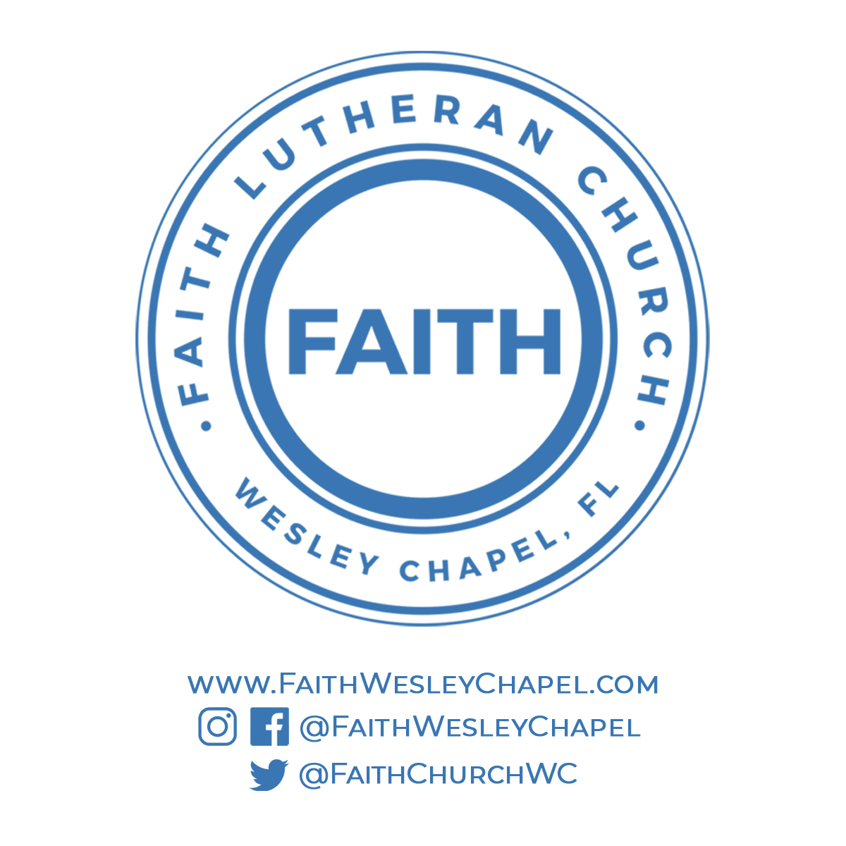**@FaithWesleyChapel**

**@FaithWesleyChapel**

**@FaithChurchWC**