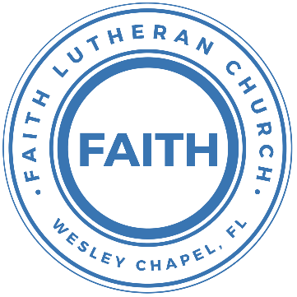

**Leading our community into a deep connection in Christ**

**Worship Service for November 26, 2023 at 11 AM**

**Welcome**

**Opening Song:**Come Thou Long Expected Jesus

Come thou long-expected Jesus, born to set thy people free,

From our fears and sins release us; let us find our rest in thee.

Israel’s strength and consolation, hope of all the earth thou art,

Dear desire of ev’ry nation, joy of every longing heart.

Come to earth to taste our sadness, He whose glories knew no end;  
by His life He brings us gladness, Our Redeemer, Shepherd, Friend.   
Leaving riches without number, born within a cattle stall;  
This the everlasting wonder, Christ was born the Lord of all!

Born Thy people to deliver, born a child and yet a king.  
Born to reign in us forever, now Thy gracious kingdom bring.  
By Thine own eternal Spirit; rule in all our hearts alone.  
By Thine all sufficient merit, raise us to Thy glorious throne.  
 © Public Domain

**Invocation**

**Advent Responsorial:**

**P:** For to us a child is born, to us a Son is given; **C:** And the government shall be upon His shoulder,

**P:** And His name shall be called Wonderful Counselor, **C:** Mighty God,

**P:** Everlasting Father, **C:** Prince of Peace.

**P:** The peace of God, which surpasses all understanding, will guard your hearts and your minds in Christ Jesus. **C:** Amen.

**Confession and Forgiveness:**

**P:** Come into the presence of the Lord our God.  
**C:** Have mercy, O Lord. If you, Lord, kept a record of sins, Lord, who could stand; but if we confess our sins, he is faithful and just to forgive us our sins and to cleanse us from all unrighteousness.

*(A time of silence to reflect and personally confess our sins)*

**P:** I said, "I will confess my transgressions to the LORD." And you forgave the guilt of my sin. Let us confess our sin before the Lord. Let us confess together.  
**C:** Heavenly Father, we confess that we are sinners.  We have sinned against you and our neighbors. We have not loved you with our whole heart and we have not loved our neighbors as ourselves. We justly deserve Your punishment.  For the sake of Your Son, Jesus Christ, have mercy on us.  Forgive us, renew us, and lead us, so that we may delight in Your will and walk in Your ways to the glory of Your holy name.  Amen.

**P:** The Lord is gracious and merciful. He promises to forgive our sins. Therefore, upon this, your confession, as a called and ordained servant of the Lord, in the stead and by the command of my Lord, Jesus Christ, I forgive you all your sins in the name of the Father and of the Son and of the Holy Spirit.  
**C:** Amen.

**Song of Praise and Thanksgiving -** Jesus Messiah

He became sin, who knew no sin,  
That we might become His Righteousness.   
He humbled Himself and carried the cross.   
Love so amazing, love so amazing!

Chorus:  
Jesus Messiah, Name above all names,  
Blessed Redeemer, Emmanuel,  
The rescue for sinners, the ransom from Heaven,  
Jesus Messiah, Lord of all.

His body the bread, His blood the wine,  
Broken and poured out all for love.  
The whole earth trembled and the veil was torn.  
Love so amazing, love so amazing!

*(Chorus)*

All our hope is in You. All our hope is in You.  
All the glory to You, God, The light of the world.

*(Chorus)*

Jesus Messiah, Lord of all. He is the Lord of all! Lord of all. © 2008 Vamos Publishing and Alletrop Music

**Old Testament Reading -** Isaiah 64:1–9

Oh that you would rend the heavens and come down,  
 that the mountains might quake at your presence—  
as when fire kindles brushwood  
 and the fire causes water to boil—  
to make your name known to your adversaries,  
 and that the nations might tremble at your presence!  
When you did awesome things that we did not look for,  
 you came down, the mountains quaked at your presence.  
From of old no one has heard  
 or perceived by the ear,  
no eye has seen a God besides you,  
 who acts for those who wait for him.  
You meet him who joyfully works righteousness,  
 those who remember you in your ways.  
Behold, you were angry, and we sinned;  
 in our sins we have been a long time, and shall we be saved?  
We have all become like one who is unclean,  
 and all our righteous deeds are like a polluted garment.  
We all fade like a leaf,  
 and our iniquities, like the wind, take us away.  
There is no one who calls upon your name,  
 who rouses himself to take hold of you;  
for you have hidden your face from us,  
 and have made us melt in the hand of our iniquities.

But now, O Lord, you are our Father;  
 we are the clay, and you are our potter;  
 we are all the work of your hand.  
Be not so terribly angry, O Lord,  
 and remember not iniquity forever.  
 Behold, please look, we are all your people.

**Reader:** This is the Word of the Lord.  
**C:** Thanks be to God.

**Epistle Reading -** 1 Timothy 6:6–8

But godliness with contentment is great gain, for we brought nothing into the world, and we cannot take anything out of the world. But if we have food and clothing, with these we will be content.

**Reader:** This is the Word of the Lord.  
**C:** Thanks be to God.

**Children's Message**

**Sermon Hymn -** Savior Of The Nations Come

Savior of the nations, come, virgin's Son, make here Thy home!

Marvel now, O heaven and earth, that the Lord chose such a birth.

Not by human flesh and blood, by the Spirit of our God,

Was the Word of God made flesh  
Woman's Off-Spring, pure and fresh.

Thou, the Father's only Son, hast o'er sin the vict'ry won.

Boundless shall Thy kingdom be; when shall we its glories see?

Praise to God the Father sing. Praise to God the Son, our King.

Praise to God the Spirit be ever and eternally. © Public Domain

**Sermon -** Series: The Search for Peace  
 Week 1: "Possessing Peace"

Matthew 2:1–2, 9–10

Now after Jesus was born in Bethlehem of Judea in the days of Herod the king, behold, wise men from the east came to Jerusalem, saying, “Where is he who has been born king of the Jews? For we saw his star when it rose and have come to worship him.”...

...After listening to the king, they went on their way. And behold, the star that they had seen when it rose went before them until it came to rest over the place where the child was. When they saw the star, they rejoiced exceedingly with great joy.

**P:** This is the Gospel of the Lord.  
**C:** Praise be to You, o Christ.

**Prayers:** *Text in prayer requests to (813) 326-5255‬*

**Apostles' Creed** *(stand)*

I believe in God, the Father almighty, maker of heaven and earth,  
And in Jesus Christ, his only Son, our Lord,  
who was conceived by the Holy Spirit,  
born of the Virgin Mary, suffered under Pontius Pilate,  
was crucified, died and was buried. He descended into hell.  
The third day he rose again from the dead.  
He ascended into heaven and sits at the right hand of God  
the Father almighty.  
From there he will come to judge the living and the dead.  
I believe in the Holy Spirit, the holy Christian Church,  
the communion of saints, the forgiveness of sins,  
the resurrection of the body, and the life everlasting. Amen.

**The Lord's Prayer** *(stand)*

Our Father who art in heaven, hallowed be Thy name, Thy kingdom come, Thy will be done on earth as it is in heaven.  Give us this day our daily bread; and forgive us our trespasses as we forgive those who trespass against us; and lead us not into temptation, but deliver us from evil.  For Thine is the kingdom and the power and the glory forever and ever.  Amen

**Offering – FaithWesleyChapel.com/give/** *(sit)*

**Benediction** *– The online service ends. The closing hymn video is on the Livestream page bulletin at FaithWesleyChapel.com with lyrics below. See announcements below as well.*

**Closing Song -**Angels From The Realms of Glory (Emmanuel) *(sit)*

Angels from the realms of glory wing your flight o'er all the earth.

You who sang creation's story now proclaim Messiah's birth.

Come and worship. Come and worship.

Worship Christ the newborn King.

Shepherds in the field abiding watching o'er your flocks by night.

God with man is now residing yonder shines the infant light.

Come and worship. Come and worship.

Worship Christ the newborn King.

Chorus:

Emmanuel, Emmanuel,

You are the God who saves us, worthy of all our praises.

Emmanuel, Emmanuel,

Come have Your way among us. We welcome You here, Lord Jesus.

Come have Your way among us. We welcome You here, Lord Jesus.

Come and worship, worship Christ the newborn King.

God is with us, even now His love is here.  
*(Repeat)*

His love is here.

*(Chorus)*

|  |  |
| --- | --- |
| **Serving This Week** | |
|  | |
| **O.T. Reader:** N/A | **Children’s Church Teacher:** |
| **Epistle Reader:** Josh Strasheim | Melissa Steinbrueck |
| **Acolyte:** Lawrence Finnerty | **Children’s Church Assistant:** |
| **Com. Asst:** Larry Chmiel | Kaylee Steinbrueck |
|  | |
| **Serving Next Week** | |
|  | |
| **1st Reader:** Kaylee Steinbrueck | **Children’s Church Teacher:** |
| **2nd Reader:** Katelyn Shuck | N/A |
| **Acolyte:** Jakob Torgrimson | **Children’s Church Assistant:** |
| **Com. Asst:** Larry Chmiel | N/A |

**Upcoming Events**

**Nov. 26, 2-6 PM Bowling/Laser Tag/Gaming** *(for everyone!)*  
Main Event

**Nov. 28, 7 PM – Growth Group**  
Renee’s Home - (Ch 13-end of the book, A Week in the Life of Corinth)

**Dec. 2, 6 PM – Christmas at the Park**  
Wesley Chapel District Park

**Dec. 10, 2 PM – Caroling at The Beach House**  
The Beach House Assisted Living

**Dec. 16, 6-10 PM – Open House Christmas Party**  
The Chmiels’ Home

**www.FaithWesleyChapel.com**

**Faith YouTube**

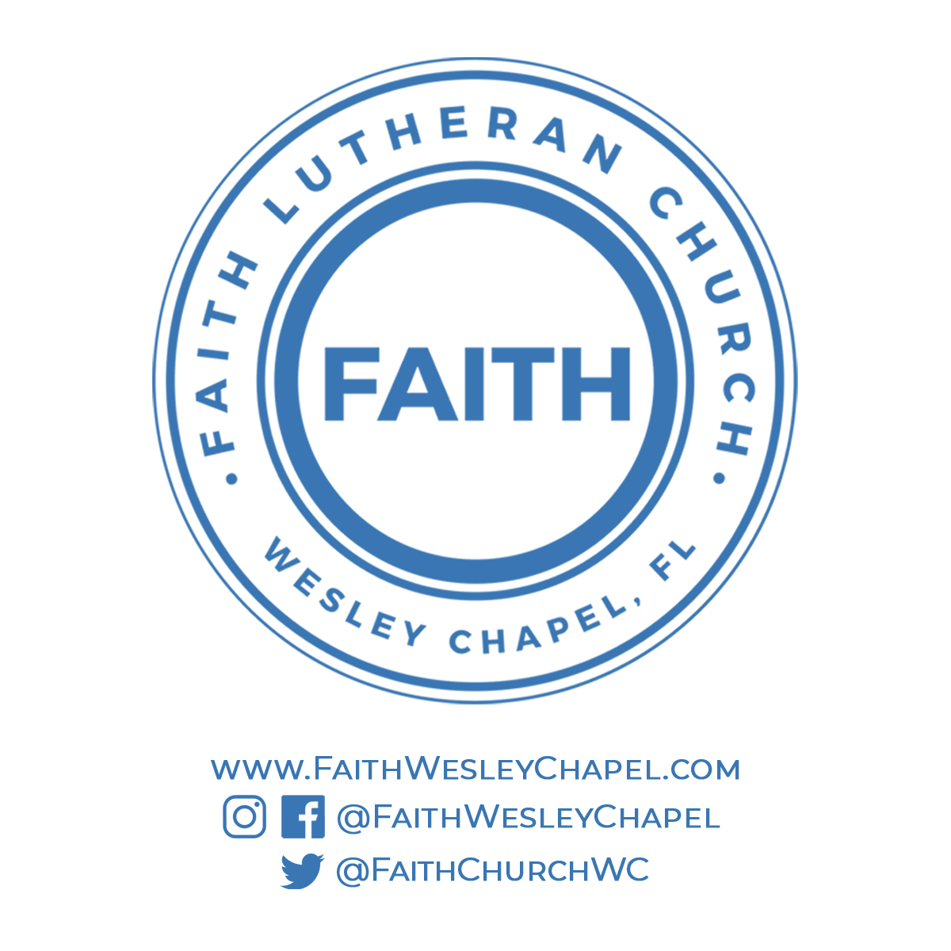**@FaithWesleyChapel**

**@FaithWesleyChapel**

**@FaithChurchWC**