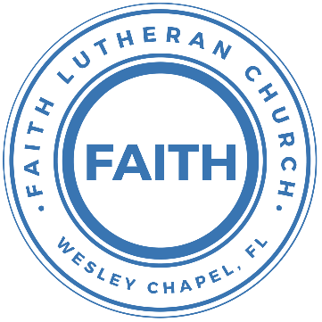

**Leading our community into a deep connection in Christ**

**Worship Service for December 10, 2023 at 11 AM**

**Welcome**

**Invocation** *(stand)*

**Advent Responsorial:**

**P:** For to us a child is born, to us a Son is given; **C:** And the government shall be upon His shoulder,

**P:** And His name shall be called Wonderful Counselor, **C:** Mighty God,

**P:** Everlasting Father, **C:** Prince of Peace.

**P:** The peace of God, which surpasses all understanding, will guard your hearts and your minds in Christ Jesus. **C:** Amen.

**Confession and Forgiveness:** *(stand)*

**P:** As we gather, today, let us cleanse our hearts and our consciences by confessing our sin to God.

*(Time of silence for reflection and confession)*

**C:** Heavenly Father, we confess that we are sinful and unclean. We have sinned against you and against our neighbor in our thoughts, words, and actions.  We are truly sorry for our sins and sincerely repent of them. We ask for Your mercy. For the sake of Jesus Christ's bitter suffering and death, please forgive us and renew us that we may walk in Your Spirit to the glory of Your holy name. Amen

**P:** The Lord has heard your confession. Therefore, as a called and ordained servant of the Lord, in the stead and by the command of my Lord, Jesus Christ, I forgive you all your sins in the name of the Father and of the Son and of the Holy Spirit.  
**C:** Amen

**Song of Thanksgiving –** “O Come, O Come, Emmanuel *(sit)*

O come, O come, Emmanuel, and ransom captive Israel,

That mourns in lonely exile here, until the Son of God appear.

Chorus:

Rejoice! Rejoice! Emmanuel shall come to thee, O Israel.

O come, Thou Key of David, come,  
And open wide our heav’nly home.

Make safe the way that leads on high,  
And close the path to misery.

*(Chorus)*

O come, Thou Dayspring, come and cheer,

Our spirits by Thine advent here,

And drive away the shades of night,

And pierce the clouds and bring us light.

*(Chorus)*

O come, Desire of nations, bind all people in one heart and mind.

Bid envy strife and quarrels cease.

Fill all the world with heaven's peace.

*(Chorus)* © 1982 The Jubilate Group

**Gospel Reading** - John 14:25–31

“These things I have spoken to you while I am still with you. But the Helper, the Holy Spirit, whom the Father will send in my name, he will teach you all things and bring to your remembrance all that I have said to you. Peace I leave with you; my peace I give to you. Not as the world gives do I give to you. Let not your hearts be troubled, neither let them be afraid. You heard me say to you, ‘I am going away, and I will come to you.’ If you loved me, you would have rejoiced, because I am going to the Father, for the Father is greater than I. And now I have told you before it takes place, so that when it does take place you may believe. I will no longer talk much with you, for the ruler of this world is coming. He has no claim on me, but I do as the Father has commanded me, so that the world may know that I love the Father. Rise, let us go from here.

**P:** This is the Gospel of the Lord.  
**C:** Praise be to You, o Christ.

**Sermon Song –** Arise And Shine In Splendor

Verse 1:

Arise and shine in splendor. Let night to day surrender.

Your light is drawing near; above, the day is beaming,

In matchless beauty gleaming. The glory of the Lord is here.

Verse 2:

See earth in darkness lying. The heathen nations dying,

In hopeless gloom and night. To You the Lord of heaven,

Your light, your hope, has given great glory, honor, and delight.

Verse 3:

The world’s remotest races upon whose weary faces,

The sun looks from the sky, shall run with zeal untiring,

With joy Your light desiring, that breaks upon them from on high.

Verse 4:

Lift up your eyes in wonder. See, nations gather yonder.

They all come to be free. The world has heard your story.

Your sons come to Your glory,  
And daughters haste Your light to see. © Public Domain

**Sermon -** Series: The Search for Peace  
 Week 3: "Rewriting Peace"

Ephesians 2:12–18

Remember that you were at that time separated from Christ, alienated from the commonwealth of Israel and strangers to the covenants of promise, having no hope and without God in the world. But now in Christ Jesus you who once were far off have been brought near by the blood of Christ. For he himself is our peace, who has made us both one and has broken down in his flesh the dividing wall of hostility by abolishing the law of commandments expressed in ordinances, that he might create in himself one new man in place of the two, so making peace, and might reconcile us both to God in one body through the cross, thereby killing the hostility. And he came and preached peace to you who were far off and peace to those who were near. For through him we both have access in one Spirit to the Father.

**P:** This is the Word of the Lord.  
**C:** Thanks be to God.

**Prayers**

**Apostles' Creed** *(stand)*

I believe in God, the Father almighty, maker of heaven and earth,

And in Jesus Christ, his only Son, our Lord,  
who was conceived by the Holy Spirit,  
born of the Virgin Mary, suffered under Pontius Pilate,  
was crucified, died and was buried. He descended into hell.  
The third day he rose again from the dead.  
He ascended into heaven  
and sits at the right hand of God  
the Father almighty.  
From there he will come to judge the living and the dead.  
I believe in the Holy Spirit, the holy Christian Church,  
the communion of saints, the forgiveness of sins,  
the resurrection of the body, and the life everlasting. Amen.

**The Lord's Prayer** *(stand)*

Our Father who art in heaven, hallowed be Thy name, Thy kingdom come, Thy will be done on earth as it is in heaven.  Give us this day our daily bread; and forgive us our trespasses as we forgive those who trespass against us; and lead us not into temptation, but deliver us from evil.  For Thine is the kingdom and the power and the glory forever and ever.  Amen

**Benediction** *(stand)*

**Closing Song:** O Come All Ye Faithful / Angels We Have Heard on High (Medley)

Oh come all ye faithful, joyful and triumphant!  
Oh come ye, oh come ye to Bethlehem;  
Come and behold Him, born the King of angels  
Oh, come let us adore Him. Oh, come let us adore Him  
Oh, come let us adore Him, Christ the Lord!

Angels we have heard on high sweetly singing o’er the plains,  
And the mountains in reply, echoing their joyous strains.  
Gloria, in excelsis Deo! Gloria, in excelsis Deo!

Come to Bethlehem and see Him whose birth the angels sing.  
Come adore on bended knee Christ the Lord the newborn King.  
Gloria, in excelsis Deo! Gloria, in excelsis Deo!

Yea, Lord we greet Thee, born this happy morning;  
Jesus, to Thee be glory giv’n!  
Word of the Father now in flesh appearing!  
Oh, come let us adore Him. Oh, come let us adore Him  
Oh, come let us adore Him, Christ the Lord! © Public Domain

**Offering** *(sit)*

**Sermon Notes:**

**_______________________________________________**

**_______________________________________________**

**_______________________________________________**

**_______________________________________________**

**_______________________________________________**

**_______________________________________________**

**_______________________________________________**

**_______________________________________________**

**_______________________________________________**

**_______________________________________________**

**_______________________________________________**

**_______________________________________________**

**_______________________________________________**

**_______________________________________________**

|  |  |
| --- | --- |
| **Serving This Week** | |
|  | |
| **O.T. Reader:** N/A | **Children’s Church Teacher:** |
| **Epistle Reader:** N/A | Terrell Jordan |
| **Acolyte:** Griffin Frost | **Children’s Church Assistant:** |
| **Com. Asst:** Larry Chmiel | Griffin Frost |
|  | |
| **Serving Next Week** | |
|  | |
| **O.T. Reader:** N/A | **Children’s Church Teacher:** |
| **Epistle Reader:** Vanessa Frost | Halston and Ben |
| **Acolyte:** Jakob Torgrimson | **Children’s Church Assistant:** |
| **Com. Asst:** Larry Chmiel | N/A |

**Upcoming Events**

**Today, 2 PM – Caroling at The Beach House**  
The Beach House Assisted Living

**Dec. 16, 6-10 PM – Open House Christmas Party**  
The Chmiels’ Home

**Dec. 24, 11 AM – No Sunday Morning Worship**  
We are worshiping in the evening.

**Dec. 24, 6 PM – Christmas Eve Worship**  
Faith Lutheran Church

**www.FaithWesleyChapel.com**

**Faith YouTube**

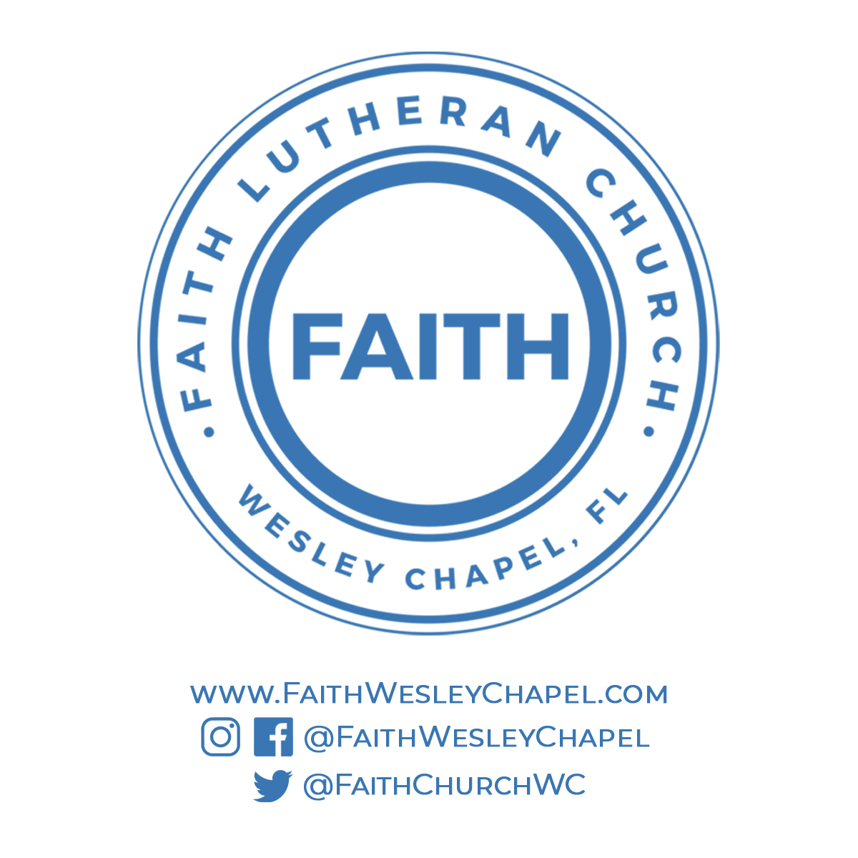**@FaithWesleyChapel**

**@FaithWesleyChapel**

**@FaithChurchWC**