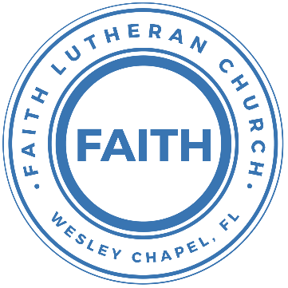

**Leading our community into a deep connection in Christ**

**Worship Service for December 17, 2023, at 11 AM**

**Welcome**

**Opening Song -** It Came Upon a Midnight Clear

It came upon a midnight clear, that glorious song of old,

From angels bending near the earth to touch their harps of gold.

"Peace on the earth, good will to men from heaven's all gracious King;"

The world in solemn stillness lay, to hear the angels sing.

Yet, with the woes of sin and strife the world hath suffered long.

Beneath the angel-strain have rolled two thousand years of wrong.

And man, at war with man, hears not the love song which they bring.

O hush the noise, ye men of strife, and hear the angels sing.

For lo! the days are hastening on by prophet bards foretold,

When, with the ever-circling years, shall come the Age of Gold.

When peace shall over all the earth its ancient splendors fling,

And all the world give back the song which now the angels sing.  
 © Public Domain

**Invocation**

**Advent Responsorial:**

**P:** For to us a child is born, to us a Son is given; **C:** And the government shall be upon His shoulder,

**P:** And His name shall be called Wonderful Counselor, **C:** Mighty God,

**P:** Everlasting Father, **C:** Prince of Peace.

**P:** The peace of God, which surpasses all understanding, will guard your hearts and your minds in Christ Jesus. **C:** Amen.

**Confession and Forgiveness:**

**P:** Our Heavenly Father asks us to come into His presence.  
**C:** But we are sinful and unworthy.

**P:** Yes, all have sinned and fall short of the glory of God, but Jesus Christ died on the cross that we may be forgiven and washed clean of all our sins by His blood spilled on the cross.  
**C:** Lord, if You wash us, we will certainly be clean and pure.

**P:** We take a moment to bow before the His cross and silently reflect on our lives and confess our sins.

*(Time of silence for reflection and confession)*

**P:** Let us confess, together, our sins to God our Father.  
**C:** Heavenly Father, we confess that we are sinners.  We have sinned against you and our neighbors. We have not loved you with our whole heart and we have not loved our neighbors as ourselves. We have not lived out our faith in our community. We justly deserve Your punishment.  For the sake of Your Son, Jesus Christ, have mercy on us.  Forgive us, renew us, and lead us, so that we may delight in Your will and walk in Your ways to the glory of Your holy name.  Amen.

**P:** Almighty God in His mercy has given His Son to die for you and for His sake forgives you all your sins.  As a called and ordained servant of Christ, and by His authority, I, therefore, forgive you all your sins in the name of the Father and of the Son and of the Holy Spirit.  
**C:** Amen

**Song of Praise and Thanksgiving:** O Holy Night

O holy night, the stars are brightly shining;  
It is the night of the dear Savior’s birth!  
Long lay the world in sin and error pining,  
Till He appeared and the soul felt its worth.  
A thrill of hope, the weary soul rejoices,  
For yonder breaks a new and glorious morn.

Fall on your knees, O hear the angel voices!  
O night divine, O night when Christ was born!  
O night divine, O night, O night divine.

Truly He taught us to love one another;  
His law is love and His Gospel is peace.  
Chains shall He break for the slave is our brother  
And in His Name all oppression shall cease.  
Sweet hymns of joy in grateful chorus raise we,  
Let all within us praise His holy Name!

Christ is the Lord; O praise His name forever!  
His power and glory evermore proclaim!  
His power and glory evermore proclaim!

Fall on your knees, O hear the angel voices!  
Noel, Noel, O night, O night divine.  
Noel, Noel, O night, O night divine. © Public Domain

**Epistle Reading** - Romans 12:9–21

Let love be genuine. Abhor what is evil; hold fast to what is good. Love one another with brotherly affection. Outdo one another in showing honor. Do not be slothful in zeal, be fervent in spirit, serve the Lord. Rejoice in hope, be patient in tribulation, be constant in prayer. Contribute to the needs of the saints and seek to show hospitality.

Bless those who persecute you; bless and do not curse them. Rejoice with those who rejoice, weep with those who weep. Live in harmony with one another. Do not be haughty, but associate with the lowly. Never be wise in your own sight. Repay no one evil for evil, but give thought to do what is honorable in the sight of all. If possible, so far as it depends on you, live peaceably with all. Beloved, never avenge yourselves, but leave it to the wrath of God, for it is written, “Vengeance is mine, I will repay, says the Lord.” To the contrary, “if your enemy is hungry, feed him; if he is thirsty, give him something to drink; for by so doing you will heap burning coals on his head.” Do not be overcome by evil, but overcome evil with good.

**Reader:** This is the Word of the Lord.  
**C:** Thanks be to God.

**Gospel Reading** - Matthew 10:34–39

“Do not think that I have come to bring peace to the earth. I have not come to bring peace, but a sword. For I have come to set a man against his father, and a daughter against her mother, and a daughter-in-law against her mother-in-law. And a person's enemies will be those of his own household. Whoever loves father or mother more than me is not worthy of me, and whoever loves son or daughter more than me is not worthy of me. And whoever does not take his cross and follow me is not worthy of me. Whoever finds his life will lose it, and whoever loses his life for my sake will find it.

**P:** This is the Gospel of the Lord.  
**C:** Praise be to You, o Christ.

**Children's Message** *(Children dismissed to Children's Church)*

**Sermon Hymn***–*What Child Is This

What child is this, who, laid to rest, on Mary’s lap is sleeping?  
Whom angels greet with anthems sweet while shepherds watch are keeping?  
This, this is Christ the king, whom shepherds guard and angels sing;  
Haste, haste to bring him laud, the babe, the son of Mary!

Why lies He in such mean estate where ox and lamb are feeding?

Good Christian, fear; for sinners here, the silent Word is pleading.  
Nails, spear shall pierce Him through, the cross be borne for me, for you;  
Hail, hail the Word made flesh, the babe, the son of Mary!

So bring Him incense, gold, and myrrh;  
Come, peasant, king, to own Him  
The King of kings salvation brings; let loving hearts enthrone Him.  
Raise, raise the song on high, the virgin sings her lullaby;  
Joy, joy, for Christ is born, the babe, the son of Mary! © Public Domain

**Sermon -** Series: The Search for Peace  
 Week 4: "Controlling Peace"

Isaiah 9:1–7

But there will be no gloom for her who was in anguish. In the former time he brought into contempt the land of Zebulun and the land of Naphtali, but in the latter time he has made glorious the way of the sea, the land beyond the Jordan, Galilee of the nations.

The people who walked in darkness have seen a great light; those who dwelt in a land of deep darkness, on them has light shone. You have multiplied the nation; you have increased its joy; they rejoice before you as with joy at the harvest, as they are glad when they divide the spoil. For the yoke of his burden, and the staff for his shoulder, the rod of his oppressor, you have broken as on the day of Midian. For every boot of the tramping warrior in battle tumult and every garment rolled in blood will be burned as fuel for the fire. For to us a child is born, to us a son is given; and the government shall be upon his shoulder, and his name shall be called Wonderful Counselor, Mighty God, Everlasting Father, Prince of Peace. Of the increase of his government and of peace there will be no end, on the throne of David and over his kingdom, to establish it and to uphold it with justice and with righteousness from this time forth and forevermore. The zeal of the Lord of hosts will do this.

**P:** This is the Word of the Lord.  
**C:** Thanks be to God.

**Prayers:** *Text in prayer requests to (813) 326-5255*

**Nicene Creed** *(stand)*

I believe in one God, the Father Almighty, maker of heaven and earth and of all things visible and invisible.

And in one Lord Jesus Christ, the only-begotten Son of God, begotten of His Father before all worlds, God of God, Light of Light, very God of very God, begotten, not made, being of one substance with the Father, by whom all things were made; who for us men and for our salvation came down from heaven and was incarnate by the Holy Spirit of the virgin Mary and was made man; and was crucified also for us under Pontius Pilate. He suffered and was buried. And the third day He rose again according to the Scriptures and ascended into heaven and sits at the right hand of the Father. And He will come again with glory to judge both the living and the dead, whose kingdom will have no end.

And I believe in the Holy Spirit, the Lord and Giver of Life, who proceeds from the Father and the Son, who with the Father and the Son together is worshiped and glorified, who spoke by the prophets. And I believe in one holy Christian and apostolic Church, I acknowledge one Baptism for the remission of sins, and I look for the resurrection of the dead and the life of the world to come. Amen.

**The Lord's Prayer** *(stand)*

Our Father who art in heaven, hallowed be Thy name, Thy kingdom come, Thy will be done on earth as it is in heaven.  Give us this day our daily bread; and forgive us our trespasses as we forgive those who trespass against us; and lead us not into temptation, but deliver us from evil.  For Thine is the kingdom and the power and the glory forever and ever.  Amen

**Offering – FaithWesleyChapel.com/give/** *(sit)*

**Benediction** *– The online service ends. The closing hymn video is on the Livestream page bulletin at FaithWesleyChapel.com with lyrics below. See announcements below as well.*

**Closing Song:**Joy To the World (Unspeakable Joy) *(sit)*

Joy to the world, the Lord is come. Let earth receive her king.  
Let every heart prepare Him room and Heaven and nature sing,  
And Heaven and nature sing,  
And Heaven, and Heaven and nature sing.

Joy to the world, the Savior reigns that all their songs employ,  
While fields and floods, rocks, hills and plains,  
Repeat the sounding joy, Repeat the sounding joy,  
Repeat, repeat the sounding joy.

*Chorus*  
Joy, unspeakable joy, an overflowing well, no tongue can tell.  
Joy, unspeakable joy rises in my soul, never lets me go.

He rules the world with truth and grace,

And makes the nations prove,  
The glories of His righteousness and wonders of His love,  
And wonders of His love, and wonders, wonders of His love.

*(Chorus)* © Vamos Publishing, Alletrop Music, and Ryan House Music

|  |  |
| --- | --- |
| **Serving This Week** | |
|  | |
| **O.T. Reader:** N/A | **Children’s Church Teacher:** |
| **Epistle Reader:** Vanessa Frost | Halston and Ben |
| **Acolyte:** Jakob Torgrimson | **Children’s Church Assistant:** |
| **Com. Asst:** Larry Chmiel | N/A |
|  | |
| **Serving Next Week (Christmas Eve 6pm)** | |
|  | |
| **1st Reader:** Darlene Mueller | **Children’s Church Teacher:** |
| **2nd Reader:** Terrell Jordan | N/A |
| **Acolyte:** Griffin Frost | **Children’s Church Assistant:** |
| **Com. Asst:** Larry Chmiel | N/A |

**Additional “Opening Proclamation” Reader for Christmas Eve:** Vanessa Frost

**Upcoming Events**

**Dec. 24, 11 AM – No Sunday Morning Worship**  
We are worshiping in the evening.

**Dec. 24, 6 PM – Christmas Eve Worship**  
Faith Lutheran Church

**Dec. 31, 11 AM – New Year’s Eve Service**  
Faith Lutheran Church *(We are worshiping in the morning as we usually do.)*

[**www.FaithWesleyChapel.com**](http://www.FaithWesleyChapel.com)

 **Faith YouTube**

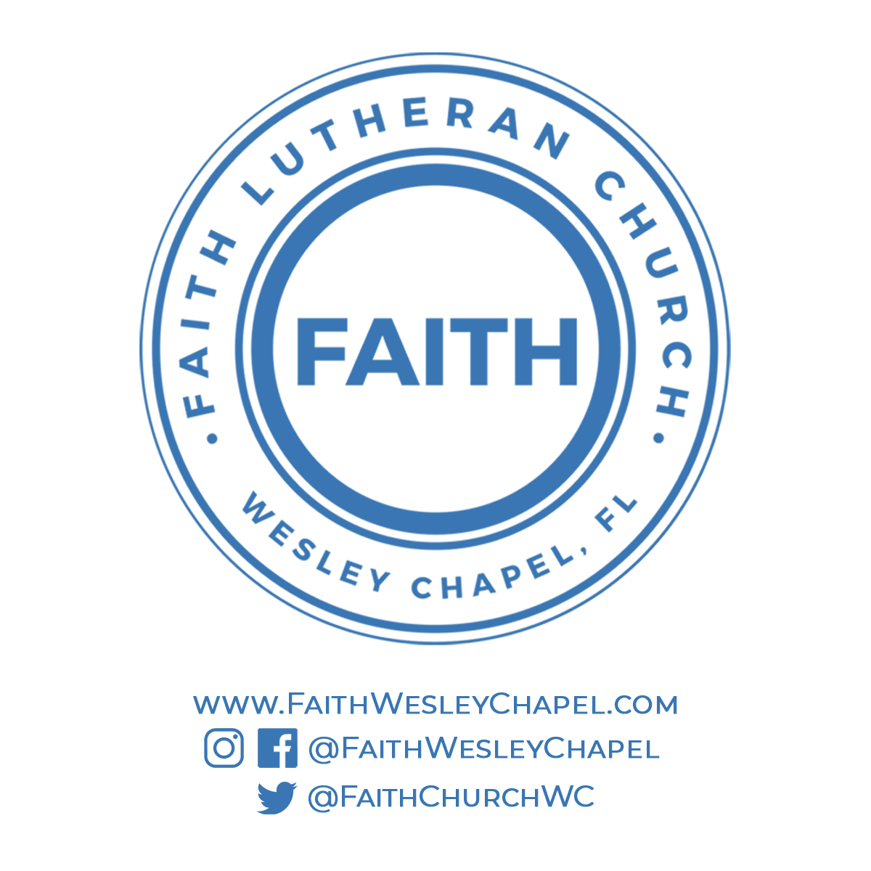**@FaithWesleyChapel**

**@FaithWesleyChapel**

**@FaithChurchWC**