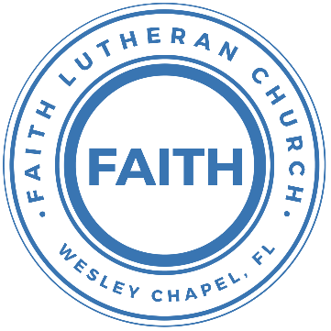

**Leading our community into a deep connection in Christ**

**Worship Service for January 7, 2024 at 11 AM**

**Welcome**

**Opening Song:**Oh, You Can't Get to Heaven

Oh, you can't get to heaven, (Oh, you can't get to heaven,)  
On roller skates. (On roller skates.)  
Oh, you can't get to heaven, (Oh, you can't get to heaven,)  
On roller skates.  
Oh, you can't get to heaven on roller skates,  
'Cause you'd roll right past those pearly gates.  
All my sins are washed away. I've been redeemed.

Oh, you can't get to heaven in a rocking chair…  
'Cause a rocking chair won't get you there.

Oh, you can't get to heaven in a limousine…  
'Cause the Lord don't sell no gasoline.

Oh, you can't get to Heaven in dirty jeans…  
'Cause heaven ain’t got no washing machines.

If you wanna get to heaven believe in Jesus name…  
'Cause it's by His name that we are saved. © Public Domain

**Invocation**

**Confession and Forgiveness:**

**P:** We have come here today to worship the Lord.  In worship we hear the Word of God, we receive God's blessings, and respond with thanks and praise.  We begin by seeking God's blessing of forgiveness.  He has promised to remove the guilt and shame of our sin through the sacrifice of Jesus Christ on the cross.

*(a time of silence to reflect and personally confess our sins)*

**P:** Let us confess our sins to the Lord.

**P:** Heavenly Father,  
**C:** Heavenly Father,

**P:** I have done things that were wrong.  
**C:** I have done things that were wrong.  
  
**P:** I have been mean to others.  
**C:** I have been mean to others.

**P:** I have not obeyed my parents.  
**C:** I have not obeyed my parents.

**P:** I have not obeyed You, God.  
**C:** I have not obeyed You, God.

**P:** But I am very sorry.  
**C:** But I am very sorry.

**P:** Please forgive me.  
**C:** Please forgive me.

**P:** I love You very much.  
**C:** I love You very much.

**P:** And I know You love me, too.  
**C:** And I know You love me, too.

**P:** Amen.  
**C:** Amen.

**P:** God has heard your apology.  He loves you very much.  God has told us that when we believe and trust in Him, He makes us His children.  As far as the east is from the west, so far does he remove our sins from us. He has told me to tell you that you are forgiven.  So, as His servant, I forgive you in the name of the Father and of the Son and of the Holy Spirit.   
**C:** Amen.

**Song:**Jesus Loves Me

Verse 1:

Jesus loves me this I know, For the Bible tells me so.

Little ones to Him belong, They are weak, but He is strong.

Chorus:

Yes, Jesus loves me, Yes, Jesus loves me,

Yes, Jesus loves me, The Bible tells me so.

Verse 2:

Jesus loves me, He who died. Heaven's gates to open wide.

He will wash away my sin, Let His little child come in.

*(Chorus)*

**First Reading -**Psalm 139:13-14

For you created my inmost being;  
 you knit me together in my mother’s womb.  
I praise you because I am fearfully and wonderfully made;  
 your works are wonderful,  
 I know that full well.

**Reader:** This is the Word of the Lord.  
**C:** Thanks be to God.

**Children's Message**"Looking to Our Creator for Purpose"

**Song:**Canvas And Clay

In my mother’s womb, You formed me with Your hands.  
Known and loved by You before I took a breath.

When I doubt it, Lord, remind me I’m wonderfully made.  
You’re an artist and a potter. I’m the canvas and the clay.

Chorus:  
You make all things work together for my future and for my good.  
You make all things work together for Your glory & for Your name.

There’s a healing light Just beyond the clouds.  
Though I’ve walked through fire, I see clearly now.

I know nothing has been wasted, no failure or mistake.  
You’re an artist and a potter. I’m the canvas and the clay.

*(Chorus 2x)* © Capitol CMG Genesis

**Second Reading -**Hebrews 12:1-2

Therefore, since we are surrounded by such a great cloud of witnesses, let us throw off everything that hinders and the sin that so easily entangles. And let us run with perseverance the race marked out for us, fixing our eyes on Jesus, the pioneer and perfecter of faith. For the joy set before him he endured the cross, scorning its shame, and sat down at the right hand of the throne of God.

**Reader:** This is the Word of the Lord.  
**C:** Thanks be to God.

**Children's Message**"Letting Go to Take Hold"

**Song:**I Surrender All

Verse 1:

All to Jesus I surrender. All to Him I freely give.

I will ever love and trust Him. In His presence daily live.

Chorus:  
I surrender all. I surrender all. All to Thee my blessed Savior, I surrender all.

Verse 2:

All to Jesus I surrender. Humbly at His feet I bow.

Worldly pleasures all forsaken. Take me, Jesus, take me now.

*(Chorus)*

Verse 4:

All to Jesus I surrender. Lord, I give myself to Thee.

Fill me with Thy love and power. Let Thy blessing fall on me.

*(Chorus 2x)* © 2005 Maranatha! Music, Nickeldimeus Music, and LAVIKMUSIC

**Sermon –**Series: "Finding What You're Looking For"  
 Week 1: "Finding Purpose"

Sermon Passage: Matthew 4:18-22

While walking by the Sea of Galilee, he saw two brothers, Simon (who is called Peter) and Andrew his brother, casting a net into the sea, for they were fishermen. And he said to them, “Follow me, and I will make you fishers of men.” Immediately they left their nets and followed him. And going on from there he saw two other brothers, James the son of Zebedee and John his brother, in the boat with Zebedee their father, mending their nets, and he called them. Immediately they left the boat and their father and followed him.

**Prayers:** *Text in prayer requests to (813) 326-5255*

**The Lord's Prayer**

Our Father who art in heaven, hallowed be Thy name, Thy kingdom come, Thy will be done on earth as it is in heaven.  Give us this day our daily bread; and forgive us our trespasses as we forgive those who trespass against us; and lead us not into temptation, but deliver us from evil.  For Thine is the kingdom and the power and the glory forever and ever.  Amen

**Offering**

**Benediction** *– The online service ends. The closing hymn video is on the Livestream page bulletin at FaithWesleyChapel.com with lyrics below. See announcements below as well.*

**Closing Song:**The Blessing *(stand)*

Verse:  
The Lord bless you and keep you,  
Make His face shine upon you and be gracious to you.  
The Lord turn His face toward you and give you peace.

Chorus:  
Amen. Amen. Amen.  
*(Repeat)*

*(Verse)*

*(Chorus)*

Bridge:  
May His favor be upon you and a thousand generations,  
And your family and your children,  
And their children and their children.  
*(Repeat)*

Bridge 2:  
May His presence go before you and behind you and beside you,  
All around you and within you. He is with you. He is with you.  
In the morning, in the evening, in your coming and your going,  
In your weeping and rejoicing He is with you. He is with you.  
He is for you. He is for you. He is for you. He is for you.  
He is for you. He is for you

*(Chorus) (Bridge 2)* 2020 Music by Elevation Worship Publishing

**Sermon Notes:**

**_______________________________________________**

**_______________________________________________**

**_______________________________________________**

**_______________________________________________**

**_______________________________________________**

**_______________________________________________**

**_______________________________________________**

**_______________________________________________**

**_______________________________________________**

**_______________________________________________**

**_______________________________________________**

**_______________________________________________**

**_______________________________________________**

**_______________________________________________**

|  |  |
| --- | --- |
| **Serving This Week** | |
|  | |
| **1st Reader:** Halston Quinn | **Children’s Church Teacher:** |
| **2nd Reader:** Jakob Torgrimson | N/A |
| **Acolyte:** Gunnar Torgrimson | **Children’s Church Assistant:** |
| **Com. Asst:** Larry Chmiel | N/A |
|  | |
| **Serving Next Week** | |
|  | |
| **O.T. Reader:** Vanessa Frost | **Children’s Church Teacher:** |
| **Epistle Reader:** Terrell Jordan | Terrell Jordan |
| **Acolyte:** Kaylee Steinbrueck | **Children’s Church Assistant:** |
| **Com. Asst:** Larry Chmiel | Kaylee Steinbrueck |

**Hey Youth!!**Do you know any worship songs you’d like to sing as part of our youth service? Let Pastor Kurt know.

Do you want to sing or play an instrument? Let Pastor Kurt know.

We want you to be a part of the service.

**Upcoming Events**

**Jan 14, After the Service – God Squad (Youth Group)**Faith Lutheran Church

**Jan 16, 7 PM – Council Meeting**  
TBD

**Jan 21, After the Service – Confirmation**Faith Lutheran Church

**www.FaithWesleyChapel.com**

**Faith YouTube**

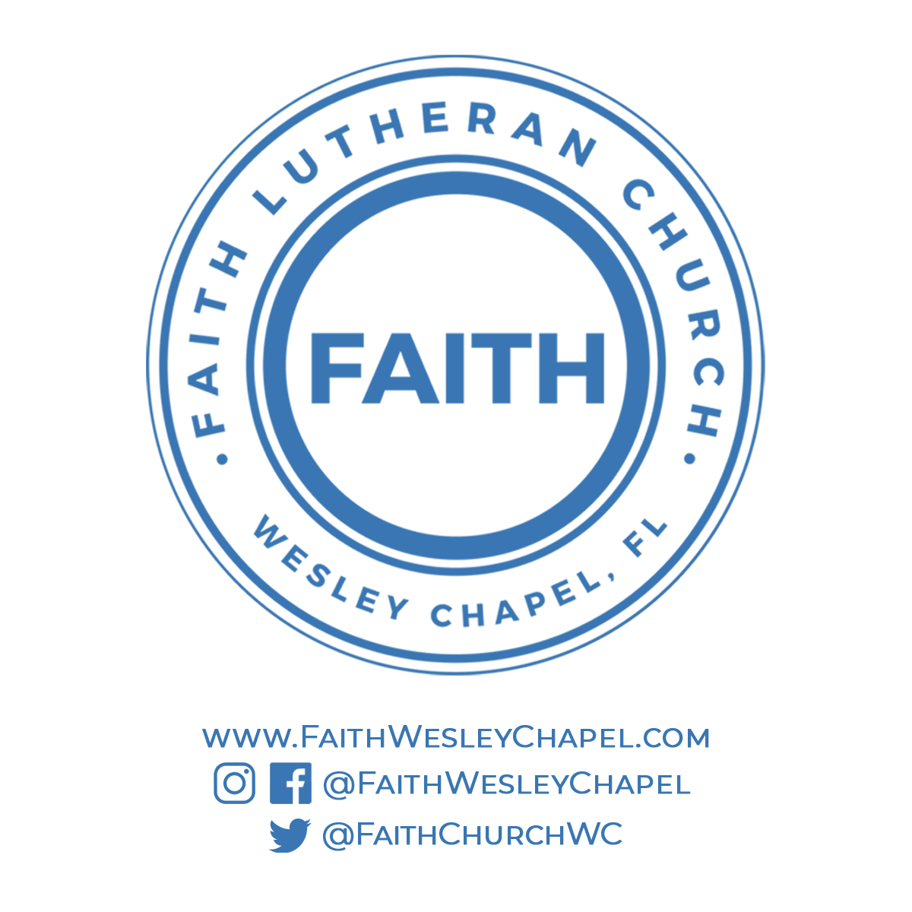**@FaithWesleyChapel**

**@FaithWesleyChapel**

**@FaithChurchWC**