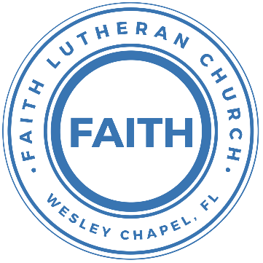

**Leading our community into a deep connection in Christ**

**Worship Service for January 21, 2024 at 11 AM**

**Welcome**

**Opening Song -** In Christ Alone

In Christ alone my hope is found.   
He is my light, my strength, my song.  
This Cornerstone, this solid ground,  
Firm through the fiercest drought and storm.  
What heights of love, what depths of peace,  
When fears are stilled, when strivings cease.  
My Comforter, my All in All. Here in the love of Christ I stand.

In Christ alone, who took on flesh,   
Fullness of God in helpless babe.  
This gift of love and righteousness,   
Scorned by the ones He came to save.  
‘Til on that cross as Jesus died,   
The wrath of God was satisfied.  
For every sin on Him was laid, Here in the death of Christ I live.

There in the ground His body lay,   
Light of the world by darkness slain.  
Then bursting forth in glorious Day,   
Up from the grave He rose again.  
And as He stands in victory, sin’s curse has lost its grip on me.  
For I am His and He is mine,   
Bought with the precious blood of Christ.

No guilt in life, no fear in death,   
This is the power of Christ in me.  
From life’s first cry to final breath,   
Jesus commands my destiny.  
No power of hell, no scheme of man,   
Can ever pluck me from His hand.  
‘Til He returns or calls me home,   
Here in the power of Christ I’ll stand.  
No power of hell, no scheme of man,   
Can ever pluck me from His hand.  
‘Til He returns or calls me home,   
Here in the power of Christ I’ll stand. © 2001 Thankyou Music

**Invocation**

**Confession and Forgiveness:**

**P:** Our Heavenly Father asks us to come into His presence.  
**C:** But we are sinful and unworthy.

**P:** Yes, all have sinned and fall short of the glory of God, but Jesus Christ died on the cross that we may be forgiven and washed clean of all our sins by His blood spilled on the cross.  
**C:** Lord, if You wash us, we will certainly be clean and pure.

**P:** We take a moment to bow before the His cross and silently reflect on our lives and confess our sins.

*(Time of silence for reflection and confession)*

**P:** Let us confess, together, our sins to God our Father.  
**C:** Heavenly Father, we confess that we are sinners.  We have sinned against you and our neighbors. We have not loved you with our whole heart and we have not loved our neighbors as ourselves. We have not lived out our faith in our community. We justly deserve Your punishment.  For the sake of Your Son, Jesus Christ, have mercy on us.  Forgive us, renew us, and lead us, so that we may delight in Your will and walk in Your ways to the glory of Your holy name.  Amen.

**P:** Almighty God in His mercy has given His Son to die for you and for His sake forgives you all your sins.  As a called and ordained servant of Christ, and by His authority, I, therefore, forgive you all your sins in the name of the Father and of the Son and of the Holy Spirit.  
**C:** Amen

**Song of Praise and Thanksgiving:** Cornerstone

My hope is built on nothing less,   
Than Jesus' blood and righteousness.  
I dare not trust the sweetest frame,   
But wholly trust in Jesus' name.

Chorus:

Christ alone, Cornerstone, Weak made strong in the Savior's love.

Through the storm He is Lord, Lord of all.

Verse 2:

When darkness seems to hide His face,

I rest on His unchanging grace.

In every high and stormy gale my anchor holds within the veil.

My anchor holds within the veil.

*(Chorus)*

He is Lord. Lord of all.

Verse 3:

When He shall come with trumpet sound,

Oh, may I then in Him be found,

Dressed in His righteousness alone,

Faultless, stand before the throne.

*(Chorus)*  © 2011 Hillsong Music

**Old Testament Reading -**Psalm 130

Out of the depths I cry to you, O Lord! O Lord, hear my voice! Let your ears be attentive to the voice of my pleas for mercy! If you, O Lord, should mark iniquities, O Lord, who could stand? But with you there is forgiveness, that you may be feared. I wait for the Lord, my soul waits, and in his word I hope; my soul waits for the Lord more than watchmen for the morning, more than watchmen for the morning. O Israel, hope in the Lord! For with the Lord there is steadfast love, and with him is plentiful redemption. And he will redeem Israel from all his iniquities.

**Reader:** This is the Word of the Lord.  
**C:** Thanks be to God.

**Gospel Reading** – Matthew 11:27-30  
At that time Jesus declared,...All things have been handed over to me by my Father, and no one knows the Son except the Father, and no one knows the Father except the Son and anyone to whom the Son chooses to reveal him. Come to me, all who labor and are heavy laden, and I will give you rest. Take my yoke upon you, and learn from me, for I am gentle and lowly in heart, and you will find rest for your souls. For my yoke is easy, and my burden is light.”

**P:** This is the Gospel of the Lord.  
**C:** Praise be to You, o Christ.

**Children's Message** *(Children dismissed to Children's Church)*

**Sermon Hymn***–*Living Hope

How great the chasm that lay between us.

How high the mountain I could not climb.

In desperation, I turned to heaven,  
And spoke Your name into the night.

Then through the darkness Your loving kindness,

Tore through the shadows of my soul.

The work is finished, the end is written,  
Jesus Christ, my Living Hope.

Who could imagine so great a mercy.

What heart could fathom such boundless grace.

The God of ages stepped down from glory,  
To wear my sin and bear my shame.

The cross has spoken. I am forgiven.

The King of Kings calls me His own.

Beautiful Savior I’m Yours forever,

Jesus Christ, my Living Hope.

Chorus:

Hallelujah, praise the one who set me free!

Hallelujah, death has lost its grip on me!

You have broken every chain. There’s salvation in Your Name,

Jesus Christ, my Living Hope.

Then came the morning that sealed the promise,

Your buried body began to breathe.

Out of the silence the roaring Lion,

Declared the grave has no claim on me.

*(Repeat)*

Jesus, Yours is the victory!

*(Chorus 2x)* © Bethel Music Publishing and Remaining portion is unaffiliated

**Sermon** - Series: "Finding What You're Looking For"  
 Week 3: "Having Hope"

Sermon Reading - 1 Peter 1:3-5  
Blessed be the God and Father of our Lord Jesus Christ! According to his great mercy, he has caused us to be born again to a living hope through the resurrection of Jesus Christ from the dead, to an inheritance that is imperishable, undefiled, and unfading, kept in heaven for you, who by God's power are being guarded through faith for a salvation ready to be revealed in the last time.

**P:** This is the Word of the Lord.  
**C:** Thanks be to God.

**Prayers:** *Text in prayer requests to (813) 326-5255*

**Nicene Creed** *(stand)*

I believe in one God, the Father Almighty, maker of heaven and earth and of all things visible and invisible.

And in one Lord Jesus Christ, the only-begotten Son of God, begotten of His Father before all worlds, God of God, Light of Light, very God of very God, begotten, not made, being of one substance with the Father, by whom all things were made; who for us men and for our salvation came down from heaven and was incarnate by the Holy Spirit of the virgin Mary and was made man; and was crucified also for us under Pontius Pilate. He suffered and was buried. And the third day He rose again according to the Scriptures and ascended into heaven and sits at the right hand of the Father. And He will come again with glory to judge both the living and the dead, whose kingdom will have no end.

And I believe in the Holy Spirit, the Lord and Giver of Life, who proceeds from the Father and the Son, who with the Father and the Son together is worshiped and glorified, who spoke by the prophets. And I believe in one holy Christian and apostolic Church, I acknowledge one Baptism for the remission of sins, and I look for the resurrection of the dead and the life of the world to come. Amen.

**The Lord's Prayer** *(stand)*

Our Father who art in heaven, hallowed be Thy name, Thy kingdom come, Thy will be done on earth as it is in heaven.  Give us this day our daily bread; and forgive us our trespasses as we forgive those who trespass against us; and lead us not into temptation, but deliver us from evil.  For Thine is the kingdom and the power and the glory forever and ever.  Amen

**Offering** *(sit)*

**Words of Institution** *(stand)*

**Benediction** *– The online service ends. The closing hymn video is on the Livestream page bulletin at FaithWesleyChapel.com with lyrics below. See announcements below as well.*

**Closing Song:**This Is Amazing Grace

Who breaks the power of sin and darkness?

Whose love is mighty and so much stronger?

The King of Glory, the King above all kings.

Who shakes the whole earth with holy thunder?

Who leaves us breathless in awe and wonder?

The King of Glory, the King above all kings.

Chorus:

This is amazing grace. This is unfailing love,

That You would take my place, That You would bear my cross.

You would lay down Your life, that I would be set free.

Jesus, I sing for all that You've done for me.

Who brings our chaos back into order?

Who makes the orphan a son and daughter?

The King of Glory, The King of Glory.

Who rules the nations with truth and justice,

Shines like the sun in all of its brilliance?

The King of Glory, the King above all kings.

*(Chorus)*

Bridge:

Worthy is the Lamb who was slain.

Worthy is the King who conquered the grave.

*(Repeat 2x)*

Worthy is the Lamb who was slain. Worthy! Worthy! Worthy!

*(Chorus) © 2012 Bethel Music, Seems Like Music, Sing My Songs, Phil Wickham Music, and Warner Chappell Music*

|  |  |
| --- | --- |
| **Serving This Week** | |
|  | |
| **O.T. Reader:** Halston Quinn | **Children’s Church Teacher:** |
| **Epistle Reader:** Dylan McConnell | Terrell Jordan |
| **Acolyte:** Griffin Frost | **Children’s Church Assistant:** |
| **Com. Asst:** Larry Chmiel | Jakob Torgrimson |
|  | |
| **Serving Next Week** | |
|  | |
| **O.T. Reader:** Terrell Jordan | **Children’s Church Teacher:** |
| **Epistle Reader:** Gunnar Torgrimson | Melissa Steinbrueck |
| **Acolyte:** Lawrence Finnerty | **Children’s Church Assistant:** |
| **Com. Asst:** Larry Chmiel | Kaylee Steinbrueck |

**Upcoming Events**

**Today, After the Service – Confirmation**Faith Lutheran Church

**Jan 28, 1:30 PM – Youth New Year’s Escape Room Party**Time Trap Escape Room – $16.95/person  
8042 Old County Rd 54 Suite a, New Port Richey, FL 34653

**Feb 14, 7 PM – Ash Wednesday Service**Grace Community Church

**www.FaithWesleyChapel.com**

**Faith YouTube**

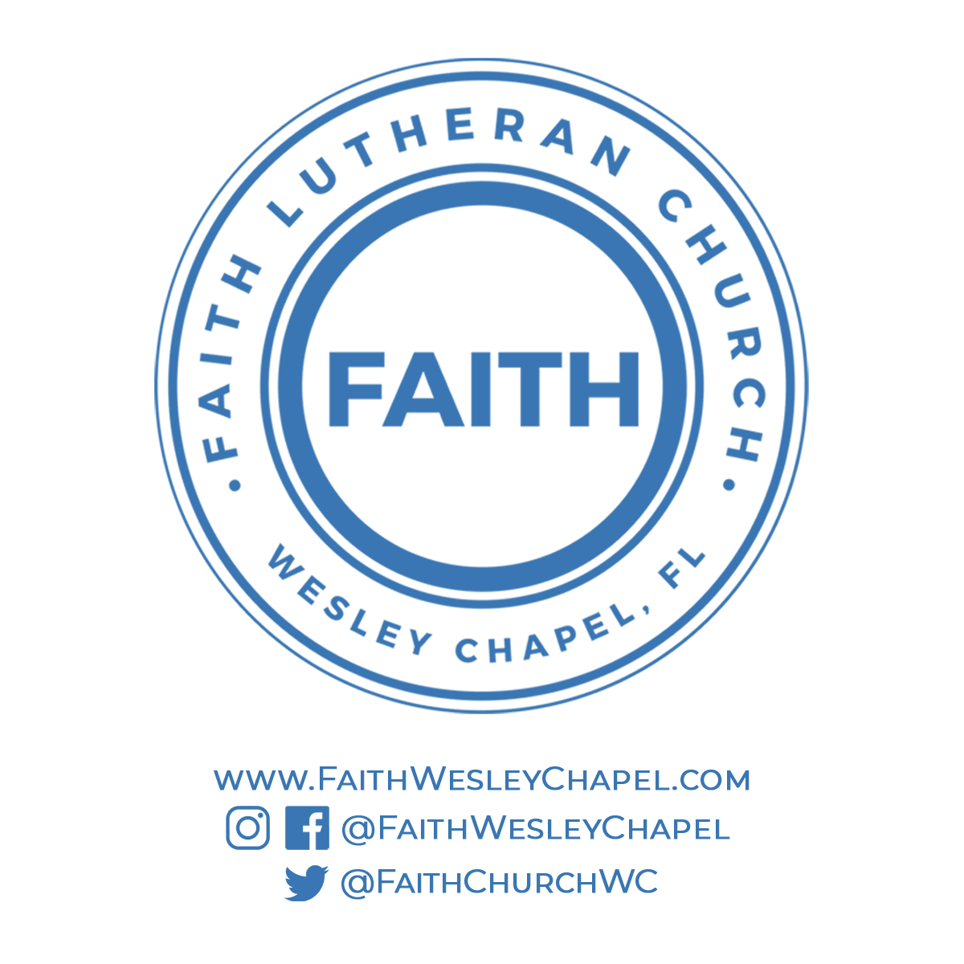**@FaithWesleyChapel**

**@FaithWesleyChapel**

**@FaithChurchWC**