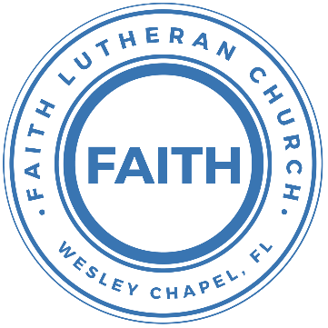

**Leading our community into a deep connection in Christ**

**Worship Service for January 28, 2024 at 11 AM**

**Welcome**

**Opening Song:**They'll Know We Are Christians By Our Love

We are one in the Spirit, we are one in the Lord;  
We are one in the Spirit, we are one in the Lord;  
And we pray that all unity will one day be restored.

Chorus:  
And they'll know we are Christians by our love, by our love,  
yes, they'll know we are Christians by our love.

We will walk with each other, we will walk hand in hand;  
We will walk with each other, we will walk hand in hand;  
And together we'll spread the news that God is in our land.

*(Chorus)*

We Will work with each other, we will work side by side;  
We will work with each other, we will work side by side;  
And we'll guard each one's dignity and save each other's pride.

*(Chorus)* © 1966 F.E.L. Publications. Assigned 1991 Lorenz Publishing Company

**Invocation**

**Confession and Forgiveness:**

**P:** Come into the presence of the Lord our God.

**C:** Have mercy, O Lord. If you, Lord, kept a record of sins, Lord, who could stand; but if we confess our sins, he is faithful and just to forgive us our sins and to cleanse us from all unrighteousness.

*(A time of silence to reflect and personally confess our sins)*

**P:** I said, "I will confess my transgressions to the LORD." And you forgave the guilt of my sin. Let us confess our sin before the Lord. Let us confess together.  
**C:** Heavenly Father, we confess that we are sinners.  We have sinned against you and our neighbors. We have not loved you with our whole heart and we have not loved our neighbors as ourselves. We justly deserve Your punishment.  For the sake of Your Son, Jesus Christ, have mercy on us.  Forgive us, renew us, and lead us, so that we may delight in Your will and walk in Your ways to the glory of Your holy name.  Amen.

**P:** The Lord is gracious and merciful. He promises to forgive our sins. Therefore, upon this, your confession, as a called and ordained servant of the Lord, in the stead and by the command of my Lord, Jesus Christ, I forgive you all your sins in the name of the Father and of the Son and of the Holy Spirit.  
**C:** Amen.

**Song of Praise and Thanksgiving -** What a Friend

Everybody has trials and temptations.  
Everybody knows heartbreak, isolation.

Pre-Chorus:  
But we can lay our burdens down. Lay our burdens down.

Chorus:  
What a friend we have in Jesus. East to west my sins are gone.  
I see grace on every horizon.  
And forever and ever His heart is my home.

Everybody has fears, everybody got worries.  
Everybody knows sorrow, devastation.

*(Pre-Chorus)  
(Chorus)*

Bridge:  
No more betrayal, for He is faithful.  
He fills me up and my cup runneth over.  
No more betrayal, for He is faithful.  
How He has proven it over and over.  
(Repeat)

*(Chorus 2x)*

And forever and ever His heart is my home. © All Essential Music

**Old Testament Reading -** Proverbs 14:25-27

A truthful witness saves lives, but one who breathes out lies is deceitful. In the fear of the Lord one has strong confidence, and his children will have a refuge. The fear of the Lord is a fountain of life, that one may turn away from the snares of death

**Reader:** This is the Word of the Lord.  
**C:** Thanks be to God.

**Second Reading -** Acts 1:3-9

He presented himself alive to them after his suffering by many proofs, appearing to them during forty days and speaking about the kingdom of God.

And while staying with them he ordered them not to depart from Jerusalem, but to wait for the promise of the Father, which, he said, “you heard from me; for John baptized with water, but you will be baptized with the Holy Spirit not many days from now.”

So when they had come together, they asked him, “Lord, will you at this time restore the kingdom to Israel?” He said to them, “It is not for you to know times or seasons that the Father has fixed by his own authority. But you will receive power when the Holy Spirit has come upon you, and you will be my witnesses in Jerusalem and in all Judea and Samaria, and to the end of the earth.” And when he had said these things, as they were looking on, he was lifted up, and a cloud took him out of their sight.

**Reader:** This is the Word of the Lord.  
**C:** Thanks be to God.

**Gospel Reading -** Luke 24:36-49

As they were talking about these things, Jesus himself stood among them, and said to them, “Peace to you!” But they were startled and frightened and thought they saw a spirit. And he said to them, “Why are you troubled, and why do doubts arise in your hearts? See my hands and my feet, that it is I myself. Touch me, and see. For a spirit does not have flesh and bones as you see that I have.” And when he had said this, he showed them his hands and his feet. And while they still disbelieved for joy and were marveling, he said to them, “Have you anything here to eat?” They gave him a piece of broiled fish, and he took it and ate before them.

Then he said to them, “These are my words that I spoke to you while I was still with you, that everything written about me in the Law of Moses and the Prophets and the Psalms must be fulfilled.” Then he opened their minds to understand the Scriptures, and said to them, “Thus it is written, that the Christ should suffer and on the third day rise from the dead, and that repentance for the forgiveness of sins should be proclaimed in his name to all nations, beginning from Jerusalem. You are witnesses of these things. And behold, I am sending the promise of my Father upon you. But stay in the city until you are clothed with power from on high.”

**P:** This is the Gospel of the Lord.  
**C:** Praise be to You, O Christ.

**Children's Message**

**Sermon Hymn -** Mighty To Save

Everyone needs compassion, a Love that's never failing.  
Let mercy fall on me.  
Everyone needs forgiveness, the kindness of a savior.  
The hope of nations

Chorus:

Savior, He can move the mountains.

My God is mighty to save. He is mighty to save.

Forever, author of salvation,

He rose and conquered the grave. Jesus conquered the grave.

So take me as you find me, all my fears and failures,

And fill my life again.

I give my life to follow everything I believe in.

Now I surrender. (I surrender)

Chorus:

Savior, He can move the mountains.

My God is mighty to save. He is mighty to save.

Forever, author of salvation,

He rose and conquered the grave. Jesus conquered the grave.

Bridge:

Shine your light and let the whole world see singing,

For the glory of the risen king, Jesus.

Shine your light and let the whole world see singing,

For the glory of the risen king

*(Chorus 2x)* © 2006 Hillsong Publishing

**Sermon –** Series: "You Are a Witness"  
 Week 1: “The Need”

**Prayers:** *Text in prayer requests to (813) 326-5255‬*

**Apostles' Creed** *(stand)*

I believe in God, the Father almighty, maker of heaven and earth,  
And in Jesus Christ, his only Son, our Lord,  
who was conceived by the Holy Spirit,  
born of the Virgin Mary, suffered under Pontius Pilate,  
was crucified, died and was buried. He descended into hell.  
The third day he rose again from the dead.  
He ascended into heaven and sits at the right hand of God  
the Father almighty.  
From there he will come to judge the living and the dead.  
I believe in the Holy Spirit, the holy Christian Church,  
the communion of saints, the forgiveness of sins,  
the resurrection of the body, and the life everlasting. Amen.

**The Lord's Prayer** *(stand)*

Our Father who art in heaven, hallowed be Thy name, Thy kingdom come, Thy will be done on earth as it is in heaven.  Give us this day our daily bread; and forgive us our trespasses as we forgive those who trespass against us; and lead us not into temptation, but deliver us from evil.  For Thine is the kingdom and the power and the glory forever and ever.  Amen

**Offering** *(sit)*

**Benediction** *– The online service ends. The closing hymn video is on the Livestream page bulletin at FaithWesleyChapel.com with lyrics below. See announcements below as well.*

**Closing Song -**I Love To Tell The Story *(sit)*

I love to tell the story of unseen things above,   
Of Jesus and His glory, of Jesus and his love.  
I love to tell the story because I know 'tis true.  
It satisfies my longings as nothing else can do.

Chorus:  
I love to tell the story. 'Twill be my theme in glory,  
To tell the old, old story of Jesus and his love.

I love to tell the story. 'Tis pleasant to repeat,   
What seems each time I tell it more wonderfully sweet.  
I love to tell the story for some have never heard,   
The message of salvation from God's own Holy Word.

*(Chorus)*

I love to tell the story, for those who know it best,  
Seem hungering and thirsting to hear it like the rest.  
And when in scenes of glory, I sing the new, new song,  
Twill be the old, old story that I have loved so long.

*(Chorus)* © Public Domain

**Being God’s Church**



**Thank you McConnells!!**

Dylan and Shayla help set up for worship every 3rd Sunday. Dylan is also on the Vision Team and serves as a greeter and Shayla has helped with Faith’s social media. Dylan was actually the person who found Song and Dance as place for us to rent for worship.

Thank you, Dylan and Shayla (and Remy)! God bless!

|  |  |
| --- | --- |
| **Serving This Week** | |
|  | |
| **O.T. Reader:** Terrell Jordan | **Children’s Church Teacher:** |
| **Epistle Reader:** Gunnar Torgrimson | Melissa Steinbrueck |
| **Acolyte:** Lawrence Finnerty | **Children’s Church Assistant:** |
| **Com. Asst:** Larry Chmiel | Kaylee Steinbrueck |
|  | |
| **Serving Next Week** | |
|  | |
| **1st Reader:** Kaylee Steinbrueck | **Children’s Church Teacher:** |
| **2nd Reader:** Kelsey Torgrimsom | N/A |
| **Acolyte:** Lawrence Finnerty | **Children’s Church Assistant:** |
| **Com. Asst:** Larry Chmiel | N/A |

**Upcoming Events**

**Today, After the Service – State of the Church Voter Meeting**Faith Lutheran Church

**Today, 1:30 PM – Youth New Year’s Escape Room Party**Time Trap Escape Room – $16.95/person  
8042 Old County Rd 54 Suite a, New Port Richey, FL 34653

**Jan 30, 7 PM – Growth Group Bible Study**Renee’s Home

**Feb 4, After the Service – Confirmation**Faith Lutheran Church

**Feb 11, 12:30 PM – 1st Joint Youth Group**Grace Community Church

**Feb 14, 7 PM – Ash Wednesday Service**Grace Community Church

**www.FaithWesleyChapel.com**

**Faith YouTube**

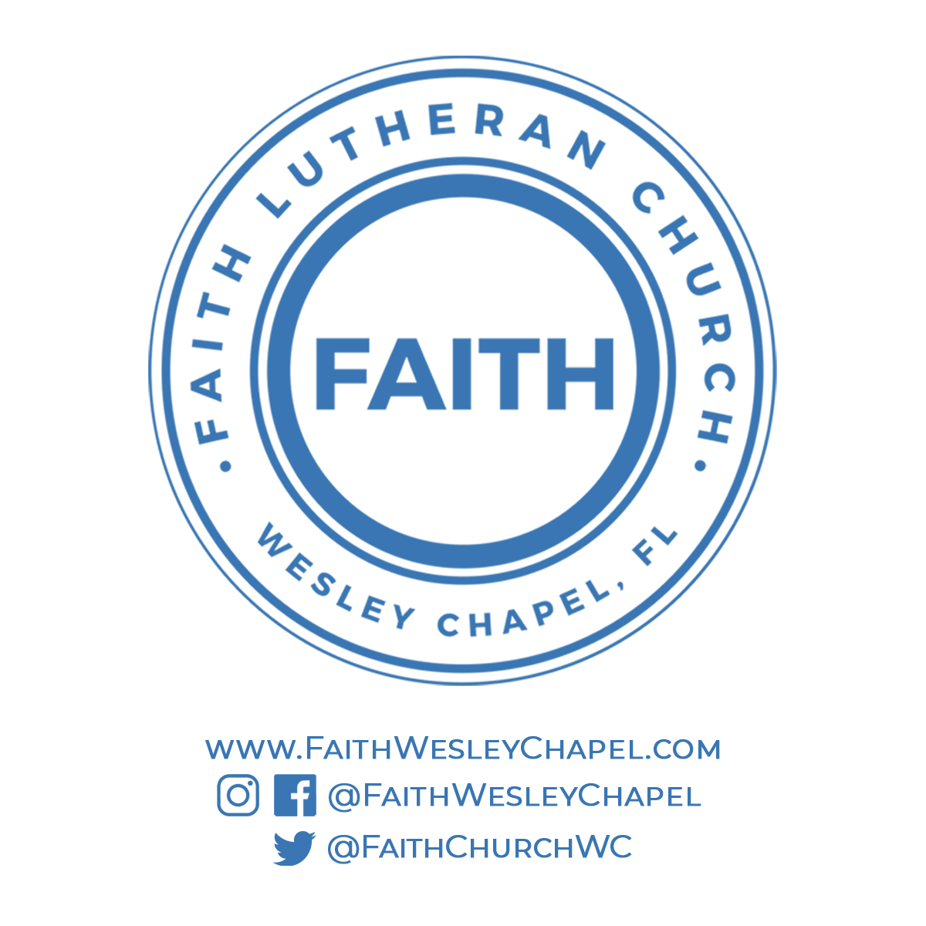**@FaithWesleyChapel**

**@FaithWesleyChapel**

**@FaithChurchWC**