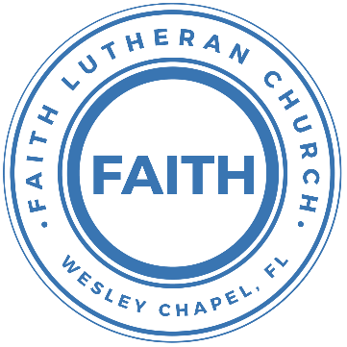

**Leading our community into a deep connection in Christ**

**Worship Service for February 4, 2024 at 11 AM**

**Welcome**

**Opening Song:**Praise Ye the Lord, Hallelujah

Side 1: Hallelu, hallelu, hallelu, hallelujah,  
Side 2: Praise ye the Lord.

Side 1: Hallelu, hallelu, hallelu, hallelujah,

Side 2: Praise ye the Lord.

Side 2: Praise ye the Lord.

Side 1: Hallelujah,

Side 2: Praise ye the Lord.

Side 1: Hallelujah,

Side 2: Praise ye the Lord.  
Side 1: Hallelujah,

All: Praise ye the Lord.

*(Repeat all)*

**Invocation**

**Confession and Forgiveness:**

**P:** We have come here today to worship the Lord.  In worship we hear the Word of God, we receive God's blessings, and respond with thanks and praise.  We begin by seeking God's blessing of forgiveness.  He has promised to remove the guilt and shame of our sin through the sacrifice of Jesus Christ on the cross.

*(a time of silence to reflect and personally confess our sins)*

**P:** Let us confess our sins to the Lord.

**P:** Heavenly Father,  
**C:** Heavenly Father,

**P:** I have done things that were wrong.  
**C:** I have done things that were wrong.  
  
**P:** I have been mean to others.  
**C:** I have been mean to others.

**P:** I have not obeyed my parents.  
**C:** I have not obeyed my parents.

**P:** I have not obeyed You, God.  
**C:** I have not obeyed You, God.

**P:** But I am very sorry.  
**C:** But I am very sorry.

**P:** Please forgive me.  
**C:** Please forgive me.

**P:** I love You very much.  
**C:** I love You very much.

**P:** And I know You love me, too.  
**C:** And I know You love me, too.

**P:** Amen.  
**C:** Amen.

**P:** God has heard your apology.  He loves you very much.  God has told us that when we believe and trust in Him, He makes us His children.  As far as the east is from the west, so far does he remove our sins from us. He has told me to tell you that you are forgiven.  So, as His servant, I forgive you in the name of the Father and of the Son and of the Holy Spirit.   
**C:** Amen.

**Song:**Jesus Loves Me

Verse 1:

Jesus loves me this I know, for the Bible tells me so.

Little ones to Him belong. They are weak, but He is strong.

Chorus:

Yes, Jesus loves me. Yes, Jesus loves me.

Yes, Jesus loves me, the Bible tells me so.

Verse 2:

Jesus loves me, He who died, Heaven's gates to open wide.

He will wash away my sin, let His little child come in.

*(Chorus)* © Public Domain

**First Reading -**Romans 3:23For all have sinned and fall short of the glory of God,

**Reader:** This is the Word of the Lord.  
**C:** Thanks be to God.

**Children's Message**"You Have a Problem: Sin"

**Song:**Amazing Grace

Amazing grace, how sweet the sound that saved a wretch like me.

I once was lost, but now am found. Was blind but now I see.

T'was grace that taught my heart to fear,

And grace my fears relieved.

How precious did that grace appear, the hour I first believed.

When we've been there ten thousand years,  
bright shining as the sun,

we've no less days to sing God’s praise,  
than when we've first begun. © Public Domain

**Second Reading -**John 3:16“For God so loved the world, that he gave his only Son, that whoever believes in him should not perish but have eternal life."

**Reader:** This is the Word of the Lord.  
**C:** Thanks be to God.

**Children's Message**"God Has the Solution: Jesus"

**Song:**I Love To Tell The Story

I love to tell the story of unseen things above,   
Of Jesus and His glory, of Jesus and his love.  
I love to tell the story because I know 'tis true.  
It satisfies my longings as nothing else can do.

Chorus:  
I love to tell the story. 'Twill be my theme in glory,  
To tell the old, old story of Jesus and his love.

I love to tell the story. 'Tis pleasant to repeat,   
What seems each time I tell it more wonderfully sweet.  
I love to tell the story for some have never heard,   
The message of salvation from God's own Holy Word.

*(Chorus)*

I love to tell the story, for those who know it best,  
Seem hungering and thirsting to hear it like the rest.  
And when in scenes of glory, I sing the new, new song,  
Twill be the old, old story that I have loved so long.

*(Chorus)* © Public Domain

**Sermon –**“The Message”

Sermon Reading - Isaiah 53:4–6  
Surely he has borne our griefs and carried our sorrows; yet we esteemed him stricken, smitten by God, and afflicted. But he was pierced for our transgressions; he was crushed for our iniquities; upon him was the chastisement that brought us peace, and with his wounds we are healed. All we like sheep have gone astray; we have turned—every one—to his own way; and the Lord has laid on him the iniquity of us all.

**Prayers:** *Text in prayer requests to (813) 326-5255*

**The Lord's Prayer**

Our Father who art in heaven, hallowed be Thy name, Thy kingdom come, Thy will be done on earth as it is in heaven.  Give us this day our daily bread; and forgive us our trespasses as we forgive those who trespass against us; and lead us not into temptation, but deliver us from evil.  For Thine is the kingdom and the power and the glory forever and ever.  Amen

**Offering**

**Benediction** *– The online service ends. The closing hymn video is on the Livestream page bulletin at FaithWesleyChapel.com with lyrics below. See announcements below as well.*

**Closing Song:**God So Loved

Come all you weary. Come all you thirsty.

Come to the well that never runs dry.

Drink of the Water. Come and thirst no more.

Come all you sinners. Come find His mercy.

Come to the table. He Will satisfy.

Taste of His goodness. Find what you’re looking for.

Chorus 1:

For God so loved the World that He gave us,

His one and only Son to save us.

Whoever believes in Him, will live forever.

Bring all your failures. Bring your addictions.

Come lay them down at the Foot of the cross.

Jesus is waiting there with open arms.

*(Chorus 1)*

Chorus 2:

The power of Hell forever defeated.

Now, it is well. I’m Walking in freedom.

For God so loved, God so loved the world.

Bridge:

Praise God! Praise God from whom all blessings flow.

Praise Him! Praise Him for the wonders of His love.

*(Repeat)*

His amazing love!

Chorus 1:

For God so loved the World that He gave us,

His one and only Son to save us.

Whoever believes in Him, will live forever.

Chorus 2:

The power of Hell forever defeated.

Now, it is well. I’m Walking in freedom.

For God so loved, God so loved the world.

Bring all your failures. Bring your addictions.

Come lay them down at the Foot of the cross.

Jesus is waiting there with open arms. © 2019 Andrew Bergthold Designee

**Being God’s Church**



**Thank you Halston and Ben!!**

Halston and Ben teach children’s church regularly. They have volunteered at various activities, like handing out flyers and Dum Dums at the Wesley Chapel Fall Festival. They have also helped out with the youth and Halston is frequently a reader for our worship services.

Thank you, Halson and Ben! God bless!

|  |  |
| --- | --- |
| **Serving This Week** | |
|  | |
| **1st Reader:** Kaylee Steinbrueck | **Children’s Church Teacher:** |
| **2nd Reader:** Kelsey Torgrimson | N/A – No Children’s Church |
| **Acolyte:** Lawrence Finnerty | **Children’s Church Assistant:** |
| **Com. Asst:** Larry Chmiel | N/A – No Children’s Church |
|  | |
| **Serving Next Week** | |
|  | |
| **O.T. Reader:** Vanessa Frost | **Children’s Church Teacher:** |
| **Epistle Reader:** Terrell Jordan | Halston and Ben |
| **Acolyte:** Kaylee Steinbrueck | **Children’s Church Assistant:** |
| **Com. Asst:** Larry Chmiel | N/A |

**Hey Youth!!**Do you know any worship songs you’d like to sing as part of our youth service? Let Pastor Kurt know.

Do you want to sing or play an instrument? Let Pastor Kurt know.

We want you to be a part of the service.

**Upcoming Events**

**Today, After the Service – Confirmation**Faith Lutheran Church

**Feb 11, 12:30 PM – 1st Joint Youth Group**Grace Community Church

**Feb 14, 7 PM – Ash Wednesday Service**Grace Community Church

**Feb 20, 7 PM Council Meeting**  
The Dunn’s house

**www.FaithWesleyChapel.com**

**Faith YouTube**

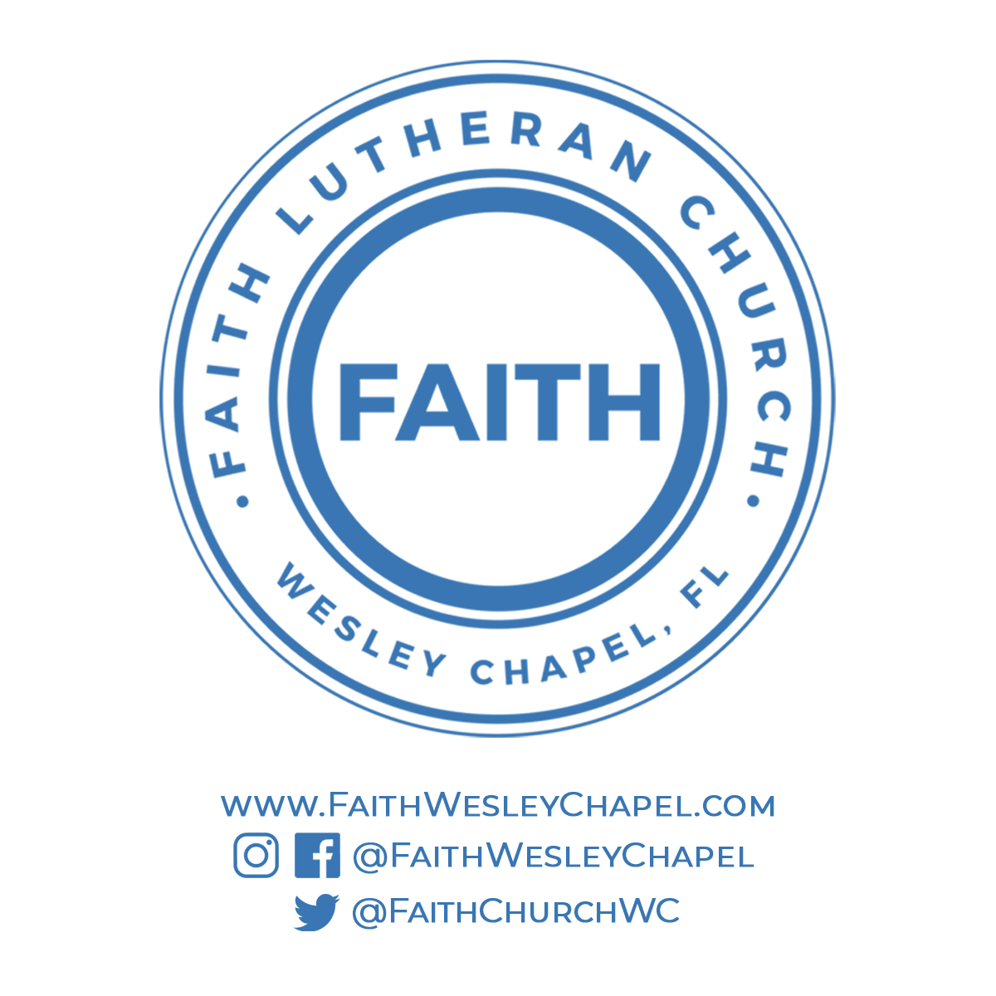**@FaithWesleyChapel**

**@FaithWesleyChapel**

**@FaithChurchWC**