

**Leading our community into a deep connection in Christ**

**Worship Service for February 11, 2024 at 11 AM**

**Welcome**

**Pray for the Food** - **People get food**

**Invocation** *(stand)*

**Confession and Forgiveness:** *(stand)*

**P:** As we gather, today, let us cleanse our hearts and our consciences by confessing our sin to God.

*(Time of silence for reflection and confession)*

**C:** Heavenly Father, we confess that we are sinful and unclean. We have sinned against you and against our neighbor in our thoughts, words, and actions.  We are truly sorry for our sins and sincerely repent of them. We ask for Your mercy. For the sake of Jesus Christ's bitter suffering and death, please forgive us and renew us that we may walk in Your Spirit to the glory of Your holy name. Amen

**P:** The Lord has heard your confession. Therefore, as a called and ordained servant of the Lord, in the stead and by the command of my Lord, Jesus Christ, I forgive you all your sins in the name of the Father and of the Son and of the Holy Spirit.  
**C:** Amen

**Songs of Praise and Thanksgiving –** Stand Up Stand Up For Jesus *(stand)*

Stand up, stand up for Jesus, ye soldiers of the cross.

Lift high His royal banner; it must not suffer loss.

From vict'ry unto vict'ry His army He shall lead,

Till ev'ry foe is vanquished, and Christ is Lord indeed.

Stand up, stand up for Jesus; the trumpet call obey;

Stand forth in mighty conflict in this His glorious day.

Let all His faithful serve Him against unnumbered foes;

Let courage rise with danger and strength to strength oppose.

Stand up, stand up for Jesus; stand in His strength alone.

The arm of flesh will fail you, ye dare not trust your own.

Put on the Gospel armor; each piece put on with prayer.

Where duty calls or danger, be never wanting there.

Stand up, stand up for Jesus; the strife will not belong;

This day the din of battle, the next the victor's song.

The soldiers, overcoming, their crown of life shall see,

And with the King of Glory shall reign eternally. © Public Domain

**Old Testament Reading** - Isaiah 55:1, 6-11

“Come, everyone who thirsts,

come to the waters;

and he who has no money,

come, buy and eat!

Come, buy wine and milk  
 without money and without price...

...“Seek the Lord while he may be found;

call upon him while he is near;

let the wicked forsake his way,

and the unrighteous man his thoughts;

let him return to the Lord, that he may have compassion on him,

and to our God, for he will abundantly pardon.

For my thoughts are not your thoughts,

neither are your ways my ways, declares the Lord.

For as the heavens are higher than the earth,

so are my ways higher than your ways

and my thoughts than your thoughts.

“For as the rain and the snow come down from heaven

and do not return there but water the earth,

making it bring forth and sprout,

giving seed to the sower and bread to the eater,

so shall my word be that goes out from my mouth;

it shall not return to me empty,

but it shall accomplish that which I purpose,

and shall succeed in the thing for which I sent it.

**Reader:** This is the Word of the Lord.  
**C:** Thanks be to God.

**Epistle Reading:**Romans 10:14-17

How then will they call on him in whom they have not believed? And how are they to believe in him of whom they have never heard? And how are they to hear without someone preaching? And how are they to preach unless they are sent? As it is written, “How beautiful are the feet of those who preach the good news!” But they have not all obeyed the gospel. For Isaiah says, “Lord, who has believed what he has heard from us?” So faith comes from hearing, and hearing through the word of Christ.

**Reader:** This is the Word of the Lord.   
**C:** Thanks be to God.

**Sermon Song –** I Love To Tell The Story

I love to tell the story of unseen things above,   
Of Jesus and His glory, of Jesus and his love.  
I love to tell the story because I know 'tis true.  
It satisfies my longings as nothing else can do.

Chorus:   
I love to tell the story. 'Twill be my theme in glory,  
To tell the old, old story of Jesus and his love.

I love to tell the story. 'Tis pleasant to repeat,   
What seems each time I tell it more wonderfully sweet.  
I love to tell the story for some have never heard,   
The message of salvation from God's own Holy Word.

Chorus:  
I love to tell the story. 'Twill be my theme in glory,  
To tell the old, old story of Jesus and his love.

I love to tell the story, for those who know it best,  
Seem hungering and thirsting to hear it like the rest.  
And when in scenes of glory, I sing the new, new song,  
Twill be the old, old story that I have loved so long.

*(Chorus)* © Public Domain

**Sermon/Discussion** – Series: "You Are a Witness"  
 Week 3: “The Action”

Sermon/Discussion: Matthew 28:16-20

Now the eleven disciples went to Galilee, to the mountain to which Jesus had directed them. And when they saw him they worshiped him, but some doubted. And Jesus came and said to them, “All authority in heaven and on earth has been given to me. Go therefore and make disciples of all nations, baptizing them in the name of the Father and of the Son and of the Holy Spirit, teaching them to observe all that I have commanded you. And behold, I am with you always, to the end of the age.”

**P:** This is the Gospel of the Lord.  
**C:** Praise be to You, O Christ.

**Prayers**

**Apostles' Creed** *(stand)*

I believe in God, the Father almighty, maker of heaven and earth,  
And in Jesus Christ, his only Son, our Lord,  
who was conceived by the Holy Spirit,  
born of the Virgin Mary, suffered under Pontius Pilate,  
was crucified, died and was buried. He descended into hell.  
The third day he rose again from the dead.  
He ascended into heaven and sits at the right hand of God  
the Father almighty.  
From there he will come to judge the living and the dead.  
I believe in the Holy Spirit, the holy Christian Church,  
the communion of saints, the forgiveness of sins,  
the resurrection of the body, and the life everlasting. Amen.

**The Lord's Prayer** *(stand)*

Our Father who art in heaven, hallowed be Thy name, Thy kingdom come, Thy will be done on earth as it is in heaven.  Give us this day our daily bread; and forgive us our trespasses as we forgive those who trespass against us; and lead us not into temptation, but deliver us from evil.  For Thine is the kingdom and the power and the glory forever and ever.  Amen

**Offering** *(sit)*

**Benediction** *– The online service ends. The closing hymn video is on the Livestream page bulletin at FaithWesleyChapel.com with lyrics below. See announcements below as well.*

**Closing Song:** Praise God From Whom All Blessings Flow *(stand)*

Praise God from Whom all blessings flow.  
Praise Him all creatures here below.  
Praise Him above, ye heavenly hosts.  
Praise Father, Son and Holy Ghost.  
Amen

**Being God’s Church**



**Thank you Melissa Steinbrueck!!**

Melissa picks out curricula for Children’s Church and also teaches Children’s Church. She helps with the bulletins each week. She also helps clean up after the service and is often one of the last people to leave. She has also volunteered at many service and outreach events. In addition to all of this, she makes it possible for Pastor Kurt to lead the service each week and attend meetings, Bible studies, and other events throughout the week.

Thank you, Melissa! God bless!

|  |  |
| --- | --- |
| **Serving This Week** | |
|  | |
| **O.T. Reader:** Vanessa Frost | **Children’s Church Teacher:** |
| **Epistle Reader:** Terrell Jordan | Halston & Ben |
| **Acolyte:** Jakob Torgrimson | **Children’s Church Assistant:** |
| **Com. Asst:** Larry Chmiel | N/A |
|  | |
| **Serving Next Week** | |
|  | |
| **O.T. Reader:** Terrell Jordan | **Children’s Church Teacher:** |
| **Epistle Reader:** Larry Chmiel | Melissa Steinbrueck |
| **Acolyte:** Emily Shuck | **Children’s Church Assistant:** |
| **Com. Asst:** Larry Chmiel | Katelyn Shuck |

**Upcoming Events**

**Today, 12:30 PM – 1st Joint Youth Group**Grace Community Church

**Feb 13, 7 PM – Growth Group Bible Study**Renee’s home

**Feb 14, 7 PM – Ash Wednesday Service**Grace Community Church

**Feb 20, 7 PM Council Meeting**  
The Dunn’s house

**Feb 25, 12:30 PM – Joint Youth Group**Grace Community Church

**www.FaithWesleyChapel.com**

**Faith YouTube**

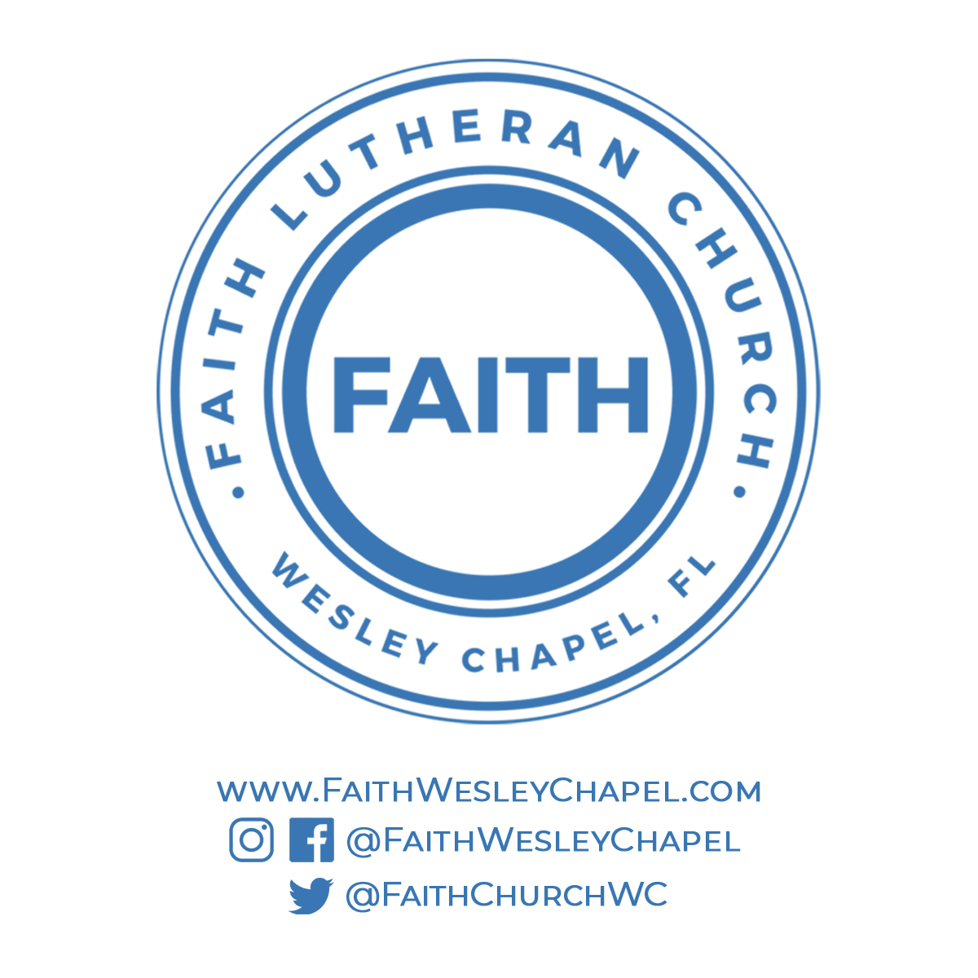**@FaithWesleyChapel**

**@FaithWesleyChapel**

**@FaithChurchWC**