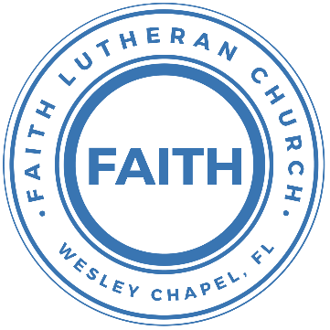

**Leading our community into a deep connection in Christ**

**Worship Service for February 18, 2024 at 11 AM**

**Welcome** & **Invocation**

**Confession and Forgiveness:**

**P:** Our Heavenly Father asks us to come into His presence, But we are sinful and unworthy. Truly, all have sinned and fall short of the glory of God, but Jesus Christ died on the cross that we may be forgiven and washed clean of all our sins by His blood poured out on the cross.  
**C:** Lord, if You wash us, we will certainly be clean and pure.

**P:** We join together in singing, “At the Cross”

**At the Cross (Love Ran Red)**

There’s a place where mercy reigns and never dies.

There’s a place where streams of grace flows deep and wide.

*Pre-Chorus:*

All the love, I’ve ever found,

Comes like a flood, comes flowing down.

*Chorus:*

At the cross, at the cross, I surrender my life.

I’m in awe of you. I’m in awe of you.

Where your love ran red, and my sins washed white.

I owe all to you. I owe all to you, Jesus.

There’s a place where sin and shame are powerless,

Where my heart has peace with God and forgiveness.

*Pre-Chorus:*

All the love, I’ve ever found,

Comes like a flood, comes flowing down.

*Chorus:*

At the cross, at the cross, I surrender my life.

I’m in awe of you. I’m in awe of you.

Where your love ran red, and my sins washed white.

I owe all to you. I owe all to you, Jesus.

**P:** We take a moment to bow before His cross and silently reflect on our lives and confess our sins.

*(a time of silence to reflect and personally confess our sins)*

**C:** Heavenly Father, we confess that we have sinned against you in thought, word, and deed. We have not loved you with our whole heart and have not loved our neighbor as ourselves. We are truly sorry and we humbly repent. For the sake of your Son Jesus Christ and His suffering and death on the cross, have mercy on us and forgive us; that we may delight in your will, and walk in your ways, to the glory of your Name. Amen

**At the Cross (Love Ran Red) continues…**

*Bridge:*

Here my hope is found, here on holy ground.

Here I bow down. Here I bow down.

Here arms open wide. Here you saved my life.

Here I bow down. Here I bow.

*(Repeat Bridge)*

*(Chorus 2x)* © Countless Wonder Publishing

**P:** The Lord our God is merciful and gracious, longsuffering, and abounding in goodness and truth, keeping mercy for thousands, forgiving iniquity and transgression and sin. Therefore I announce unto you the grace of our Lord Jesus Christ. In His stead and by the command of my Lord Jesus Christ, I forgive you all your sins in the name of the Father and of the Son and of the Holy Spirit.  
**C:** Amen.

**Song of Praise and Thanksgiving:** What a Friend

Everybody has trials and temptations.  
Everybody knows heartbreak, isolation.

Pre-Chorus:  
But we can lay our burdens down. Lay our burdens down.

Chorus:  
What a friend we have in Jesus. East to west my sins are gone.  
I see grace on every horizon.  
And forever and ever His heart is my home.

Everybody has fears, everybody got worries.  
Everybody knows sorrow, devastation.

*(Pre-Chorus)  
(Chorus)*

Bridge:  
No more betrayal, for He is faithful.  
He fills me up and my cup runneth over.  
No more betrayal, for He is faithful.  
How He has proven it over and over.  
(Repeat)

*(Chorus 2x)*

And forever and ever His heart is my home. © All Essential Music

**Epistle Reading** - Revelation 21:1-5

Then I saw a new heaven and a new earth, for the first heaven and the first earth had passed away, and the sea was no more. And I saw the holy city, new Jerusalem, coming down out of heaven from God, prepared as a bride adorned for her husband. And I heard a loud voice from the throne saying, “Behold, the dwelling place of God is with man. He will dwell with them, and they will be his people, and God himself will be with them as their God. He will wipe away every tear from their eyes, and death shall be no more, neither shall there be mourning, nor crying, nor pain anymore, for the former things have passed away.” And he who was seated on the throne said, “Behold, I am making all things new.” Also he said, “Write this down, for these words are trustworthy and true.”

**Reader:** This is the Word of the Lord.  
**C:** Thanks be to God.

**Gospel Reading** - John 3:1-15

Now there was a man of the Pharisees named Nicodemus, a ruler of the Jews. This man came to Jesus by night and said to him, “Rabbi, we know that you are a teacher come from God, for no one can do these signs that you do unless God is with him.” Jesus answered him, “Truly, truly, I say to you, unless one is born again he cannot see the kingdom of God.” Nicodemus said to him, “How can a man be born when he is old? Can he enter a second time into his mother's womb and be born?” Jesus answered, “Truly, truly, I say to you, unless one is born of water and the Spirit, he cannot enter the kingdom of God. That which is born of the flesh is flesh, and that which is born of the Spirit is spirit. Do not marvel that I said to you, ‘You must be born again.’ The wind blows where it wishes, and you hear its sound, but you do not know where it comes from or where it goes. So it is with everyone who is born of the Spirit.” Nicodemus said to him, “How can these things be?” Jesus answered him, “Are you the teacher of Israel and yet you do not understand these things? Truly, truly, I say to you, we speak of what we know, and bear witness to what we have seen, but you do not receive our testimony. If I have told you earthly things and you do not believe, how can you believe if I tell you heavenly things? No one has ascended into heaven except he who descended from heaven, the Son of Man. And as Moses lifted up the serpent in the wilderness, so must the Son of Man be lifted up, that whoever believes in him may have eternal life.

**P:** This is the Gospel of the Lord.  
**C:** Praise be to You, o Christ.

**Children's Message** *(Children dismissed to Children's Church)*

**Sermon Hymn***–*Thy Strong Word

Thy strong word did cleave the darkness;

At Thy speaking it was done.

For created light we thank Thee,

While Thine ordered seasons run.

Refrain:

Alleluia, alleluia! Praise to Thee who light dost send!

Alleluia, alleluia! Alleluia without end!

Lo, on those who dwelt in darkness,

Dark as night and deep as death,

Broke the light of thy salvation,

Breathed thine own life-giving breath. *(Refrain)*

Thy strong Word bespeaks us righteous;

Bright with thine own holiness,

Glorious now, we press toward glory,

And our lives our hope confess. *(Refrain)*

Give us lips to sing thy glory, Tongues thy mercy to proclaim,

Throats to shout the hope that fills us,

Mouths to speak thy holy name. *(Refrain)*  
 © 1969 Concordia Publishing House

**Sermon** - "Behold, I Am Making All Things New"

Isaiah 43:16-25

Thus says the Lord, who makes a way in the sea, a path in the mighty waters, who brings forth chariot and horse, army and warrior; they lie down, they cannot rise, they are extinguished, quenched like a wick: “Remember not the former things, nor consider the things of old. Behold, I am doing a new thing; now it springs forth, do you not perceive it? I will make a way in the wilderness and rivers in the desert. The wild beasts will honor me, the jackals and the ostriches, for I give water in the wilderness, rivers in the desert, to give drink to my chosen people, the people whom I formed for myself that they might declare my praise. “Yet you did not call upon me, O Jacob; but you have been weary of me, O Israel! You have not brought me your sheep for burnt offerings, or honored me with your sacrifices. I have not burdened you with offerings, or wearied you with frankincense. You have not bought me sweet cane with money, or satisfied me with the fat of your sacrifices. But you have burdened me with your sins; you have wearied me with your iniquities. “I, I am he who blots out your transgressions for my own sake, and I will not remember your sins.

**P:** This is the Word of the Lord.  
**C:** Thanks be to God.

**Prayers:** *Text in prayer requests to (813) 326-5255*

**Nicene Creed** *(stand)*

I believe in one God, the Father Almighty, maker of heaven and earth and of all things visible and invisible.

And in one Lord Jesus Christ, the only-begotten Son of God, begotten of His Father before all worlds, God of God, Light of Light, very God of very God, begotten, not made, being of one substance with the Father, by whom all things were made; who for us men and for our salvation came down from heaven and was incarnate by the Holy Spirit of the virgin Mary and was made man; and was crucified also for us under Pontius Pilate. He suffered and was buried. And the third day He rose again according to the Scriptures and ascended into heaven and sits at the right hand of the Father. And He will come again with glory to judge both the living and the dead, whose kingdom will have no end.

And I believe in the Holy Spirit, the Lord and Giver of Life, who proceeds from the Father and the Son, who with the Father and the Son together is worshiped and glorified, who spoke by the prophets. And I believe in one holy Christian and apostolic Church, I acknowledge one Baptism for the remission of sins, and I look for the resurrection of the dead and the life of the world to come. Amen.

**The Lord's Prayer** *(stand)*

Our Father who art in heaven, hallowed be Thy name, Thy kingdom come, Thy will be done on earth as it is in heaven.  Give us this day our daily bread; and forgive us our trespasses as we forgive those who trespass against us; and lead us not into temptation, but deliver us from evil.  For Thine is the kingdom and the power and the glory forever and ever.  Amen

**Offering** *(sit)*

**Benediction** *– The online service ends. The closing hymn video is on the Livestream page bulletin at FaithWesleyChapel.com with lyrics below. See announcements below as well.*

**Closing Song:**Praise To The Lord The Almighty

Praise to the Lord the Almighty, the King of creation.

O my soul, praise Him for He is your health and salvation.

Let all who hear, now to His temple draw near,

Joining in glad adoration.

Praise to the Lord who o’er all things is wondrously reigning,

And as on wings of an eagle, uplifting, sustaining.

Have you not seen, all that is needful has been,

Sent by His gracious ordaining?

Praise to the Lord! O let all that is in me adore Him.

All that has life and breath come now with praises before Him.

Let the “Amen” sound from His people again.  
Gladly forever adore Him. © Public Domain

|  |  |
| --- | --- |
| **Serving This Week** | |
|  | |
| **Gospel Reader:** Terrell Jordan | **Children’s Church Teacher:** |
| **Epistle Reader:** Larry Chmiel | Melissa Steinbrueck |
| **Acolyte:** Emily Shuck | **Children’s Church Assistant:** |
| **Com. Asst:** Larry Chmiel | Katelyn Shuck |
|  | |
| **Serving Next Week** | |
|  | |
| **O.T. Reader:** Terrell Jordan | **Children’s Church Teacher:** |
| **Epistle Reader:** Vanessa Frost | Terrell Jordan |
| **Acolyte:** Lawrence Finnerty | **Children’s Church Assistant:** |
| **Com. Asst:** Larry Chmiel | Kaylee Steinbrueck |

**Upcoming Events**

**Today, After the service – Confirmation**  
Faith Lutheran Church

**Feb 20, 7 PM – Council Meeting**  
Zoom

**Feb 25, 12:30 PM – Joint Youth Group**Grace Community Church

**www.FaithWesleyChapel.com**

**Faith YouTube**

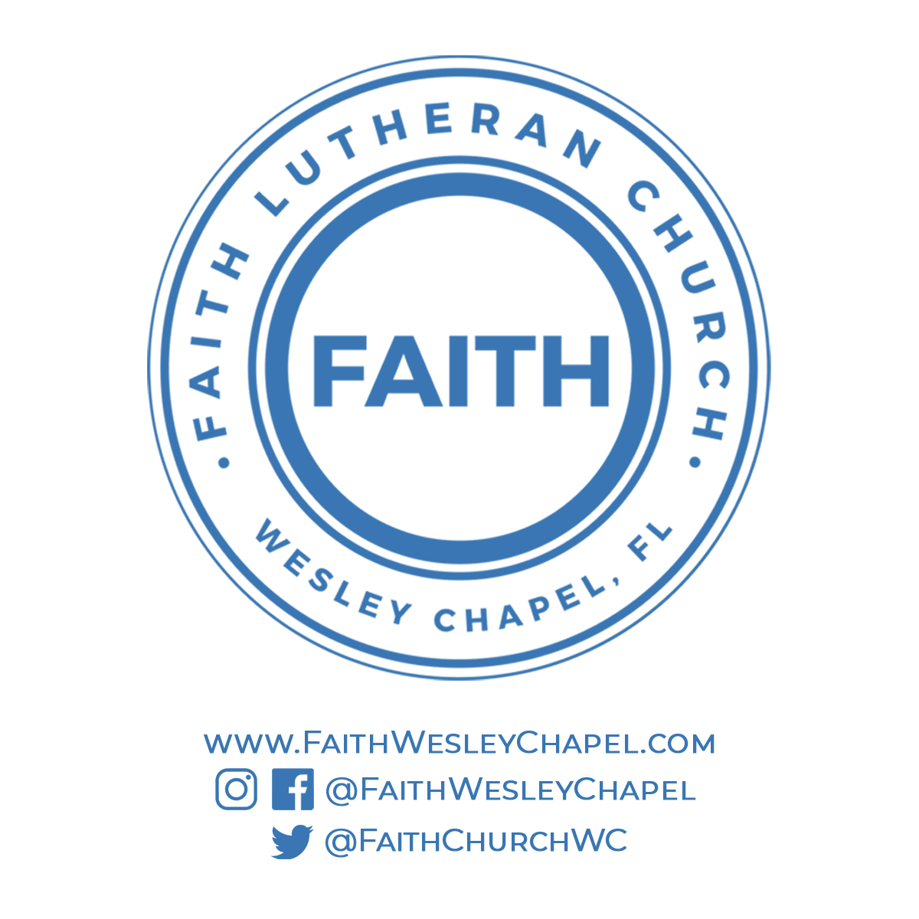**@FaithWesleyChapel**

**@FaithWesleyChapel**

**@FaithChurchWC**