

**Leading our community into a deep connection in Christ**

**Worship Service for March 3, 2024 at 11 AM**

**Welcome**

**Opening Song:**Down In My Heart

I’ve got the joy, joy, joy, joy down in my heart, (where?)  
Down in my heart, (where?), down in my heart.  
I’ve got the joy, joy, joy, joy down in my heart, (where?)  
Down in my heart to stay.

Chorus:  
And I’m so happy, so very happy.   
I’ve got the love of Jesus in my heart.  
And I’m so happy, so very happy.   
I’ve got the love of Jesus in my heart

I’ve got the peace that passes understanding down in my heart…

*(Chorus)*

I’ve got the love of Jesus, love of Jesus, down in my heart…

*(Chorus)*

I’ve got the wonderful love of my blessed redeemer way down in the depths of my heart…

*(Chorus)* © Public Domain

**Invocation**

**Confession and Forgiveness:**

**P:** We have come here today to worship the Lord.  In worship we hear the Word of God, we receive God's blessings, and respond with thanks and praise.  We begin by seeking God's blessing of forgiveness.  He has promised to remove the guilt and shame of our sin through the sacrifice of Jesus Christ on the cross.

*(a time of silence to reflect and personally confess our sins)*

**P:** Let us confess our sins to the Lord.

**P:** Heavenly Father,  
**C:** Heavenly Father,

**P:** I have done things that were wrong.  
**C:** I have done things that were wrong.  
  
**P:** I have been mean to others.  
**C:** I have been mean to others.

**P:** I have not obeyed my parents.  
**C:** I have not obeyed my parents.

**P:** I have not obeyed You, God.  
**C:** I have not obeyed You, God.

**P:** But I am very sorry.  
**C:** But I am very sorry.

**P:** Please forgive me.  
**C:** Please forgive me.

**P:** I love You very much.  
**C:** I love You very much.

**P:** And I know You love me, too.  
**C:** And I know You love me, too.

**P:** Amen.  
**C:** Amen.

**P:** God has heard your apology.  He loves you very much.  God has told us that when we believe and trust in Him, He makes us His children.  As far as the east is from the west, so far does he remove our sins from us. He has told me to tell you that you are forgiven.  So, as His servant, I forgive you in the name of the Father and of the Son and of the Holy Spirit.   
**C:** Amen.

**Song:**God Is So Good

God is so good. God is so good.  
God is so good. He's so good to me.

He died for me. He died for me so.  
He died for me. He's so good to me.

He loves me so. He loves me so.  
He loves me so. He's so good to me. © Public Domain

**First Reading -**Matthew 6:31-33

Therefore do not be anxious, saying, ‘What shall we eat?’ or ‘What shall we drink?’ or ‘What shall we wear?’ For the Gentiles seek after all these things, and your heavenly Father knows that you need them all. But seek first the kingdom of God and his righteousness, and all these things will be added to you.

**Reader:** This is the Word of the Lord.  
**C:** Thanks be to God.

**Children's Message**"God Knows What You Need"

**Song:**Seek Ye First

Seek ye first, the Kingdom of God and His righteousness,  
And all these things shall be added unto you. Allelu, Alleluia.

Ask and it shall be given unto you. Seek and ye shall find.  
Knock and it shall be opened unto you. Allelu, Alleluia.

Man shall not live by bread alone, but by every word,  
That proceeds out from the mouth of the Lord. Allelu, Alleluia.  
 © Public Domain

**Second Reading -**Hebrews 13:5

Keep your life free from love of money, and be content with what you have, for he has said, “I will never leave you nor forsake you.”

**Reader:** This is the Word of the Lord.  
**C:** Thanks be to God.

**Children's Message**"Don't Worry, I'm Here."

**Sermon Hymn:**Great Is Thy Faithfulness

Great is Thy faithfulness, O God my Father.  
There is no shadow of turning with Thee  
Thou changest not, Thy compassions they fail not.  
As Thou hast been, Thou forever wilt be.

Chorus:

Great is Thy faithfulness! Great is Thy faithfulness!

Morning by morning new mercies I see

All I have needed Thy hand has provided.

Great is Thy faithfulness, Lord unto me.

Summer and winter and springtime and harvest,

Sun, moon and stars in their courses above

Join with all nature in manifold witness

To Thy great faithfulness mercy and love.

*(Chorus)*

Pardon for sin and a peace that endureth,Thine own dear presence to cheer and to guide;Strength for today and bright hope for tomorrow,Blessings all mine, with ten thousand beside.

*(Chorus)* © 1923. Renewed 1951 Hope Publishing Company

**Sermon –**“Behold, The Lilies of the Field”

**Sermon Reading -** Matthew 6:25-34

“Therefore I tell you, do not be anxious about your life, what you will eat or what you will drink, nor about your body, what you will put on. Is not life more than food, and the body more than clothing? Look at the birds of the air: they neither sow nor reap nor gather into barns, and yet your heavenly Father feeds them. Are you not of more value than they? And which of you by being anxious can add a single hour to his span of life? And why are you anxious about clothing? Consider the lilies of the field, how they grow: they neither toil nor spin, yet I tell you, even Solomon in all his glory was not arrayed like one of these. But if God so clothes the grass of the field, which today is alive and tomorrow is thrown into the oven, will he not much more clothe you, O you of little faith? Therefore do not be anxious, saying, ‘What shall we eat?’ or ‘What shall we drink?’ or ‘What shall we wear?’ For the Gentiles seek after all these things, and your heavenly Father knows that you need them all. But seek first the kingdom of God and his righteousness, and all these things will be added to you.

“Therefore do not be anxious about tomorrow, for tomorrow will be anxious for itself. Sufficient for the day is its own trouble.

**Prayers:** *Text in prayer requests to (813) 326-5255*

**The Lord's Prayer**

Our Father who art in heaven, hallowed be Thy name, Thy kingdom come, Thy will be done on earth as it is in heaven.  Give us this day our daily bread; and forgive us our trespasses as we forgive those who trespass against us; and lead us not into temptation, but deliver us from evil.  For Thine is the kingdom and the power and the glory forever and ever.  Amen

**Offering**

**Benediction** *– The online service ends. The closing hymn video is on the Livestream page bulletin at FaithWesleyChapel.com with lyrics below. See announcements below as well.*

**Closing Song:**Children Of The Heavenly Father

Verse 1:

Children of the Heavenly Father safely in His bosom gather.

Nestling bird nor star in heaven such a refuge e’er was given.

Verse 2:

God His own doth tend and nourish.  
In His holy courts they flourish.

From all evil things He spares them.  
In His mighty arms He bears them.

Chorus:

Precious children, You have called us. Making us heirs with Your Son.

“Abba Father”, now we call You. In Your presence, now we come.

Verse 3:

Neither life nor death shall ever from the Lord His children sever.

Unto them His grace He showeth,  
And their sorrows all He knoweth.

*(Chorus)*

Verse 4:

Though he giveth or He taketh, God His children ne’er forsaketh;

His the loving purpose solely to preserve them pure and holy.

© Public Domain

**Being God’s Church**



**Thank you Carrie and Josh Strasheim!!**

Josh has been very helpful setting up for Christmas in the Park. Carrie serves as President Elect (soon to be President) on the church council and made all the beautiful banners for the church. She also helped with the fundraising for the National Youth Gathering. Luke was the first infant baptized at Faith and he and Heidi are a joy have here at Faith.

Thank you, Carrie, Josh, Heidi, and Luke! God bless!

|  |  |
| --- | --- |
| **Serving This Week** | |
|  | |
| **1st Reader:** Kaylee Steinbrueck | **Children’s Church Teacher:** |
| **2nd Reader:** Katelyn Shuck | N/A – No Children’s Church |
| **Acolyte:** Jakob Torgrimson | **Children’s Church Assistant:** |
| **Com. Asst:** Larry Chmiel | N/A – No Children’s Church |
|  | |
| **Serving Next Week** | |
|  | |
| **O.T. Reader:** Terrell Jordan | **Children’s Church Teacher:** |
| **Epistle Reader:** Ginger Torgrimson | Halston & Ben |
| **Acolyte:** Griffin Frost | **Children’s Church Assistant:** |
| **Com. Asst:** Larry Chmiel |  |

**Upcoming Events**

**Today, After Service – Voter Meeting**  
Faith Lutheran Church

**Today, After Service – Confirmation**  
Faith Lutheran Church

**Mar 10, After Service – “God Squad” Youth Group**  
Grace Community Church

**Mar 12, 7 PM – Growth Group Bible Study**   
Renee’s Home

**Mar 28, 7 PM – Maundy Thursday Service**  
Grace Community Church

**Mar 29, 7 PM – Good Friday Service**  
Faith Lutheran Church

**Mar 31, 10 AM – Easter Breakfast**  
Faith Lutheran Church

**Mar 31, 11 AM – Easter Worship Service**  
Faith Lutheran Church

**www.FaithWesleyChapel.com**

**Faith YouTube**

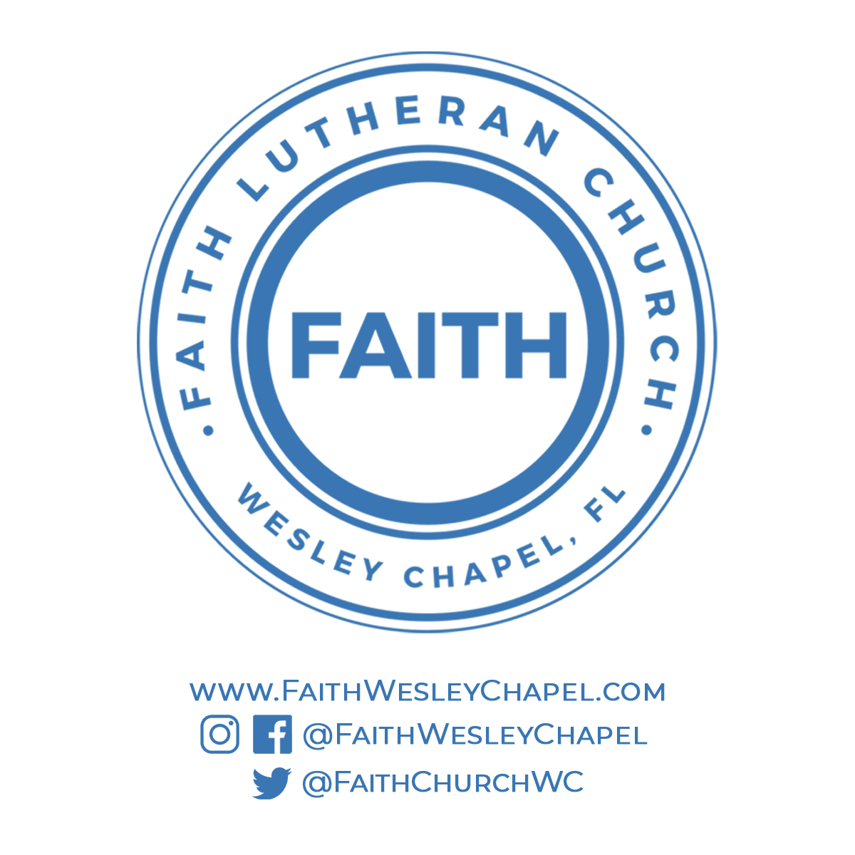**@FaithWesleyChapel**

**@FaithWesleyChapel**

**@FaithChurchWC**