

**Leading our community into a deep connection in Christ**

**___________________________________________________**

**Worship Service for March 10, 2024 at 11 AM**

**Welcome**

**Pray for the Food** - **People get food**

**Invocation** *(stand)*

**Confession and Forgiveness:** *(stand)*

**P:** As we gather, today, let us cleanse our hearts and our consciences by confessing our sin to God.

*(Time of silence for reflection and confession)*

**C:** Heavenly Father, we confess that we are sinful and unclean. We have sinned against you and against our neighbor in our thoughts, words, and actions.  We are truly sorry for our sins and sincerely repent of them. We ask for Your mercy. For the sake of Jesus Christ's bitter suffering and death, please forgive us and renew us that we may walk in Your Spirit to the glory of Your holy name. Amen

**P:** The Lord has heard your confession. Therefore, as a called and ordained servant of the Lord, in the stead and by the command of my Lord, Jesus Christ, I forgive you all your sins in the name of the Father and of the Son and of the Holy Spirit.  
**C:** Amen

**Songs of Praise and Thanksgiving –** By Grace I'm Saved

By grace I'm saved, grace free and boundless.  
My soul, believe and doubt it not.  
Why stagger at this word of promise?  
Has Scripture ever falsehood taught?  
No! Then this word must true remain;  
By grace you too will life obtain.

By grace God's Son, our only Savior,

Came down to earth to bear our sin.

Was it because of your own merit,

That Jesus died your soul to win?

No, it was grace, and grace alone,

That brought Him from His heav'nly throne.

By grace! On this I'll rest when dying.

In Jesus' promise I rejoice!

For though I know my heart's condition,

I also know my Savior's voice.

My heart is glad, all grief has flown,

Since I am saved by grace alone. © Public Domain

**Gospel Reading** - Matthew 7:24-29

“Everyone then who hears these words of mine and does them will be like a wise man who built his house on the rock. And the rain fell, and the floods came, and the winds blew and beat on that house, but it did not fall, because it had been founded on the rock. And everyone who hears these words of mine and does not do them will be like a foolish man who built his house on the sand. And the rain fell, and the floods came, and the winds blew and beat against that house, and it fell, and great was the fall of it.”And when Jesus finished these sayings, the crowds were astonished at his teaching, for he was teaching them as one who had authority, and not as their scribes.

**P:** This is the Gospel of the Lord.  
**C:** Praise be to You, o Christ.

**Sermon Song –** This I Believe

Our Father everlasting, the all creating One, God almighty,  
Through Your Holy Spirit conceiving Christ the Son,  
Jesus our Savior.

Chorus:  
I believe in God our Father. I believe in Christ the Son.  
I believe in the Holy Spirit. Our God is three in one.  
I believe in the resurrection, that we will rise again.  
For I believe in the name of Jesus.

Verse 2:  
Our Judge and our Defender, suffered and crucified,  
Forgiveness is in You.  
Descended into darkness, You rose in glorious life,  
Forever seated high.

Chorus

Bridge: (2x)  
I believe in You. I believe You rose again.  
I believe that Jesus Christ is Lord.

Chorus 2:  
I believe in life eternal. I believe in the virgin birth.  
I believe in the saints' communion and in Your holy church.  
I believe in the resurrection, when Jesus comes again.  
For I believe in the name of Jesus.  
For I believe in the name of Jesus.

© 2014 © Hillsong Music Publishing (Admin. by EMI Christian Music Publishing)

**Sermon/Discussion** – Behold - The Folly of God

**Sermon/Epistle Reading** - 1 Corinthians 1:18-31

For the word of the cross is folly to those who are perishing, but to us who are being saved it is the power of God. For it is written,

“I will destroy the wisdom of the wise,  
and the discernment of the discerning I will thwart.”  
Where is the one who is wise? Where is the scribe? Where is the debater of this age? Has not God made foolish the wisdom of the world? For since, in the wisdom of God, the world did not know God through wisdom, it pleased God through the folly of what we preach to save those who believe. For Jews demand signs and Greeks seek wisdom, but we preach Christ crucified, a stumbling block to Jews and folly to Gentiles, but to those who are called, both Jews and Greeks, Christ the power of God and the wisdom of God. For the foolishness of God is wiser than men, and the weakness of God is stronger than men.

For consider your calling, brothers: not many of you were wise according to worldly standards, not many were powerful, not many were of noble birth. But God chose what is foolish in the world to shame the wise; God chose what is weak in the world to shame the strong; God chose what is low and despised in the world, even things that are not, to bring to nothing things that are, so that no human being might boast in the presence of God. And because of him you are in Christ Jesus, who became to us wisdom from God, righteousness and sanctification and redemption, so that, as it is written, “Let the one who boasts, boast in the Lord.”

**P:** This is the Word of the Lord.  
**C:** Thanks be to God.

**Prayers**

**Apostles' Creed** *(stand)*

I believe in God, the Father almighty, maker of heaven and earth,  
And in Jesus Christ, his only Son, our Lord,  
who was conceived by the Holy Spirit,  
born of the Virgin Mary, suffered under Pontius Pilate,  
was crucified, died and was buried. He descended into hell.  
The third day he rose again from the dead.  
He ascended into heaven and sits at the right hand of God  
the Father almighty.  
From there he will come to judge the living and the dead.  
I believe in the Holy Spirit, the holy Christian Church,  
the communion of saints, the forgiveness of sins,  
the resurrection of the body, and the life everlasting. Amen.

**The Lord's Prayer** *(stand)*

Our Father who art in heaven, hallowed be Thy name, Thy kingdom come, Thy will be done on earth as it is in heaven.  Give us this day our daily bread; and forgive us our trespasses as we forgive those who trespass against us; and lead us not into temptation, but deliver us from evil.  For Thine is the kingdom and the power and the glory forever and ever.  Amen

**Offering**

**Benediction** *– The online service ends. The closing hymn video is on the Livestream page bulletin at FaithWesleyChapel.com with lyrics below. See announcements below as well.*

**Closing Song:** Praise God From Whom All Blessings Flow *(stand)*

Praise God from Whom all blessings flow.  
Praise Him all creatures here below.  
Praise Him above, ye heavenly hosts.  
Praise Father, Son and Holy Ghost.  
Amen

**Being God’s Church**



**Thank You Matt, Darlene, and Lawrence**

Matt, Darlene, and Lawrence are here early most Sundays helping to set up for worship. Matt has played in the praise band since Faith launched and made the cart on which we move our equipment. Both Matt and Darlene were instrumental in the formation of the church. Darlene was Faith’s first Treasurer and served in that position on the council for several years.

All three have served in many ways over the years and are always willing to give a helping hand to a member in need.

Thank you, Matt, Darlene, and Lawrence and God bless!

**Developing Your Skill at Sharing Your Faith**

**Saturday, April 13**.

**9:00 AM – Noon**

Messiah Lutheran Church

14920 Hutchinson Rd., Tampa, FL.

* Devotion: “History of Lutherans in Tampa”
* Bible Study by FL-GA District VP, David Brockhoff
* Main Presentation by Pastor Nate Guelzow:

***"Helping Others Meet Jesus Is Easier Than You Think.”***

|  |  |
| --- | --- |
| **Serving This Week** | |
|  | |
| **Epistle Reader:** Terrell Jordan | **Children’s Church Teacher:** |
| **Gospel Reader:** Ginger Torgrimson | Terrell Jordan |
| **Acolyte:** Griffin Frost | **Children’s Church Assistant:** |
| **Com. Asst:** Larry Chmiel | Emily Shuck |
|  | |
| **Serving Next Week** | |
|  | |
| **O.T. Reader:** Kaylee Steinbrueck | **Children’s Church Teacher:** |
| **Epistle Reader:** Josh Strasheim | Melissa Steinbrueck |
| **Acolyte:** Griffin Frost | **Children’s Church Assistant:** |
| **Com. Asst:** Larry Chmiel | Kaylee Steinbrueck |

**Upcoming Events**

**Today, After Service – “God Squad” Youth Group**  
Grace Community Church

**Mar 12, 7 PM – Growth Group Bible Study**   
Renee’s Home

**Mar 17, After Service – Confirmation**  
Faith Lutheran Church

**Mar 28, 7 PM – Maundy Thursday Service**  
Grace Community Church

**Mar 29, 7 PM – Good Friday Service**  
Faith Lutheran Church

**Mar 31, 10 AM – Easter Breakfast**  
Faith Lutheran Church

**Mar 31, 11 AM – Easter Worship Service**  
Faith Lutheran Church

[**www.FaithWesleyChapel.com**](http://www.FaithWesleyChapel.com)

 **Faith YouTube**

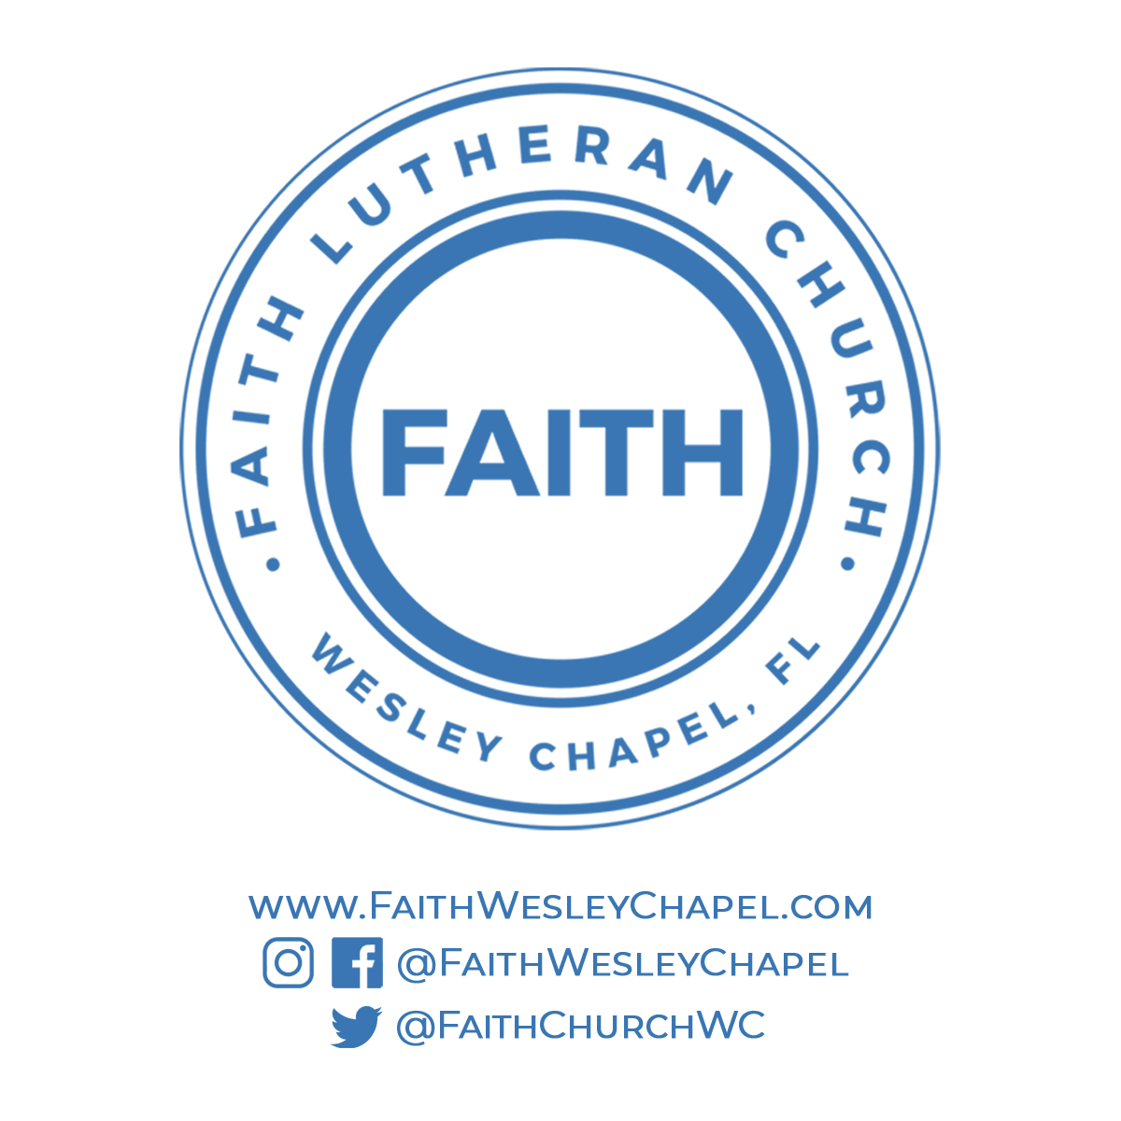**@FaithWesleyChapel**

**@FaithWesleyChapel**

**@FaithChurchWC**