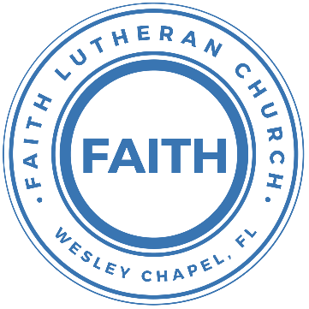

**Leading our community into a deep connection in Christ**

**___________________________________________________**

**Worship Service for March 17, 2024 at 11 AM**

**Welcome**

**Invocation**

**Confession and Forgiveness:**

**P:** As we gather, today, let us cleanse our hearts and our consciences by confessing our sin to God.

*(Time of silence for reflection and confession)*

**P:** Today, we confess our sins by singing the song, “Lord, I Need You.”

**Song of Confession:** Lord, I Need You

Lord I come, I confess. Bowing here, I find my rest.  
Without You, I fall apart. You're the one that guides my heart.

Chorus:  
Lord, I need You, oh I need You. Every hour I need You.  
My one defense, my righteousness, Oh God, how I need You.

Where sin runs deep, Your grace is more.  
Where grace is found is where You are.  
And where You are Lord I am free. Holiness is Christ in me.

Chorus:  
Lord, I need You, oh I need You. Every hour I need You.  
My one defense, my righteousness, Oh God, how I need You.

So teach my song to rise to You, when temptation comes my way.  
And when I cannot stand I'll fall on You.   
Jesus, You're my hope and stay.

Chorus:Lord, I need You, oh I need You. Every hour I need You  
My one defense, my righteousness, Oh God, how I need You  
My one defense, my righteousness, Oh God, how I need You  
My one defense, my righteousness, Oh God, how I need You

© 2011 Sweater Weather Music, Valley Of Songs Music, and Thankyou Music

**P:** The Lord has heard your confession. Therefore, as a called and ordained servant of the Lord, in the stead and by the command of my Lord, Jesus Christ, I forgive you all your sins in the name of the Father and of the Son and of the Holy Spirit.  
**C:** Amen

**Song of Praise and Thanksgiving:** Love Divine All Loves Excelling

Love divine, all loves excelling, Joy of heav'n, to earth come down!  
Fix in us Thy humble dwelling, all Thy faithful mercies crown.  
Jesus, Thou art all compassion, pure, unbounded love Thou art;  
Visit us with Thy salvation, enter ev'ry trembling heart.

Breathe, O breathe Thy loving Spirit into ev'ry troubled breast;  
Let us all in Thee inherit; let us find Thy promised rest.  
Take away the love of sinning; Alpha and Omega be;  
End of faith, as its beginning, set our hearts at liberty.

Come, Almighty, to deliver. Let us all Thy life receive.  
Suddenly return, and never, nevermore Thy temples leave.  
Thee we would be always blessing. Serve Thee as Thy hosts above.  
Pray and praise Thee without ceasing. Glory in Thy perfect love.

Finish then Thy new creation, pure and spotless let us be;  
Let us see Thy great salvation perfectly restored in Thee,  
Changed from glory into glory, till in heav'n we take our place,  
Till we cast our crowns before Thee,  
Lost in wonder, love, and praise! © Public Domain

**Old Testament Reading** - Psalm 23

The Lord is my shepherd; I shall not want. He makes me lie down in green pastures. He leads me beside still waters. He restores my soul. He leads me in paths of righteousness for his name's sake. Even though I walk through the valley of the shadow of death, I will fear no evil, for you are with me; your rod and your staff, they comfort me. You prepare a table before me in the presence of my enemies; you anoint my head with oil; my cup overflows. Surely goodness and mercy shall follow me all the days of my life, and I shall dwell in the house of the Lord forever.

**Reader:** This is the Word of the Lord.  
**C:** Thanks be to God.

**Epistle Reading** - Philippians 4:4-9

Rejoice in the Lord always; again I will say, rejoice. Let your reasonableness be known to everyone. The Lord is at hand; do not be anxious about anything, but in everything by prayer and supplication with thanksgiving let your requests be made known to God. And the peace of God, which surpasses all understanding, will guard your hearts and your minds in Christ Jesus. Finally, brothers, whatever is true, whatever is honorable, whatever is just, whatever is pure, whatever is lovely, whatever is commendable, if there is any excellence, if there is anything worthy of praise, think about these things. What you have learned and received and heard and seen in me—practice these things, and the God of peace will be with you.

**P:** This is the Gospel of the Lord.  
**C:** Praise be to You, o Christ.

**Children's Message** *(Children dismissed to Children's Church)*

**Sermon Hymn***–*Whom Shall I Fear

You hear me when I call. You are my morning song.

Though darkness fills the night, it cannot hide the light.

Whom shall I fear?

You crush the enemy underneath my feet.

You are my sword and shield, though troubles linger still.

Whom shall I fear?

Chorus:

I know who goes before me. I know who stands behind.

The God of angel armies is always by my side.

The One who reigns forever, He is a friend of mine.

The God of angel armies is always by my side.

My strength is in Your name for You alone can save.

You will deliver me. Yours is the victory!

Whom shall I fear? Whom shall I fear?

*(Chorus)*

Bridge:

And nothing formed against me shall stand.

You hold the whole world in Your hands.

I'm holding on to Your promises. You are faithful. You are faithful.

*(Repeat)*  
You are faithful

*(Chorus)* © 2012 Worship Together Music

**Sermon** - "Behold - The Peace of God"

John 14:25-27  
“These things I have spoken to you while I am still with you. But the Helper, the Holy Spirit, whom the Father will send in my name, he will teach you all things and bring to your remembrance all that I have said to you. Peace I leave with you; my peace I give to you. Not as the world gives do I give to you. Let not your hearts be troubled, neither let them be afraid.

**P:** This is the Word of the Lord.  
**C:** Thanks be to God.

**Prayers:** *Text in prayer requests to (813) 326-5255*

**Nicene Creed** *(stand)*

I believe in one God, the Father Almighty, maker of heaven and earth and of all things visible and invisible.

And in one Lord Jesus Christ, the only-begotten Son of God, begotten of His Father before all worlds, God of God, Light of Light, very God of very God, begotten, not made, being of one substance with the Father, by whom all things were made; who for us men and for our salvation came down from heaven and was incarnate by the Holy Spirit of the virgin Mary and was made man; and was crucified also for us under Pontius Pilate. He suffered and was buried. And the third day He rose again according to the Scriptures and ascended into heaven and sits at the right hand of the Father. And He will come again with glory to judge both the living and the dead, whose kingdom will have no end.

And I believe in the Holy Spirit, the Lord and Giver of Life, who proceeds from the Father and the Son, who with the Father and the Son together is worshiped and glorified, who spoke by the prophets. And I believe in one holy Christian and apostolic Church, I acknowledge one Baptism for the remission of sins, and I look for the resurrection of the dead and the life of the world to come. Amen.

**The Lord's Prayer** *(stand)*

Our Father who art in heaven, hallowed be Thy name, Thy kingdom come, Thy will be done on earth as it is in heaven.  Give us this day our daily bread; and forgive us our trespasses as we forgive those who trespass against us; and lead us not into temptation, but deliver us from evil.  For Thine is the kingdom and the power and the glory forever and ever.  Amen

**Offering –** [**https://FaithWesleyChapel.com/Give**](https://FaithWesleyChapel.com/Give)

**Benediction** *– The online service ends. The closing hymn video is on the Livestream page bulletin at FaithWesleyChapel.com with lyrics below. See announcements below as well.*

**Closing Song:**The Blessing

Verse:  
The Lord bless you and keep you,  
Make His face shine upon you and be gracious to you.  
The Lord turn His face toward you and give you peace.

Chorus:  
Amen. Amen. Amen.  
*(Repeat)*

*(Verse)*

*(Chorus)*

Bridge:  
May His favor be upon you and a thousand generations,  
And your family and your children,  
And their children and their children.  
*(Repeat)*

Bridge 2:  
May His presence go before you and behind you and beside you,  
All around you and within you. He is with you. He is with you.  
In the morning, in the evening, in your coming and your going,  
In your weeping and rejoicing He is with you. He is with you.  
He is for you. He is for you. He is for you. He is for you.  
He is for you. He is for you.

*(Chorus) (Bridge 2)* 2020 Music by Elevation Worship Publishing

|  |  |
| --- | --- |
| **Serving This Week** | |
|  | |
| **O.T. Reader:** Terrell Jordan | **Children’s Church Teacher:** |
| **Epistle Reader:** Josh Strasheim | Melissa Steinbrueck |
| **Acolyte:** Griffin Frost | **Children’s Church Assistant:** |
| **Com. Asst:** Larry Chmiel | Katelyn Shuck |
|  | |
| **Serving Next Week** | |
|  | |
| **O.T. Reader:** Vanessa Frost | **Children’s Church Teacher:** |
| **Epistle Reader:** Terrell Jordan | Terrell Jordan |
| **Acolyte:** Lawrence Finnerty | **Children’s Church Assistant:** |
| **Com. Asst:** Larry Chmiel | Kaylee Steinbrueck |

**Upcoming Events**

**Today, After Service - Confirmation**  
Faith Lutheran Church

**Mar 19, 7 PM - Council Meeting**  
Larry’s House

**Mar 24, After Service – “God Squad” Youth Group**  
Grace Community Church

**Mar 26, 7 PM – “Risen” Movie**  
Davie’s Home

**Mar 28, 7 PM – Maundy Thursday Service**  
Grace Community Church

**Mar 29, 7 PM – Good Friday Service**  
Faith Lutheran Church

**Mar 31, 10 AM – Easter Breakfast**  
Faith Lutheran Church

**Mar 31, 11 AM – Easter Worship Service**  
Faith Lutheran Church

[**www.FaithWesleyChapel.com**](http://www.FaithWesleyChapel.com)

 **Faith YouTube**

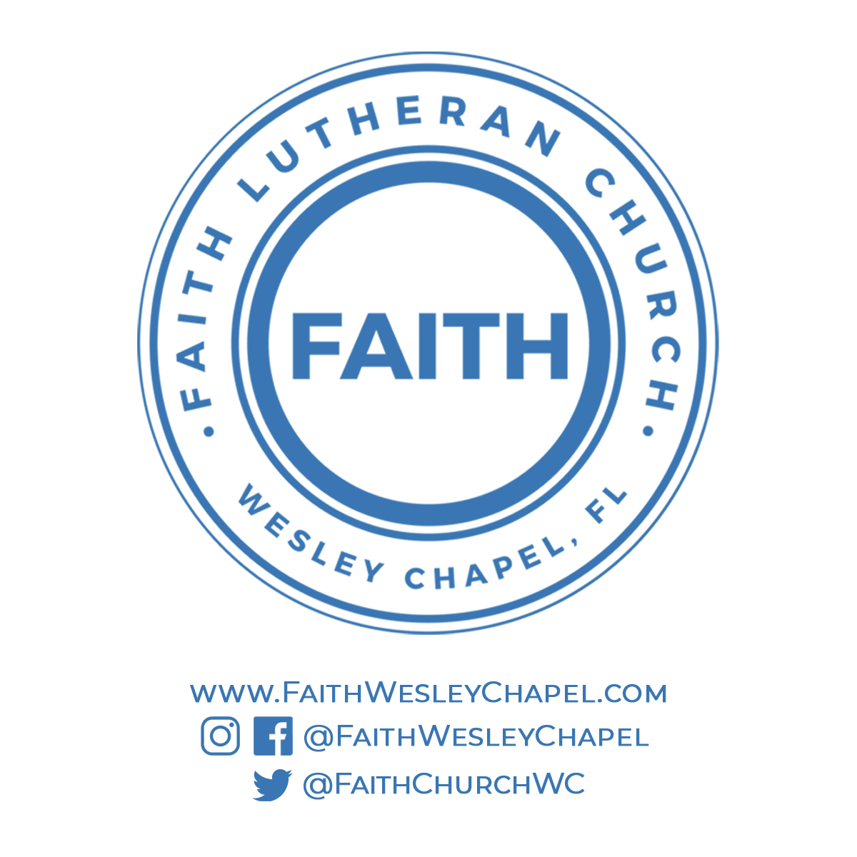**@FaithWesleyChapel**

**@FaithWesleyChapel**

**@FaithChurchWC**