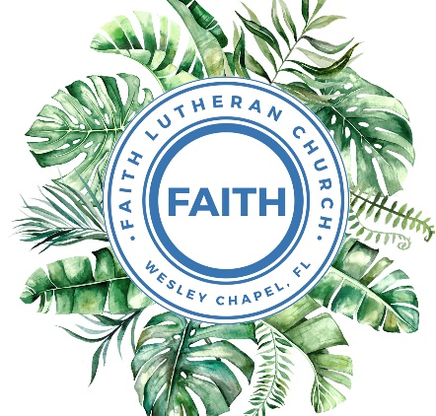

**Leading our community into a deep connection in Christ**

**Palm Sunday Worship Service for March 24, 2024 at 11 AM**

**Welcome**

**Opening Song:**Sing To The King

Verse 1:

Sing to the King who is coming to reign.  
Glory to Jesus, the Lamb that was slain.

Life and salvation His empire shall bring,

And joy to the nations when Jesus is King.

Chorus:

Come, let us sing a song, a song declaring that we belong to Jesus.

He’s all we need.

Lift up a heart of praise. Sing now with voices raised to Jesus.

Sing to the King.

Verse 2:

For His returning we watch and we pray.

We will be ready the dawn of that day.

We'll join in singing with all the redeemed,

'Cause Satan is vanquished and Jesus is King.

*(Chorus 2x)* © Public Domain

**Invocation**

**Confession and Forgiveness:**

**P:** Come into the presence of the Lord our God.  
**C:** Have mercy, O Lord. If you, Lord, kept a record of sins, Lord, who could stand; but if we confess our sins, he is faithful and just to forgive us our sins and to cleanse us from all unrighteousness.

*(A time of silence to reflect and personally confess our sins)*

**P:** I said, "I will confess my transgressions to the LORD." And you forgave the guilt of my sin. Let us confess our sin before the Lord.   
**C:** Heavenly Father, we confess that we are sinners.  We have sinned against you and our neighbors. We have not loved you with our whole heart and we have not loved our neighbors as ourselves. We justly deserve Your punishment.  For the sake of Your Son, Jesus Christ, have mercy on us.  Forgive us, renew us, and lead us, so that we may delight in Your will and walk in Your ways to the glory of Your holy name.  Amen.

**Pronouncement of Forgiveness**  
**C:** Amen.

**Song of Praise and Thanksgiving -** Hosanna (Praise Is Rising)

Praise is rising, eyes are turning to You. We turn to You.  
Hope is stirring, hearts are yearning for You. We long for You.

Pre-Chorus:  
When we see You we find strength to face the day.  
In Your presence all our fears are washed away, washed away.

Chorus:  
Hosanna! Hosanna!  
You are the God who saves us, worthy of all our praises.  
Hosanna! Hosanna!  
Come have Your way among us.  
We welcome You here Lord Jesus.

Hear the sound of hearts returning to You. We turn to You.  
In Your Kingdom broken lives are made new.  
You make all things new.

*(Pre-Chorus)  
(Chorus)* © 2005, 2006 Integrity's Hosanna! Music and Thankyou Music

**Old Testament Reading -** Daniel 7:13–14

“I saw in the night visions, and behold, with the clouds of heaven there came one like a son of man, and he came to the Ancient of Days and was presented before him. And to him was given dominion and glory and a kingdom, that all peoples, nations, and languages should serve him; his dominion is an everlasting dominion, which shall not pass away, and his kingdom one that shall not be destroyed.

**Reader:** This is the Word of the Lord.  
**C:** Thanks be to God.

**Gospel Reading -** Matthew 21:1-11

Now when they drew near to Jerusalem and came to Bethphage, to the Mount of Olives, then Jesus sent two disciples, saying to them, “Go into the village in front of you, and immediately you will find a donkey tied, and a colt with her. Untie them and bring them to me. If anyone says anything to you, you shall say, ‘The Lord needs them,’ and he will send them at once.” This took place to fulfill what was spoken by the prophet, saying,

“Say to the daughter of Zion, ‘Behold, your king is coming to you,  
 humble, and mounted on a donkey, on a colt, the foal of a beast of burden.’”

The disciples went and did as Jesus had directed them. They brought the donkey and the colt and put on them their cloaks, and he sat on them. Most of the crowd spread their cloaks on the road, and others cut branches from the trees and spread them on the road. And the crowds that went before him and that followed him were shouting, “Hosanna to the Son of David! Blessed is he who comes in the name of the Lord! Hosanna in the highest!” And when he entered Jerusalem, the whole city was stirred up, saying, “Who is this?” And the crowds said, “This is the prophet Jesus, from Nazareth of Galilee.”

**P:** This is the Gospel of the Lord.  
**C:** Praise be to You, o Christ.

**Children's Message**

**Sermon Hymn -** Hosanna, Loud Hosanna

Hosanna, loud hosanna, the little children sang;  
Through pillared court and temple the lovely anthem rang.  
To Jesus, who had blessed them, close folded to His breast,  
The children sang their praises, the simplest and the best.

From Olivet they followed mid an exultant crowd,  
The victor palm branch waving and chanting clear and loud.  
The Lord of earth and heaven rode on in lowly state,  
Nor scorned that little children should on His bidding wait.

"Hosanna in the highest!" that ancient song we sing;  
For Christ is our Redeemer, the Lord of heav'n our King.  
Oh, may we ever praise Him with heart and life and voice,  
And in His blissful presence eternally rejoice! © Public Domain

**Sermon -** "Behold, The King of Kings"

2 John 1:4-11

I rejoiced greatly to find some of your children walking in the truth, just as we were commanded by the Father. And now I ask you, dear lady—not as though I were writing you a new commandment, but the one we have had from the beginning—that we love one another. And this is love, that we walk according to his commandments; this is the commandment, just as you have heard from the beginning, so that you should walk in it. For many deceivers have gone out into the world, those who do not confess the coming of Jesus Christ in the flesh. Such a one is the deceiver and the antichrist. Watch yourselves, so that you may not lose what we have worked for, but may win a full reward. Everyone who goes on ahead and does not abide in the teaching of Christ, does not have God. Whoever abides in the teaching has both the Father and the Son. If anyone comes to you and does not bring this teaching, do not receive him into your house or give him any greeting, for whoever greets him takes part in his wicked works.

**Reader:** This is the Word of the Lord.  
**C:** Thanks be to God.

**Prayers:** *Text in prayer requests to (813) 326-5255‬*

**Apostles' Creed** *(stand)*

I believe in God, the Father almighty, maker of heaven and earth,  
And in Jesus Christ, his only Son, our Lord,  
who was conceived by the Holy Spirit,  
born of the Virgin Mary, suffered under Pontius Pilate,  
was crucified, died and was buried. He descended into hell.  
The third day he rose again from the dead.  
He ascended into heaven and sits at the right hand of God  
the Father almighty.  
From there he will come to judge the living and the dead.  
I believe in the Holy Spirit, the holy Christian Church,  
the communion of saints, the forgiveness of sins,  
the resurrection of the body, and the life everlasting. Amen.

**The Lord's Prayer** *(stand)*

Our Father who art in heaven, hallowed be Thy name, Thy kingdom come, Thy will be done on earth as it is in heaven.  Give us this day our daily bread; and forgive us our trespasses as we forgive those who trespass against us; and lead us not into temptation, but deliver us from evil.  For Thine is the kingdom and the power and the glory forever and ever.  Amen

**Offering** *(sit)*

**Benediction** *– The online service ends. The closing hymn video is on the Livestream page bulletin at FaithWesleyChapel.com with lyrics below. See announcements below as well.*

**Closing Song -**Our God/All Hail the Power of Jesus Name

*Our God - Verse 1:*

Water You turned into wine, opened the eyes of the blind.

There's no one like You, none like You.

*Our God - Verse 2:*

Into the darkness You shine. Out of the ashes we rise.

There's no one like You, none like You.

*Our God - Chorus:*

Our God is greater. Our God is stronger.

God, You are higher than any other.

Our God is healer, awesome in power, our God, our God.

*Crown Him - Verse 1:*

All hail the pow'r of Je- sus' name! Let angels prostrate fall;

Bring forth the royal diadem and crown Him Lord of all!

Bring forth the royal diadem and crown Him Lord of all!

*Crown Him - Verse 3:*

Ye seed of Israel's chosen race, Ye ransomed from the fall,

Hail Him who saves you by His grace and crown Him Lord of all!

Hail Him who saves you by His grace and crown Him Lord of all!

*(Our God - Verse 2)*

*(Our God - Chorus)*

*Our God - Bridge:*And if our God is for us, then who could ever stop us? And if our God is with us, then what could stand against? *(Repeat)*

Then what could stand against? Then what could stand against?

*Crown Him - Verse 6:*

Let ev'ry kindred, ev'ry tribe, On this terrestrial ball,

To Him all majesty ascribe and crown Him Lord of all!

To Him all majesty ascribe and crown Him Lord of all!

*Our God - Chorus:*Our God is greater. Our God is stronger.God, You are higher than any other.Our God is healer, awesome in power, our God, our God.  
We crown Him Lord of all! © Public Domain

|  |  |
| --- | --- |
| **Serving This Week** | |
|  | |
| **O.T Reader:** Vanessa Frost | **Children’s Church Teacher:** |
| **Epistle Reader:** N/A | Terrell Jordan |
| **Acolyte:** Jakob Torgrimson | **Children’s Church Assistant:** |
| **Com. Asst:** Larry Chmiel | Kaylee Steinbrueck |
|  | |
| **Serving Good Friday** | |
|  | |
| **1st Reader:** Terrell Jordan | **5th Reader:** Ginger Torgrimson |
| **2nd Reader:** Vanessa Frost | **6th Reader:** Ginger Dunn |
| **3rd Reader:** Larry Chmiel | **Acolyte:** Kaylee Steinbrueck |
| **4th Reader:** Josh Strasheim |  |
| *No Children’s Church or Communion* | |
|  | |
| **Serving Easter** | |
|  | | |
| **O.T Reader:** Terrell Jordan | | **Children’s Church Teacher:** |
| **Epistle Reader:** Vanessa Frost | | N/A |
| **Acolyte:** Jakob Torgrimson | | **Children’s Church Assistant:** |
| **Com. Asst:** Larry Chmiel | | N/A |
|  | |  |

**Upcoming Events**

**Mar 24, After Service – “God Squad” Youth Group**  
Grace Community Church

**Mar 26, 7 PM – “Risen” Movie**   
Davie’s Home – 4205 Barletta Ct. WC, FL. Gate Code: 5328

**Mar 28, 7 PM – Maundy Thursday Service**  
Grace Community Church

**Mar 29, 7 PM – Good Friday Service**  
Faith Lutheran Church

**Mar 31, 10 AM – Easter Breakfast**  
Faith Lutheran Church

**Mar 31, 11 AM – Easter Worship Service**  
Faith Lutheran Church

**Apr 13, 9 AM - Noon – Developing Your Skill at Sharing Your Faith** *"Helping Others Meet Jesus Is Easier Than You Think."*  
Messiah Lutheran Church - 14920 Hutchinson Rd., Tampa, FL

**www.FaithWesleyChapel.com**

**Faith YouTube**

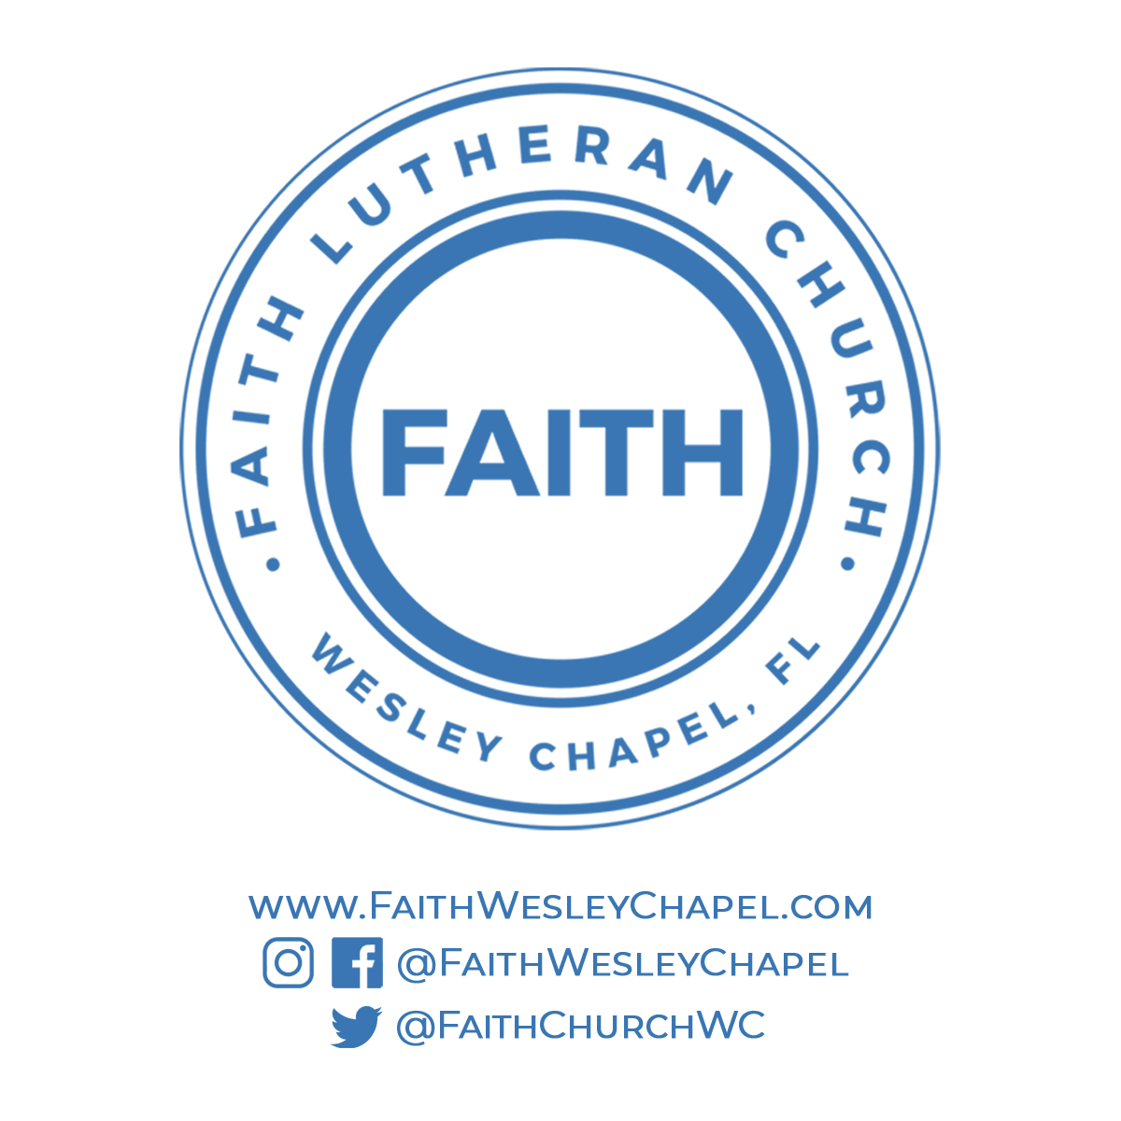**@FaithWesleyChapel**

**@FaithWesleyChapel**

**@FaithChurchWC**