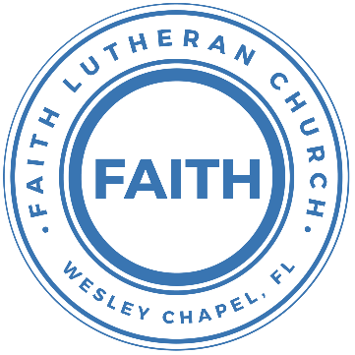

**Leading our community into a deep connection in Christ**

**Worship Service for April 7, 2024 at 11 AM**

**Welcome**

**Opening Song:**Father Abraham

Father Abraham had many sons. Many sons had Father Abraham.

I am one of them and so are you. So, let's just praise the Lord!

Right arm, Left arm, Right foot, Left foot, Chin up, Turn around, Sit down © Public Domain

**Invocation**

**Confession and Forgiveness:**

**P:** We have come here today to worship the Lord.  In worship we hear the Word of God, we receive God's blessings, and respond with thanks and praise.  We begin by seeking God's blessing of forgiveness.  He has promised to remove the guilt and shame of our sin through the sacrifice of Jesus Christ on the cross.

*(a time of silence to reflect and personally confess our sins)*

**P:** Let us confess our sins to the Lord.

**P:** Heavenly Father,  
**C:** Heavenly Father,

**P:** I have done things that were wrong.  
**C:** I have done things that were wrong.  
  
**P:** I have been mean to others.  
**C:** I have been mean to others.

**P:** I have not obeyed my parents.  
**C:** I have not obeyed my parents.

**P:** I have not obeyed You, God.  
**C:** I have not obeyed You, God.

**P:** But I am very sorry.  
**C:** But I am very sorry.

**P:** Please forgive me.  
**C:** Please forgive me.

**P:** I love You very much.  
**C:** I love You very much.

**P:** And I know You love me, too.  
**C:** And I know You love me, too.

**P:** Amen.  
**C:** Amen.

**P:** God has heard your apology.  He loves you very much.  God has told us that when we believe and trust in Him, He makes us His children.  As far as the east is from the west, so far does he remove our sins from us. He has told me to tell you that you are forgiven.  So, as His servant, I forgive you in the name of the Father and of the Son and of the Holy Spirit.   
**C:** Amen.

**Song:**Jesus Loves Me

Jesus loves me this I know, for the Bible tells me so.

Little ones to Him belong. They are weak, but He is strong.

Chorus:

Yes, Jesus loves me. Yes, Jesus loves me.

Yes, Jesus loves me, the Bible tells me so.

Jesus loves me, He who died, Heaven's gates to open wide.

He will wash away my sin, let His little child come in.

*(Chorus)* © Public Domain

**First Reading -**1 John 1:8-9

If we say we have no sin, we deceive ourselves, and the truth is not in us. If we confess our sins, he is faithful and just to forgive us our sins and to cleanse us from all unrighteousness.

**Reader:** This is the Word of the Lord.  
**C:** Thanks be to God.

**Children's Message**"What is Confession?"

**Song:**Come As You Are

Come out of sadness from wherever you've been.

Come broken hearted let rescue begin.

Come find your mercy. Oh, sinner come kneel.

Earth has no sorrow that Heaven can't heal.

Earth has no sorrow that Heaven can't heal.

Chorus:

So, lay down your burdens, lay down your shame.

All who are broken, lift up your face.

Oh, wanderer come home. You're not too far.

So, lay down your hurt. Lay down your heart.

Come as you are.

There's hope for the hopeless, and all those who've strayed.

Come sit at the table. Come taste of the grace.

There's rest for the weary, rest that endures.

Earth has no sorrow that Heaven can't cure.

*(Chorus)*

Bridge:

Come as you are. Fall in his arms. Come as you are.  
 © 2014 9 © t One Songs

**Second Reading -**1 John 1:8-9

If we say we have no sin, we deceive ourselves, and the truth is not in us. If we confess our sins, he is faithful and just to forgive us our sins and to cleanse us from all unrighteousness.

**Reader:** This is the Word of the Lord.  
**C:** Thanks be to God.

**Children's Message**"What is forgiveness?"

**Song:**What a Friend

Everybody has trials and temptations.  
Everybody knows heartbreak, isolation.

Pre-Chorus:  
But we can lay our burdens down. Lay our burdens down.

Chorus:  
What a friend we have in Jesus. East to west my sins are gone.  
I see grace on every horizon.  
And forever and ever His heart is my home.

Everybody has fears, everybody got worries.  
Everybody knows sorrow, devastation.

Pre-Chorus:  
But we can lay our burdens down. Lay our burdens down.

*(Chorus)*

Bridge:  
No more betrayal, for He is faithful.  
He fills me up and my cup runneth over.  
No more betrayal, for He is faithful.  
How He has proven it over and over.  
(Repeat)

*(Chorus 2x)*And forever and ever His heart is my home. © All Essential Music

**Gospel Reading -**John 20:19–23

On the evening of that day, the first day of the week, the doors being locked where the disciples were for fear of the Jews, Jesus came and stood among them and said to them, “Peace be with you.” When he had said this, he showed them his hands and his side. Then the disciples were glad when they saw the Lord. Jesus said to them again, “Peace be with you. As the Father has sent me, even so I am sending you.” And when he had said this, he breathed on them and said to them, “Receive the Holy Spirit. If you forgive the sins of any, they are forgiven them; if you withhold forgiveness from any, it is withheld.”

**P:** This is the Gospel of the Lord.  
**C:** Praise be to You, o Christ.

**Sermon Hymn:**Rock of Ages

Rock of Ages, cleft for me, let me hide myself in Thee;  
Let the water and the blood,  
From thy wounded side which flowed,  
Be of sin the double cure; cleanse me from its guilt and power.

Not the labors of my hands can fulfill Thy law's demands;  
Could my zeal no respite know,  
Could my tears forever flow,  
All for sin could not atone; Thou must save, and Thou alone.

Nothing in my hand I bring, simply to Thy cross I cling;  
Naked, come to Thee for dress;  
Helpless, look to Thee for grace;  
Foul, I to the fountain fly; wash me, Savior, or I die.

While I draw this fleeting breath,  
When mine eyelids close in death,  
When I soar to worlds unknown,  
See Thee on thy judgment throne,  
Rock of Ages, cleft for me, let me hide myself in Thee; © Public Domain

**Sermon –**"The Forgiveness of Sins"

**Prayers:** *Text in prayer requests to (813) 326-5255*

**The Lord's Prayer**

Our Father who art in heaven, hallowed be Thy name, Thy kingdom come, Thy will be done on earth as it is in heaven.  Give us this day our daily bread; and forgive us our trespasses as we forgive those who trespass against us; and lead us not into temptation, but deliver us from evil.  For Thine is the kingdom and the power and the glory forever and ever.  Amen

**Responsive Reading** - Psalm 32:1-5

**P:** Blessed is the one whose transgression is forgiven, whose sin is covered.  
**C:** Blessed is the man against whom the Lord counts no iniquity, and in whose spirit there is no deceit.

**P:** For when I kept silent, my bones wasted away through my groaning all day long.  
**C:** For day and night your hand was heavy upon me; my strength was dried up as by the heat of summer.

**P:** I acknowledged my sin to you, and I did not cover my iniquity;  
**C:** I said, “I will confess my transgressions to the Lord,” and you forgave the iniquity of my sin.

**Offering**

**Benediction** *– The online service ends. The closing hymn video is on the Livestream page bulletin at FaithWesleyChapel.com with lyrics below. See announcements below as well.*

**Closing Song:**Living Hope

How great the chasm that lay between us.

How high the mountain I could not climb.

In desperation, I turned to heaven,  
And spoke Your name into the night.

Then through the darkness Your loving kindness,

Tore through the shadows of my soul.

The work is finished, the end is written,  
Jesus Christ, my Living Hope.

Who could imagine so great a mercy.

What heart could fathom such boundless grace.

The God of ages stepped down from glory,  
To wear my sin and bear my shame.

The cross has spoken. I am forgiven.

The King of Kings calls me His own.

Beautiful Savior I’m Yours forever,

Jesus Christ, my Living Hope.

Chorus:

Hallelujah, praise the one who set me free!

Hallelujah, death has lost its grip on me!

You have broken every chain. There’s salvation in Your Name,

Jesus Christ, my Living Hope.

Then came the morning that sealed the promise,

Your buried body began to breathe.

Out of the silence the roaring Lion,

Declared the grave has no claim on me.

*(Repeat)*

Jesus, Yours is the victory!

*(Chorus 2x)* © Bethel Music Publishing and Remaining portion is unaffiliated

|  |  |
| --- | --- |
| **Serving This Week** | |
|  | |
| **1st Reader:** Alanna Bingaman | **1st Reader:** Alanna Bingaman |
| **2nd Reader:** Halston Quinn | **2nd Reader:** Halston Quinn |
| **Acolyte:** Katelyn Shuck | **Acolyte:** Katelyn Shuck |
| **Com. Asst:** Larry Chmiel | **Com. Asst:** Larry Chmiel |
|  | |
| **Serving Next Week** | |
|  | |
| **O.T. Reader:** Larry Chmiel | **O.T. Reader:** Larry Chmiel |
| **Epistle Reader:** Terrell Jordan | **Epistle Reader:** Terrell Jordan |
| **Acolyte:** Jakob Torgrimson | **Acolyte:** Jakob Torgrimson |
| **Com. Asst:** Larry Chmiel | **Com. Asst:** Larry Chmiel |
|  | |  |

**Upcoming Events**

**Today, After the Service – Confirmation**  
Faith Lutheran Church

**Apr 14, 11 AM – Faith and Food Worship Service**  
Faith Lutheran Church

**Apr 14, After the Service – “God Squad” Youth Group**  
Faith Lutheran Church

**Apr 13, 9 AM - Noon – Developing Your Skill at Sharing Your Faith** *"Helping Others Meet Jesus Is Easier Than You Think."*  
Messiah Lutheran Church - 14920 Hutchinson Rd., Tampa, FL

**www.FaithWesleyChapel.com**

**Faith YouTube**

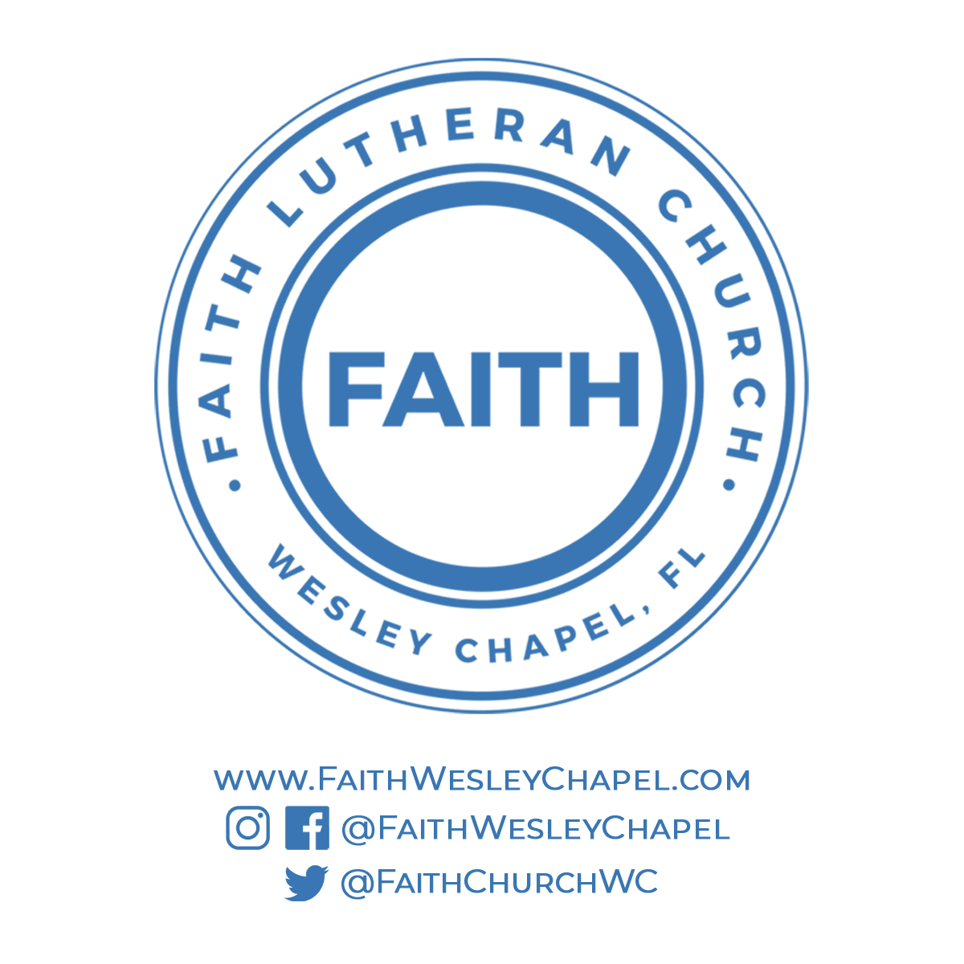**@FaithWesleyChapel**

**@FaithWesleyChapel**

**@FaithChurchWC**