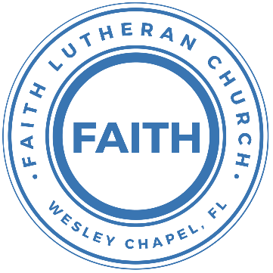

**Leading our community into a deep connection in Christ**

**___________________________________________________**

**Worship Service for April 21, 2024 at 11 AM**

**Welcome**

**Invocation**

**Opening Song:** Mighty To Save

Everyone needs compassion, a Love that's never failing.

Let mercy fall on me.

Everyone needs forgiveness, the kindness of a savior.

The hope of nations

Chorus:

Savior, He can move the mountains.

My God is mighty to save. He is mighty to save.

Forever, author of salvation,

He rose and conquered the grave. Jesus conquered the grave.

So take me as you find me, all my fears and failures,

And fill my life again.

I give my life to follow everything I believe in.

Now I surrender. (I surrender)

Bridge:

Shine your light and let the whole world see, singing,

For the glory of the risen king, Jesus.

Shine your light and let the whole world see, singing,

For the glory of the risen king

*(Chorus 2x)* © 2006 Hillsong Publishing

**Confession and Forgiveness:**

**P:** Our Heavenly Father asks us to come into His presence.  
**C:** But we are sinful and unworthy.

**P:** Yes, all have sinned and fall short of the glory of God, but Jesus Christ died on the cross that we may be forgiven and washed clean of all our sins by His blood spilled on the cross.  
**C:** Lord, if You wash us, we will certainly be clean and pure.

**P:** We take a moment to bow before the His cross and silently reflect on our lives and confess our sins.

*(Time of silence for reflection and confession)*

**P:** Let us confess, together, our sins to God our Father.  
**C:** Heavenly Father, we confess that we are sinners.  We have sinned against you and our neighbors. We have not loved you with our whole heart and we have not loved our neighbors as ourselves. We have not lived out our faith in our community. We justly deserve Your punishment.  For the sake of Your Son, Jesus Christ, have mercy on us.  Forgive us, renew us, and lead us, so that we may delight in Your will and walk in Your ways to the glory of Your holy name.  Amen.

**P:** Almighty God in His mercy has given His Son to die for you and for His sake forgives you all your sins.  As a called and ordained servant of Christ, and by His authority, I, therefore, forgive you all your sins in the name of the Father and of the Son and of the Holy Spirit.  
**C:** Amen

**Song of Praise and Thanksgiving:** This Is the Feast

Refrain:  
This is the feast of victory for our God. Alleluia, alleluia, alleluia.

Worthy is Christ, the Lamb who was slain,  
Whose blood set us free to be people of God. *(Refrain)*

Power, riches, wisdom, and strength,  
And honor, blessing, and glory are His. *(Refrain)*

Sing with all the people of God,  
And join in the hymn of all creation;

“Blessing, honor, glory, and might,  
Be to God and the Lamb forever. Amen.” *(Refrain)*

For the Lamb who was slain has begun his reign. Alleluia!  
*(Refrain)* © 2008 Sharon Dennis, Doris Au MacDonald, and Lutheran Book of Worship

**Old Testament Reading** - Isaiah 12

You will say in that day: “I will give thanks to you, O Lord, for though you were angry with me, your anger turned away, that you might comfort me. “Behold, God is my salvation; I will trust, and will not be afraid; for the Lord God is my strength and my song, and he has become my salvation.” With joy you will draw water from the wells of salvation. And you will say in that day: “Give thanks to the Lord, call upon his name, make known his deeds among the peoples, proclaim that his name is exalted. “Sing praises to the Lord, for he has done gloriously; let this be made known in all the earth. Shout, and sing for joy, O inhabitant of Zion, for great in your midst is the Holy One of Israel.”

**Reader:** This is the Word of the Lord.  
**C:** Thanks be to God.

**Epistle Reading** - 1 Corinthians 9:19-23

For though I am free from all, I have made myself a servant to all, that I might win more of them. To the Jews I became as a Jew, in order to win Jews. To those under the law I became as one under the law (though not being myself under the law) that I might win those under the law. To those outside the law I became as one outside the law (not being outside the law of God but under the law of Christ) that I might win those outside the law. To the weak I became weak, that I might win the weak. I have become all things to all people, that by all means I might save some. I do it all for the sake of the gospel, that I may share with them in its blessings.

**Reader:** This is the Word of the Lord.  
**C:** Thanks be to God.

**Children's Message** *(Children dismissed to Children's Church)*

**Sermon Song –** Now All The Vault Of Heaven Resounds

Now all the vault of Heav'n resounds,

In praise of love that still abound,

“Christ has triumphed! He is living!"

Sing, choirs of angels, loud and clear.

Repeat their song of glory here.

“Christ has triumphed! Christ has triumphed!

Alleluia, alleluia, alleluia.”

O fill us, Lord, with dauntless love;

Set heart and will on things above,

That we conquer through your triumph.

Grant grace sufficient for life's day,

That by our life we ever say,

“Christ has triumphed! He is living!

Alleluia, alleluia, alleluia.”

Eternal is the gift He brings.

Therefore, our heart with rapture sings,

“Christ has triumphed! He is living!"

Now, still, He comes to give us life,

And by His presence stills all strife.

Christ has triumphed! He is living!

Alleluia, alleluia, alleluia.

Adoring praises now we bring  
And with the heavenly blessed sing,  
“Christ has triumphed, Alleluia!  
Be to the Father, and our Lord,  
To Spirit blest, most holy God,  
All the glory, never-ending!  
Alleluia, alleluia, alleluia.“ © 1989,1994 Lorenz Publishing Company

**Sermon** - "Sharing Your Faith"

Sermon Reading - Matthew 9:35-38

And Jesus went throughout all the cities and villages, teaching in their synagogues and proclaiming the gospel of the kingdom and healing every disease and every affliction. When he saw the crowds, he had compassion for them, because they were harassed and helpless, like sheep without a shepherd. Then he said to his disciples, “The harvest is plentiful, but the laborers are few; therefore pray earnestly to the Lord of the harvest to send out laborers into his harvest.”

**P:** This is the Gospel of our Lord.  
**C:** Praise be to You, O Christ.

**Prayers:** *Text in prayer requests to (813) 326-5255*

**Nicene Creed** *(stand)*

I believe in one God, the Father Almighty, maker of heaven and earth and of all things visible and invisible.

And in one Lord Jesus Christ, the only-begotten Son of God, begotten of His Father before all worlds, God of God, Light of Light, very God of very God, begotten, not made, being of one substance with the Father, by whom all things were made; who for us men and for our salvation came down from heaven and was incarnate by the Holy Spirit of the virgin Mary and was made man; and was crucified also for us under Pontius Pilate. He suffered and was buried. And the third day He rose again according to the Scriptures and ascended into heaven and sits at the right hand of the Father. And He will come again with glory to judge both the living and the dead, whose kingdom will have no end.

And I believe in the Holy Spirit, the Lord and Giver of Life, who proceeds from the Father and the Son, who with the Father and the Son together is worshiped and glorified, who spoke by the prophets. And I believe in one holy Christian and apostolic Church, I acknowledge one Baptism for the remission of sins, and I look for the resurrection of the dead and the life of the world to come. Amen.

**The Lord's Prayer** *(stand)*

Our Father who art in heaven, hallowed be Thy name, Thy kingdom come, Thy will be done on earth as it is in heaven.  Give us this day our daily bread; and forgive us our trespasses as we forgive those who trespass against us; and lead us not into temptation, but deliver us from evil.  For Thine is the kingdom and the power and the glory forever and ever.  Amen

**Offering**

**Benediction** *– The online service ends. The closing hymn video is on the Livestream page bulletin at FaithWesleyChapel.com with lyrics below. See announcements below as well.*

**Closing Song:**We Are *(sit)*

Every secret, every shame, every fear, every pain,

Live inside the dark, but that’s not who we are.

We are children of the day.

Pre-Chorus:

So wake up sleeper, lift your head.

We were meant for more than this

Fight the shadows conquer death.

Make the most of the time we have left

Chorus:

We are the light of the world. We are the city on a hill

We are the light of the world

We gotta, we gotta, we gotta let the light shine

*(Repeat)*  
Let the light shine, let the light shine

We are called to the spread the news.  
Tell the world the simple truth.  
Jesus came to save. There’s freedom in His Name.  
So let it all break through

*(Chorus)*

Bridge:  
We are the light we are the light we are the light  
So let your light shine brighter  
We the light we are the light we are the light... Jesus  
You are the light you are the light you are the light.  
We will lift you high and Shine, shine, shine

*(Chorus)* © 2011 Alletrop Music, Centricity Music Publishing

|  |  |
| --- | --- |
| **Serving This Week** | |
|  | |
| **O.T. Reader:** Josh Strasheim | **Children’s Church Teacher:** |
| **Epistle Reader:** Vanessa Frost | Melissa Steinbrueck |
| **Acolyte:** Griffin Frost | **Children’s Church Assistant:** |
| **Com. Asst:** Larry Chmiel | Emily Shuck |
|  | |
| **Serving Next Week** | |
|  | |
| **O.T. Reader:** Ginger Torgrimson | **Children’s Church Teacher:** |
| **Epistle Reader:** Melissa S. | Halston and Ben |
| **Acolyte:** Eli Bingaman | **Children’s Church Assistant:** |
| **Com. Asst:** Larry Chmiel | N/A |

**Upcoming Events**

**Apr 21, After the Service – Confirmation**  
Faith Lutheran Church

**Apr 23, 7 PM – Growth Group Bible Study**  
Renee Martin’s Home

**Apr 28, After the Service – Voter Meeting**  
Faith Lutheran Church

[**www.FaithWesleyChapel.com**](http://www.FaithWesleyChapel.com)

 **Faith YouTube**

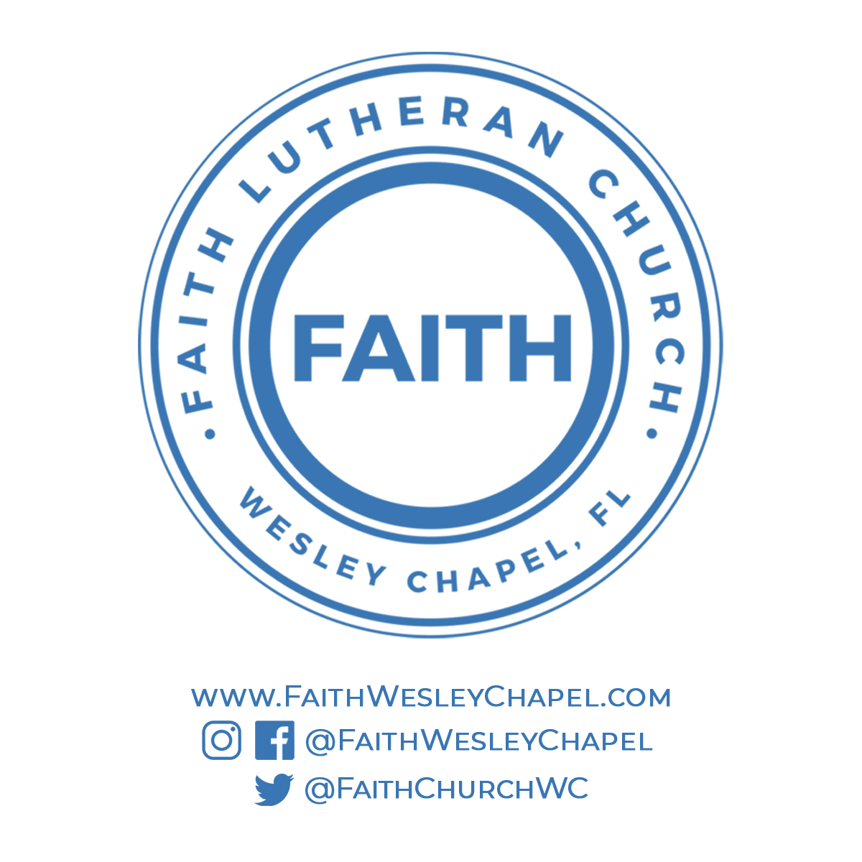**@FaithWesleyChapel**

**@FaithWesleyChapel**

**@FaithChurchWC**