

**Leading our community into a deep connection in Christ**

**Worship Service for April 28, 2024 at 11 AM**

**Welcome**

**Opening Song:**Christ Has Arisen, Alleluia Verse 1:Christ has arisen, alleluia. Rejoice and praise Him, alleluia.For our Redeemer burst from the tomb,Even from death, dispelling its gloom.

Refrain:

Let us sing praise to Him with endless joy;

Death’s fearful sting He has come to destroy.

Our sin forgiving, alleluia! Jesus is living, alleluia!

Verse 2:

For three long days, the grave did its worst

Until its strength by God was dispersed.

He who gives life did death undergo;

And in its conquest, His might did show.

*(Refrain)*

Verse 4:

Go spread the news: He’s not in the grave;

He has arisen this world to save.

Jesus’ redeeming labors are done; Even the battle with sin is won.

*(Refrain)* Tr. © 1977 Augsburg Publishing House; © 1968 Lutheran Theological  
 College, Makomira, Tanzania, admin. Augsburg Fortress

**Invocation**

**Confession and Forgiveness:**

**P:** Come into the presence of God. It is God, Himself, who bids us to come to Him in prayer, especially when we have sinned, so that we may receive His forgiveness. So, we enter His courts with confidence that if we confess our sins, He will forgive us as He promised.

*(A time of silence to reflect and personally confess our sins)*

**C:** Heavenly Father, we confess that we have sinned against you in thought, word, and deed. We have not loved you with our whole heart and have not loved our neighbor as ourselves. We are truly sorry and we humbly repent. For the sake of your Son Jesus Christ and His suffering and death on the cross, have mercy on us and forgive us; that we may delight in your will, and walk in your ways, to the glory of your Name. Amen

**P:** The Lord our God is merciful and gracious, longsuffering, and abounding in goodness and truth, keeping mercy for thousands, forgiving iniquity and transgression and sin. Therefore I announce unto you the grace of our Lord Jesus Christ. In His stead and by the command of my Lord Jesus Christ, I forgive you all your sins in the name of the Father and of the Son and of the Holy Spirit.

**C:** Amen.

**Song of Praise and Thanksgiving -** Give Thanks

Give thanks with a grateful heart. Give thanks to the Holy One.

Give thanks because He's given Jesus Christ, His son.

(repeat)

And now let the weak say I am strong, let the poor say I am rich,

Because of what the Lord has done for us.

(repeat)

Give thanks. Give thanks. We give thanks. © 1978 Integrity's Hosanna! Music

**Old Testament Reading -** 1 Chronicles 29:14-18

“But who am I, and what is my people, that we should be able thus to offer willingly? For all things come from you, and of your own have we given you. For we are strangers before you and sojourners, as all our fathers were. Our days on the earth are like a shadow, and there is no abiding. O Lord our God, all this abundance that we have provided for building you a house for your holy name comes from your hand and is all your own.  
I know, my God, that you test the heart and have pleasure in uprightness. In the uprightness of my heart I have freely offered all these things, and now I have seen your people, who are present here, offering freely and joyously to you. O Lord, the God of Abraham, Isaac, and Israel, our fathers, keep forever such purposes and thoughts in the hearts of your people, and direct their hearts toward you.

**Reader:** This is the Word of the Lord.  
**C:** Thanks be to God.

**Gospel Reading -** Matthew 25:14-30

“For it will be like a man going on a journey, who called his servants and entrusted to them his property. To one he gave five talents, to another two, to another one, to each according to his ability. Then he went away. He who had received the five talents went at once and traded with them, and he made five talents more. So also he who had the two talents made two talents more. But he who had received the one talent went and dug in the ground and hid his master's money.  
Now after a long time the master of those servants came and settled accounts with them. And he who had received the five talents came forward, bringing five talents more, saying, ‘Master, you delivered to me five talents; here, I have made five talents more.’ His master said to him, ‘Well done, good and faithful servant. You have been faithful over a little; I will set you over much. Enter into the joy of your master.’ And he also who had the two talents came forward, saying,   
‘Master, you delivered to me two talents; here, I have made two talents more.’ His master said to him, ‘Well done, good and faithful servant. You have been faithful over a little; I will set you over much. Enter into the joy of your master.’  
He also who had received the one talent came forward, saying, ‘Master, I knew you to be a hard man, reaping where you did not sow, and gathering where you scattered no seed, so I was afraid, and I went and hid your talent in the ground. Here, you have what is yours.’ But his master answered him, ‘You wicked and slothful servant! You knew that I reap where I have not sown and gather where I scattered no seed? Then you ought to have invested my money with the bankers, and at my coming I should have received what was my own with interest. So take the talent from him and give it to him who has the ten talents. For to everyone who has will more be given, and he will have an abundance. But from the one who has not, even what he has will be taken away. And cast the worthless servant into the outer darkness. In that place there will be weeping and gnashing of teeth.’

**P:** This is the Gospel of the Lord.  
**C:** Praise be to You, o Christ.

**Children's Message** *(Children dismissed to Children's Church)*

**Sermon Hymn -** The Earth is the Lord’s

The earth is the Lord’s and the fullness thereof.

Redemption reminds us, O God, of your love.

By grace we are learning, as year leads to year.

We’re called to be stewards, your caretakers here.

Too often, O God, we abuse your good earth.

We fail to remember its beauty and worth.

We take from creation much more than we need,

We threaten your mission through excess and greed.

May we be good stewards of all that you give  
Extending your Gospel wherever we live.

May we be a church that renews and restores

And lovingly cares for these gifts that are yours. © Public Domain

**Sermon -** Series: Faithful Stewards of God's Grace  
 This Week: "Receiving and Using God’s Gifts"

1 Peter 4:10

As each has received a gift, use it to serve one another, as good stewards of God's varied grace:

**P:** This is the word of the Lord.  
**C:** Thanks be to God.

**Prayers:** *Text in prayer requests to (813) 326-5255‬*

**Nicene Creed** *(stand)*

I believe in one God, the Father Almighty, maker of heaven and earth and of all things visible and invisible.

And in one Lord Jesus Christ, the only-begotten Son of God, begotten of His Father before all worlds, God of God, Light of Light, very God of very God, begotten, not made, being of one substance with the Father, by whom all things were made; who for us men and for our salvation came down from heaven and was incarnate by the Holy Spirit of the virgin Mary and was made man; and was crucified also for us under Pontius Pilate. He suffered and was buried. And the third day He rose again according to the Scriptures and ascended into heaven and sits at the right hand of the Father. And He will come again with glory to judge both the living and the dead, whose kingdom will have no end.

And I believe in the Holy Spirit, the Lord and Giver of Life, who proceeds from the Father and the Son, who with the Father and the Son together is worshiped and glorified, who spoke by the prophets. And I believe in one holy Christian and apostolic Church, I acknowledge one Baptism for the remission of sins, and I look for the resurrection of the dead and the life of the world to come. Amen.

**The Lord's Prayer** *(stand)*

Our Father who art in heaven, hallowed be Thy name, Thy kingdom come, Thy will be done on earth as it is in heaven.  Give us this day our daily bread; and forgive us our trespasses as we forgive those who trespass against us; and lead us not into temptation, but deliver us from evil.  For Thine is the kingdom and the power and the glory forever and ever.  Amen

**Offering**

**Benediction** *– The online service ends. The closing hymn video is on the Livestream page bulletin at FaithWesleyChapel.com with lyrics below. See announcements below as well.*

**Closing Song -**As For Me and My House *(sit)*

Let our foundation be built on your majesty.  
Let every word you speak fill this home.  
Jesus our cornerstone, the anchor for our souls,  
Your glory will be shown by our love.

Chorus:  
As for me and my house, as for me and my house,  
We will serve you. We will serve you.  
As for me and my house, as for me and my house,  
We will serve you. We will serve you.

We stand on Holy Ground. This is where lost get found.  
Your goodness all around, it’s pouring out.  
Your presence is new wine. The old is left behind.  
There’s nothing but new life to be found.

Chorus:  
As for me and my house, as for me and my house,  
We will serve you. We will serve you.  
As for me and my house, as for me and my house,  
We will serve you. We will serve you.

Bridge:  
This is a house where idols fall.  
This is a house where dead man walk.  
This is a house where freedoms calls.  
Can you hear it now, hear it now?  
*(Repeat)*

*(Chorus 2x)* © Integrity's Alleluia! Music

|  |  |
| --- | --- |
| **Serving This Week** | |
|  | |
| **O.T. Reader:** Melissa Steinbrueck | **Children’s Church Teacher:** |
| **Gospel Reader:** N/A | Halston and Ben |
| **Acolyte:** Eli Bingaman | **Children’s Church Assistant:** |
| **Com. Asst:** Larry Chmiel | N/A |
|  | |
| **Serving Next Week** | |
|  | |
| **1st Reader:** Kelsey Torgrimson | **Children’s Church Teacher:** |
| **2nd Reader:** Tomas Horness | N/A |
| **Acolyte:** Lawrence Finnerty | **Children’s Church Assistant:** |
| **Com. Asst:** Larry Chmiel | N/A |

**Upcoming Events**

**Today, After the Service – Voter Meeting**  
Faith Lutheran Church

**April 30, 7 PM Growth Group**  
Davi’s house

**May 5th, After the Service – Confirmation**   
Faith Lutheran Church

**May 18th, 5 PM Picnic & Games**   
Wesley Chapel District Park

**www.FaithWesleyChapel.com**

**Faith YouTube**

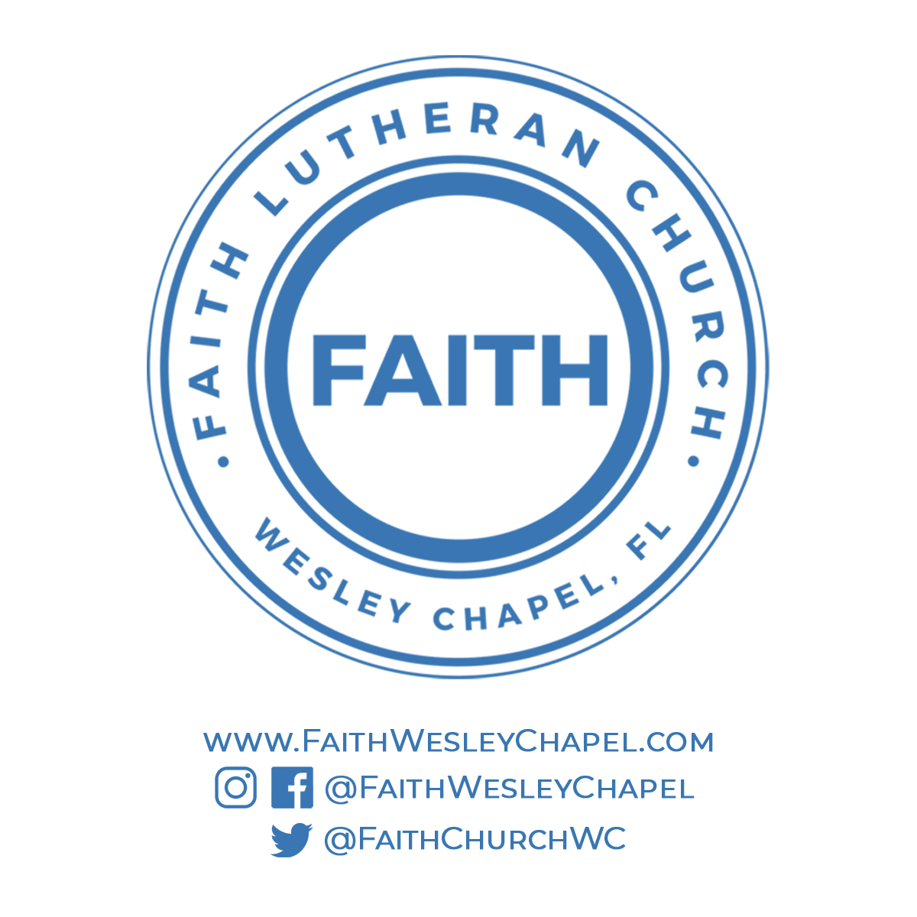**@FaithWesleyChapel**

**@FaithWesleyChapel**

**@FaithChurchWC**