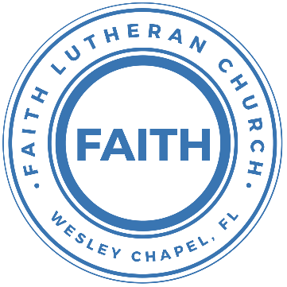

**Leading our community into a deep connection in Christ**

**___________________________________________________**

**Worship Service for May 5, 2024 at 11 AM**

**Welcome**

**Opening Song:**The Fruit of the Spirit Song

Oh, the fruit of the Spirit's not a coconut.  
Oh, the fruit of the Spirit's not a coconut.  
If you want to be a coconut, (Banana, Watermelon, Lemon)  
You might as well hear it. You can't be a fruit of the Spirit.

Chorus:  
'Cause the Fruit is...love, joy, peace, patience,  
Kindness, goodness, faithfulness, gentleness and self-control.  
Love, joy, peace, patience,  
Kindness, goodness, faithfulness, gentleness and self-control.

© Public Domain

**Invocation**

**Confession and Forgiveness:**

**P:** We have come here today to worship the Lord.  In worship we hear the Word of God, we receive God's blessings, and respond with thanks and praise.  We begin by seeking God's blessing of forgiveness.  He has promised to remove the guilt and shame of our sin through the sacrifice of Jesus Christ on the cross.

*(a time of silence to reflect and personally confess our sins)*

**P:** Let us confess our sins to the Lord.

**P:** Heavenly Father,  
**C:** Heavenly Father,

**P:** I have done things that were wrong.  
**C:** I have done things that were wrong.  
  
**P:** I have been mean to others.  
**C:** I have been mean to others.

**P:** I have not obeyed my parents.  
**C:** I have not obeyed my parents.

**P:** I have not obeyed You, God.  
**C:** I have not obeyed You, God.

**P:** But I am very sorry.  
**C:** But I am very sorry.

**P:** Please forgive me.  
**C:** Please forgive me.

**P:** I love You very much.  
**C:** I love You very much.

**P:** And I know You love me, too.  
**C:** And I know You love me, too.

**P:** Amen.  
**C:** Amen.

**P:** God has heard your apology.  He loves you very much.  God has told us that when we believe and trust in Him, He makes us His children.  As far as the east is from the west, so far does he remove our sins from us. He has told me to tell you that you are forgiven.  So, as His servant, I forgive you in the name of the Father and of the Son and of the Holy Spirit.   
**C:** Amen.

**Song:**God Is So Good

God is so good. God is so good.  
God is so good. He's so good to me.

He died for me. He died for me so.  
He died for me. He's so good to me.

He loves me so. He loves me so.  
He loves me so. He's so good to me. © Public Domain

**First Reading -**Luke 10:27, 36-37

“You shall love the Lord your God with all your heart and with all your soul and with all your strength and with all your mind, and your neighbor as yourself.”...  
...Which of these three, do you think, proved to be a neighbor to the man who fell among the robbers?” He said, “The one who showed him mercy.” And Jesus said to him, “You go, and do likewise.”

**Reader:** This is the Word of the Lord.  
**C:** Thanks be to God.

**Children's Message**"The Good Samaritan"

**Song: Seek Ye First**

Seek ye first, the Kingdom of God and His righteousness,  
And all these things shall be added unto you. Allelu, Alleluia.

Ask and it shall be given unto you. Seek and ye shall find.  
Knock and it shall be opened unto you. Allelu, Alleluia.

Man shall not live by bread alone, but by every word,  
That proceeds out from the mouth of the Lord. Allelu, Alleluia.

© Public Domain

**Second Reading -**Galatians 5:13-14

For you were called to freedom, brothers. Only do not use your freedom as an opportunity for the flesh, but through love serve one another. For the whole law is fulfilled in one word: “You shall love your neighbor as yourself.”

**Reader:** This is the Word of the Lord.  
**C:** Thanks be to God.

**Children's Message**"Free to Serve"

**Sermon Song:**I’m Free

I’m free! (echo)  
I’m free! (echo)  
I’m free to be a servant of the Lord  
Repeat

Chorus:  
He taught me how to praise Him,   
He taught me how to sing His song.  
He taught me how to L…O…V…E!  
I’m free to be a servant of the Lord.

**Sermon –**Series: Faithful Stewards of God's Grace  
 This Week: "Serve One Another"

**Prayers:** *Text in prayer requests to (813) 326-5255*

**The Lord's Prayer**

Our Father who art in heaven, hallowed be Thy name, Thy kingdom come, Thy will be done on earth as it is in heaven.  Give us this day our daily bread; and forgive us our trespasses as we forgive those who trespass against us; and lead us not into temptation, but deliver us from evil.  For Thine is the kingdom and the power and the glory forever and ever.  Amen

**Offering**

**Benediction** *– The online service ends. The closing hymn video is on the Livestream page bulletin at FaithWesleyChapel.com with lyrics below. See announcements below as well.*

**Closing Song:**Echo  *(sit)*

When night has fallen, when fear is common,

Still You're calling me. When faith is lost and,

My hope exhausted, You will be my strength.

Pre-Chorus:

When my mind says I'm not good enough, God,  
You're enough for me.

I've decided I'm not giving up 'cause You won't give up on me.

You won't give up on me!

Chorus:

Your love is holding on and it won't let go.

I feel it breaking out like an echo.  
Your love is holding on and it won't let go.  
I feel it breaking out like an echo.

Post-Chorus:

Echo in my so-o-o-o-oul, So-o-o-o-oul.

Echo in my so-o-o-o-oul, So-o-o-o-oul.

Verse 2:

In every season You keep repeating promises to me.

Now there's no stopping what you have started,

Until it is complete.

Post-Chorus:  
*(Repeat x2)*

© Elevation Worship Publishing

|  |  |
| --- | --- |
| **Serving This Week** | |
| **1st Reader:** Kelsey Torgrimson | |
| **2nd Reader:** Thomas Horness | **Children’s Church Teacher:** |
| **Acolyte:** Lawrence Finnerty | Halston and Ben |
| **Com. Asst:** Larry Chmiel | **Children’s Church Assistant:** |
|  | N/A |
| **Serving Next Week** | |
|  | |
| **O.T. Reader:** Ginger Torgrimson | |
| **Epistle Reader:** Melissa Steinbrueck | **Children’s Church Teacher:** |
| **Acolyte:** Jakob Torgrimson | N/A |
| **Com. Asst:** Larry Chmiel | **Children’s Church Assistant:** |
| **Serving This Week** | N/A |

**Hey Youth!!**Do you know any worship songs you’d like to sing as part of our youth service? Let Pastor Kurt know.

Do you want to sing or play an instrument? Let Pastor Kurt know.

We want you to be a part of the service.

**Upcoming Events**

**Today, After the Service – Confirmation**   
Faith Lutheran Church

**May 18th, 5 PM – Picnic & Games**   
Wesley Chapel District Park

**May 21st, 7 PM – Council Meeting**  
Carrie’s home

**May 25th – Everyone Come to Church for Pictures Sunday**   
Faith Lutheran Church

**May 28th, 7 PM – Growth Group**   
Renee’s home - 3436 Chapel Creek Cir  
Wesley Chapel, FL 33544

[**www.FaithWesleyChapel.com**](http://www.FaithWesleyChapel.com)

 **Faith YouTube**

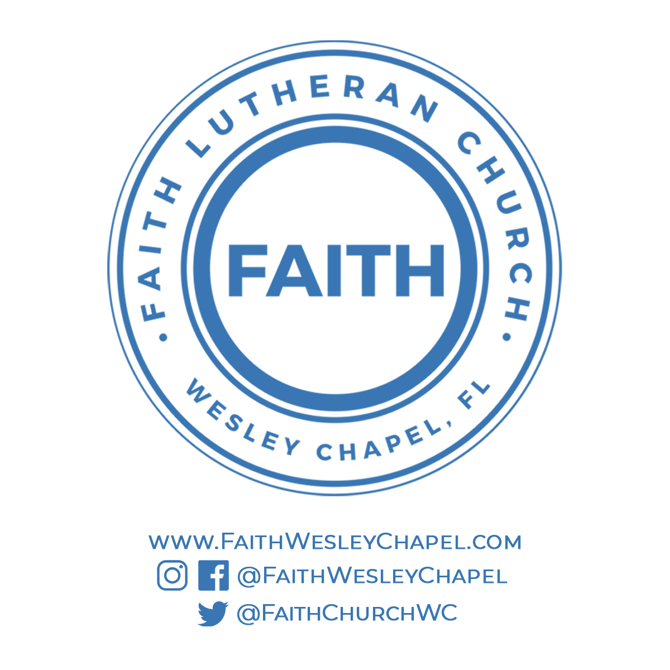**@FaithWesleyChapel**

**@FaithWesleyChapel**

**@FaithChurchWC**