

**Leading our community into a deep connection in Christ**

**Worship Service for May 12, 2024 at 11 AM**

**Welcome**

**Pray for the Food** - **People get food**

**Invocation** *(stand)*

**Confession and Forgiveness:** *(stand)*

**P:** As we gather, today, let us cleanse our hearts and our consciences by confessing our sin to God.

*(Time of silence for reflection and confession)*

**C:** Heavenly Father, we confess that we are sinful and unclean. We have sinned against you and against our neighbor in our thoughts, words, and actions.  We are truly sorry for our sins and sincerely repent of them. We ask for Your mercy. For the sake of Jesus Christ's bitter suffering and death, please forgive us and renew us that we may walk in Your Spirit to the glory of Your holy name. Amen

**P:** The Lord has heard your confession. Therefore, as a called and ordained servant of the Lord, in the stead and by the command of my Lord, Jesus Christ, I forgive you all your sins in the name of the Father and of the Son and of the Holy Spirit.  
**C:** Amen

**Songs of Praise and Thanksgiving –** This Is My Father's World

This is my Father's world, and to my listening ears,  
All nature sings, and round me rings the music of the spheres.  
This is my Father's world. I rest me in the thought,  
Of rocks and trees, of skies and seas;  
His hand the wonders wrought.

This is my Father's world. The birds their carols raise.  
The morning light, the lily white, declare their Maker's praise.   
This is my Father's world. He shines in all that's fair.  
In the rustling grass I hear Him pass. He speaks to me everywhere.

This is my Father's world. O let me ne'er forget,  
That though the wrong seems oft so strong, God is the ruler yet. This is my Father's world. Why should my heart be sad?   
The Lord is King; let the heavens ring!   
God reigns; let the earth be glad!

This is my Father's world. Why should my heart be sad?   
The Lord is King; let the heavens ring!   
God reigns; let the earth be glad!

*(Repeat last 2 lines)* © 2005 Maranatha! Music, Nickeldimeus Music, and LAVIKMUSIC

**Old Testament Reading:**Genesis 1:26-28

Then God said, “Let us make man in our image, after our likeness. And let them have dominion over the fish of the sea and over the birds of the heavens and over the livestock and over all the earth and over every creeping thing that creeps on the earth.”

So God created man in his own image,  
 in the image of God he created him;  
 male and female he created them.

And God blessed them. And God said to them, “Be fruitful and multiply and fill the earth and subdue it, and have dominion over the fish of the sea and over the birds of the heavens and over every living thing that moves on the earth.”

**Reader:** This is the Word of the Lord.  
**C:** Thanks be to God.

**Epistle Reading** - 1 Corinthians 4:1-5

This is how one should regard us, as servants of Christ and stewards of the mysteries of God. Moreover, it is required of stewards that they be found faithful. But with me it is a very small thing that I should be judged by you or by any human court. In fact, I do not even judge myself. For I am not aware of anything against myself, but I am not thereby acquitted. It is the Lord who judges me. Therefore do not pronounce judgment before the time, before the Lord comes, who will bring to light the things now hidden in darkness and will disclose the purposes of the heart. Then each one will receive his commendation from God.

**Reader:** This is the Word of the Lord.  
**C:** Thanks be to God.

**-Sermon Song –** What Is the World To Me

What is the world to me With all its vaunted pleasure

When You, and You alone, Lord Jesus, are my Treasure!

You only, dearest Lord, My soul's Delight shall be;

You are my Peace, my Rest, What is the world to me!

The world seeks after wealth And all that Mammon offers,

Yet never is content Though gold should fill it coffers.

I have a higher good, Content with it I'll be:

My Jesus is my Wealth, What is the world to me!

What is the world to me! My Jesus is my Treasure,

My Life, my Health, my Wealth, My Friend, my Love, my Pleasure,

My Joy, my Crown, my All, My Bliss eternally.

Once more, then, I declare: What is the world to me! © Public Domain

**Sermon/Discussion** – Series: Faithful Stewards of God's Grace  
 This Week: "Good Stewards of God’s Grace"

Sermon/Discussion - Luke 16:1-13

He also said to the disciples, “There was a rich man who had a manager, and charges were brought to him that this man was wasting his possessions. And he called him and said to him, ‘What is this that I hear about you? Turn in the account of your management, for you can no longer be manager.’ And the manager said to himself, ‘What shall I do, since my master is taking the management away from me? I am not strong enough to dig, and I am ashamed to beg. I have decided what to do, so that when I am removed from management, people may receive me into their houses.’

So, summoning his master's debtors one by one, he said to the first, ‘How much do you owe my master?’ He said, ‘A hundred measures of oil.’ He said to him, ‘Take your bill, and sit down quickly and write fifty.’ Then he said to another, ‘And how much do you owe?’ He said, ‘A hundred measures of wheat.’ He said to him, ‘Take your bill, and write eighty.’ The master commended the dishonest manager for his shrewdness. For the sons of this world are more shrewd in dealing with their own generation than the sons of light. And I tell you, make friends for yourselves by means of unrighteous wealth, so that when it fails they may receive you into the eternal dwellings.

“One who is faithful in a very little is also faithful in much, and one who is dishonest in a very little is also dishonest in much. If then you have not been faithful in the unrighteous wealth, who will entrust to you the true riches? And if you have not been faithful in that which is another's, who will give you that which is your own? No servant can serve two masters, for either he will hate the one and love the other, or he will be devoted to the one and despise the other. You cannot serve God and money.”

**P:** This is the Gospel of the Lord.  
**C:** Thanks be to God.

**Prayers**

**Apostles' Creed** *(stand)*

I believe in God, the Father almighty, maker of heaven and earth,  
And in Jesus Christ, his only Son, our Lord,  
who was conceived by the Holy Spirit,  
born of the Virgin Mary, suffered under Pontius Pilate,  
was crucified, died and was buried. He descended into hell.  
The third day he rose again from the dead.  
He ascended into heaven and sits at the right hand of God  
the Father almighty.  
From there he will come to judge the living and the dead.  
I believe in the Holy Spirit, the holy Christian Church,  
the communion of saints, the forgiveness of sins,  
the resurrection of the body, and the life everlasting. Amen.

**The Lord's Prayer** *(stand)*

Our Father who art in heaven, hallowed be Thy name, Thy kingdom come, Thy will be done on earth as it is in heaven.  Give us this day our daily bread; and forgive us our trespasses as we forgive those who trespass against us; and lead us not into temptation, but deliver us from evil.  For Thine is the kingdom and the power and the glory forever and ever.  Amen

**Offering** *(sit)*

**Benediction** *– The online service ends. The closing hymn video is on the Livestream page bulletin at FaithWesleyChapel.com with lyrics below. See announcements below as well.*

**Closing Song:** Praise God From Whom All Blessings Flow *(stand)*

Praise God from Whom all blessings flow.  
Praise Him all creatures here below.  
Praise Him above, ye heavenly hosts.  
Praise Father, Son and Holy Ghost.  
Amen

|  |  |
| --- | --- |
| **Serving This Week** | |
|  | |
| **O.T. Reader:** Ginger Torgrimson | **Children’s Church Teacher:** |
| **Epistle Reader:** Melissa Steinbrueck | Melissa Steinbrueck |
| **Acolyte:** Jakob Torgrimson | **Children’s Church Assistant:** |
| **Com. Asst:** Larry Chmiel | Kaylee Steinbrueck |
|  | |
| **Serving Next Week** | |
|  | |
| **O.T. Reader:** Josh Strasheim | **Children’s Church Teacher:** |
| **Epistle Reader:** Ginger Dunn | Halston & Ben |
| **Acolyte:** Alanna Bingaman | **Children’s Church Assistant:** |
| **Com. Asst:** Larry Chmiel | N/A |

**Upcoming Events**

**May 18th, 5 PM – Picnic & Games**   
Wesley Chapel District Park

**May 21st, 7 PM – Council Meeting**  
Carrie’s home

**May 26th – Everyone Come to Church for Pictures Sunday**   
Faith Lutheran Church

**May 28th, 7 PM – Growth Group**   
Renee’s home

**www.FaithWesleyChapel.com**

**Faith YouTube**

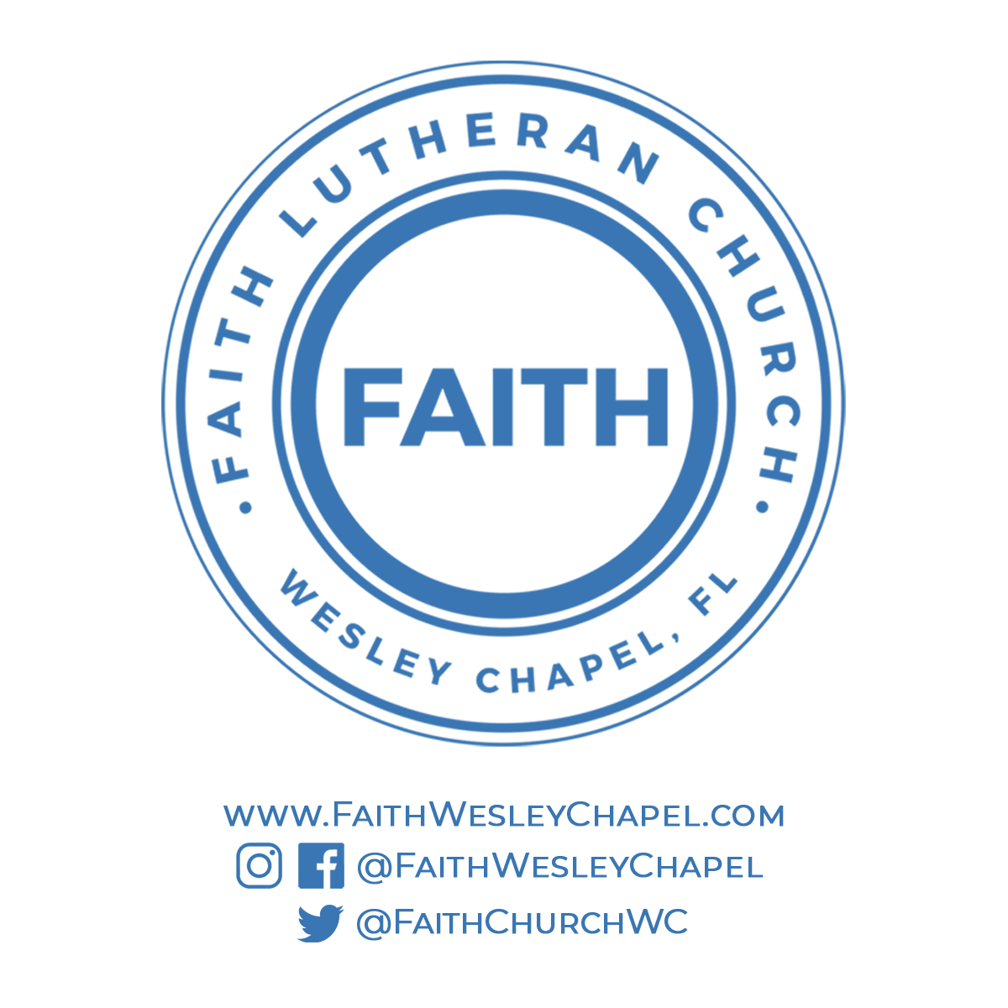**@FaithWesleyChapel**

**@FaithWesleyChapel**

**@FaithChurchWC**