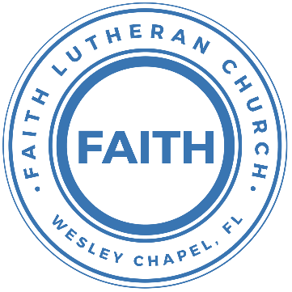

**Leading our community into a deep connection in Christ**

**___________________________________________________**

**Worship Service for May 26, 2024 at 11 AM**

**Welcome**

**Invocation**

**Song: The Steadfast Love**

The steadfast love of the Lord never ceases

His mercies never come to an end

They are new every morning, New every morning

Great is Thy faithfulness, O Lord. Great is Thy faithfulness

(repeat)

**Confession and Forgiveness:**

**P:** When God created mankind, He said mankind was very good. Then man rebelled against God and sin entered the world. Immediately after, God promised a savior to save His rebellious creation.  
**C:** Praise be to God whose mercies are new every day.

**P:** In the fullness of time, God sent His Son, born of a woman, born under the law, to redeem those under the law.  
**C:** Praise be to God whose mercies are new every day.

**P:** At His baptism, Jesus was numbered among us sinners that He might offer Himself as a sacrifice upon the cross for sinners.  
**C:** Praise be to God whose mercies are new every day.

**P:** Through Jesus Christ, God bids us come to Him and confess our sins, promising to forgive our sins and purify us.  
**C:** Praise be to God whose mercies are new every day. Let us confess our sins and seek God's mercy.

(a time of silence to reflect and personally confess our sins)

**C:** Heavenly Father, we confess that we have sinned against you in thought, word, and deed. We have not loved you with our whole heart and have not loved our neighbor as ourselves. We are truly sorry and we humbly repent. For the sake of your Son Jesus Christ and His suffering and death on the cross, have mercy on us and forgive us; that we may delight in your will, and walk in your ways, to the glory of your Name. Amen

**P:** The Lord our God is merciful and gracious, longsuffering, and abounding in goodness and truth, keeping mercy for thousands, forgiving iniquity and transgression and sin. Therefore, I announce unto you the grace of our Lord Jesus Christ. In His stead and by the command of my Lord Jesus Christ, I forgive you all your sins in the name of the Father and of the Son and of the Holy Spirit.  
**C:** Amen.Praise be to God whose mercies are new every day.

**The Steadfast Love**

The steadfast love of the Lord never ceases

His mercies never come to an end

They are new every morning, New every morning

Great is Thy faithfulness, O Lord. Great is Thy faithfulness

**Song of Praise and Thanksgiving -** Holy, Holy, Holy

Holy, holy, holy, Lord God almighty:  
Early in the morning our song shall rise to Thee.  
Holy, holy, holy, merciful and mighty,  
God in three persons blessed Trinity.

Holy, holy, holy, all the saints adore Thee,  
Casting down their golden crowns around the glassy sea.  
Cherubim and Seraphim falling down before Thee,  
Which wert and art and evermore shall be.

Holy, holy, holy, though the darkness hide Thee,  
Though the eye of sinful man Thy glory may not see,  
Only Thou art holy there is none beside Thee,  
Perfect in pow’r, in love, and purity.

Holy, holy, holy, Lord God almighty!  
All Thy works shall praise Thy name in earth and sky and sea.  
Holy, holy, holy, merciful and mighty,  
God in three persons blessed Trinity.  
God in three persons blessed Trinity. © Public Domain

**Old Testament Reading -** Deuteronomy 6:4-9

“Hear, O Israel: The Lord our God, the Lord is one. You shall love the Lord your God with all your heart and with all your soul and with all your might. And these words that I command you today shall be on your heart. You shall teach them diligently to your children, and shall talk of them when you sit in your house, and when you walk by the way, and when you lie down, and when you rise. You shall bind them as a sign on your hand, and they shall be as frontlets between your eyes. You shall write them on the doorposts of your house and on your gates.

**Reader:** This is the Word of the Lord.  
**C:** Thanks be to God.

**Epistle Reading** - Hebrews 1:1–4

Long ago, at many times and in many ways, God spoke to our fathers by the prophets, but in these last days he has spoken to us by his Son, whom he appointed the heir of all things, through whom also he created the world. He is the radiance of the glory of God and the exact imprint of his nature, and he upholds the universe by the word of his power. After making purification for sins, he sat down at the right hand of the Majesty on high, having become as much superior to angels as the name he has inherited is more excellent than theirs.

**Reader:** This is the Word of the Lord.  
**C:** Thanks be to God.

**Gospel Reading -** Matthew 3:13-17

Then Jesus came from Galilee to the Jordan to John, to be baptized by him. John would have prevented him, saying, “I need to be baptized by you, and do you come to me?” But Jesus answered him, “Let it be so now, for thus it is fitting for us to fulfill all righteousness.” Then he consented. And when Jesus was baptized, immediately he went up from the water, and behold, the heavens were opened to him, and he saw the Spirit of God descending like a dove and coming to rest on him; and behold, a voice from heaven said, “This is my beloved Son, with whom I am well pleased.”

**P:** This is the Gospel of the Lord.  
**C:** Praise be to You, O Christ.

**Children's Message**

**Sermon Hymn -** You Are Holy and Holy, Holy, Holy

Verse 1:  
Praise Father God, giver of life  
Power and might, goodness and light  
Ruler of all

Praise to the Son, the living Christ  
Body and blood, mercy and love  
Sweet sacrifice

Chorus 1:  
You are holy, holy, You are holy, holy

Verse 2:  
Praise Holy Ghost, voice in the dark  
Healer and friend, fire and wind  
Lord of our hearts

Praise Father God; praise to the Son  
Praise Holy Ghost; Praise Father, Son  
And Holy Ghost

Chorus 2:  
You are holy, holy, You are holy, holy  
You are holy, holy, You are holy, holy  
Praise Father God.

© 2002 New Spring, Never Say Never Songs, Meaux Jeaux, and Swervalina Music

**Series:** Loving God with Your Mind  
This Week: Who Is God and How Do We Know He Exists?

**Prayers:** *Text in prayer requests to (813) 326-5255‬*

**Apostles' Creed** *(stand)*

I believe in God, the Father almighty,  
maker of heaven and earth,

And in Jesus Christ, his only Son, our Lord,  
who was conceived by the Holy Spirit,  
born of the Virgin Mary,  
suffered under Pontius Pilate,  
was crucified, died and was buried.  
He descended into hell.  
The third day he rose again from the dead.  
He ascended into heaven and sits at the right hand of God  
the Father almighty.  
From there he will come to judge the living and the dead.

I believe in the Holy Spirit,  
the holy Christian Church,  
the communion of saints,  
the forgiveness of sins,  
the resurrection of the body,  
and the life everlasting. Amen.

**The Lord's Prayer** *(stand)*

Our Father who art in heaven, hallowed be Thy name, Thy kingdom come, Thy will be done on earth as it is in heaven.  Give us this day our daily bread; and forgive us our trespasses as we forgive those who trespass against us; and lead us not into temptation, but deliver us from evil.  For Thine is the kingdom and the power and the glory forever and ever.  Amen

**Offering** *(sit)*

**Benediction Benediction** *– The online service ends. The closing hymn video is on the Livestream page bulletin at FaithWesleyChapel.com with lyrics below. See announcements below as well.*

**Closing Song -**You Are Holy (Prince Of Peace) *(sit)*

Verse:

You are holy. *(Women echo)* You are mighty. *(Women echo)*

You are worthy, *(Women echo)* Worthy of praise *(Women echo)*

I will follow. *(Women echo)* I will listen. *(Women echo)*

I will love You, *(Women echo)* All of my days. *(Women echo)*

*Chorus:*

*(MEN) (WOMEN)*

I will sing to He is Lord of Lords

And worship He is King of Kings

The King who He is Mighty God

Is worthy Lord of everything

I will love and He's Emmanuel

Adore Him He's the Great I Am

And I will bow down He's my Prince of Peace

before Him Who is the Lamb

I will sing to He's my Living God

And worship He's my Saving Grace

The King who He will reign forever

Is worthy He is Ancient of Days

I will love and He is Alpha, Omega

Adore Him Beginning and End

And I will bow down He's my Savior, Messiah

Before Him Redeemer and friend

All: He's my Prince of Peace, and I will live my life for Him.  
 © 1994 Imboden Music and Martha Jo Publishing

|  |  |
| --- | --- |
| **Serving This Week** | |
|  | |
| **O.T. Reader:** Vanessa Frost | **Children’s Church Teacher:** |
| **Epistle Reader:** Larry Chmiel | Melissa Steinbrueck |
| **Acolyte:** Thomas Horness | **Children’s Church Assistant:** |
| **Com. Asst:** Larry Chmiel | Kelsey Torgrimson |
|  | |
| **Serving Next Week** | |
|  | |
| **1st Reader:** Kaylee Steinbrueck | **Children’s Church Teacher:** |
| **2nd Reader:** Eli Bingaman | N/A – Youth Service |
| **Acolyte:** Jacob Torgrimon | **Children’s Church Assistant:** |
| **Com. Asst:** Larry Chmiel | N/A – Youth Service |

**Upcoming Events**

**Today, Everyone Come to Church for Pictures Sunday**   
Faith Lutheran Church

**After Service, 1 PM – Series: Loving God with Your Mind  
(Lunch and Bible Study)**  
Pastor Kurt’s Home

**June 2nd – 1 PM – Series: Loving God with Your Mind   
(Lunch and Bible Study)**  
Location - TBD

**June 9th – After Service, “God Squad” Youth Group**Faith Lutheran Church

[**www.FaithWesleyChapel.com**](http://www.FaithWesleyChapel.com)

 **Faith YouTube**

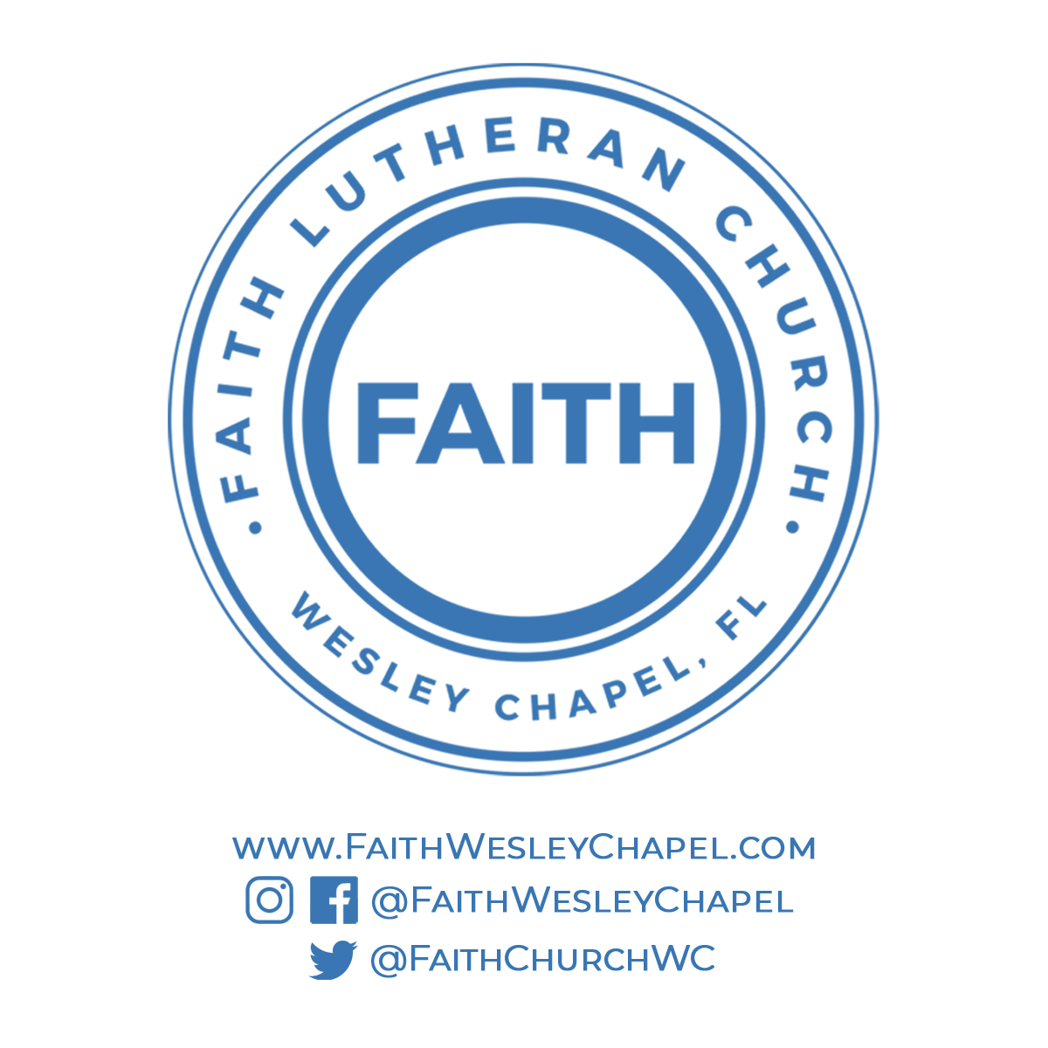**@FaithWesleyChapel**

**@FaithWesleyChapel**

**@FaithChurchWC**