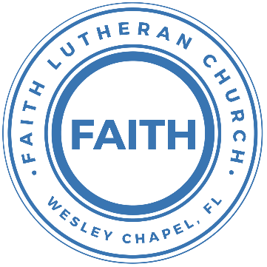

**Leading our community into a deep connection in Christ**

**Worship Service for June 2, 2024 at 11 AM**

**Welcome**

**Opening Song:**I Just Wanna Be A Sheep

Chorus:  
I just wanna be a sheep, baa baa baa baa.  
I just wanna be a sheep, baa baa baa baa.  
I pray the Lord my soul to keep,   
I just wanna be a sheep, baa baa baa baa.

Verse 1:  
Don't wanna be a goat...nope! Don't wanna be a goat...nope!  
Haven't got any hope...nope! Don't wanna be a goat...nope!

Verse 4:  
Don't wanna be a Sadducee. Don't wanna be a Sadducee.  
'Cause they're so sad you see. Don't wanna be a Sadducee.

*(Chorus)*

Verse 5:  
Just wanna be a child of God. Just wanna be a child of God.  
Walkin' the same path He trod. Just wanna be a child of God.

*(Chorus)*  © 1974 Mission Hills Music

**Invocation**

**Confession and Forgiveness:**

**P:** We have come here today to worship the Lord.  In worship we hear the Word of God, we receive God's blessings, and respond with thanks and praise.  We begin by seeking God's blessing of forgiveness.  He has promised to remove the guilt and shame of our sin through the sacrifice of Jesus Christ on the cross.

*(a time of silence to reflect and personally confess our sins)*

**P:** Let us confess our sins to the Lord.

**P:** Heavenly Father,  
**C:** Heavenly Father,

**P:** I have done things that were wrong.  
**C:** I have done things that were wrong.  
  
**P:** I have been mean to others.  
**C:** I have been mean to others.

**P:** I have not obeyed my parents.  
**C:** I have not obeyed my parents.

**P:** I have not obeyed You, God.  
**C:** I have not obeyed You, God.

**P:** But I am very sorry.  
**C:** But I am very sorry.

**P:** Please forgive me.  
**C:** Please forgive me.

**P:** I love You very much.  
**C:** I love You very much.

**P:** And I know You love me, too.  
**C:** And I know You love me, too.

**P:** Amen.  
**C:** Amen.

**P:** God has heard your apology.  He loves you very much.  God has told us that when we believe and trust in Him, He makes us His children.  As far as the east is from the west, so far does he remove our sins from us. He has told me to tell you that you are forgiven.  So, as His servant, I forgive you in the name of the Father and of the Son and of the Holy Spirit.   
**C:** Amen.

**Song:**Jesus Loves Me

Verse 1:

Jesus loves me this I know, for the Bible tells me so.

Little ones to Him belong. They are weak, but He is strong.

Chorus:

Yes, Jesus loves me. Yes, Jesus loves me.

Yes, Jesus loves me, the Bible tells me so.

Verse 2:

Jesus loves me, He who died, Heaven's gates to open wide.

He will wash away my sin, let His little child come in.

*(Chorus)* © Public Domain

**First Reading -**Exodus 20:8-11

“Remember the Sabbath day, to keep it holy. Six days you shall labor, and do all your work, but the seventh day is a Sabbath to the Lord your God...

...For in six days the Lord made heaven and earth, the sea, and all that is in them, and rested on the seventh day. Therefore the Lord blessed the Sabbath day and made it holy.

**Reader:** This is the Word of the Lord.  
**C:** Thanks be to God.

**Children's Message**"What Is the Sabbath?"

**Song:**Every Move I Make

Verse:  
Every move I make, I make in You.  
You make me move, Jesus.  
Every breath I take, I breathe in You.

Every step I take, I take in You.  
You are my way, Jesus.  
Every breath I take, I breathe in You.

Chorus:  
Waves of mercy, Waves of grace,  
Everywhere I look, I see Your face.  
Your love has captured me.  
Oh my God, this love, how can it be?

Bridge:  
Na Na Na...  
*(Repeat)*

*(Verse)*

*(Chorus)*

*(Bridge (2x)* © 1996 Mercy/Vineyard Publishing, Vineyard Songs Canada, and ION Publishing

**Second Reading -**Deuteronomy 5:12-15

“‘Observe the Sabbath day, to keep it holy, as the Lord your God commanded you. Six days you shall labor and do all your work, but the seventh day is a Sabbath to the Lord your God. On it you shall not do any work, you or your son or your daughter or your male servant or your female servant, or your ox or your donkey or any of your livestock, or the sojourner who is within your gates, that your male servant and your female servant may rest as well as you.

You shall remember that you were a slave in the land of Egypt, and the Lord your God brought you out from there with a mighty hand and an outstretched arm. Therefore the Lord your God commanded you to keep the Sabbath day.

**Reader:** This is the Word of the Lord.  
**C:** Thanks be to God.

**Children's Message**"What Is the Purpose of the Sabbath?"

**Sermon Hymn:** Your Grace Is Enough

Great is Your faithfulness oh God.  
You wrestle with the sinner's restless heart.  
You lead us by still waters into mercy,  
And nothing can keep us apart.

Pre-chorus:  
So, remember Your people. Remember Your children.  
Remember Your promise, Oh God.

Chorus:  
Your grace is enough. Your grace is enough.  
Your grace is enough for me.

Great is Your love and justice God of Jacob.  
You use the weak to lead the strong.  
You lead us in the song of Your salvation,  
And all Your people sing along.

*(Pre-chorus)*

*(Chorus 2x)* © 2003 spiritandsong.com and Thankyou Music

**Sermon –**"How Do We Honor the Sabbath?"

Sermon Reading - Mark 2:23-28

One Sabbath he was going through the grainfields, and as they made their way, his disciples began to pluck heads of grain. And the Pharisees were saying to him, “Look, why are they doing what is not lawful on the Sabbath?” And he said to them, “Have you never read what David did, when he was in need and was hungry, he and those who were with him: how he entered the house of God, in the time of Abiathar the high priest, and ate the bread of the Presence, which it is not lawful for any but the priests to eat, and also gave it to those who were with him?” And he said to them, “The Sabbath was made for man, not man for the Sabbath. So the Son of Man is lord even of the Sabbath.”

**Prayers:** *Text in prayer requests to (813) 326-5255*

**The Lord's Prayer**

Our Father who art in heaven, hallowed be Thy name, Thy kingdom come, Thy will be done on earth as it is in heaven.  Give us this day our daily bread; and forgive us our trespasses as we forgive those who trespass against us; and lead us not into temptation, but deliver us from evil.  For Thine is the kingdom and the power and the glory forever and ever.  Amen

**Offering** *(sit)*

**Benediction Benediction** *– The online service ends. The closing hymn video is on the Livestream page bulletin at FaithWesleyChapel.com with lyrics below. See announcements below as well.*

**Closing Song:**Marvelous Light

Chorus:  
Into marvelous light I'm running, out of darkness out of shame.  
By the cross you are the truth, You are the life, You are the way.

I once was fatherless, a stranger with no hope.  
Your kindness wakened me, wakened me from my sleep, now.  
Your love it beckons deeply, a call to come and die.  
By grace now I will come. Take this life, take your life!

Pre-Chorus:  
Sin has lost its power! Death has lost its sting!  
From the grave you've risen victoriously!

*(Chorus)*

My dead heart now is beating, my deepest stains now clean.  
Your breath fills up my lungs, now I'm free, now I'm free.  
*(Repeat)*

*(Pre-Chorus)*

*(Chorus)*

Bridge:  
Lift my hands and spin around. See the light that I have found,  
Oh the marvelous light, marvelous light!  
*(Repeat)*

*(Chorus 2x)*  2005 sixsteps Music

|  |  |
| --- | --- |
| **Serving This Week** | |
|  | |
| **1st Reader:** Kaylee Steinbrueck | **Children’s Church Teacher:** |
| **2nd Reader:** Eli Bingaman | N/A – Youth Service |
| **Acolyte:** Lawrence Finnerty | **Children’s Church Assistant:** |
| **Com. Asst:** Larry Chmiel | N/A – Youth Service |
|  | |
| **Serving Next Week** | |
|  | |
| **O.T. Reader:** Darlene Mueller | **Children’s Church Teacher:** |
| **Epistle Reader:** Ginger Dunn | Melissa Steinbrueck |
| **Acolyte:** Griffin Frost | **Children’s Church Assistant:** |
| **Com. Asst:** Larry Chmiel | Kaylee Steinbrueck |

**Upcoming Events**

**Today – After Service 1 PM, Series: Loving God with Your Mind   
(Lunch and Bible Study)**  
Pastor Kurt’s Home

**June 9th – Faith and Food Service**Faith Lutheran Church

**June 9th – After Service, “God Squad” Youth Group**Faith Lutheran Church

**June 11th – 7 PM Growth Group**   
Renee’s home

**www.FaithWesleyChapel.com**

**Faith YouTube**

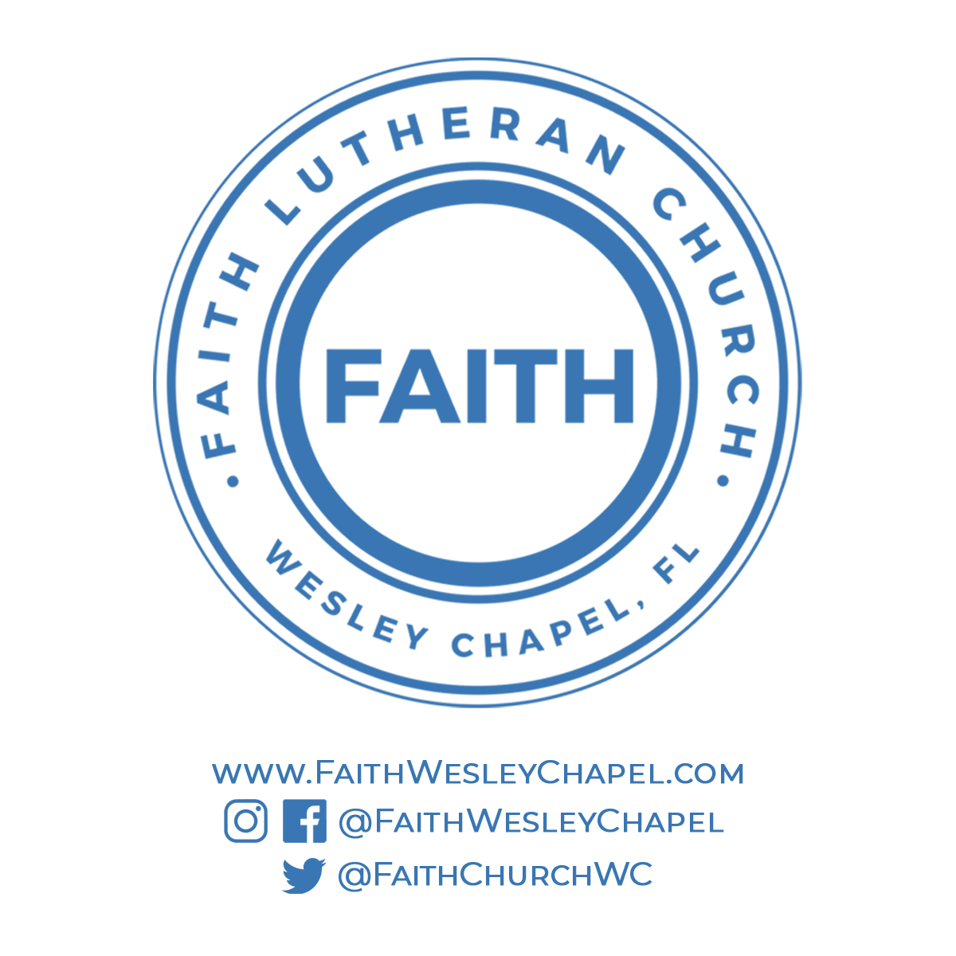**@FaithWesleyChapel**

**@FaithWesleyChapel**

**@FaithChurchWC**