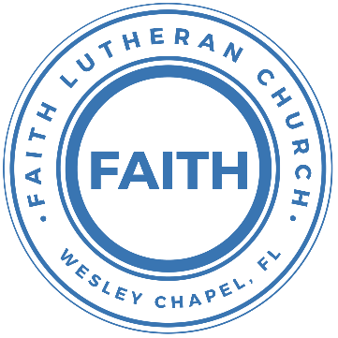

**Leading our community into a deep connection in Christ**

**___________________________________________________**

**Worship Service for June 9, 2024 at 11 AM**

**Welcome**

**Pray for the Food** - **People get food**

**Invocation** *(stand)*

**Confession and Forgiveness:** *(stand)*

**P:** As we gather, today, let us cleanse our hearts and our consciences by confessing our sin to God.

*(Time of silence for reflection and confession)*

**C:** Heavenly Father, we confess that we are sinful and unclean. We have sinned against you and against our neighbor in our thoughts, words, and actions.  We are truly sorry for our sins and sincerely repent of them. We ask for Your mercy. For the sake of Jesus Christ's bitter suffering and death, please forgive us and renew us that we may walk in Your Spirit to the glory of Your holy name. Amen

**P:** The Lord has heard your confession. Therefore, as a called and ordained servant of the Lord, in the stead and by the command of my Lord, Jesus Christ, I forgive you all your sins in the name of the Father and of the Son and of the Holy Spirit.  
**C:** Amen

**Songs of Praise and Thanksgiving –** Beautiful Savior

Beautiful Savior, King of creation,

Son of God and Son of man.

Truly I’d love Thee, Truly I’d serve Thee.

Light of my soul, my joy, my crown.

Fair are the meadows. Fair are the woodlands,

Robed in the flow’rs of blooming spring.

Jesus is fairer. Jesus is purer.

He makes our sorrowing spirit sing.

Beautiful Savior, Lord of the nations,

Son of God and Son of man.

Glory and honor, praise adoration,

Now and forever more be Thine! © 1957 New Spring

**Old Testament Reading:**Proverbs 30:5-9

Every word of God proves true; he is a shield to those who take refuge in him. Do not add to his words, lest he rebuke you and you be found a liar. Two things I ask of you; deny them not to me before I die: Remove far from me falsehood and lying; give me neither poverty nor riches; feed me with the food that is needful for me, lest I be full and deny you and say, “Who is the Lord?” or lest I be poor and steal and profane the name of my God.

**Reader:** This is the Word of the Lord.  
**C:** Thanks be to God.

**Epistle Reading** - Ephesians 4:11-16

And he gave the apostles, the prophets, the evangelists, the shepherds and teachers, to equip the saints for the work of ministry, for building up the body of Christ, until we all attain to the unity of the faith and of the knowledge of the Son of God, to mature manhood, to the measure of the stature of the fullness of Christ, so that we may no longer be children, tossed to and fro by the waves and carried about by every wind of doctrine, by human cunning, by craftiness in deceitful schemes. Rather, speaking the truth in love, we are to grow up in every way into him who is the head, into Christ, from whom the whole body, joined and held together by every joint with which it is equipped, when each part is working properly, makes the body grow so that it builds itself up in love.

**Reader:** This is the Word of the Lord.  
**C:** Thanks be to God.

**Sermon Song –** Cornerstone

My hope is built on nothing less,   
Than Jesus' blood and righteousness.  
I dare not trust the sweetest frame,   
But wholly trust in Jesus' name.

Chorus:

Christ alone, Cornerstone, Weak made strong in the Savior's love.

Through the storm He is Lord, Lord of all.

Verse 2:

When darkness seems to hide His face,

I rest on His unchanging grace.

In every high and stormy gale My anchor holds within the veil.

My anchor holds within the veil.

*(Chorus)*

He is Lord. Lord of all.

Verse 3:

When He shall come with trumpet sound,

Oh, may I then in Him be found,

Dressed in His righteousness alone,

Faultless, stand before the throne.

Chorus:

Christ alone, Cornerstone, Weak made strong in the Savior's love.

Through the storm He is Lord, Lord of all.

© 2011 Hillsong Music

**Sermon/Discussion**  
"Is There Absolute Truth and Why Does It Matter?"

Sermon/Discussion - John 18:37-38

Then Pilate said to him, “So you are a king?” Jesus answered, “You say that I am a king. For this purpose I was born and for this purpose I have come into the world—to bear witness to the truth. Everyone who is of the truth listens to my voice.” Pilate said to him, “What is truth?” After he had said this, he went back outside to the Jews and told them, “I find no guilt in him.

**P:** This is the Gospel of the Lord.  
**C:** Praise be to You, O Christ.

* **Malachi 3:6** “For I the Lord do not change; therefore you, O children of Jacob, are not consumed.
* **Psalm 119:142** Your righteousness is righteous forever, and your law is true.
* **Psalm 119:160** The sum of your word is truth, and every one of your righteous rules endures forever.
* **Psalm 43:3** Send out your light and your truth; let them lead me; let them bring me to your holy hill and to your dwelling!
* **Matthew 7:24-27** “Everyone then who hears these words of mine and does them will be like a wise man who built his house on the rock. 25 And the rain fell, and the floods came, and the winds blew and beat on that house, but it did not fall, because it had been founded on the rock. 26 And everyone who hears these words of mine and does not do them will be like a foolish man who built his house on the sand. 27 And the rain fell, and the floods came, and the winds blew and beat against that house, and it fell, and great was the fall of it.”
* **John 14:6** Jesus said to him, “I am the way, and the truth, and the life. No one comes to the Father except through me.
* **John 17:17** Sanctify them in the truth; your word is truth.
* **1 John 3:18** Little children, let us not love in word or talk but in deed and in truth.
* **Ephesians 4:17-25** Now this I say and testify in the Lord, that you must no longer walk as the Gentiles do, in the futility of their minds. 18 They are darkened in their understanding, alienated from the life of God because of the ignorance that is in them, due to their hardness of heart. 19 They have become callous and have given themselves up to sensuality, greedy to practice every kind of impurity. 20 But that is not the way you learned Christ!— 21 assuming that you have heard about him and were taught in him, as the truth is in Jesus, 22 to put off your old self, which belongs to your former manner of life and is corrupt through deceitful desires, 23 and to be renewed in the spirit of your minds, 24 and to put on the new self, created after the likeness of God in true righteousness and holiness. 25 Therefore, having put away falsehood, let each one of you speak the truth with his neighbor, for we are members one of another.

**Prayers**

**Apostles' Creed** *(stand)*

I believe in God, the Father almighty, maker of heaven and earth,  
And in Jesus Christ, his only Son, our Lord,  
who was conceived by the Holy Spirit,  
born of the Virgin Mary, suffered under Pontius Pilate,  
was crucified, died and was buried. He descended into hell.  
The third day he rose again from the dead.  
He ascended into heaven and sits at the right hand of God  
the Father almighty.  
From there he will come to judge the living and the dead.  
I believe in the Holy Spirit, the holy Christian Church,  
the communion of saints, the forgiveness of sins,  
the resurrection of the body, and the life everlasting. Amen.

**The Lord's Prayer** *(stand)*

Our Father who art in heaven, hallowed be Thy name, Thy kingdom come, Thy will be done on earth as it is in heaven.  Give us this day our daily bread; and forgive us our trespasses as we forgive those who trespass against us; and lead us not into temptation, but deliver us from evil.  For Thine is the kingdom and the power and the glory forever and ever.  Amen

**Offering**

**Benediction Benediction** *– The online service ends. The closing hymn video is on the Livestream page bulletin at FaithWesleyChapel.com with lyrics below. See announcements below as well.*

**Closing Song:** Praise God From Whom All Blessings Flow *(stand)*

Praise God from Whom all blessings flow.  
Praise Him all creatures here below.  
Praise Him above, ye heavenly hosts.  
Praise Father, Son and Holy Ghost.  
Amen

|  |  |
| --- | --- |
|  | |
| **Serving This Week** | |
|  | |
| **O.T. Reader:** Darlene Mueller | **Children’s Church Teacher:** |
| **Epistle Reader:** Ginger Dunn | Melissa Steinbrueck |
| **Acolyte:** Alanna Bingaman | **Children’s Church Assistant:** |
| **Com. Asst:** Larry Chmiel | Griffin Frost |
|  | |
| **Serving Next Week** | |
|  | |
| **O.T. Reader:** Melissa Steinbrueck | **Children’s Church Teacher:** |
| **Epistle Reader:** Vanessa Frost | Halston & Ben |
| **Acolyte:** Kaylee Steinbrueck | **Children’s Church Assistant:** |
| **Com. Asst:** Larry Chmiel | N/A |

**Upcoming Events**

**June 9th – After Service, “God Squad” Youth Group**Faith Lutheran Church

**June 11th – 8 AM Food Pantry**   
Atonement

**June 11th – 7 PM Growth Group**   
Renee’s home

**June 16th – After Service 1 PM, Loving God with Your Mind   
(Lunch and Bible Study)**  
Pastor Kurt’s Home

[**www.FaithWesleyChapel.com**](http://www.FaithWesleyChapel.com)

 **Faith YouTube**

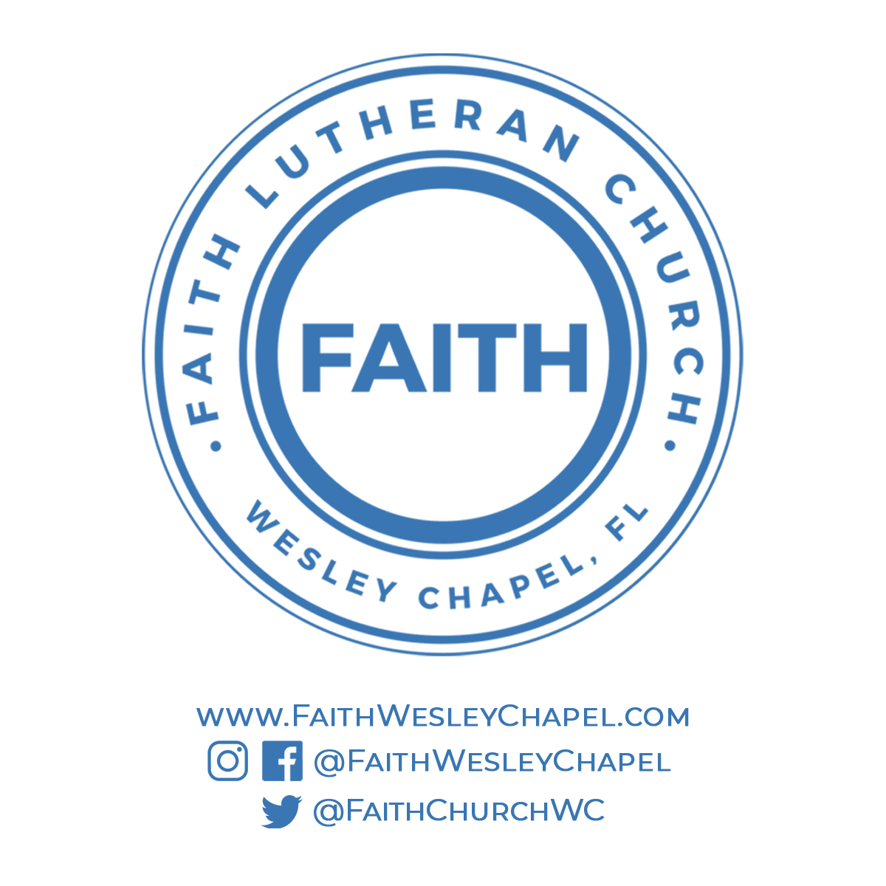**@FaithWesleyChapel**

**@FaithWesleyChapel**

**@FaithChurchWC**